Market Manual 1: Connecting to Ontario's Power System
Part 1.7: Synchrophasor Data Requirements
Issue 2.1
December 2, 2026
MAN-131

This document provides detailed procedures to be followed by connection applicants who wish to connect to the IESO-controlled grid.
PUBLIC
Market Manual

Document Change History
Issue | Reason for Issue | Date
Refer to Issue 1.0 (PRO-723) for changes prior to Market Transition.
1.0 | Market transition | April 4, 2025
2.0 | Issued for Baseline 54.1 | December 3, 2025
2.1 | Issued as part of Updates to IESO Monitoring Requirements | December 2, 2026

Related Documents
Document ID | Document Title
RUL-11 | Market Rules Chapter 2: Grid Connection Requirements
RUL-12 | Market Rules Chapter 2: Grid Connection Requirements – Appendices
RuL-24 | Market Rules Chapter 11: Definitions

Table of Contents

Table of Contents i
List of Figures ii
List of Tables iii
Table of Changes iv
Market Manual Conventions 1
1 Introduction 3
1.1 Purpose 3
1.2 Scope 3
1.3 Contact Information 4
2 Requirements: Generators 5
2.1 Infrastructure Requirements for Generators 5
2.2 Phasor Data Requirements for Generators 7
2.3 Applicable Generator Connection Configurations 14
2.4 Reliability, Maintenance and Repair 15
2.5 Low Capacity Factor 15
3 Requirements: Transmitters 17
3.1 Infrastructure Requirements for Transmitters 17
3.2 Phasor Data Requirements for Transmitters 18
3.3 Reliability, Maintenance and Repair 23
4 Requirements: Electricity Storage Participants 24
4.1 Infrastructure Requirements for Electricity Storage Participants 24
4.2 Phasor Data Requirements for Electricity Storage Participants 25
4.3 Applicable Electricity Storage Units Connection 30
4.4 Reliability, Maintenance and Repair 30
5 PMU Registration Process 31
6 PMU Connection Process 35
7 Background Information for Synchrophasors and Associated Infrastructure 38
7.1 Typical Infrastructure for Providing Synchrophasor Data 38

List of Figures
Figure 2-1: Examples for synchrophasor data measurement locations for different generator connection configurations. 13
Figure 4-1: Examples of synchrophasor data measurement locations for different electricity storage facilities and PMU connection configurations 27
Figure 4-1: PMU Registration Process 29
Figure 4-2: Sample PMU Registration Form to be completed. Download PMU Registration Form from IESO website 30
Figure 4-3: Sample PDC Registration Form to be completed. Download the PMU Registration Form from IESO website. 31
Figure 5-1: Typical infrastructure required for providing synchrophasor data (single PMU) 33
Figure 5-2: Typical infrastructure for multiple PMUs 33
Figure 5-3: PMU and Phasor Data Concentrators 35
Figure 5-4: AC waveform during dynamics 35

List of Tables
Table 2-1: Requirements for Generators 6
Table 3-1: Requirements for Transmitters 15
Table 4-1: Requirements for Electricity Storage Units 22

Table of Changes
Reference | Description of Change
Section 4 | New section to outline requirements for electricity storage facilities
Section 6 | New section to outline PMU connection process
Throughout | Reformatting to post-MRP template and conventions
Sections 2 and 3 | Voltage and current phasors are required for each phase.  Minimum reporting rate increased from 30 to 60 samples/second.

Market Manuals
Market manuals set out procedural and administrative details with respect to market rule requirements. Where there is a conflict between the requirements described in a market manual or appended document, and those within the market rules, the market rules shall prevail.

Market Manual Conventions
The standard conventions followed for market manuals are as follows:
- The word 'shall' denotes a mandatory requirement;
- References to market rule sections and sub-sections may be abbreviated in accordance with the following representative format: ‘MR Ch.1 ss.1.1-1.2’ (i.e. market rules, Chapter 1, sections 1.1 to 1.2).
- References to market manual sections and sub-sections may be abbreviated in accordance with the following representative format: ‘MM 1.5 ss.1.1-1.2’ (i.e. market manual 1.5, sections 1.1 to 1.2).
- Internal references to sections and sub-sections within this manual take the representative format: ‘sections 1.1 – 1.2’
- Terms and acronyms used in this market manual and its appended documents that are italicized have the meanings ascribed thereto in MR Ch.11;
- All user interface labels and options that appear on the IESO gateway and tools are formatted with the bold font style; and
- Data fields are identified in all capitals.
– End of Section –

– End of Section –

Introduction

Purpose
This market manual elaborates on synchrophasor data requirements for:
- Generation facilities connected to the IESO-controlled grid, as documented in MR Ch.4 App. 4.15;
- Transmission systems connected to the IESO-controlled grid, as documented in MR Ch.4 App. 4.16; and
- Electricity storage facilities connected to the IESO-controlled grid, as documented in MR Ch. App. 4.24.
Sections 2, 3, and 4 include technical specifications and guidelines for generators, transmitters, and electricity storage participants for supplying synchrophasor data with the required attributes to the IESO for utilization in planning and operation of the IESO-controlled grid. Section 5 and 6 includes the process of registering Phasor Measurement Units (PMUs) with the IESO before a connection can be established for the transmission of synchrophasor data and the process for connecting PMUs.

Scope
This market manual supplements the following market rules:
- MR Ch.4 s.7.2: Provision of Connection-Related Information
- MR Ch. App. 4.15: IESO Monitoring Requirements: Generators
- MR Ch. App. 4.16: IESO Monitoring Requirements: Transmitters
- MR Ch. App. 4.24: IESO Monitoring Requirements: Electricity storage participants
Synchrophasor data is primarily generated by dedicated devices. However, synchrophasor data can also be produced by other multi-purpose devices that incorporate synchrophasor data capabilities such as (1) modern Dynamic Disturbance Recorders or (2) Intelligent Electronic Devices used for protection. The technical requirements and functionalities of those devices are unique and materially different to each other. The scope of this market manual does not include technical requirements of those devices but is instead focused on clarifying the technical requirements of the synchrophasor data that any of those devices, each considered to be a phasor measurement unit (PMU), must produce to meet the IESO’s requirements.
The synchrophasor data from the PMU devices may be transmitted to the IESO via a processor called the Phasor Data Concentrator (PDC). The technical requirements of the PDC are also not in the scope of this market manual.

Contact Information
Changes to this market manual are managed via the IESO Change Management process. Stakeholders are encouraged to participate in the evolution of this market manual via this process. To contact the IESO, you can email IESO Customer Relations at customer.relations@ieso.ca or use telephone or mail. Telephone numbers and the mailing address can be found on the IESO website. IESO Customer Relations staff will respond as soon as possible.

– End of Section –

Requirements: Generators

Infrastructure Requirements for Generators
(MR Ch. 4 App.4.15)

Market participants are expected to follow NERC’s IRO-010-3 standard as described in MM 11.1 s.7 when providing synchrophasor data to the IESO which will be used for situational awareness and planning analyses purposes. In cases where the synchrophasor data will be provided from devices already classified as a BES Cyber Asset then the data and its associated infrastructure must comply with NERC Critical Infrastructure Protection (CIP) program.
Transmission of synchrophasor data to the IESO must occur over the internet using a secure IPsec site-to-site VPN connection with the following specifications:

- Internet connection with bandwidth and latency specifications as per Table 2-1;
- Public static IP address; and
- Firewall device capable of creating IPsec site-to-site VPN tunnel with the following settings: IKEv2, AES-256 Encryption, SHA256 Data Integrity, 2048 bit DH group, PFS with 2048 bit DH group.
In certain circumstances, the IESO may permit the use of a private communication link instead of a public internet-based VPN connection. Approval for such arrangements can be requested at the time of PMU registration via e-mail submissions at PMUregistration@ieso.ca. The IESO has the sole discretion in approving such arrangements and will evaluate each request on a case-by-case basis.

Phasor Data Requirements for Generators
(MR Ch. 4 App.4.15)

The IESO may, at its discretion, require generators to provide synchrophasor data for reliability and system awareness purposes. Such need will be informed by considerations such as proximity to other synchrophasor measurement units, criticality of the facility from system stability perspective, etc. If the IESO determines that synchrophasor data is required from a generation facility for reliability and system awareness purposes, the IESO shall notify the market participant of such requirement.
If a market participant is required to provide and/or update syncrophasor data to the IESO in respect of multiple facilities commencing in the same calendar year, such market participant can email IESOCustomerRelations@ieso.ca to request a staged implementation plan. The IESO may permit a staged implementation plan, the specific terms of which will be subject to mutual agreement.
Table 2-1 sets forth the synchrophasor data requirements relating to a generation facility.
Table 2--1: Requirements for Generators
Attribute | Status | Requirement
Measurement Point | Required | Requirements (1) and (2) pertain to generation facilities that are directly connected to a Bulk Power System (BPS) Station OR have a connection point voltage greater than 200 kV.  - For any single generation unit rated equal to or greater than 100 MVA name-plate rating, provide synchrophasor data measured at generator terminal (i.e. low side of the generator output transformer). Generation facilities in operation prior to December 31, 2024 that have disturbance monitoring equipment on the high side of the generator output transformer may provide synchrophasor data from those existing measuring locations. See configuration 1 of Figure 2-1.  - Multiple generation units that have an aggregate name-plate rating that is equal to or greater than 100 MVA, must provide synchrophasor data measured at the generation facility side of each point of connection to the IESO-controlled grid. See configurations 2, 3, 4 of Figure 2-1. Alternatively, other measuring locations of synchrophasor data inside the generation facility can be provided if they allow for calculating the aggregated synchrophasor data at the generation facility side of each point of connection. See configurations 2, 3, 4 of Figure 2-1.  - Generation facilities subject to (1) and (2) above will not be required to provide the synchrophasor data if the IESO determines, in its sole discretion, that they meet one of the following criteria:  - The generation facility is expected to be deregistered by December 31, 2029; or  - The annual gross capacity factor of the generation facility meets the requirements as stipulated in Section 2.5.  If the IESO determines that a generation facility meets such criteria, it shall notify the generator of such determination and such determination remains subject to the IESO’s periodic review and assessment of the decommissioning plan and evaluation of capacity factor and can be revoked at the IESO’s discretion by providing the generator with notice of such new determination.  If the IESO revokes its determination, and subject to the possibility of an IESO-approved staged implementation plan in accordance with section 2.2, the generation facility will be required to provide the synchrophasor data within 3 years from the notification date.  All generation units whose output power flow contributes to an Interconnection Reliability Operating Limit (IROL) definition, regardless of rated size, must provide voltage and current phasor for all three phases and frequency at the terminals defining the IROL.
Measurement Point | Preferred | Provide additional synchrophasor data from a generation facility for specific reliability needs (e.g. generation facility with history of oscillatory events or to achieve sufficient observability over the IESO-controlled grid).
Measured Quantities | Required | Provide the following for all 3 phases:  - the voltage magnitude (Volts or kV);  - the voltage phasor angle (degrees);  - the current phasor magnitude (Amperes or kA); and  - current phasor angle (degrees).  In addition, provide frequency (Hz) and rate of change of frequency (ROCOF) measurements.
Coordinates | Required | Provide phasor data in polar coordinates where magnitudes must be in SI units.
System Frequency | Required | Provide phasor data continuously at frequency between 57 Hz and 62 Hz.
Reporting Rate | Required | Provide synchrophasor data at least once in every one sixtieth of a second (i.e. 60 samples per second).
Time-Tag Format and Accuracy | Required | All synchrophasor data shall be reported in Coordinated Universal Time (UTC time) with zero offset.  For each phasor measurement, data shall include a time tag traceable to UTC clock that includes the time and time quality at the time of measurement. The time tag shall accurately resolve time of measurement to at least 1µs within a specified 100-year period.
Data Format and Accuracy Standard | Required | Data provided to the IESO shall comply with the IEEE Std 60255-118-1-2018. Notwithstanding the foregoing, market participants connected to the IESO-controlled grid with synchrophasor data measurement infrastructure meeting IEEE Std C37.118 (2005, 2011, or 2014) and operating as part of the IESO-administered markets prior to December 31 2024, the market participant may use such existing measurement infrastructure for the remainder of its expected useful life.
Network Protocol | Required | Provide synchrophasor data via a site-to-site VPN with the IESO.  A public static IP address is required.
Instrumentation Channel | Required | Provide instrument transformers and its corresponding instrumentation channel components with accuracy high enough to be appropriately utilized in IESO real-time applications⁽⁾.
Latency | Required | Provide total latency for synchrophasor data from PMU to the IESO control center or IESO owned PDC no more than 500 ms. The market participant shall be required to provide latency of no more than a 100 ms if informed by the IESO that its synchrophasor data is to be used in a Linear State Estimator as part of a Transient Stability program.
Latency | Preferred | Provide total latency for synchrophasor data from PMU to the IESO control center or IESO owned PDC no more than 100 ms.
Bandwidth | Required | Provide communication channels with bandwidth adequate to reliably transmit the volume of PMU data at the required reporting rate.  For most generation facilities a bandwidth of 1 Mbps per transmitting PMU device will be sufficient.
Bandwidth | Preferred | Provide dedicated communication channels.
Critical Infrastructure Protection (CIP) | Preferred | Market participants to include synchrophasor data under their NERC Critical Infrastructure Protection (CIP) program.
Redundancy | Required | Provide primary communication path for synchrophasor data to the IESO.  The market participant shall be required to provide primary and secondary communication paths for synchrophasor data if informed by the IESO that its data is to be used in a Linear State Estimator as part of a Transient Stability program.
Redundancy | Preferred | Provide primary and secondary communication paths fsynchrophasor data to the IESO,
CVT/PT Selection | Preferred | Provide Metering Class Bus CVT or PT measurements where possible or Metering Class Transmission line or feeder CVT/PT measurements for better accuracy.
CT Selection | Preferred | Provide Protection Class CTs measurements where possible to capture the dynamic and fault conditions.

Applicable Generator Connection Configurations
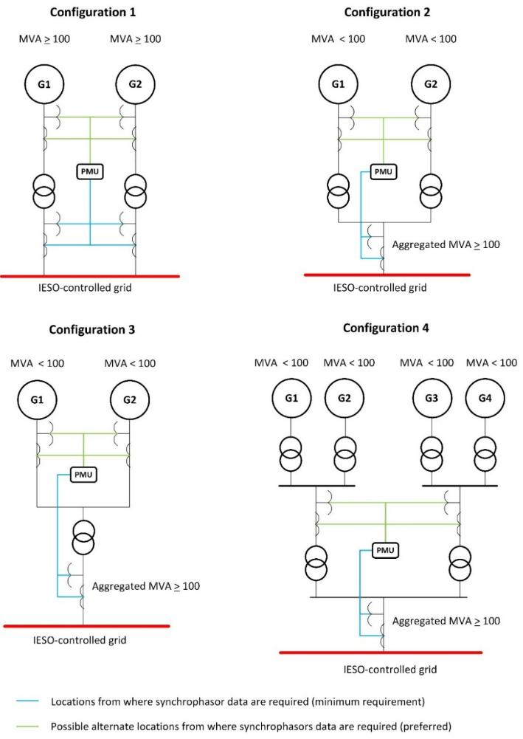
(MR Ch.4 s.7.2)
Figure 2-1 illustrates measurement points for applicable generation facilities.

Reliability, Maintenance and Repair
Figure 2-1: Examples for synchrophasor data measurement locations for different generator connection configurations.
(MR Ch.4 s.7.7)
MR Ch. 4, Sec. 7.7, is applicable to installed synchrophasor data devices and associated required infrastructure including instrument transformers, communication channels and PDCs.

Low Capacity Factor
MR Ch. 4 App.4.15)
This section explains the process for identifying generation units that are excluded from synchrophasor data requirements due to a Capacity Factor (CF) below 10%. When the IESO determines that a generation unit has a CF less than 10%, such generation unit will not be required to provide the IESO with synchrophasor data until otherwise directed by the IESO.
At least once a year the IESO will calculate the annual average CF using historical data for the last 3 years or since the in-service date, whichever is less, only for generation units that had CF below 10% in all prior assessments. Upon performing the annual assessment, if the CF for a generation unit is greater than or equal to 10%, the IESO will notify the facility owner that:
- The exclusion from synchrophasor requirements is no longer valid
- The generation unit will no longer be included for future annual CF assessments
- Synchrophasor data must be provided to the IESO within 3 years from the notification date. Market participants having multiple facilities whose CF becomes greater than or equal to 10% in the same year, may provide synchrophasor data via mutually agreed staged implementation plan, if required.
Future generation projects will be assessed during the connection approval process to determine if they qualify for exclusion from the synchrophasor requirements.
– End of Section –

Requirements: Transmitters

Infrastructure Requirements for Transmitters
(MR Ch. 4 App.4.16)

Market participants are expected to follow NERC’s IRO-010-3 standard as described in MM 11.1 s.7 when providing synchrophasor data to the IESO which will be used for situational awareness and planning analyses purposes. In cases where the synchrophasor data will be provided from devices already classified as a BES Cyber Asset then the data and its associated infrastructure must comply with NERC Critical Infrastructure Protection (CIP) program.

Transmission of synchrophasor data to the IESO must occur over the internet using a secure IPsec site-to-site VPN connection with the following specifications:
  - Internet connection with bandwidth and latency specifications as per Table 2-1;
  - Public static IP address; and
  - Firewall device capable of creating IPsec site-to-site VPN tunnel with the following settings: IKEv2, AES-256 Encryption, SHA256 Data Integrity, 2048 bit DH group, PFS with 2048 bit DH group.
In certain circumstances, the IESO may permit the use of a private communication link instead of a public internet-based VPN connection. Approval for such arrangements can be requested at the time of PMU registration via e-mail submissions at PMUregistration@ieso.ca. IESO has the sole discretion in approving such arrangements and will evaluate each request on a case-by-case basis.

Phasor Data Requirements for Transmitters
(MR Ch. 4 App.4.16)

The IESO may, at its discretion, require transmitters to provide synchrophasor data for reliability and system awareness purposes. Such need will be informed by considerations such as proximity to other synchrophasor measurement units, criticality of the facility from system stability perspective, etc. If the IESO determines a transmission facility is required to provide synchrophasor data for reliability and system awareness purposes, the IESO shall notify the market participant of such requirement.
If a market participant is required to provide and/or update synchrophasor data to the IESO in respect of multiple facilities commencing in the same calendar year, such market participant can email IESOCustomerRelations@ieso.ca to request a staged implementation plan. The IESO may permit a staged implementation plan, the specific terms of which will be subject to mutual agreement.

Table 3-1 sets forth the synchrophasor data requirements relating to transmission facilities.

Table 3-1: Requirements for Transmitters
Attribute | Status | Requirement
Measurement Points and quantities | Required | Two separate 500 kV buses in 500 kV stations, two separate BPS-classified buses in BPS stations, two separate buses in stations that are required to restore the grid from black-start units. Provide the following for all 3 phases:  - the voltage magnitude (Volts or kV);  - the voltage phasor angle (degrees);  - the frequency (Hz); and  - the rate of change of frequency (ROCOF).  In addition, provide frequency (Hz) and rate of change of frequency (ROCOF) measurements.  Terminals of circuits defining Interconnection Reliability Operating Limits (IROL) and Interties.  Provide all 3 phases of the following:  - the voltage magnitude (Volts or kV);  - the voltage phasor angle (degrees);  - the current phasor magnitude (Amperes or kA); and  - the current phasor angle (degrees).  In addition, provide frequency (Hz) and rate of change of frequency (ROCOF) measurements.  Terminal bus of Static Var Compensators (SVC), synchronous condensers and static synchronous compensators (STATCOM).  Provide the following for all 3 phases:  - the voltage magnitude (Volts or kV);  - the voltage phasor angle (degrees);  - the current phasor magnitude (Amperes or kA); and  - the current phasor angle (degrees).  In addition, provide frequency (Hz) and rate of change of frequency (ROCOF) measurements.
Coordinates | Required | Provide phasor data in polar coordinates where magnitudes must be in SI units.
System Frequency | Required | Provide phasor data continuously at frequency between 57 Hz and 62 Hz.
Reporting Rate | Required | Provide synchrophasor data at least once in every one sixtieth of a second (i.e. 60 samples per second).
Time-Tag Format and Accuracy | Required | All synchrophasor data shall be reported in Coordinated Universal Time (UTC time) with zero offset.  For each phasor measurement, data shall include a time tag traceable to UTC clock that includes the time and time quality at the time of measurement. The time tag shall accurately resolve time of measurement to at least 1 microsecond within a specified 100-year period.
Data Format and Accuracy Standard | Required | Data provided to the IESO shall comply with the IEEE Std 60255-118-1-2018. Notwithstanding the foregoing, market participants connected to the IESO-controlled grid with synchrophasor data measurement infrastructure meeting IEEE Std C37.118 (2005, 2011, or 2014) and operating as part of the IESO-administered market prior to December 31, 2024 the market participant may use such existing measurement infrastructure for the remainder of its expected useful life..
Network Protocol | Required | Provide synchrophasor data via a site-to-site VPN with the IESO.  A public static IP address is required.
Instrumentation Channel | Required | Provide instrument transformers and its corresponding instrumentation channel components with accuracy high enough to be appropriately utilized in IESO real-time applications⁽⁾.
Latency | Required | Provide total latency for synchrophasor data from PMU to the IESO control center or IESO owned PDC no more than 500 ms. The market participant shall be required to provide latency of no more than a 100 ms if informed by the IESO that its synchrophasor data is to be used in a Linear State Estimator as part of a Transient Stability program.
Latency | Preferred | Provide total latency for synchrophasor data from PMU to the IESO control center or IESO owned PDC no more than 100 ms.
Bandwidth | Required | Provide communication channels with bandwidth adequate to reliably transmit the volume of PMU data at the required reporting rate.  For most transmission facilities a bandwidth of 1 Mbps per transmitting PMU device will be sufficient.
Bandwidth | Preferred | Provide dedicated communication channels to avoid any data transmission interruption and excessive latency.
Circuit Breaker Status | Preferred | Provide Circuit Breaker Status (Digital Channels) of all transmission lines or feeders for Linear State Estimator Estimation, and for Single Line Diagram topological display purposes  This may become a requirement in the future as the IESO deploys PMUs into real-time operations.  Note that this data supports industry best practice to collect this data directly from PMUs to reduce dependencies and provide a solution for state estimation when SCADA is not available.
Isolator Status | Preferred | Provide Isolator Status (Digital Channels) of all transmission lines or feeders for Linear State Estimator Estimation, and for Single Line Diagram topological display purposes.  This may become required in the future as the IESO deploys PMUs into real-time operations.  Note that this data supports industry best practice to collect this data directly from PMUs to reduce dependencies and provide a solution for state estimation when SCADA is not available.
CVT/PT Selection | Preferred | Provide Metering Class Bus CVT or PT measurements where possible or Metering Class Transmission line or feeder CVT/PT measurements for better accuracy.
CT Selection | Preferred | Provide Protection Class CTs measurements where possible to capture the dynamic and fault conditions.

Reliability, Maintenance and Repair
(MR Ch.4 s.7.7)
MR Ch. 4, Sec. 7.7, is applicable to installed synchrophasor data devices and associated required infrastructure including instrument transformers, communication channels and PDCs.
– End of Section –

Requirements: Electricity Storage Participants

Infrastructure Requirements for Electricity Storage Participants
(MR Ch. 4 App.4.24)
Market participants are expected to follow NERC’s IRO-010-3 standard as described in MM 11.1 s.7 when providing synchrophasor data to the IESO which will be used for situational awareness and planning analyses purposes. In cases where the synchrophasor data will be provided from devices already classified as a BES Cyber Asset then the data and its associated infrastructure must comply with NERC Critical Infrastructure Protection (CIP) program.

Transmission of synchrophasor data to the IESO must occur over the internet using a secure IPsec site-to-site VPN connection with the following specifications:
- Internet connection with bandwidth and latency specifications as per Table 2-1;
- Public static IP address; and
- Firewall device capable of creating IPsec site-to-site VPN tunnel with the following settings: IKEv2, AES-256 Encryption, SHA256 Data Integrity, 2048 bit DH group, PFS with 2048 bit DH group.

In certain circumstances, the IESO may permit the use of a private communication link instead of a public internet-based VPN connection. Approval for such arrangements can be requested at the time of PMU registration via e-mail submissions at PMUregistration@ieso.ca. The IESO has the sole discretion in approving such arrangements and will evaluate each request on a case-by-case basis.

Phasor Data Requirements for Electricity Storage Participants
(MR Ch. 4 App.4.24)
The IESO may, at its discretion, require electricity storage participants to provide synchrophasor data for reliability and system awareness purposes. Such need will be informed by considerations such as proximity to other synchrophasor measurement units, criticality of the facility from system stability perspective, etc. If the IESO determines an electricity storage facility is required to provide synchrophasor data for reliability and system awareness purposes, the IESO shall notify the market participant of such requirement.
Table 4-1 sets forth the synchrophasor data requirements relating to an electricity storage facility.
Table 4-1: Requirements for Electricity Storage Units
Attribute | Status | Requirement
Measurement Point | Required | Requirements (1) and (2) pertain to electricity storage units that are directly connected to a Bulk Power System (BPS) Station OR have a connection point voltage greater than 200 kV.  - For any single electricity storage unit rated equal to or greater than 20 MVA name-plate rating, provide synchrophasor data measured at electricity storage units terminal (i.e. low side of the generator output transformer). See configuration 1 of Figure 4-1.  - Multiple electricity storage units that in aggregate equal to or greater than 20 MVA name-plate rating, must provide synchrophasor data measured at the electricity storage unit’s facility side of each point of connection to the IESO-controlled grid. See configuration 2 Figure 4-1. Alternatively, other measuring locations of synchrophasor data inside the facility can be provided if they allow for calculating the aggregated synchrophasor data at the electricity storage unit’s facility side of each point of connection. See configurations of Figure 4-1.  For all electricity storage units whose output power flow contributes to an Interconnection Reliability Operating Limit (IROL) definition, regardless of rated size, must provide voltage and current phasor for all three phases and frequency at the terminals defining the IROL.
Measurement Point | Preferred | Provide additional synchrophasor data from an electricity storage facility for specific reliability needs (e.g. electricity storage facility with history of oscillatory events or to achieve sufficient observability over the IESO-controlled grid).
Measured Quantities and Units | Required | Provide the following for all 3 phases:  - the voltage magnitude (Volts or kV);  - the voltage phasor angle (degrees);  - the current phasor magnitude (Amperes or kA); and  - the current phasor angle (degrees).  In addition, provide frequency (Hz) and rate of change of frequency (ROCOF) measurements.
Coordinates | Required | Provide phasor data in polar coordinates where magnitudes must be in SI units.
System Frequency | Required | Provide phasor data continuously at frequency between 57 Hz and 62 Hz.
Reporting Rate | Required | Provide synchrophasor data at least once in every one sixtieth of a second (i.e. 60 samples per second).
Time-Tag Format and Accuracy | Required | All synchrophasor data shall be reported in Coordinated Universal Time (UTC time) with zero offset.  For each phasor measurement, data shall include a time tag traceable to UTC clock that includes the time and time quality at the time of measurement. The time tag shall accurately resolve time of measurement to at least 1µs within a specified 100-year period.
Data Format and Accuracy Standard | Required | Data provided to the IESO shall comply with the IEEE Std 60255-118-1-2018.
Network Protocol | Required | Provide synchrophasor data via a site-to-site VPN with the IESO.  A public static IP address is required.
Instrumentation Channel | Required | Provide instrument transformers and its corresponding instrumentation channel components with accuracy high enough to be appropriately utilized in IESO real-time applications⁽⁾.
Latency | Required | Provide total latency for synchrophasor data from PMU to the IESO control center or IESO owned PDC no more than 500 ms. The market participant shall be required to provide latency of no more than a 100 ms if informed by the IESO that its synchropashor data is to be used in a Linear State Estimator as part of a Transient Stability program.
Latency | Preferred | Provide total latency for synchrophasor data from PMU to the IESO control center or IESO owned PDC no more than 100 ms.
Bandwidth | Required | Provide communication channels with bandwidth adequate to reliably transmit the volume of PMU data at selected reporting rate.  For most electricity storage facilities a bandwidth of 1 Mbps per transmitting PMU device will be sufficient.
Bandwidth | Preferred | Provide dedicated communication channels.
Critical Infrastructure Protection (CIP) | Preferred | Market participants to include synchrophasor data under their NERC Critical Infrastructure Protection (CIP) program.
Redundancy | Required | Provide primary communication path for synchrophasor data to the IESO.  The market participant shall be required to provide primary and secondary communication paths for synchrophasor data if informed by the IESO that its data is to be used in a Linear State Estimator as part of a Transient Stability program.
Redundancy | Preferred | Provide primary and secondary communication paths for synchrophasor data to the IESO.
CVT/PT Selection | Preferred | Provide Metering Class Bus CVT or PT measurements where possible or Metering Class Transmission line or feeder CVT/PT measurements for better accuracy.
CT Selection | Preferred | Provide Protection Class CTs measurements where possible to capture the dynamic and fault conditions.

Applicable Electricity Storage Units Connection
(MR Ch. 4 s.7.2)
Figure 4-1 illustrates measurement points for applicable electricity storage units.
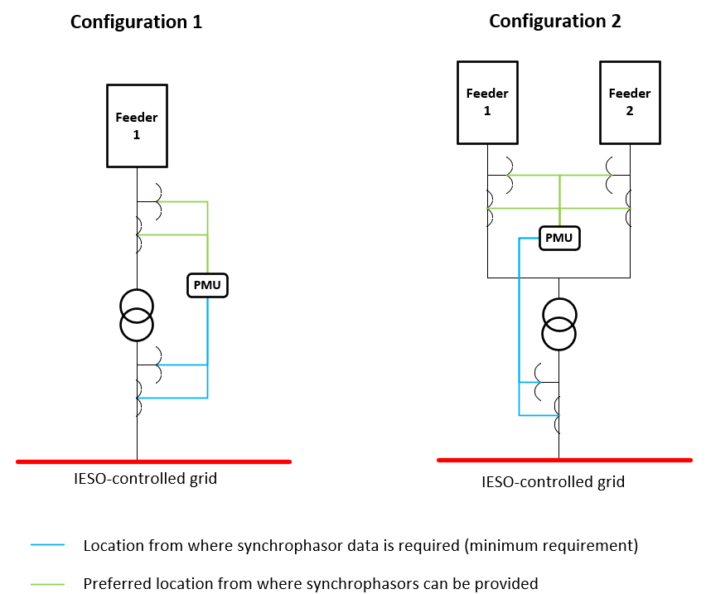

Figure 4-1: Examples of synchrophasor data measurement locations for different electricity storage facilities and PMU connection configurations

Reliability, Maintenance and Repair
(MR Ch.4 s.7.7)
MR Ch.4 s.7.7, is applicable to installed synchrophasor data devices and associated required infrastructure including instrument transformers, communication channels and PDCs.
– End of Section –

PMU Registration Process
(MR Ch.4 s.7.2)
This section describes the process of registering PMUs with the IESO. A PMU registration form must be completed for each PMU required to transmit data to the IESO. See Figure 5-2.
In cases where data from PMUs will be sent via PDC, the registration information of that PDC is to be provided shown in Figure 5-3.
The IESO will review the information provided and provide a response about any registration data that might need further clarification. The PMU registration information is required for IESO to deem that the PMU is ready to be connected, and the expected data will be transmitted. Upon completion of the review the market participant’s PMU/PDC equipment will be entered into a queue for establishing a connection to the IESO. Market participants will be provided a timeframe for when it will be their turn to connect.
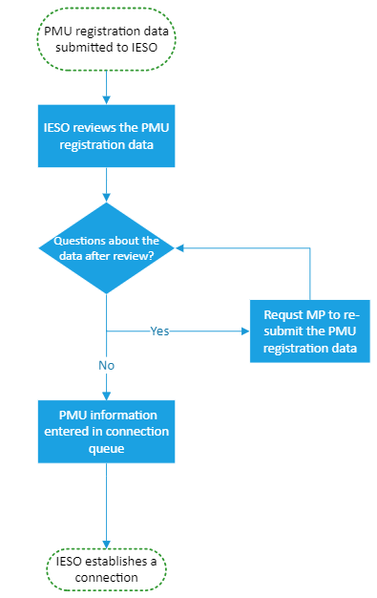
Figure 5-1: PMU Registration Process

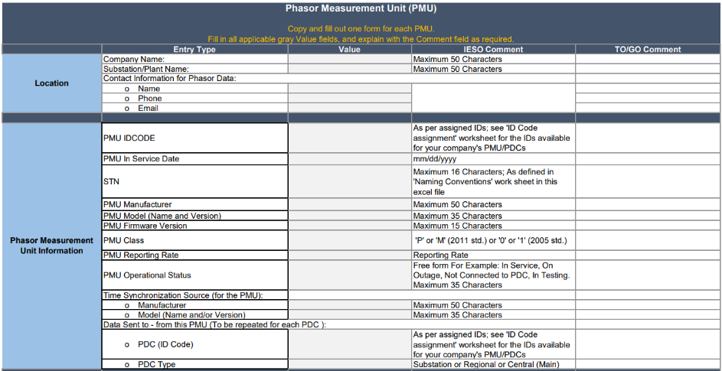
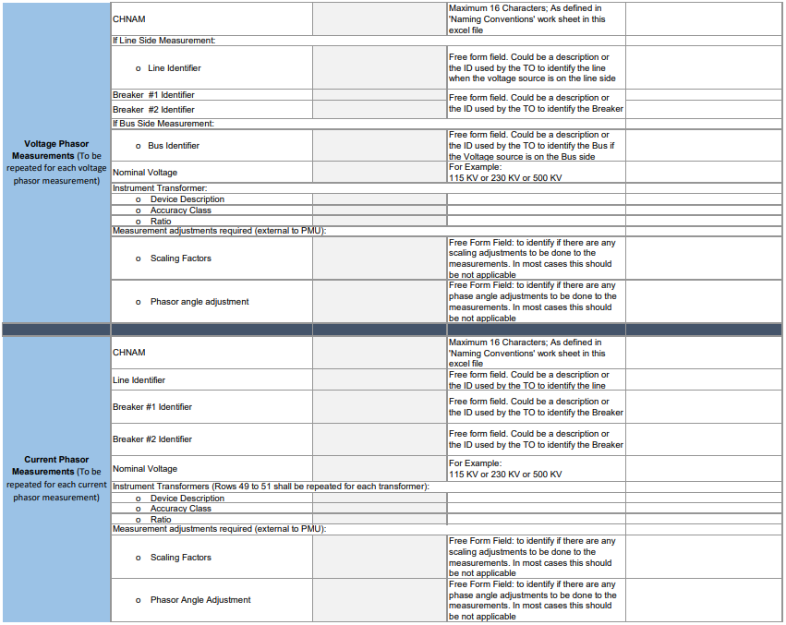
Figure 5-2: Sample PMU Registration Form to be completed. Download PMU Registration Form from IESO website
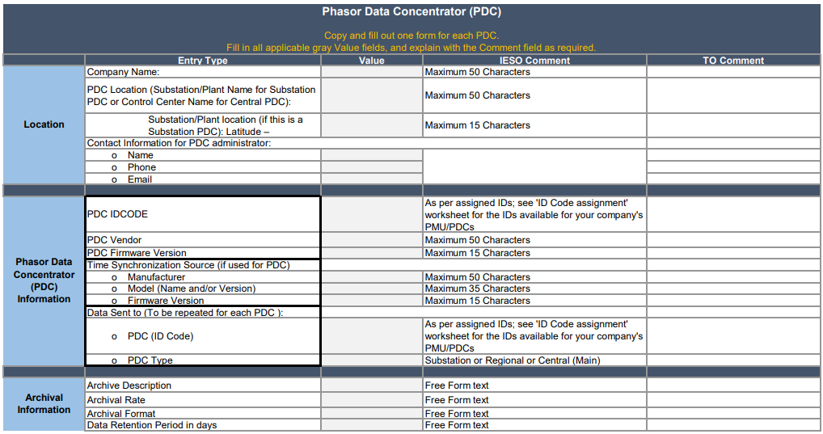
Figure 5-3: Sample PDC Registration Form to be completed. Download the PMU Registration Form from IESO website.
– End of Section –

PMU Connection Process
(MR Ch.4 s.7.2)
This section defines the required steps for establishing a secure and reliable connection between the market participant and the IESO for the purpose of synchrophasor data being transmitted continuously to the IESO. The initiation for this process is the completion of the PMU registration process as outlined in the previous section.
For instances where a market participant has multiple devices capable of generating synchrophasor data at a given facility the recommended option is for a PDC to be utilized as it minimizes the amount of VPN connections required between the IESO and market participant. In addition, PDC helps with the transmission of synchrophasor data ensuring all of the data is time-aligned from the various devices at site and transmitting it in a more compact way to the IESO. The connection architecture will be discussed in the initial meeting that starts the Connection Process to ensure that the chosen architecture is easy to maintain and administer.
Table 6-1: Steps involved in establishing connection with the IESO for the transmission of synchrophasor data
Step | Description
6.1 Initial Design Discussion | Market participant and the IESO shall review the networking technical requirements via meeting
6.2 Exchange of VPN Form | Market participant shall complete and submit the VPN configuration form provided by the IESO
6.3 Network and/or Application Validation Meeting | IESO will implement VPN tunnel based on 6.2 above, and once ready initiate a meeting to validate the connection at the network and application levels
6.4 Final Confirmation | Following the application validation meeting, market participant commences transmission of the synchophasor data and the IESO confirms successful receipt of the data and the PMU connection process is complete.

In Figure 6-1 the most common ways of transmitting synchrophasor data to the IESO are illustrated. During the initial design discussion the market participant and IESO will determine the details in terms of establishing the connection required for the transmission to take place.

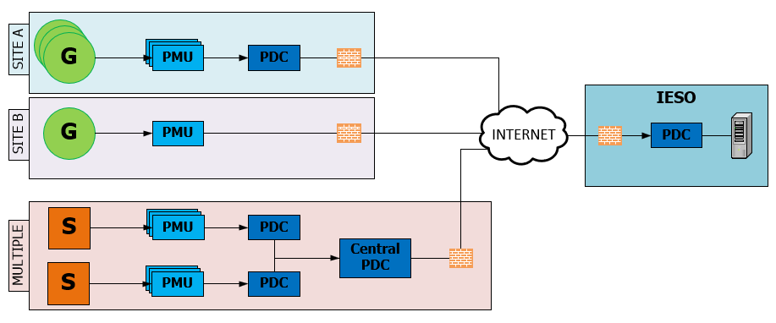
Figure 6-1: Typical synchrophasor data flow architecture based on number of PMUs at a given site and/or number of sites

– End of Section –

- cos ωt + sin ωt
- cos ωt + sin ωtC sin (ωt + α)
- C sin (ωt + α)sin (ωt + β)
- (α - β)

– End of Section –

– End of Document –

Specifications noted as “required” must be satisfied, specifications noted as “preferred” are not required but add additional operational value and should be satisfied wherever practical.
Market Participants should contact the IESO if they need assistance determining whether their plant is part of an IROL.
This requirement intends to provide flexibility to market participants to utilize their current Instrumentation Channel infrastructure with minimum accuracy equal or better than those used for SCADA measurements.
Specifications noted as “required” must be satisfied, specifications noted as “preferred” are not required but add additional operational value and should be satisfied wherever practical.
This requirement intends to provide flexibility to market participants to utilize their current Instrumentation Channel infrastructure with minimum accuracy equal or better than those used for SCADA measurements.
Specifications noted as “required” must be satisfied, specifications noted as “preferred” are not required but add additional operational value and should be satisfied wherever practical.
This requirement intends to provide flexibility to market participants to utilize their current Instrumentation Channel infrastructure with minimum accuracy equal or better than those used for SCADA measurements.

