Market Manual
PUBLIC
Market Manual 1: Connecting to Ontario’s Power System

Part 0.1.3: Identity Management Operations Guide
Issue 2.1
September 10, 2025
This guide describes the processes for Market Participants and the IESO to register for, initialize, change, and revoke User Accounts and request system access privileges required for access to IESO-secure Web servers.

Document Change History
Issue | Reason for Issue | Date
Refer to Issue 28.0 (IMP_GDE_0088) for versions prior to Market Transition.
1.0 | Market Transition | November 11, 2024
2.0 | Issued in advance of MRP Go Live - May 1, 2025 | April 25, 2025
2.1 | Issued for Baseline 54.0 | September 10, 2025

Related Documents
Document ID | Document Title

Table of Contents
Table of Contents i
List of Figures iv
List of Tables vii
Table of Changes viii
Market Transition ix
Market Manual Conventions x
1. Introduction 1
1.1. Purpose 1
1.2. Scope of this Market Manual 1
1.3. Overview 1
1.4. Contact Information 4
2. Information Security Overview 5
2.1. Provisioning, Identity Management, the IESO and the Participant 5
2.2. User Account Identity Credentials 5
3. Identity Trust Operational Model 8
3.1. IESO Trust Model 8
3.2. Identity Proofing 9
3.3. Rights Administrator Model 10
4. Identity Management Procedural Workflows 11
4.1. Participant User Account Application Scenario 12
4.2. Participant User Account Change Scenario 1 13
4.3. Participant User Account Change Scenario 2 14
4.4. Participant User Account Deprovisioning / Deactivation Scenario 15
4.5. Participant User Account Recovery Scenario 1 16
4.6. Participant User Account Recovery Scenario 2 17
4.7. Participant Rights Administrator Enrolment Scenario 18
4.8. Participant Rights Administrator User Account Change Scenario 1 19
4.9. Participant Rights Administrator User Account Change Scenario 2 20
4.10. Participant Rights Administrator Role Termination Scenario 21
4.11. Subscriber User Account Initialization / Password Reset 22
4.12. Periodic Update of Subscriber User Account Password 23
5. Participant Primary Contact Operational Guidelines 24
5.1. Primary Contact Definition 24
5.2. IESO Trust Model and Identity Credential Proofing 24
5.2.1. Participant Rights Administrator 25
5.3. Appointing a Rights Administrator 25
5.4. Process to Register a Rights Administrator and Request an Account and System Access 25
5.5. Requesting a Person’s Rights Administrator Role Termination 25
5.5.1. Circumstances for Deactivation of IESO Systems Access and User Account 26
5.6. Steps for Registering a Rights Administrator for Registration System Access and a User Account 26
6. Participant Rights Administrator Operational Guidelines 27
6.1. Rights Administrator Definition 27
6.2. Instructions for Using the IESO Registration System 27
6.3. IESO Trust Model and Guidelines for Proofing Credential Subscribers 27
6.3.1. When should the Identity of a Credential Subscriber Be Proofed 28
6.3.2. Process to Validate the Identity of the Credential Subscriber 28
6.4. Guidelines for Form Storage, Protection, and Archival 29
6.5. IESO Customer Relations Communications 29
6.6. Guidelines for Distributing and Using Identity Credential Activation Data 30
6.6.1. IESO Personal User Account Credentials 30
6.6.2. User Account Password Reset 31
6.6.3. Delivery of Password Reset Email 32
6.6.4. Direct Delivery of Temporary Password from Customer Relations 33
6.7. Person ID Number 33
6.8. Basic Trouble Shooting 34
7. Credential Subscriber Operational Guidelines 35
7.1. Introduction 35
7.2. IESO Trust Model and Identity Credential Proofing 36
7.2.1. Participant Rights Administrator 36
7.3. Protection of Identity Credential Activation Data 36
7.4. Person ID Number 36
7.5. Password Creation Guidelines 37
7.6. Applying for an IESO Account 37
7.7. IESO Systems Access Requests 38
7.8. IESO Account Deactivation 38
7.8.1. Account Deactivation 38
7.9. IESO Account Change 39
7.10. Account Recovery 39
8. Use of the Online IESO Registration System 40
8.1. Introduction 40
8.1.1. Login to the Online IESO Registration System 40
8.1.2. Online IESO – Registration Application Actions 42
8.1.3. Online IESO Registration System Grant/Revoke Access 53
8.1.4. Registration System Mange Contact Information 69
9. Use of Account Provisioning Tools 71
9.1. Use of the Password Change & Reset Functions 71
9.1.2. User Account Initialization 72
9.1.3. Self-Service Password Reset 74
9.1.4. Temporary Password Change by IESO Customer Relations 76
9.1.5. User Security Profile Options 80
9.1.6. Troubleshooting 82
10. Browser Use 84
10.1. Browser Versions 84
11. MIM Application Web Services 85
11.1. Introduction 85
11.2. Downloading the MIM Web Services Files 85
Appendix A: Account Management Procedural Steps 87
A.1. Participant Account Application Scenario 87
A.2. Participant Account Change Scenario 1 88
A.3. Participant User Account Change Scenario 2 90
A.4. Participant User Account Deprovisioning / Deactivation Scenario 91
A.5. Participant User Account Recovery Scenario 1 93
A.6. Participant User Account Recovery Scenario 2 94
A.7. Participant Rights Administrator Enrolment Scenario 96
A.8. Participant Rights Administrator User Account Change Scenario 1 97
A.9. Participant Rights Administrator User Account Change Scenario 2 98
A.10. Participant Rights Administrator Role Termination Scenario 99
A.11. Credential Subscriber User Account Initialization / Password Reset 101
A.12. Periodic Update of Subscriber User Account Password 102
A.13. Description of Changes 103
Appendix B: Glossary of Terms 105
References 108

List of Figures
Figure 4-1: Participant User Account Application Scenario 12
Figure 4-2: Participant User Account Change Scenario 1 13
Figure 4-3: Participant User Account Change Scenario 2 14
Figure 4-4: Participant User Account Deprovisioning / Deactivation Scenario 15
Figure 4-5: Participant User Account Recovery Scenario 1 16
Figure 4-6: Participant User Account Recovery Scenario 2 17
Figure 4-7: Participant Rights Administrator Enrolment Scenario 18
Figure 4-8: Participant Rights Administrator Account Change Scenario 1 19
Figure 4-9: Participant Rights Administrator Account Change Scenario 2 20
Figure 4-10: Participant Rights Administrator Role Termination Scenario 21
Figure 4-11: Subscriber Account Initialization / Password Reset 22
Figure 4-12: Periodic Renewal of User Account Password 23
Figure 8-1: IESO Gateway Login Page with Legal Disclaimer 41
Figure 8-2: Gateway System Landing Page Example 41
Figure 8-3: Online IESO Applicant Representative - Actions Page 42
Figure 8-4: Online IESO Applicant Representative – Select Participation Type Page 43
Figure 8-5: Online IESO Applicant Representative – Select Participation Type Option 43
Figure 8-6: Online IESO Applicant Representative – Market Participation Type 43
Figure 8-7: Online IESO Applicant Representative – Market Participation Choices 44
Figure 8-8: Online IESO Applicant Representative – Choosing Capacity Auction Market Participation 44
Figure 8-9: Online IESO Applicant Representative – Participation Required Tasks 44
Figure 8-10: Online IESO Applicant Representative Update Organization Request Type 45
Figure 8-11: Online IESO Applicant Representative Update Contact Role(s) Update Type 45
Figure 8-12: Online IESO Applicant Representative Update Contact Role(s) Registered Person Search 46
Figure 8-13: Online IESO Applicant Representative Update Contact Role(s) Registered Person Search Results 46
Figure 8-14: Online IESO Applicant Representative Update Contact Role(s) Registered Person Search Results 2 47
Figure 8-15: Online IESO Applicant Representative Update Contact Role(s) Selection for Selected Person 47
Figure 8-16: Online IESO Applicant Representative Update Contact Role(s) Added Person 48
Figure 8-17: Online IESO Applicant Representative Update Contact Role(s), Confirmation 49
Figure 8-18: Online IESO Applicant Representative Update Contact Role(s), Final Confirmation 49
Figure 8-19: Online IESO Applicant Representative Update Contact Role(s) Select Contact Role List 50
Figure 8-20: Online IESO Applicant Representative Update Contact Role(s) – Existing Contacts 51
Figure 8-21: Online IESO Applicant Representative Update Contact Role(s) – Existing plus New Contacts 51
Figure 8-22: Online IESO Applicant Representative Update Contact Role(s) – Primary Confirmation 52
Figure 8-23: Online IESO Registration System Rights Administrator Actions Page 53
Figure 8-24: Online IESO Registration System Normal Contact Actions Page 53
Figure 8-25: Choose an Organization Page 54
Figure 8-26: Select System Access Request Type Page 54
Figure 8-27: Select Account Type Page - Grant 55
Figure 8-28: Search for a Registered Person Page - Grant 56
Figure 8-29: Select a Registered Person Page - Grant 57
Figure 8-30: Register a New Person Page - Grant 58
Figure 8-31: Confirm New Person Registration Page - Grant 59
Figure 8-32: Select Access Roles to be Granted Page 60
Figure 8-33: Confirm Access Role(s) to be Granted Page 61
Figure 8-34: Select Access Roles to be Revoked Page 62
Figure 8-35: Confirm Access Role(s) to be Revoked Page 63
Figure 8-36: Select Machine Account Page - Grant 64
Figure 8-37: Select Machine Account Page - Revoke 64
Figure 8-38: Confirm Existing Machine Account Page - Grant 65
Figure 8-39: Create Machine Account for Access Role Grant Page 66
Figure 8-40: Select Access Role(s) to be Granted – Machine Account Page 67
Figure 8-41: Confirm Access Role(s) to be Granted – Machine Account Page 68
Figure 8-42: Choose an Action Page 69
Figure 8-43: Update Person Information Page 69
Figure 8-44: Confirm Person Information Page 70
Figure 9-1: Gateway Activation Email – Activate Account Link 72
Figure 9-2: Gateway Activation Email – Activate Account Page 72
Figure 9-3: Gateway Multifactor Authentication Options Setup 73
Figure 9-4: Secret Question and Answer Setup 73
Figure 9-5: Setup Secret Question Verification 74
Figure 9-6: Login Page – Need Help Signing in Link 74
Figure 9-7: Login Page – Forgot Password Link 75
Figure 9-9: Reset Password – Reset Via Email 75
Figure 9-10: Customer Relations Reset Password – Reset Via Email 77
Figure 9-11: Customer Relations Reset Password via Email – Password Reset Page 77
Figure 9-12: Login Page Using Temporary Password 78
Figure 9-13: Password Reset – Entering Old Temporary Password 79
Figure 9-14: Password Reset – Entering New Password 79
Figure 9-15: IESO Gateway – User Dashboard Settings 80
Figure 9-16: IESO Gateway – User Profile Settings Options 80
Figure 9-17: Security Profile - Change Password 81
Figure 9-18: Security Profile - Change Password Result 81
Figure 9-19: Security Profile – Extra Verification Options 82
Figure 11-1: Market Information Management Application Interface (Web Services) Download 85

List of Tables
Table 4-1: Legend for Work Flow Diagrams 11
Table A-1: Participant User Account Application Scenario Task Details 87
Table A-2: Account Change Scenario 1 Task Details 89
Table A-3: Participant User Account Change Scenario 2 Task Details 90
Table A-4: Participant User Account Deactivation Scenario Task Details 91
Table A-5: Participant User Account Recovery Scenario 1 Task Details 93
Table A-6: Account Recovery Scenario 2 Task Details 94
Table A-7: Rights Administrator Enrolment Scenario Task Details 96
Table A-8: Rights Administrator Change Scenario 1 Task Details 97
Table A-9: Participant Rights Administrator Account Change Scenario 2 Task Details 98
Table A-10: Participant Rights Administrator Role Termination Scenario Task Details 100
Table A-11: Credential Subscriber, Account Initialization Task Details 101
Table A-12: Update of Account Passwords 102

Table of Changes
Reference (Section and Paragraph) | Description of Change
Related Documents | Removed reference to IESO_GDE_0209.
Figures 4-5, 4-6 and 4-11 | Removed SMS as an option for multi-factor authentication (MFA).
Section 9 and Appendix A | Removed SMS as an option for multi-factor authentication (MFA) throughout section 9 and appendix A including updates to figures and tables where applicable.

Market Transition
A.1.1 This market manual is part of the renewed market rules, which pertain to:
A.1.1.1 the period prior to a market transition insofar as the provisions are relevant and applicable to the rights and obligations of the IESO and market participants relating to preparation for participation in the IESO administered markets following commencement of market transition; and
A.1.1.2 the period following commencement of market transition in respect of all the rights and obligations of the IESO and market participants.
A.1.2 All references herein to chapters or provisions of the market rules or market manuals will be interpreted as, and deemed to be references to chapters and provisions of the renewed market rules.
A.1.3 Upon commencement of the market transition, the legacy market rules will be immediately revoked and only the renewed market rules will remain in force.
A.1.4 For certainty, the revocation of the legacy market rules upon commencement of market transition does not:
A.1.4.1 affect the previous operation of any market rule or market manual in effect prior to the market transition;
A.1.4.2 affect any right, privilege, obligation or liability that came into existence under the market rules or market manuals in effect prior to the market transition;
A.1.4.3 affect any breach, non-compliance, offense or violation committed under or relating to the market rules or market manuals in effect prior to the market transition, or any sanction or penalty incurred in connection with such breach, non-compliance, offense or violation; or
A.1.4.4 affect an investigation, proceeding or remedy in respect of:
(a) a right, privilege, obligation or liability described in subsection A.1.4.2; or
(b) a sanction or penalty described in subsection A.1.4.3.
A.1.5 An investigation, proceeding or remedy pertaining to any matter described in subsection A.1.4.3 may be commenced, continued or enforced, and any sanction or penalty may be imposed, as if the legacy market rules had not been revoked.

Market Manual Conventions
The standard conventions followed for market manuals are as follows:
- The word 'shall' denotes a mandatory requirement;
- References to market rule sections and sub-sections may be appreviated in accordance with the following representative format: ‘MR Ch.1 ss.1.1-1.2’ (i.e. market rules, Chapter 1, sections 1.1 to 1.2);
- References to market manual sections and sub-sections may be appreviated in accordance with the following representative format: ‘MM 1.5 ss.1.1-1.2’ (i.e. market manual 1.5, sections 1.1 to 1.2);
- Internal references to sections and sub-sections within this manual take the representative format: ‘sections 1.1 – 1.2’;
- Terms and acronyms used in this market manual in its appended documents that are italicized have the meanings ascribed thereto in MR Ch.11;
- All user interface labels and options that appear on the IESO gateway and tools are formatted with the bold font style;
- Data fields are identified in all capitals;
– End of Section –

Introduction

Purpose
This market manual provides administrative and procedural details to the market rules governing the identity management processes for the market systems, including supplementary information relevant to understanding the rights and obligations of the IESO and market participants.
Market manuals must be read in conjunction with the applicable market rules. Where there is a conflict between a market manual and the market rules, the market rules shall prevail.

Scope of this Market Manual
This market manual contains the following sections:
- Section 2: Overview
- Section 3: Identity Trust Operational Model
- Section 4: Identity Management Procedural Work Flows
- Section 5: Participant Primary Contact Operational Guidelines
- Section 6: Participant Rights Administrator Operational Guidelines
- Section 7: Credential Subscriber Operational Guidelines
- Section 8: Use of the Online IESO Registration System
- Section 9: Use of Account Provisioning Tools
- Section 10: Browser Use
- Section 11: MIM Application Web Services
- Appendix A: Account Management Procedural Steps
- Appendix B: Glossary of Terms

Overview
The “Identity Management Operations Guide” describes the various processes for user provisioning and identity management that are employed to manage users regarding registration, authentication, authorization of access permissions to the various market systems, self-service, as well as disabling and termination of user accounts. This guide provides information on identity management processes for the market systems.
Included is the definition of what provisioning and identity management are, the detailed Participant guidelines for dealing with provisioning and Identity Management, and the guidelines for Participant management of user accounts and identity credentials throughout their lifecycle.
Each individual within an organization participating in the IESO-administered markets must possess valid and appropriate user identity credentials such as a User Account / password for proper authentication and access to IESO-secure Web servers and or Web Services. Activities for which access to IESO-secure Web servers or Web Services is required include, but are not limited to, the following:
- Accessing the Energy Market Interface system for entering bids/offers;
- Accessing the Transmission Rights Auction system;
- Accessing IESO Workspaces (formerly Watchdox) and which now hosts all the former Collaboration communities such as the SOE LDC Extranet and MACD communities. Portal Collaboration is being decommissioned as a result;
- Accessing the Confidential and Public Reports system (IESO Reports Site);
- Accessing the Meter Trouble Reporting (MTR) via Online IESO;
- Accessing the Notice of Disagreement (NOD) via Online IESO;
- Accessing the Reliability Compliance System via Online IESO;
- Accessing the Prudential system via IESO Online;
- Accessing the Capacity Auction via Online IESO;
- Accessing the Energy Limited Forecast system via Online IESO;
- Accessing the CROW Outage Management system;
- Accessing the Dispatch Services system; and
- Accessing the Registration system via Online IESO:
- By individual users for managing their own person information and accessing market functionality;
- By organizations’ Rights Administrators and Applicant Representatives to register for, initialize, change, and revoke user accounts and register contact roles and request system access privileges required for access to IESO-secure Web servers for people within their organizations; and
- By organizations’ Applicant Representatives to register Facilities and Equipment associated to their organizations.
IESO web servers, systems, and business processes shall in most cases require the use of appropriate user identity credentials (e.g. User ID-based User Account / Password) for authentication and authorization purposes. IESO Workspaces will require a separate email based account.
All web-based applications, excluding the IESO Reports site and any application web services shall be accessible by navigating to the IESO Gateway system at: https://gateway.ieso.ca. Sandbox environment applications are accessible at: https://gateway-sbx.ieso.ca.
An organization must have applied for authorization to participate in the IESO-administered markets or applied for metering service provider (MSP) registration before its employees or representatives can apply for their user account / identity credentials. Refer to MM 1.5, or MM 3.1.
This market manual will help to guide the actions taken by the participants regarding user provisioning and identity credentials, such as user registration and other related processes including those for User Account / password for users under their span of control. The document provides the participant with the IESO approved Identity Proofing options, different provisioning and identity management process scenarios, as well as the Operational Guidelines for the Primary Contact and the Rights Administrator. This market manual explains the following:
- What user provisioning and identity management is and why it is necessary;
- What user accounts / credentials are and what forms they can or may take;
- The standards employed for user accounts / credentials;
- Roles and Responsibilities of identity management entities;
- IESO-approved Identity Proofing Model;
- How provisioning for user accounts / credentials and system access control works within identity management regarding:
- What delegated user administration is and how it is used;
- How to make authorized requests for a user account / credentials;
- How to initialize various user credentials;
- How to request changes affecting a user account / credentials;
- How to reset and or change a User Account’s password and answers to security questions where applicable;
- The conditions under which a user credential may be revoked;
- How to apply for a deactivation or termination of user account / credentials;
- How to obtain and learn about the MIM Web Services package.

Contact Information
Changes to this market manual are managed via the IESO Change Management process. Stakeholders are encouraged to participate in the evolution of this market manual via this process.
To contact the IESO, market participants can email IESO Customer Relations at customer.relations@ieso.ca or use telephone or mail. Telephone numbers and the mailing address can be found on the IESO website . IESO Customer Relations staff will respond as soon as possible.
– End of Section –

Information Security Overview
Information security is a priority for organizations that conduct communications and business transactions via the Internet. Identity Management, including user provisioning, is a set of processes used for managing authentication, authorization and access to information systems. Identity management means ensuring that only the intended users have the required credentials, access and the correct level of privileges to secured information. Identity management deals with credentials such as User Account / Password and security questions and information.
Provisioning is the set of identity management processes and tools used for actually defining and securing proper access credentials and privileges to users. This includes the use of tools and activation codes, information or temporary passwords supplied during the registration process to provide for online initialization of the credentials as well as password changes, password reset, credential recovery, credential renewal etc.
To ensure security and confidentiality, identity credential rules around things like password construction and use need to be enforced. This means strong passwords (i.e. eight characters or more, upper and lower case plus numeric and special characters). Regular password changes may also be required but where not, are recommended, typically every 90 days and reuse of old passwords is prohibited.

Provisioning, Identity Management, the IESO and the Participant
The IESO identity management trust model provides for the Participant organization to assume most of the responsibilities of identity management in regards to the proofing of individuals and handling of end user credentials. Please reference the “Identity Trust Operational Model” in s 3 to gain a better understanding of the IESO approved identity proofing model.

User Account Identity Credentials
The IESO employs User Accounts (in combination with passwords). User Accounts issued with the identity management system shall adhere to IESO global naming conventions and be enforced / validated during provisioning. Unique user identifiers shall remain permanently tied to an individual or machine/application account and to no other. This reduces the risk that any new Participants’ employees, service providers etc. will receive inadvertent erroneous access to confidential market systems, resources or information. Account rationalization to all market systems at the IESO has been essentially realized. Only one credential set will be issued to any given person where possible. This shall mean that at most, a user will receive one personal User Account where feasible. The exceptions are the new IESO Workspaces application (replaces Watchdox and Portal Collaboration) which requires a separate email based account and for users who represent more than one participant for the transmission rights auction where they will need a separate UserID based account for each participant they represent.
The market rules governing the IESO and Participants require that the IESO provide access control for confidentiality of information over electronic communications. The use of identity management processes, including available user provisioning tools, to supply User Accounts allows the IESO to fulfill the appropriate market rules governing confidentiality. Properly managed User IDs can be used to establish authentication, authorization, and integrity.
Before receiving any IESO identity credential, Participant individuals should be positively identified by their organization through a secure method of authentication, as an individual or application user is bound to the credential appropriately issued to them. Each user account / credential when issued will be registered to an individual person and as such these people are known as 'Credential Subscribers'. Participant Credential Subscribers may be one of the following:
- Authorized Representatives
- Primary Contacts
- Rights Administrators
- Individual Subscriber, (For a User Account, access up to and including transaction level systems and information by a person) for access to IESO market facing systems as one or more of the contact roles listed in the Guide for all Contact Roles (ieso.ca) webpage.
- Application Subscriber (machine account; access up to and including transaction level systems and information by a computer application)
Each Authorized Representative, Primary Contact and Rights Administrator shall be issued a User Account for access to the Registration system and for other IESO transaction system level access where applicable by the person’s roles.
For the typical Individual Subscriber (and where required an Application Subscriber) a User Account credential and password will be issued upon authorized registration for access to the appropriate systems and applications. An account activation link via email shall be supplied in conjunction with the User Account credential for a User account for the Reports site, Energy Market Interface, Outage Management system, Dispatch Services system, Transmission Rights Auction, Prudential Manager, IESO Workspaces, Online IESO system for, Registration and any other application purposes or where applicable Web Services.
The password needs to be setup by the end user through activating their account by initially navigating to the IESO Gateway link as indicated in an email sent to the user during automated account provisioning. The new IESO Gateway User Guide details the process for doing so. The activation link will expire automatically after a fixed period of time (90 days) during which time the end user can activate their account via the IESO Gateway link. After the link expires, a request to IESO Customer Relations will be required to issue a temporary password for the account.
Upon initial navigation to the IESO Gateway link, the user shall be required to setup their password using the documented online web provisioning process and to select a multifactor authentication method as well as choose a security question and answer. The multifactor authentication (MFA) process may be presented to the user on each login to the IESO Gateway to provide confidence that user is the one registered and that the authentic IESO system is being connected and logged in to. The MFA method chosen by the user shall be usable by the IESO Gateway to confirm the user’s identity as required under circumstances where that identity is suspect. This would include logging in from different workstations, odd times of day compared to the user’s normal practices etc. so the user should not be surprised if the MFA prompt presented during login even when the correct password has been entered. The security question and answer will also be used to permit the users to reset their own passwords if forgotten during login. The IESO Gateway’s password setup procedure shall ensure that the password the user chooses meets IESO global security policies and standards. Any replacement passwords if and when required shall meet the same security policies and standards. The user shall after login to the Gateway, be able to change their password as well as documented in the IESO Gateway User Guide.
A person’s Gateway user account is common to the, Online IESO system, Energy Market Interface, CROW Outage Management System (OCSS), TRA Auction, Prudential Manager, Dispatch Service and Reports site where that user has access to any of those systems. This means the same account UserID and enduring password is used for access to each system. A separate email based account is required for access to the IESO Workspaces system which is also accessed via the IESO Gateway using that separate email based account.
Individual persons and Participant programmatic applications (represented by a custodian) accessing the appropriate market systems will use these types of credentials.
– End of Section –

Identity Trust Operational Model

IESO Trust Model
The trust model is an abstract delegation construct by which the IESO assigns access rights to persons to connect to and use information and systems provided by the IESO, while maintaining the ability to hold those persons legally accountable for misuse or misconduct with those access rights.
We maintain this trust model to protect against two types of risk:
- Use of granted access rights causes harm to the IESO, another participant, or any stakeholder of the IESO-administered markets. The ability to legally seek redress is the mitigation of this risk.
- Use of granted access rights causes harm to the participant organization itself. The trust model and the audit records we keep of the trust model protect IESO against legal liability from the organization for misuse of access rights.
From before market opening in May 2002, the IESO has maintained a trust model to delegate access rights. The original trust model was supported by technical controls provided by expensive and administratively burdensome Public Key Infrastructure (PKI) technologies. The use of PKI technologies was discontinued in 2012 which reduced costs extensively, but administrative burden to a lesser degree. The roles associated with the obsolete PKI trust model were essentially continued although the processes to grant and revoke access rights remained quite manual.
With updated registration processes including automated account provisioning, the IESO is further enabling business process automation and removing more of the administrative burden for the participants. Further automation within the Online IESO BPMS tools for actual account provisioning direct to and by account holders instead of manual creation and communications will realize same day account issuance for most end users.
In the updated trust model for management of access rights, Authorized Representatives are still at the top of the hierarchy, next are Primary Contacts, next are Rights Administrators, and last are the custodians or holders of an account with rights to access information held by the IESO or exercise functionality offered by IESO systems.
Authorized Representative is a role given to persons who have the authority to legally bind their organizations. This role group is established for the Participant when the Participation Agreement is signed, and the signatory becomes the first and original Authorized Representative for their organization. The Authorized Representative may, and is encouraged to, delegate additional Authorized Representatives so that a single individual departing the organization does not leave the Authorized Representative role group for their organization empty, thus breaking the trust model and the risk mitigation that provides. Should this happen, a new first and original Authorized Representative must be established for their organization, and the IESO requires a letter and signature of this person to accomplish this.
Authorized Representatives have one specific responsibility in the trust model, and that is assigning Primary Contacts for their organization. Primary Contacts have the responsibility to be the primary point of contact between the IESO and their organization, but within the trust model, their primary responsibility is to assign Rights Administrators and assign additional Primary Contacts. The Authorized Representatives will be asked to establish new Primary Contacts should the Primary Contact role group become vacant for an organization.
Rights Administrators have responsibilities entirely within the scope of the trust model. Those responsibilities are to assign access rights to persons to connect to and use information and systems provided by the IESO. The scope of access rights available to be assigned are defined by the IESO, and entirely based upon the market, program and service provider participations requested by or authorized to that organization. The Primary Contacts will be asked to establish new Rights Administrators should the Rights Administrator role group become vacant for an organization.
Custodians of accounts have responsibilities to conduct the business of their organization and the IESO using the access rights assigned to the accounts they hold. Their responsibility in the trust model is to neither share their account or the account’s credentials nor the misuse the account to cause harm to their organization, the IESO, or stakeholders of the IESO.

Identity Proofing
There is no requirement by the IESO for identity proofing of Primary Contacts, Rights Administrators or persons acting in other roles although it is prudent that Participants do so.
It is up to the Participant to determine and employ the identity procedures that best fits within their own policies. Identity proofing an individual is the process of authenticating that an individual is who they claim to be. The process for determining that an individual is who they say they are may vary, but a generally accepted and recommended practice is for the Participant to compare at least two of the individual’s credentials with the physical characteristics of the individual in a face-to-face meeting. An example of this would be for the independent individual to review the Passport and Driver License of the individual and compare the photos with the person present. Additionally, the independent party may ask the individual to sign his name and compare the signed signature with the one on the Passport and Driver’s License.

Rights Administrator Model
This model is the only one going forward. Its use via the Online IESO Registration system reduces administrative overhead for all concerned.
In this model the Participant has an employee that is authorized as the Rights Administrator to manage user accounts of Individual Subscribers or Application Subscribers (Custodian person). A Primary Contact is an employee of the Participant responsible for validating the identity and credentials of Rights Administrator and registering that person in that role for the Participant via the Online IESO Registration system.
Individual Subscribers and Application Subscribers applying for a User Account will do so via the Rights Administrator who will use the Online IESO Registration system to submit a request for user accounts for those persons.
The Rights Administrator is responsible for handling all user account requests other than Primary Contacts and Authorized Representatives. This includes the User Account issuance and system access role requests, user credential changes and deactivation requests and User Account password reset requests.
– End of Section –

Identity Management Procedural Workflows
The following diagrams represent the flow of work and information relating to the Identity Management procedures among the IESO, and external Participant involved in the procedure.
The steps illustrated in the diagrams are described in detail in Appendix A.
Table 4-1: Legend for Work Flow Diagrams
Legend | Description
Oval | An event that triggers a task or that completes a task. Trigger events and completion events are numbered sequentially within procedure (01 to 99).
Task Box | Shows reference number, the party responsible for performing task (if “other party”), and the task name or brief summary of the task. Reference number (e.g., 1A.02) indicates procedure number within the current Market Manual (1), sub-procedure identifier (if applicable) (e.g. A, AA), and the task number (02).
Solid horizontal line | Shows the information flow between the IESO and external parties.
Solid vertical line | Shows the linkage between tasks.
Broken line | Links trigger events and completion events to the preceding or succeeding task.

Participant User Account Application Scenario
In this scenario, a Participant employee or contractor applies for a user account and participant contact roles / permissions via the Participant Applicant Representative.
Figure 4-1: Participant User Account Application Scenario

Participant User Account Change Scenario 1
In this scenario, an existing Individual Subscriber or Application Subscriber applies for a change that does not impact identity credentials directly but does involve granting or revoking one or more participant contact roles and/or system access roles / permissions via an Applicant Representative / Rights Administrator where applicable.
Figure 4-2: Participant User Account Change Scenario 1

Participant User Account Change Scenario 2
In this scenario, an existing Individual Subscriber or Application Subscriber submits ‘person’ record changes that impact the credential attributes for the person’s associated personal or machine user account such as name, machine account custodian name, email address, phone number.
Figure 4-3: Participant User Account Change Scenario 2

Participant User Account Deprovisioning / Deactivation Scenario
In this scenario, an existing Individual Subscriber’s or Application Subscriber’s account requires removal of participant contact roles and/or system access roles / permissions, and potentially deactivation where it is no longer required and a Participant Applicant Representative and/or Rights Administrator submits those requests.
Figure 4-4: Participant User Account Deprovisioning / Deactivation Scenario

Participant User Account Recovery Scenario 1
In this scenario, an existing Individual Subscriber or Application Subscriber performs an online recovery of their identity credential or requests the recovery of their identity credential via IESO Customer Relations.
Figure 4-5: Participant User Account Recovery Scenario 1

Participant User Account Recovery Scenario 2
In this scenario, an existing Rights Administrator performs an online recovery of their identity credential or requests the recovery of their identity credential via IESO Customer Relations.
Figure 4-6: Participant User Account Recovery Scenario 2

Participant Rights Administrator Enrolment Scenario
In this scenario, a Participant Primary Contact requests the Rights Administrator role for an employee in either Sandbox and/or Production environments.
Figure 4-7: Participant Rights Administrator Enrolment Scenario

Participant Rights Administrator User Account Change Scenario 1
In this scenario, an existing Rights Administrator requests a change that impacts credential attributes for their account such as name, email address, phone number information.
Figure 4-8: Participant Rights Administrator Account Change Scenario 1

Participant Rights Administrator User Account Change Scenario 2
In this scenario, a person in an existing Rights Administrator role requests participant contact roles and/or system access permissions changes for self or another Rights Administrator.
Figure 4-9: Participant Rights Administrator Account Change Scenario 2

Participant Rights Administrator Role Termination Scenario
In this scenario, the Primary Contact is requesting the termination of a person’s Rights Administrator role (and specific participant contact roles / system access roles) and where applicable deactivation of the related User Account.
Figure 4-10: Participant Rights Administrator Role Termination Scenario

Subscriber User Account Initialization / Password Reset
The following diagram represents the process by which an Authorized Representative, Primary Contact, Individual Subscriber, Application Subscriber or Rights Administrator, etc. can activate their IESO Gateway (Online IESO, Energy Market Interface, Outage Management, TRA, Prudential Manager, Dispatch Service system, Reports site) User Account/Password or reset the password for their account.
Figure 4-11: Subscriber Account Initialization / Password Reset

Periodic Update of Subscriber User Account Password
The following diagram represents the process by which the user account password for any Authorized Representative, Primary Contact, Individual Subscriber, Application Subscriber or Rights Administrator, etc. is initialized or reset when logging in to the IESO Gateway. Password initialization or reset involves password changes to a User Account. After password initialization/reset has been completed successfully, the same account may be used to login to the IESO Gateway, Report Site, Energy Market Interface site, Outage Management site, Dispatch Service, Prudential Manager, Transmission Rights Auction, or Online IESO Registration system, etc. where granted access privileges permit. The exception is email based accounts which are specific only to the Online Workspaces system.
Figure 4-12: Periodic Renewal of User Account Password
- End of Section -

Participant Primary Contact Operational Guidelines
Section organization:
- What is a Primary Contact?
- IESO Trust Model and Identity Credential Proofing
- Appointing a Rights Administrator
- Instructions for using the IESO Registration System to Register a Rights Administrator and Request an Account and System Access
- Requesting a Person’s Rights Administrator Role Termination
- Steps to be Taken When Registering a Rights Administrator for Registration System Access and a User Account.

Primary Contact Definition
The Primary Contact is an officer of a Participant Organization who is authorized by the Authorized Representative (e.g. Senior Officer) to register Rights Administrators for identity credential services on behalf of the Participant Organization. The identities of Primary Contacts are communicated to the IESO by the Authorized Representative via the Online IESO Registration System. Typically, this should be done at the time of initial Participant registration but can be done any time afterwards if missed at that point and it should be done any time a change occurs with a Primary Contact.
The Primary Contact then designates and delegates the role of the Rights Administrator via the Registration system. The term Credential Subscriber generically refers to any person who possesses an IESO User account.

IESO Trust Model and Identity Credential Proofing
Participants have just one trust model provided by the IESO. Although not required to do so by the IESO, it is prudent for each Participant to do their own identity proofing of Rights Administrators, Individual Subscribers and Application Subscribers. Refer to section 3 of this guide regarding the trust model and suggested identity proofing.

Participant Rights Administrator
Within the model the Participant has an employee who will act as the Rights Administrator (refer to “Appointing a Rights Administrator” in the section below). Individual Subscribers and Application Subscribers applying for a user account shall go to the Rights Administrator to be proofed and to use the Rights Administrator for all identity credential and IESO system access lifecycle management functions.

Appointing a Rights Administrator
A Rights Administrator is an employee of a Participant Organization that is authorized to perform the face-to-face proofing of Individual Subscribers and Application Subscribers requesting market systems access and an IESO identity credential. As a trusted entity in the IESO Identity Management solution, the Rights Administrator attests to the IESO that to the best of their knowledge the Individual Subscriber or Application Subscriber is who they say they are.
The method used in appointing a Rights Administrator is at the sole discretion of the Participant Organization. The IESO make no assertions to the individuals that should be selected. The IESO does, however, make the following recommendations on the traits that should be possessed by an individual selected for this Trusted Role:
- full time employee of the Participant and not a Contractor working for the Participant;
- be in good standing with the government; and
- be in good standing with the Participant Organization.

Process to Register a Rights Administrator and Request an Account and System Access
Refer to section 8 on Registering a Rights Administrator and requesting an account and systems access.

Requesting a Person’s Rights Administrator Role Termination
A Primary Contact can initiate termination of the role for any Rights Administrator entity under their span of control. To gain a better understanding of the process flow for this request, please reference the “Identity Management Procedural Workflows” in section 4 in this Guide.

Circumstances for Deactivation of IESO Systems Access and User Account
Deactivation of the IESO Market system access and user account is the process of permanently ending the operational period of a User Account’s system access privileges and the User Account as well where applicable from a specified time forward and not reissuing replacement identity credentials. Some of the suggested reasons for requesting user account deactivation of any Participant Rights Administrator entity are detailed below, but the Primary Contact may request a deactivation for any reason they deem necessary:
- organization is in bankruptcy or liquidation;
- affiliation change;
- individual terminates job; or
- job responsibilities no longer require IESO identity credentials

Steps for Registering a Rights Administrator for Registration System Access and a User Account
Refer to section 4.7; Participant Rights Administrator Enrolment Scenario.
– End of Section –

Participant Rights Administrator Operational Guidelines
Section organization:
- What is a Rights Administrator?
- Instructions for using the IESO Registration System
- IESO Trust Model and Guidelines for Proofing Credential Subscribers
- Guidelines for Form Storage, Protection, and Archival
- IESO Customer Relations Communications
- Guidelines for Distributing and Using Identity Credential Activation Data
- Person ID Number
- Basic Trouble Shooting

Rights Administrator Definition
The Rights Administrator is an employee of a Participant who is authorized submits requests for user accounts and system access via the Online IESO Registration system. Throughout this document the term Credential Subscriber refers to the Individual Subscriber and the Application Subscriber (Custodian person).
The Primary Contact shall request an identity credential for the Rights Administrator’s use within the Registration system and shall assign the Rights Administrator role to an employee within the Participant. The same principles and practices apply when issuing credentials to a Rights Administrator as they do when issuing identity credentials to an Individual or Application Subscriber.

Instructions for Using the IESO Registration System
Refer to section 8 on requesting a user account and systems access for a Credential Subscriber.

IESO Trust Model and Guidelines for Proofing Credential Subscribers
Participants have only one trust model provided by the IESO. Although not required to do so by the IESO, it is prudent for each Participant to do proofing of Individual Subscribers and Application Subscribers and it is up to the Participant to determine and employ the identity procedures that best fits within their own policies. This section of the Rights Administrator Operational Guidelines details proofing guidelines that may be used by Rights Administrators but it is up to each Participant to determine the procedures to be used or not.

When should the Identity of a Credential Subscriber Be Proofed
It is recommended that the identity of a Credential Subscriber should be proofed in the following circumstances:
- On initial identity credential issuance request,
- If a Credential Subscriber requesting an identity credential transaction has not previously authenticated his or her self to the Rights Administrator at the Participant,
- If a Credential Subscriber incurs Significant Change, (refer to Appendix B for explanation), or
- When deemed necessary by the Rights Administrator.

Process to Validate the Identity of the Credential Subscriber
The IESO recommends that a person requesting market systems access and an identity credential transaction on behalf of a Participant that has not previously authenticated himself to the Rights Administrator should present himself in person to the Rights Administrator along with two pieces of identification. Original or notarized copies should be provided and at least one piece of identification should be photo identification containing the requester’s current name and address. Examples of appropriate identification include – Valid Passport, Birth Certificate, Valid Provincial/Territorial Driver’s License, Canadian/US/Other Citizenship Certificate, or Organization Identification.
If the Credential Subscriber requesting the transaction has an existing relationship with the Rights Administrator, the Credential Subscriber should authenticate himself to the Rights Administrator by providing evidence of that relationship. Appropriate techniques can include but are not limited to:
- Confirmation of a shared secret; or
- Answering pre-defined questions that would be difficult for someone else to correctly answer.
The IESO recommends that the Rights Administrator should verify that the relationship is true and in good standing and that the person’s original credential information is current. It is prudent that the Rights Administrator retain a record of the original proof of identity of the individual based on internal Participant documentation practices. The Credential Subscriber should also retain a copy of this and store it in a secure location for future reference. At no time should the copy be available to any other individual except the Rights Administrator.

Guidelines for Form Storage, Protection, and Archival
Although the IESO no longer requires the Participant to do so, internal Participant forms or reports used in the identity management process help establish a paper/ information trail. As such, it is recommended that forms be maintained with security and protection in mind. Following are recommended guidelines for storing and archiving forms in a secure and protected manner:
- Only authorized Participant individuals should have access to the completed forms
- Any photocopied original Identity Credentials should be highly secured (The IESO suggests that copies of Individual Identity Credentials not be made nor retained by the Participant)
- The Rights Administrator should provide the Credential Subscriber a copy of the forms for their own records
- The Participant should have an organised system for active record retrieval and archived record retrieval
- Active records should be securely locked in a drawer, filing cabinet, safe, or a similarly secured storage location
- It is suggested the Participant archive forms for a minimum of seven (7) years in a secured and environmentally controlled off-site facility.

IESO Customer Relations Communications
In the event that the IESO Registration system is unavailable or where problems are experienced with such, please contact IESO Customer Relations so that they can ensure that any issue with it can be dealt with in a timely manner.
IESO Customer Relations Toll Free Phone Number: | 1-888-448-7777
IESO Customer Relations Phone Number: | 905-403-6900
IESO Customer Relations Fax Number: | 905-403-6921
IESO Customer Relations e-mail: | customer.relations@ieso.ca

Guidelines for Distributing and Using Identity Credential Activation Data
The Credential Subscriber who applies for and receives a User Account credential will receive an activation email which will permit them to setup a password and initial login to the IESO Gateway identity management system used for authentication to market facing applications, or IESO Workspaces system or the IESO Reports site. The activation email link for a User Account credential must first be used to setup a password as well as a security question and choose some multifactor authentication options and then login to the IESO Gateway. The activation email link will cease to do so after 90 days after which, if the account is still required, the user will need to communicate to the IESO for a temporary password. The IESO Gateway User Guide details how to initialize a user account.
The same is essentially the same now for the Credential Subscriber (custodian) who applies for and receives an API User Account credential used with the EMI, CROW OCSS, Dispatch Service or Online IESO Web Services or Reports Site (i.e. machine account). They will securely receive an activation email from the IESO Gateway system. The custodian will then need to use the activation email link and in the process of doing so setup the password to one of his/her own choosing and set up the associated security question and answer and any IESO configured MFA options. However, the machine account will have no market application access permissions in the IESO Gateway and the custodian can logout. The account can then be used with the MIM, OCSS, Dispatch or Online IESO Web Services or Reports site where registered for such use. The custodian can periodically (on a schedule of his / her own choosing), change the password and security question and answer for the machine account (refer to the IESO Gateway User Guide for the self service password reset procedure).

IESO Personal User Account Credentials
Any User Account credential for an IESO personal user account ID shall be up to an 8-character alpha string generated by the IESO Registration system when used by the Rights Administrator under the following algorithm rules where feasible.
- Up to 8 characters’ long
- Up to the first 7 characters shall represent the last name of the user. It the user’s last name is greater than 7 characters, then it will be truncated at the 7th character
- The 8 character shall be the first letter of the user’s first name. (i.e. Users “Jim Jones” and “Steve MacMasterly” would have user accounts “jonesj” and “macmasts” respectively)
If the user account already exists for a different person, then the up to the first 6 characters will represent the user’s last name and the 7th and 8th characters will represent the initials from the user’s first and second name. (I.e. Users “Jim L. Smith” and “John H. Smith” would have user accounts “smithjl” and “smithjs” respectively. If users Jim Smith” and “Jim. Smith Jr. exist, user accounts smithj” and “smitji” would be created.) The user profile information in the identity management systems would be populated to accurately reflect the differences.
Any User Account credential for an IESO machine/application account shall be a variable character alpha string generated automatically by the IESO Registration system under the following algorithm rules.
- The first 6 characters shall be APIIESO to clearly identify the account as a machine account used for IESO systems.
- This shall be followed by up to 5 numeric characters. Each new API account will have the numeric component incremented so that the account ID is unique.
Existing API accounts manually generated before use of the Online IESO Registration System will remain as they are.
The Online IESO Registration system will use automated account provisioning in conjunction with the IESO Gateway system (based on Okta) for creating the account or granting system access privileges. The IESO Gateway system will create the User Account and will via an activation email, send the account information directly to the Credential Subscriber based on the email address provided by the Rights Administrator in the Registration system. It is critical to the trust model employed within the Online IESO Registration system and identity management solutions that the email address for the Individual or Application Subscriber (custodian) be current and accurate.
However, in the event that the email address is incorrectly defined by the Rights Administrator within the Online IESO Registration system and no activation email is received, the Credential Subscriber should contact the Rights Administrator to make a correction to ensure in the delivery of the User Account to the Credential Subscriber by registering the correct email and follow up with IESO Customer Relations.

User Account Password Reset
Any User Account credential for an IESO user or machine account used with the IESO Gateway, Report Site, Energy Market Interface, CROW Outage Management system, Dispatch Service, TRA, Prudential Manager, Online IESO system, or any Web Service or the IESO Workspaces system where needed can have its password self reset by the end user via the Gateway login pages.
In cases where there are problems doing so the end user can request to a have their password reset by IESO Gateway authentication system via IESO Customer Relations.
Where applicable only two methods will be used for reset of the password for the Credential Subscriber; password reset email or a temporary password provided to the end user. Throughout the entire process, knowledge of the password / email must be kept solely between IESO Customer Relations and the Credential Subscriber. Once the email or temporary password has been received by the Credential Subscriber, they can login to the IESO Gateway Identity Management system with that User Account and one-time password or use the password reset email and reset their password as required.
The Credential Subscriber should have already chosen an appropriate MFA method and security question and appropriate answer for password self-recovery and extra authentication purposes as well.
Passwords have the following rules.
- at least 8 characters’ long
- zase sensitive
- require a mix of both upper and lower case alpha and numeric characters
- allow special characters (various forms of punctuation and other symbols)
- no parts of your username
Other rules for User Account passwords include the following:
- Passwords shall not be stored in clear text.
- Password histories shall be maintained for each user or machine account. The user should not be allowed to reuse any of the last four passwords.

Delivery of Password Reset Email
There might be a situation where an end user cannot recover their own password and will need to have it reset by an IESO Administrator.
**Please note: This option should only be considered after attempts to follow the Self Service Password Reset have failed.
In order to initiate the “Password Reset by Administrator” process, the end user must start by sending an email requesting a password reset to customer.relations@ieso.ca. They should include as much details as possible in this email but at minimum they must include either:
- The end user’s email address associated with their IESO Gateway (Okta) Account which should match the one registered for the end user.
OR
- Their IESO Gateway (Okta) UserID (if applicable)
This way the administrators will be able to assist the end user as quickly and as efficiently as possible. Once the Administrator resets the end user’s password, they will receive an email with a “Reset Password” button. If an end user receives this e-mail, they can perform the steps shown in the IESO Gateway User Guide in order to reset their password or refer to section 9 of this document.

Direct Delivery of Temporary Password from Customer Relations
Direct delivery involves delivering the password directly from an IT Operations Administrator to the Credential Subscriber as follows:

By Phone
IESO Customer Relations will phone the Credential Subscriber to deliver the temporary / reset password to the Credential Subscriber validating that they are talking with the correct individual at the time. The phone number will be captured during person registration in the Online IESO system. After receiving the temporary password, the end user can use the procedure as defined in the IESO Gateway User Guide to set a permanent password.
It shall be the responsibility of each person to maintain correct phone and email information in their person record and in their user account. General company phone numbers alone should not be used for registration or for user accounts. Extensions where applicable should be registered. The Online IESO Registration system will permit each person to login with their user account (once it is created) and perform updates to this information. The system will maintain a historical record of all changes.

Person ID Number
Online IESO Registration of people for a Participant will automatically assign a unique person ID number to each person when that person record is first created. This will enable distinguishing one person with the name of John Smith from another person with the same name for example. Each person will be able to identify their own Person ID number in the Registration system within their person record but they will not be able to alter it.
During the Initial Issuance process for identity credentials, the Rights Administrator, for each Credential Subscriber, will ensure via this Person ID number that they are requesting a User Account for the intended person. The User Account record stored on the system will be linked to the intended person record to ensure future transactions for user system access are correctly processed.

Basic Trouble Shooting
For situations that require trouble shooting, please contact IESO Customer Relations.
– End of Section –

Credential Subscriber Operational Guidelines
Section organization:
- Introduction
- IESO Trust Model and Identity Credential Proofing
- Protection of Identity Credential Activation Data
- Person ID Number
- Password Creation Guidelines
- Applying for an IESO Account
- IESO Systems Access Requests
- IESO Account Deactivation
- IESO Account Change
- IESO Account Recovery

Introduction
These guidelines are meant to supplement Sections 8 and 9 of this Guide to help the Individual Subscriber and the Application Subscribers through the identity credential lifecycle process. Throughout this document the term Credential Subscriber refers to the Individual Subscriber or the Application Subscriber (Custodian person).
To interact with IESO Gateway, Online IESO, Energy Market Interface, CROW Outage Management system, Dispatch Service, Transmission Rights Auction, Prudential Manager, IESO Reports Site or other secure IESO Web servers, individuals require an IESO identity credential (i.e. a User Account / Password). Refer to section 1.4.2 User Account Identity Credentials of this Guide for more information on identity credentials.
Before receiving an IESO identity credential, it is recommended Participant individuals be positively identified through a secure method of authentication by the Participant Rights Administrator, as the individual or application account is bound to the appropriate identity credential issued to them. Each identity credential will be registered to an individual person (Individual Subscriber or Application Subscriber).
A User Account is assigned to an individual (person) or application (custodian). Where it is assigned to an application, the Application Subscriber (a.k.a. Application Custodian) is the point of contact even though it may be used by others within the context of machine to machine communications.

IESO Trust Model and Identity Credential Proofing
Participants have just one trust model provided by the IESO. Although not required to do so by the IESO, it is prudent for each Participant to do identity proofing of Credential Subscribers. Refer to section 3 of this guide regarding the trust model and suggested identity proofing. Within this trust model the Credential Subscriber shall communicate with the Rights Administrator to obtain a User Account and request system access privileges.

Participant Rights Administrator
In the trust model, the Participant has an employee that will act as the Rights Administrator. Individual Subscribers and Application Subscribers applying for an identity credential shall go to the Rights Administrator to be proofed and to use the Rights Administrator as the liaison between the IESO and the individual for identity credential lifecycle management functions.

Protection of Identity Credential Activation Data
Activation Data is the data required for accessing the User Account or other confidential data; examples of Activation Data include passwords, access codes, biometric authentifiers, and the authorization code. In the IESO implementation Activation Data is required to use a User Account.
The Activation Data required to activate the User Account is a password. The password must be input any time that the identity credential needs to be used.
All Activation Data shall be unique and unpredictable, and of strength appropriate for the information it is protecting. All Activation Data should be generated and installed by the Credential Subscriber in their exclusive custody.

Person ID Number
Online IESO Registration of people for Participants will automatically assign a unique person ID number to each person. This will enable distinguishing one person with the name of John Smith from another person with the same name etc. Each person will be able to identify their own Person ID number in the Registration system within their person record but they will not be able to alter it.
During the Initial Issuance process for identity credentials, the Rights Administrator, for each Credential Subscriber, will ensure via this Person ID number that they are requesting a User Account for the intended person. The User Account record stored on the system will be linked to the intended person record to ensure future transactions for user system access are correctly processed.

Password Creation Guidelines
Passwords for all identity credentials are case sensitive (The "Caps Lock" key should be off) and must meet the following rules:
- eight characters or longer, (longer is preferable)
- contains the following distinguishing features:
- upper-case
- lower-case
- a numeric character
- Special character (punctuation and other symbols). Do not use ampersand &, backslash \, less than symbol <, greater than symbol >, single quote ‘, double quote “
- no spaces
- no parts of the UserID, username
- not a reused password from the last four stored in history
Passwords should not be made up of words that appear in any dictionary or contain the user’s name or User Account.
Passwords should not be easy-to-guess as an easy-to-guess password increases the chances that an attacker can gain access to the private key protected by that password and represent him as a valid user.

Applying for an IESO Account
In order to apply for Market Systems access and an account the Credential Subscriber should obtain the proper internal approvals and communicate their requirement to the Participant Rights Administrator or Applicant Representative within their organization. Once the Initial Issuance process has been competed the Credential Subscriber will receive an email of the User Account name (i.e. UserID) created and an activation email from the IESO Gateway system. It shall be the responsibility of each person to maintain correct phone and email information in their person record in the Registration system going forward. The Registration system will permit each person to login with their user account (once it is created and activated) and perform updates to this information. The system will maintain a historical record of all changes.
Refer to Section 9 of this guide for instructions on how to use a User Account’s temporary password.

IESO Systems Access Requests
All grant or revoke requests regarding IESO systems access privileges shall be communicated to an authorized Participant Rights Administrator or Applicant Representative along with the appropriate internal Participant approval for such. The Rights Administrator / Applicant Representative will use the Online IESO Registration System to request the user’s account be granted or revoked membership in the appropriate participant contact roles or access role groups regarding the targeted systems access. Contact roles’ access rights typically are enabled immediately within the Online IESO Registration system. The Registration system will record the user’s systems access privileges changes in the IESO master database and an automated provisioning workflow will be created where required by the Registration system to the IESO Gateway system to add or remove the user’s account in the authentication system’s access role groups and notification of the enrolment change will be sent back to the Rights Administrator and also to the Credential Subscriber via email.

IESO Account Deactivation
All requests for IESO account deactivation should be communicated to the Participant Rights Administrator.

Account Deactivation
Account deactivation is the process of permanently ending the operational period of an account from a specified time forward and leaving the User Account in a deactivated state. Some of the suggested reasons for requesting a deactivation of any Participant entity are detailed below.
- Organization is in bankruptcy or liquidation
- Compromise or suspected compromise of a User Account
- Affiliation change of the entity
- Account is superseded
- Individual terminates job or job responsibilities no longer require an IESO account
- Whenever any other circumstances or reasonable care would require that an account be deactivated / revoked.

IESO Account Change
All requests for an identity credential change should be communicated to the Participant Rights Administrator.
An identity credential Change request is required if the Subscriber currently has a User Account for use within the IESO Gateway system, Reports site, Online IESO Registration system, Prudential system, Energy Market Interface, Outage Management System, TRA system or MIM, Dispatch or OCSS web services and the user account attributes have become inaccurate (e.g. name change, email address change, phone number change) or system access requirements have changed.

Account Recovery
All requests for User Account ‘forgotten password’ reset that the users (or custodian for machine accounts) cannot reset themselves with their self-chosen security questions and answers) should first be communicated to the Participant Rights Administrator. However, forgotten User Account password reset requests may be communicated verbally or via email to the IESO Customer Relations contact. Sufficient user verifying information (i.e. account information, Person ID number etc.) must be provided by the user to sufficiently identify the request as genuine and enable password reset, otherwise the request will be denied.
Once the User Account and temporary password or a password reset email is communicated to the Credential Subscriber, the user can log on to the IESO Gateway system and change their password if and where applicable.
– End of Section –

Use of the Online IESO Registration System

Introduction
Participants shall be able use the Online IESO Registration System to establish the identity of Authorized Representatives, Primary Contacts, Rights Administrators, Individual Subscribers and Application Subscribers, assign them to specific Contact roles and request User Accounts for all. Participants maintain the trust model described in section 3 via the use of the Registration System. This must be done independently in both Sandbox and Production Registration systems as required by Participants. The choice of who to register in the Sandbox and Production Registration systems is up to each Participant.
Once one or more Authorized Representatives for a Participant have been established any one of them can login to the Registration System to define and designate persons in the role of Primary Contact who in turn can define and assign persons in the role of Rights Administrator. The steps shown below apply to the Rights Administrator role for requesting user accounts and systems access for other users.
The IESO makes a distinction between ‘Person’ and ‘User Account’ in its systems. Within the Registration System a person record represents an individual person and the data within the records for that person define who they are. A person’s data such as name, email address, phone number etc., may change over time and this can be updated in the Registration system. A person’s relationship with one or more organizations in various Participant contact roles may exist over time as well. A User Account record however defines the electronic identity credentials that a person may be associated with and a user account is categorized as either a Personal account or a Machine account as defined in section 7.1. A person’s record may be associated to one or more personal or machine accounts in the Registration system and in addition a person’s personal or machine user account(s) may be associated to one or more Participant contact roles or system access roles for various Participants over time as required. Rights Administrators will use the Registration system to define unique Person records and request user accounts for each person.

Login to the Online IESO Registration System
All Participant Organization Applicant Representatives, Contacts and Rights Administrators can access the Online IESO system by first navigating to the IESO Gateway system (either Sandbox or Production environment) to access the login page as shown in Figure 8-1.
Ensure that they are using the IESO supported browser and operating system as listed on the Supported Client Platform page available on the IESO Corporate website.
The IESO legal disclaimer will be displayed on the login page as shown.
Note that this section shall not deal with other market application functionality now available in Online IESO other than for registration identity and access permission processes.
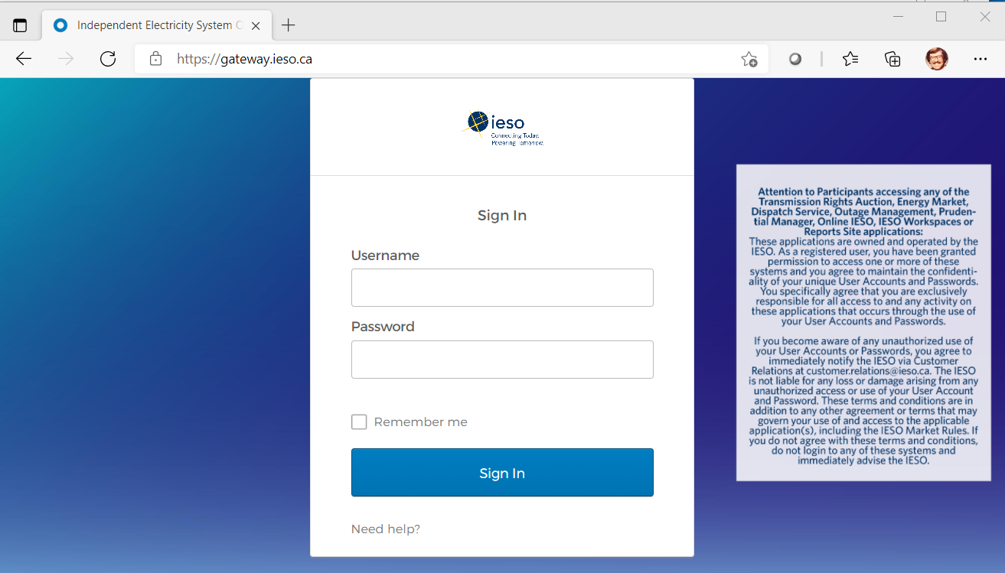
Figure 8-1: IESO Gateway Login Page with Legal Disclaimer
The person’s Sandbox and/or Production user account is common for all applications including Online IESO Registration systems in each environment but the same account/password instance is not used between Production and Sandbox environments.
Once logged in, the link in each Gateway environment will navigate the Participant user to the associated Sandbox or Production Online IESO Registration system as shown in the example in Figure 8-2.
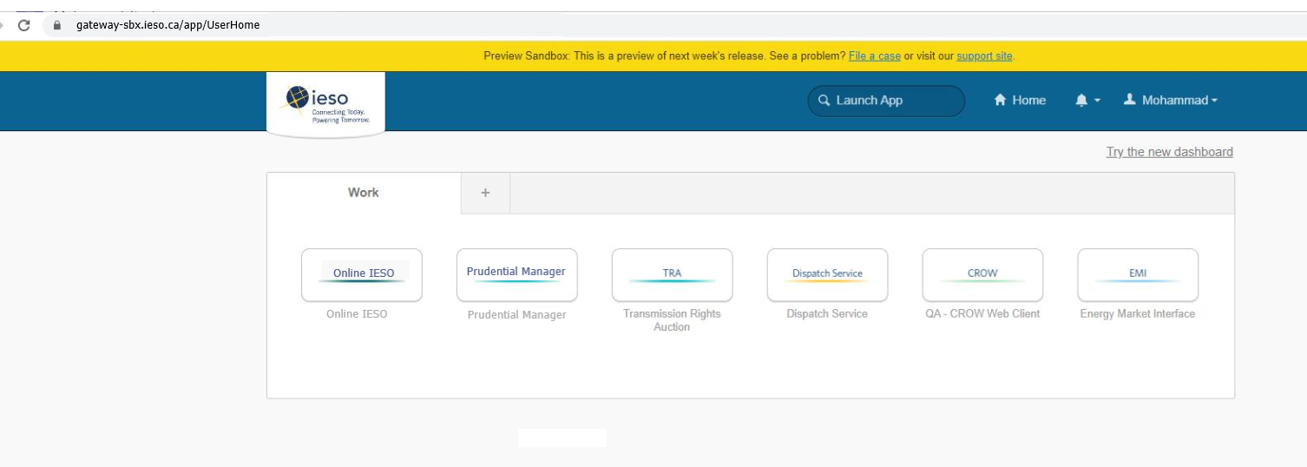
Figure 8-2: Gateway System Landing Page Example
The “Need help signing in?” link on the Gateway login page will navigate the user to the corresponding Portal login page (Sandbox or Production) where they can attempt to recover the password. Refer to section 9.1.2. The person’s Sandbox and/or Production user account is common for all applications within the IESO Gateway including the Online IESO Registration system in each environment, but the same account/password is not used between Production and Sandbox.

Online IESO – Registration Application Actions

Applicant Representative
Successful login to the IESO Gateway and then navigating to the Online IESO Registration system by an Applicant Representative will take them to an ‘Actions’ page as shown in Figure 8-3.
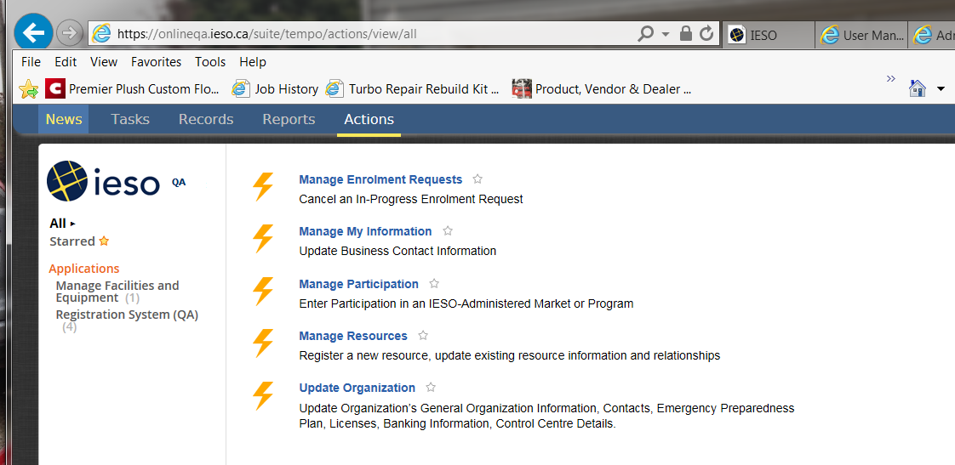
Figure 8-3: Online IESO Applicant Representative - Actions Page
He or she can choose to update their own personal contact information, Manage Enrolment requests, Manage Participations, Manage Resources (i.e. user- resource relationships) or Update Organization (i.e. contacts etc.).

Participations
The Applicant Representative can choose “Manage Participation” to begin a process instance for requesting participation for their organization from one of those listed in the Online Guide for all Contact Roles. This will impact what contact roles can be requested for various individuals at the participant. Once ‘Manage Participation’ has been chosen the Applicant Representative will be presented with the page to choose the type of Participation as shown in Figure 8-4.
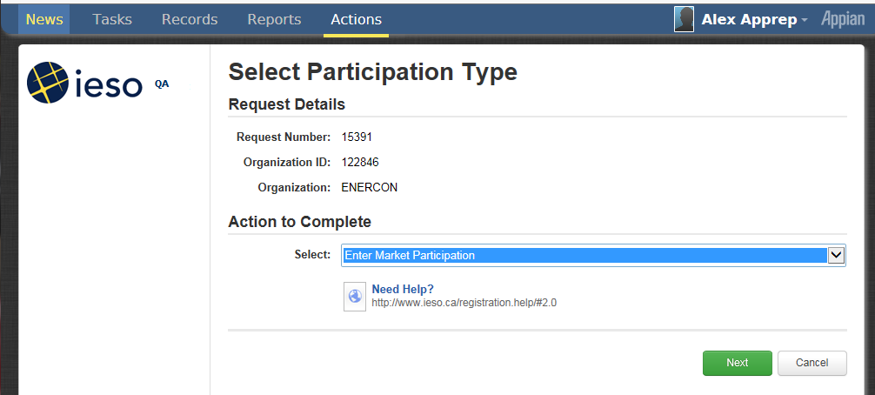
Figure 8-4: Online IESO Applicant Representative – Select Participation Type Page
The Applicant Representative can choose one of 3 options from the drop down and click on the ‘Next’ button. This will limit choosing the actual type of participation.
Figure 8-5: Online IESO Applicant Representative – Select Participation Type Option
For example, if Market Participation is chosen then the Applicant Representative will be present with the page shown in Figure 8-6.
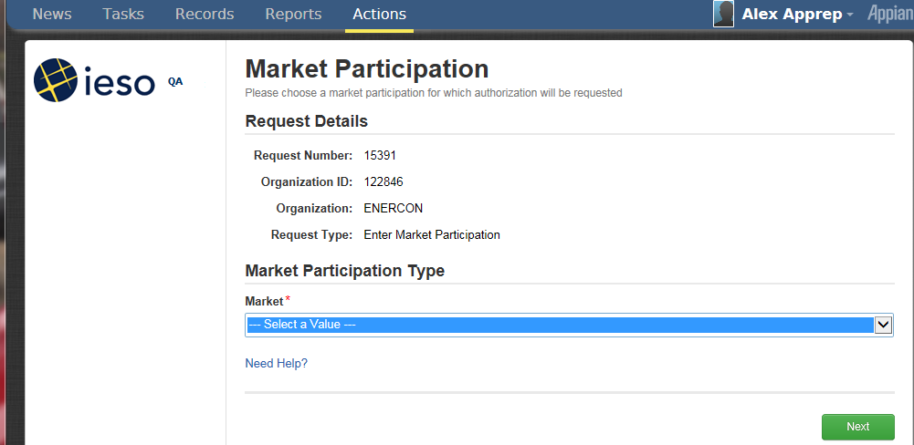
Figure 8-6: Online IESO Applicant Representative – Market Participation Type
The Applicant Representative can then choose the desired participation for the Market category from the dropdown list as shown in Figure 8-7.
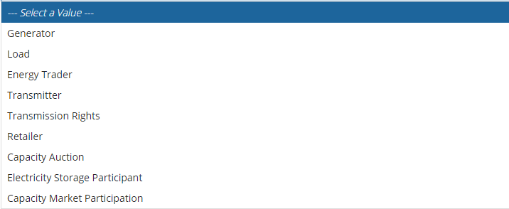
Figure 8-7: Online IESO Applicant Representative – Market Participation Choices
The Applicant Representative could choose to enable her/his organization to participate in capacity auctions as shown in Figure 8-8 and then select the ‘Next’ button.
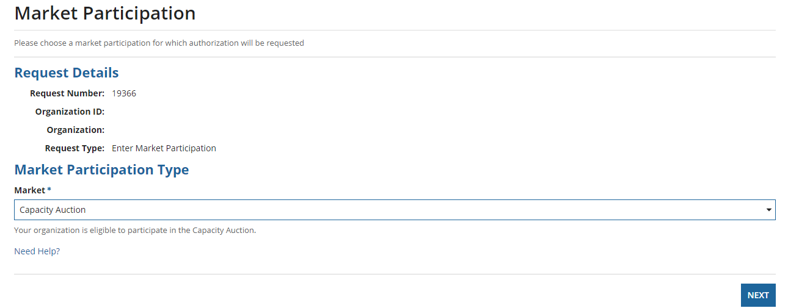
Figure 8-8: Online IESO Applicant Representative – Choosing Capacity Auction Market Participation
The page would then update to show the Applicant Representative what tasks are next needed to be done as shown in Figure 8-9
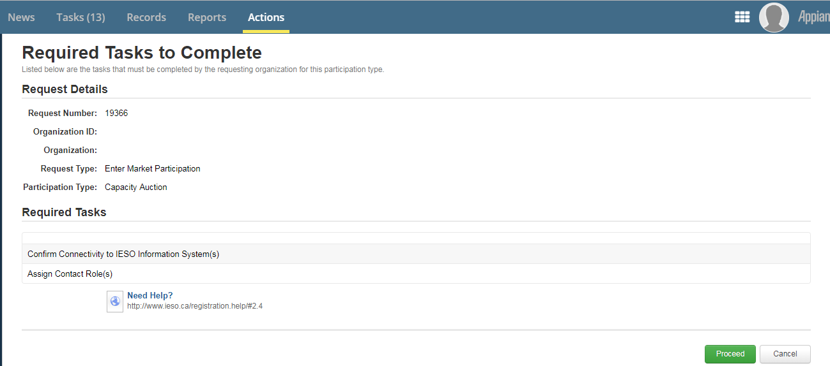
Figure 8-9: Online IESO Applicant Representative – Participation Required Tasks
The Applicant Representative would then just select the ‘Proceed’ button to complete the Participation registration and return to the Actions main page and assign contacts and verify connectivity for the contacts to the required IESO IT system that the participation is permitting.

Update Organization and Contacts
The Applicant Representative can choose ‘Update Organization’ to update Contact Roles to add one or more people to a desired contact role once the required participations applied for have been granted and approved by the IESO. The list of contact roles available (dependent on the registered participations) is shown in the Guide for all Contact Roles (ieso.ca) webpage.
Once a required participation for an organization is active the Applicant Representative can choose Update Organization and then choose to Update Contact Role(s) from the dropdown list as shown in Figure 8-10 and then select the Next button to proceed.
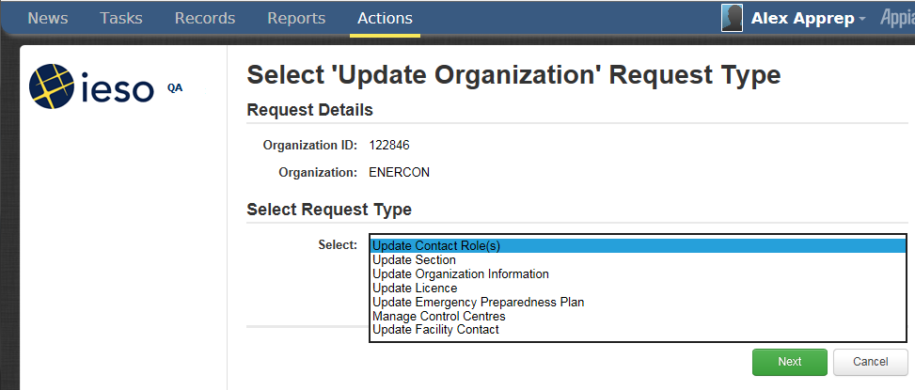
Figure 8-10: Online IESO Applicant Representative Update Organization Request Type
They can then choose to do so: “By Person”, “By Role” or “By Section” buttons
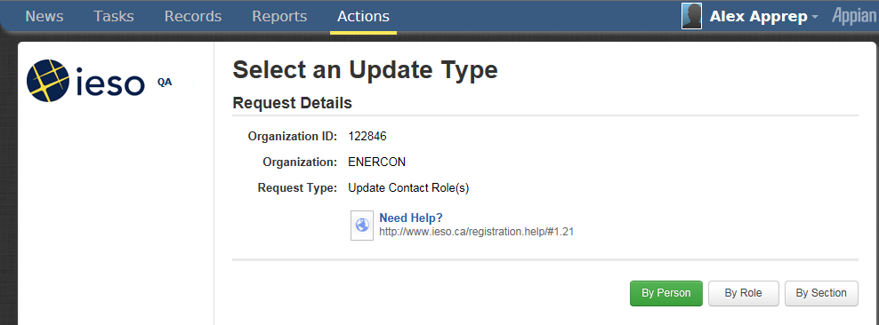
Figure 8-11: Online IESO Applicant Representative Update Contact Role(s) Update Type
If choosing ‘By Person’ the Applicant Representative will need to know some information about the person they want to register a contact role for so they can search for and select that person.
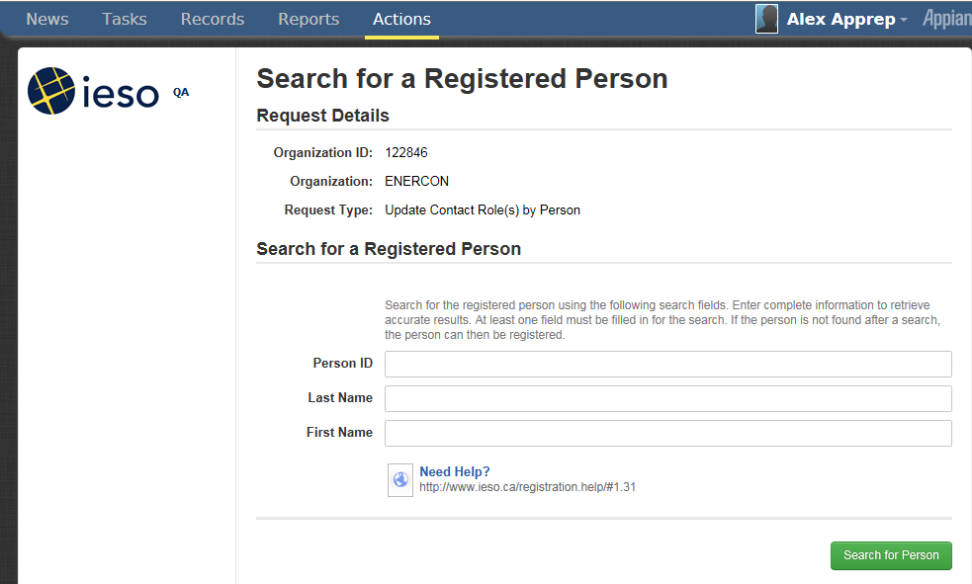
Figure 8-12: Online IESO Applicant Representative Update Contact Role(s) Registered Person Search
For example, if the Applicant Representative knows the person’s last name is Smith they can type Smith (or any part of the last name) in and click on ‘Search for Person’. The results would show all people with Smith (or all those with last names matching the pattern input) as a last name and the Applicant Representative can sift through the list until they find the right person. The list is not necessarily sorted alphabetically so multiple pages may have to be looked at.
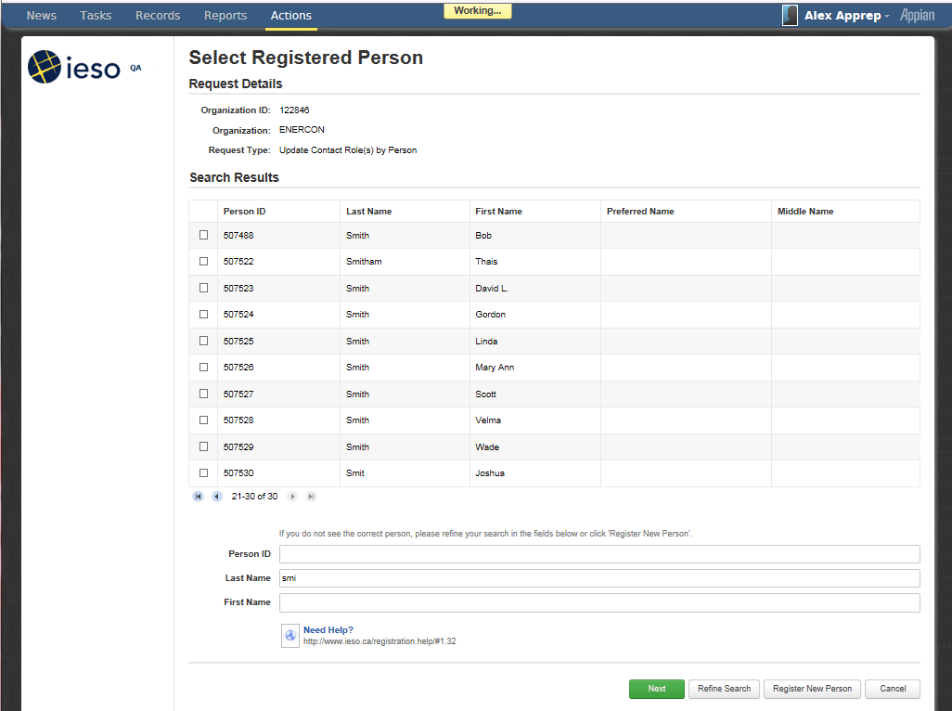
Figure 8-13: Online IESO Applicant Representative Update Contact Role(s) Registered Person Search Results
The Applicant Representative can enter in both last and first names and do a search. Figure 8-14 contains an example for “Smith” and “Bob”.
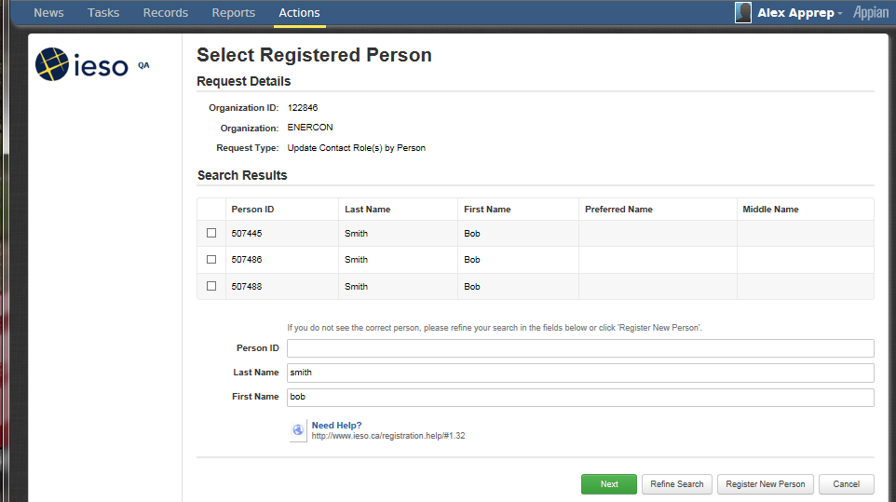
Figure 8-14: Online IESO Applicant Representative Update Contact Role(s) Registered Person Search Results 2
The Applicant Representative upon finding and choosing the right person, (e.g. “Bob Smith”) with the correct Person ID, would check mark that person in the list and select ‘Next’. The system will present a list of available contact roles that person can be made a member of. The Applicant Representative must make absolutely sure they are choosing the correct person where multiple people have the same name.
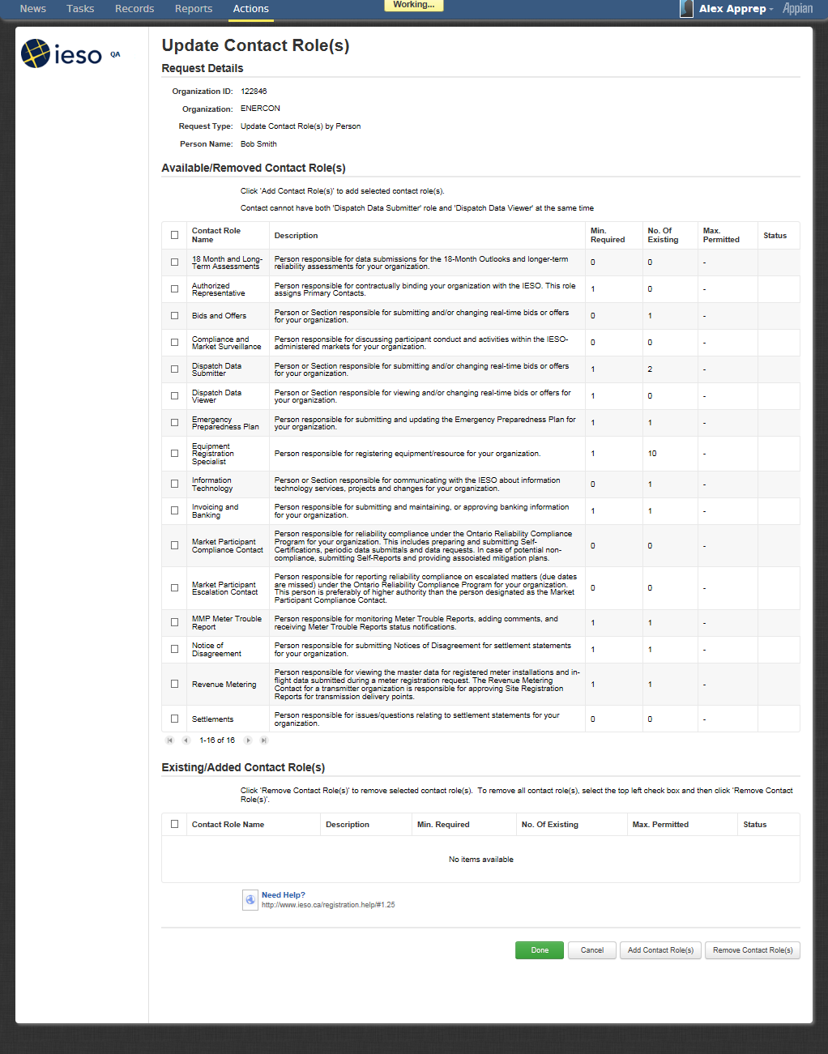
Figure 8-15: Online IESO Applicant Representative Update Contact Role(s) Selection for Selected Person
If the person needed to be added as a Settlements contact, the Applicant Representative would check mark that Contact Role selection and select the Add Contact Role(s) button. In this example. the page will update showing that one person will now be added to the Settlements Contact Role
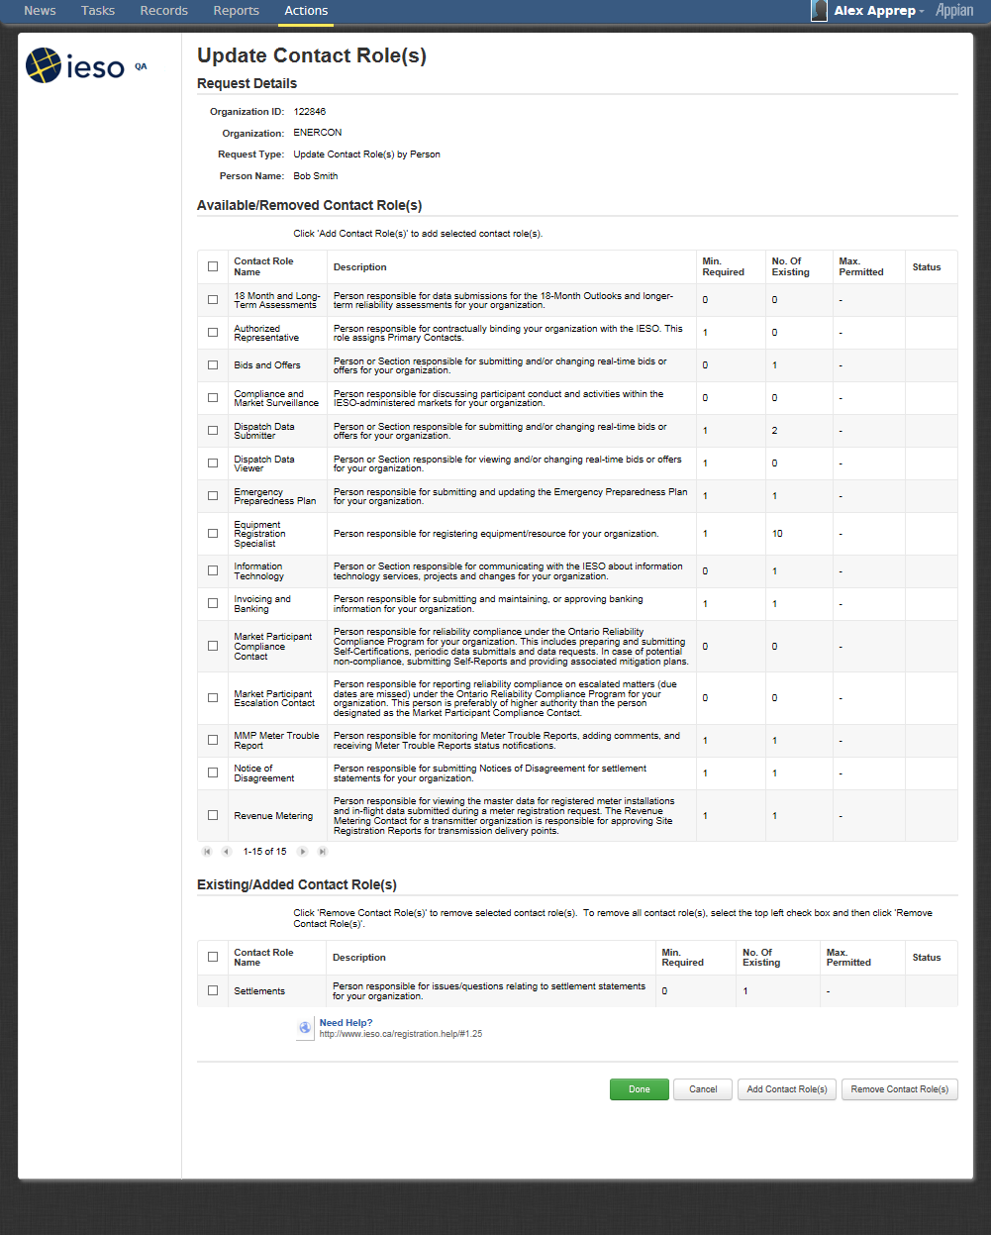
Figure 8-16: Online IESO Applicant Representative Update Contact Role(s) Added Person
The Applicant Representative will then select the ‘Done’ button to continue with registering the person as a contact or ‘Cancel’ or choose and ‘Add (other) Contact Role(s)’ or choose and ‘Remove (other) Contact Role(s)’. Upon choosing ‘Done’ the page shown in Figure 8-17 will be displayed. Where applicable automated provisioning with the IESO Gateway system will add the person’s actual user account to the required role group(s) so that they have access ASAP.
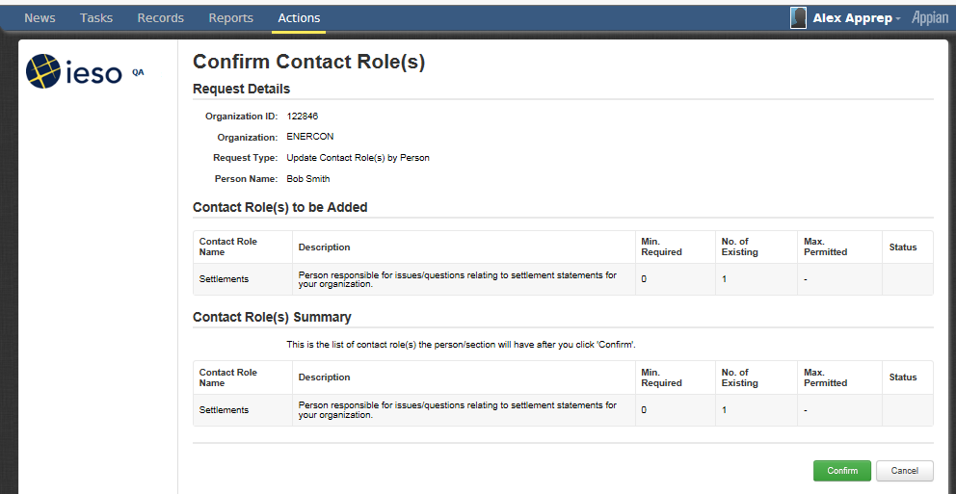
Figure 8-17: Online IESO Applicant Representative Update Contact Role(s), Confirmation
The Applicant Representative can choose ‘Confirm’ or ‘Cancel’. Upon choosing confirm they will get one last chance to abort the addition or go ahead with it as shown in Figure 8-18.
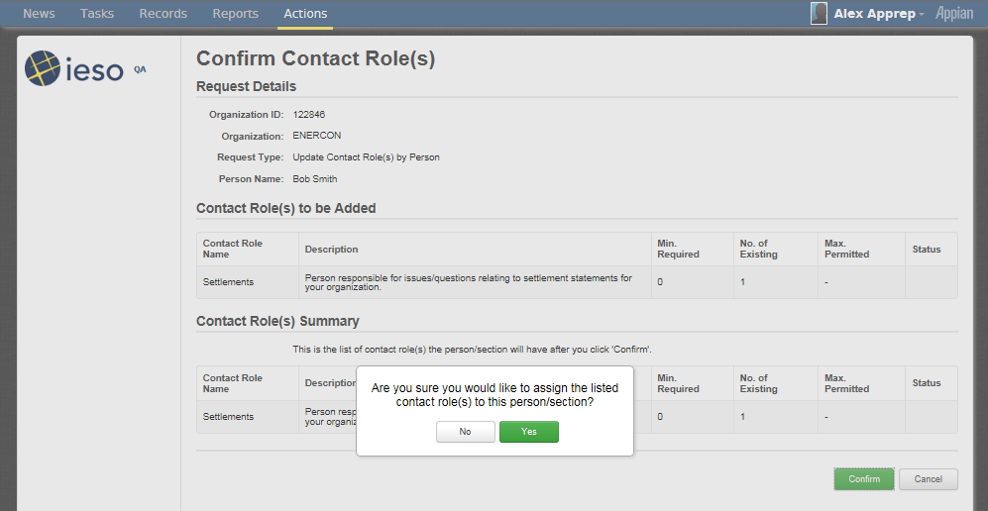
Figure 8-18: Online IESO Applicant Representative Update Contact Role(s), Final Confirmation
Alternatively, the Applicant Representative can choose the ‘By Role’ selection to retrieve all applicable roles for their organization’s active participations. This will result in a list similar to the one shown in Figure 8-19.
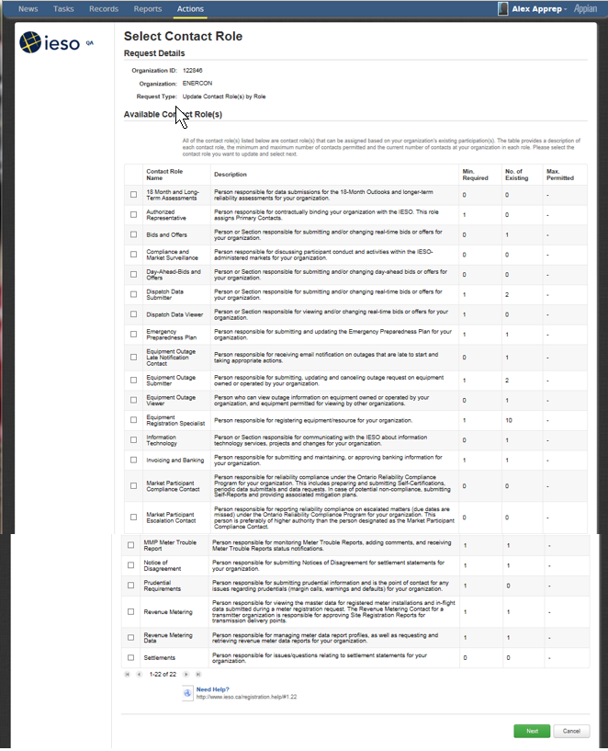
Figure 8-19: Online IESO Applicant Representative Update Contact Role(s) Select Contact Role List
Choosing any contact role (e.g. Dispatch Data Submitter) and selecting the Next button will show a list of those already in that role (Figure 8-20) and options to Cancel, Remove Person or Add Person or choose ‘Done’. Choosing Add Person will provide the ’Search for a Registered Person’ page as shown above in Figure 8-6.
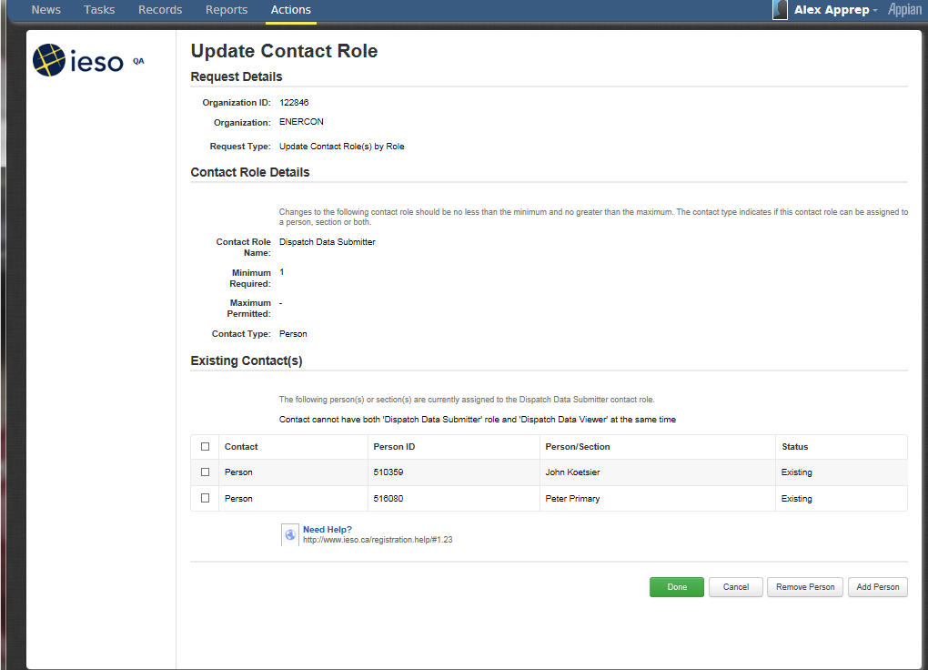
Figure 8-20: Online IESO Applicant Representative Update Contact Role(s) – Existing Contacts
Choosing the desired “Bob Smith” person and the Next button will result in that shown in Figure 8-21. The existing people will show as existing and “Bob Smith” with no status.
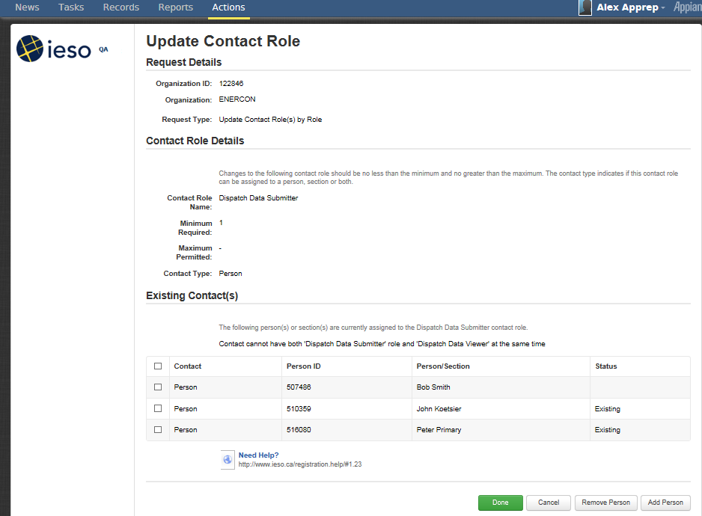
Figure 8-21: Online IESO Applicant Representative Update Contact Role(s) – Existing plus New Contacts
Selecting Done will display a primary Confirmation page as in Figure 8-22. Selecting Confirm will prompt the Applicant Representative to select Yes or No to proceed. Selecting ‘Yes’ will add the person to the contact role. Where applicable automated provisioning with the IESO Gateway system will update the person’s actual user account to the additional required role group(s) so that their access is updated as soon as possible.
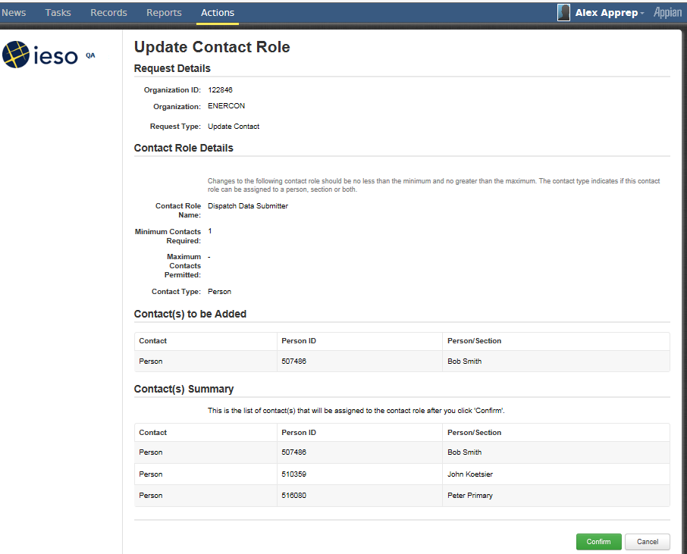
Figure 8-22: Online IESO Applicant Representative Update Contact Role(s) – Primary Confirmation

Rights Administrator
Successful login to the Online IESO Registration system by a Rights Administrator will take them to an Actions page as shown in Figure 8-23. The Rights Administrator user can choose “Grant/Revoke Access” to begin a process instance for granting or revoking IESO systems access for a User Account for the Participant(s) the Rights Administrator represents. They can also choose to update their own personal contact information, request systems access to IESO systems (inside or outside of Online IESO) for themselves or request to register with the “Manage My Information” choice.
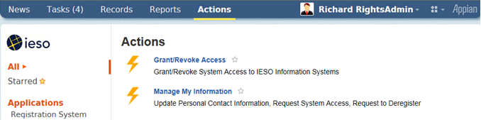
Figure 8-23: Online IESO Registration System Rights Administrator Actions Page
Other Participant contacts can login to the Online IESO / Registration System and choose the “Manage My Information” task as shown by the example in Figure 8-24 to edit/update their own person information such as name, phone numbers, address, email addresses and any contact notes.
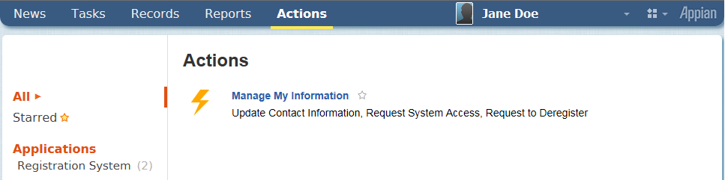
Figure 8-24: Online IESO Registration System Normal Contact Actions Page

Online IESO Registration System Grant/Revoke Access

Select System Access Request Type
Upon choosing the Grant/Revoke Access, task the Rights Administrator, if they only represent one Participant organization, will be navigated to a “Select System Access Request Type” page as shown by the example in Figure 8-26 where the Participant organization they represent will be shown and a drop down selection list of the System Access Request Types can be chosen to start the process.
If the Rights Administrator represents multiple Participant organizations, they will first be navigated to a page “Choose an Organization” as shown by the example in Figure 8-25 where they must choose which organization they will be processing the Grant/Revoke access task for and click on the “Next” button.
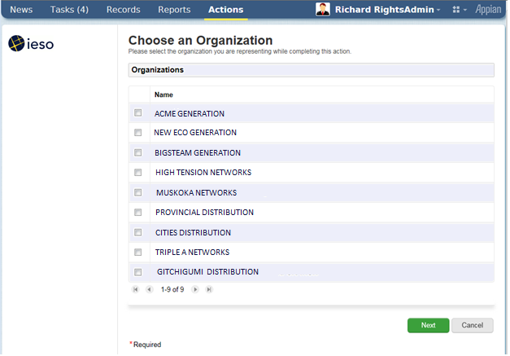
Figure 8-25: Choose an Organization Page
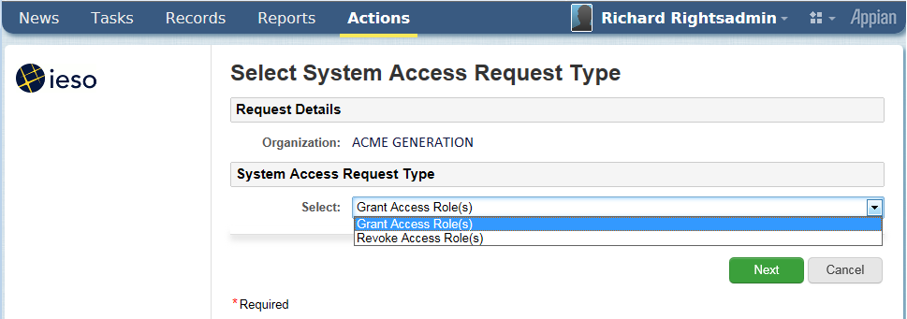
Figure 8-26: Select System Access Request Type Page
Upon landing on the Select System Access Request Type Page the Rights Administrator must choose either “Grant Access Role(s)” or “Revoke Access Role(s)” as required by the situation and click on the “Next” button. This will navigate the Rights Administrator to a “Select Account Type” page as shown in Figure 8-27. In the example provided, a grant access role(s) request is shown. The page for revoke access role(s) will be similar.
Both the “Grant Access Role(s)” or “Revoke Access Role(s)” processes will require the selection of an account type. However, while the “Grant Access Role(s)” process will later let the Rights Administrator choose an existing person or machine account or create a new person or machine account, the “Revoke Access Role(s)” will only apply to existing person or machine accounts.

Select Account Type
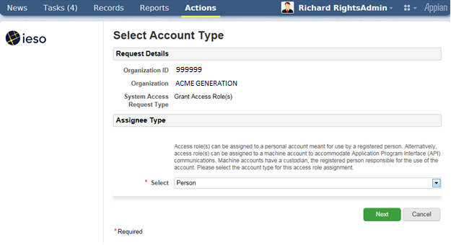
Figure 8-27: Select Account Type Page - Grant
The choices in the drop down list for account type are “Person” for use by an individual or “Machine” for use with API communications. The Rights Administrator must choose one or the other as the situation requires and click on the “Next’ button to continue. This will navigate the Rights Administrator to a “Search for a Registered Person” page as shown in Figure 8-28 where they can search for the person who already possesses a user account. In the example provided, a grant access role(s) request page is shown. The page for revoke access role(s) will be similar for selecting a registered person.

Search and Select a Registered Person
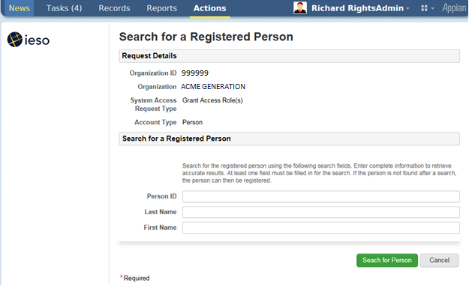
Figure 8-28: Search for a Registered Person Page - Grant
The Rights Administrator can search based on the Person ID if it is known (i.e. it should be) or the last name or first name of the person that the Grant/Revoke access role(s) request is for. Once the Rights Administrator has filled in the search parameters they must click on the “Next” button. This will start the search and return all existing results as shown by the example for “Select a Registered Person” page in Figure 8-29 or none if there is no match found.
It is possible that person record(s) may be retrieved for people with the same first and last names as the actual person the Rights Administrator is dealing with. It is up to the Rights Administrator to verify that an existing person record retrieved is for the intended person or not. For grant access role(s) requests, if no existing registered person record exists for the intended person, the Rights Administrator can proceed to creation of a new person record for the targeted individual. The Rights Administrator should conduct a thorough search via the “Refine Search” button before selecting one of the retrieved person results and clicking on the “Next” button before attempting to create a new Person Record with the Register New Person.
Note that for all existing registered persons, User Accounts will already exist for them.
For Persons being newly registered by the Rights Administrator for the grant access role(s) request process, the Registration system will at the appropriate point in the process include within the grant ticket issued to the IESO, the instructions to create an account for the person with an automatically assigned User Name. Once IESO Access Management creates the actual account, the Registration system will email the person with the user account name details
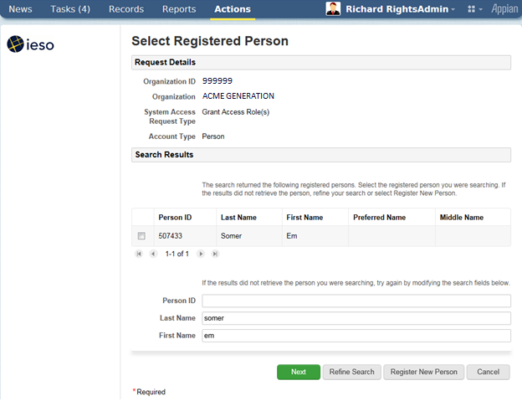
Figure 8-29: Select a Registered Person Page - Grant
Where an existing person record is not found and the Rights Administrator clicks on the “Register New Person” button, the Rights Administrator will be navigated to a “Register a New Person’ page as shown by the example in Figure 8-30.
If the Rights Administrator does choose an existing person by check marking the row and clicking on the Next button they will be navigated to:
- A “Select Access Roles to be Granted” page as shown in Figure 8-32 if the “Grant Access Role(s)” system access request type was chosen; or
- A “Select Access Roles to be Revoked” page as shown in Figure 8-34 if the “Revoke Access Role(s)” system access request type was chosen.

Register a New Person
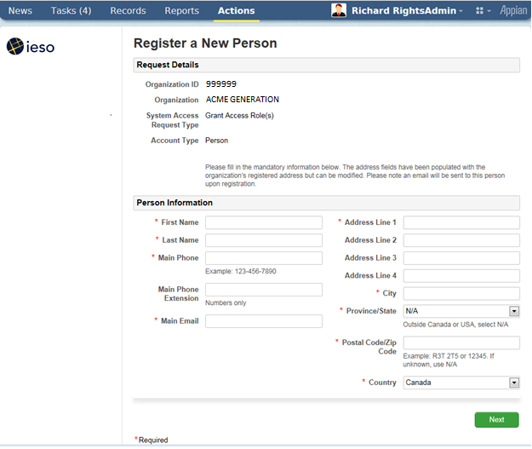
Figure 8-30: Register a New Person Page - Grant
All required attributes for the person must be filled in before clicking on “Next” button. A new unique Person ID will be automatically assigned by the system when it is saved and this can be referenced later as required.
When the Rights Administrator clicks on “Next” they will be navigated to a Confirm New Person Registration as shown in Figure 8-31. The Rights Administrator can choose to “Go Back” to correct or fill in any information or click on the “Next” button.
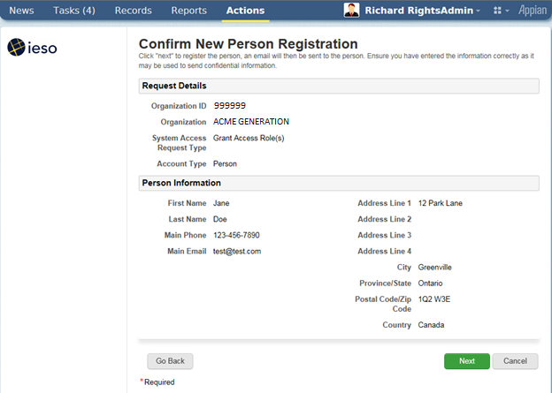
Figure 8-31: Confirm New Person Registration Page - Grant
After the Register and Confirm New Person Registration sub-process flow the Rights Administrator will then be navigated to the “Select Access Roles to be Granted” page as shown in Figure 8-32. Note that the Person ID information is now displayed.
In the case of revoking access roles, the Rights Administrator will then be navigated to the “Select Access Roles to be Revoked” page as shown in Figure 8-34.
The information displayed for an existing person being processed for either a grant or revoke access role(s) request will show any existing access roles (that a user account for the person is associated with) for the Participant organization.
The “Select Access Role(s) to be Granted” page will only display personal account related access roles associated to the Market or Program participation that the organization has registered for. This is true for the “Select Access Role(s) to be Revoked” page as well.
This is to prevent unintended Grant or Revoke requests from being submitted to the IESO Gateway system for the Participant person. If an access role is not shown that the Rights Administrator thinks should be there, they should contact IESO Customer Relations. It is possible that a technical problem could exist or it may be possible that the Participant needs to register for additional Markets or Programs. This document does not cover registering for Markets or Programs by a Participant.

Select Access Roles to be Granted
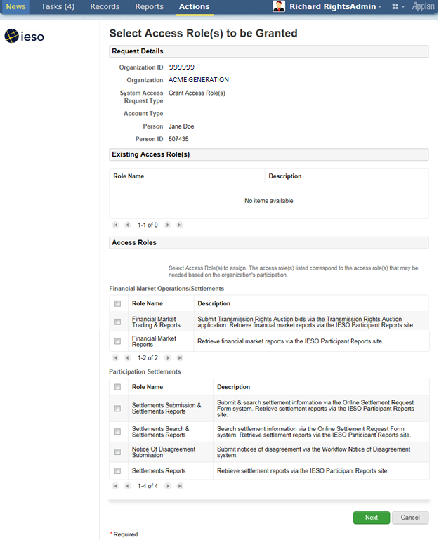
Figure 8-32: Select Access Roles to be Granted Page
The Rights Administrator should in the case of granting access roles to the person, choose only the required access roles (i.e. those authorized for the person by the Participant) by check marking them and clicking on the “Next” button. Multiple access roles available may be displayed by the first, next previous and last arrow buttons shown on the page.
Once the Rights Administrator has clicked on the “Next” button they will be navigated to a “Confirm Access Role(s) to be Granted” page as shown in Figure 8-33.
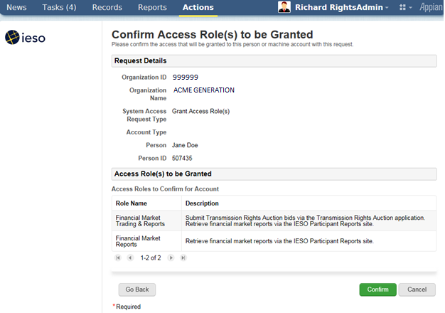
Figure 8-33: Confirm Access Role(s) to be Granted Page
The page will show the access roles selected and the Rights Administrator can use either the “Go Back” button to correct the selected access roles or click on the “Confirm” button and continue the process. Once confirmed, the system will associate the access roles to the person’s primary user account for the Participant organization chosen and send an automated provisioning grant request to the IESO Gateway system to enroll the person’s account in the access roles requested.

Select Access Roles to be Revoked
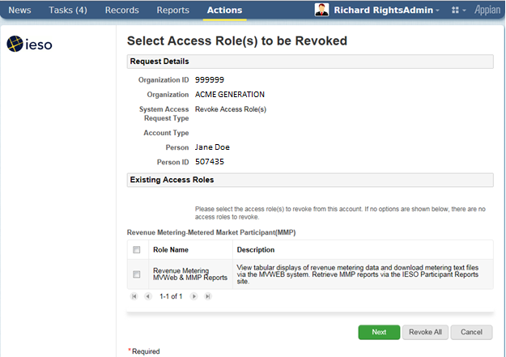
Figure 8-34: Select Access Roles to be Revoked Page
The “Select Access Role(s) to be Revoked” page will show only those access roles the person’s user account is currently associated with.
The Rights Administrator should in the case of revoking access roles to the person, choose only the targeted access roles (i.e. those authorized for revocation by the Participant) by check marking them and clicking on the “Next” button. Multiple access roles available may be displayed by the first, next previous and last arrow buttons shown on the page. The page does provide a “Revoke All” button to conveniently permit the Rights Administrator to request revocation of all access roles for the person’s user account if that is what the Rights Administrator has been authorized to do.
Once the Rights Administrator has clicked on the “Next” button they will be navigated to a “Confirm Access Role(s) to be Revoked” page as shown in Figure 8-35.
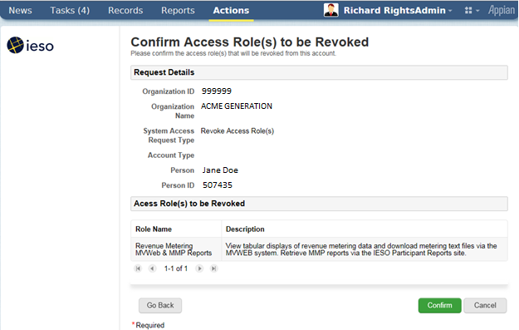
Figure 8-35: Confirm Access Role(s) to be Revoked Page
The page will show the access roles selected for revocation and the Rights Administrator can use either the “Go Back” button to correct the selected access roles or click on the “Confirm” button and continue the process. Once confirmed the system will process the access roles to be revoked for the person’s primary user account for the Participant organization chosen and send an automated provisioning revoke request to the IESO Gateway system to remove the association that the person’s account has with the access roles requested.

Machine Account Grant or Revoke Access Requests
When a Rights Administrator chooses the machine account selection within the dropdown on the “Select Account Type” page shown above in Figure 8-27 and clicks on the “next’ button, they will be redirected to the “Select Machine Account” page as shown by the example in Figure 8-36 for grant access role(s) requests. The page for revoke access role(s) for machine account selection is shown by the example in Figure 8-37.
The Rights Administrator can choose to search for an existing machine account and choose it or click on the “New Machine Account” button if a new one is required. The Rights Administrator must know the Machine Account ID when they want to find and choose an existing one and the choice of an existing one must be done carefully to prevent unintended access role changes and potential confidentiality breaches or loss of access.
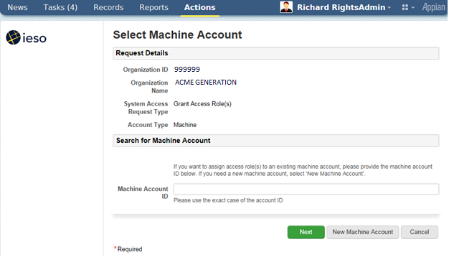
Figure 8-36: Select Machine Account Page - Grant
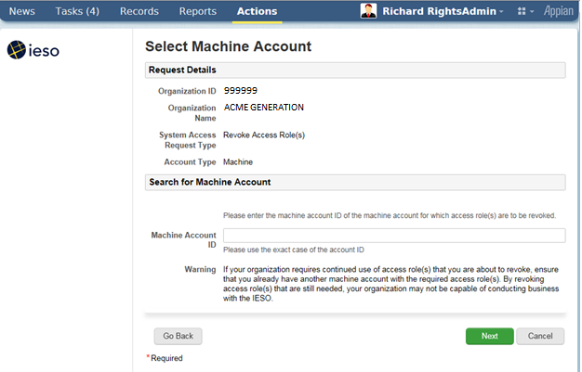
Figure 8-37: Select Machine Account Page - Revoke
Note the warning regarding revocation of machine account access roles on the page.
If the Rights Administrator enters a non-existent Machine Account ID it will not be found and the system will inform the Rights Administrator when they click on the “Next” button.
If a machine account ID is found when the Next” button is clicked, a “Confirm Existing Machine Account” page will be displayed as shown in the example in Figure 8-38. The page shown is for grant access role(s). The one for the revoke access roles for machine account process is similar.
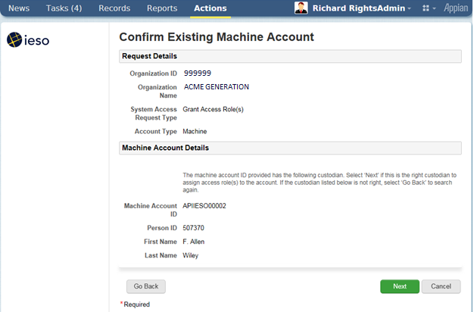
Figure 8-38: Confirm Existing Machine Account Page - Grant
The “Confirm Existing Machine Account” page will show the selected machine account and its custodian person information. This will enable the Rights Administrator to verify that they have chosen the intended machine account to assign access roles to for the selected Participant. If it is not the correct machine account, the Rights Administrator can use the “Go back” button to enter and search for the right one to use.

New Machine Account
When a Rights Administrator chooses the process to create a new machine account they will be navigated to the “Create Machine Account for Access Role Grant” page as shown by the example in Figure 8-39. The Rights Administrator must provide the IP Address assigned to the Participant workstation or server where this machine account will be used so that the IESO can use it in defining firewall rules to permit communications between the selected Participant workstation or server and IESO systems. The rationale is that machine account passwords assigned by the custodian after receiving an IESO Gateway activation email and creating the user account will typically be enduring and potentially more subject to a breach of security so firewall rules at the IESO will limit the use of the machine account to the registered Participant system.
Once the Rights Administrator enters the Participant IP address to be associated to the new machine account and clicks on the “Next” button, they will be navigated to the “Search for a Registered Person” page as shown in Figure 8-28 to start the process to choose a Custodian for the machine account. Through the person selection process the Rights Administrator can choose to either choose to assign an existing person to the machine account as custodian or register a new person as custodian as shown in Figures 8-29 through 8-31.
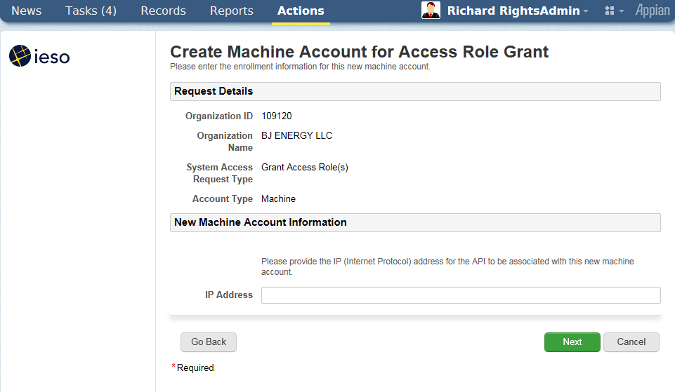
Figure 8-39: Create Machine Account for Access Role Grant Page
Once the Rights Administrator has either:
- Confirmed an existing machine account to be used; or
- Chosen or entered the custodian person associated with the new machine account
they will be navigated to the Select Access Role(s) to be Granted” page for the machine account as shown by the example in Figure 8-40.
For revocation of access role requests for existing machine accounts the Rights Administrator will be navigated to a Select Access Role(s) to be Revoked” page similar to that shown by Figure 8-34 except that only machine account access role associated to the account will be available for selection.
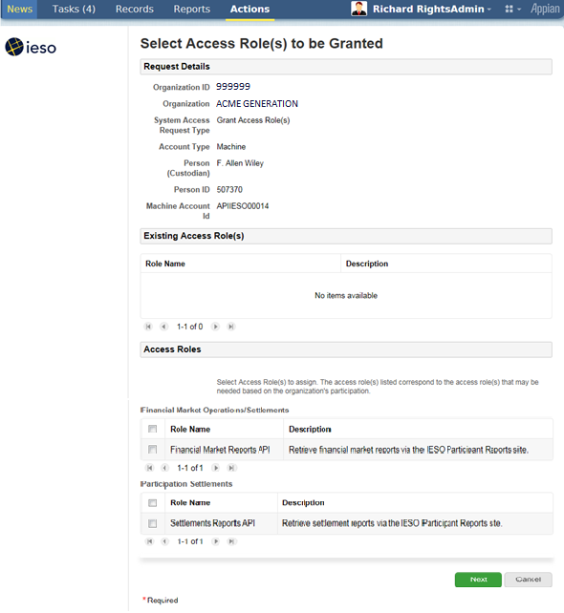
Figure 8-40: Select Access Role(s) to be Granted – Machine Account Page
The information displayed for an existing machine account/custodian being processed for a new grant or revoke access role will show any existing access roles (that the machine account/custodian is associated with) for the Participant organization.
The “Select Access Role(s) to be Granted” page(s) will only display machine account related access roles associated to the Market or Program participation that the organization has registered for. This is to prevent unintended ‘grant’ requests from being submitted to the IESO for the Participant machine account. If an access role is not shown that the Rights Administrator thinks should be there, they should contact IESO Customer Relations. It is possible that a technical problem could exist or it may be possible that the Participant needs to register for additional Markets or Programs.
The Rights Administrator should in the case of granting access roles to the machine account, choose only the required access roles (i.e. those authorized for the machine account by the Participant) by check marking them and clicking on the “Next” button. Multiple access roles available may be displayed by the first, next previous and last arrow buttons shown on the page.
Once the Rights Administrator has clicked on the “Next” button they will be navigated to a “Confirm Access Role(s) to be Granted” page as shown in Figure 8-41.
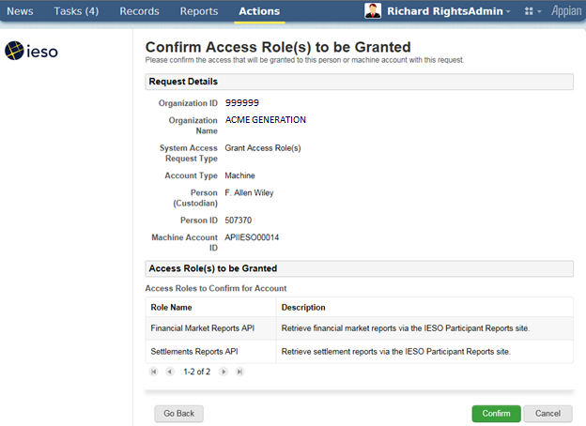
Figure 8-41: Confirm Access Role(s) to be Granted – Machine Account Page
The page will show the access roles selected to be granted and the Rights Administrator can use either the “Go Back” button to correct the selected access roles or click on the “Confirm” button and continue the process. Once confirmed the system will associate the access roles to the machine account for the Participant organization chosen and send an automated provisioning grant request to the IESO Gateway system to enroll the actual machine account in the access roles requested.
For revoke access role(s) requests for machine accounts upon selection by the Rights Administrator of the required access roles to be revoked and clicking on the “Next” button (or use of the “Revoke All” button) they will be navigated to a Confirm Access Role(s) to be Revoke page similar to that shown in Figure 8-35. The page will show the access roles selected for revocation and the Rights Administrator can use either the “Go Back” button to correct the selected access roles or click on the “Confirm” button and continue the process. Once confirmed the system will process the access roles to be revoked for the machine account for the Participant organization chosen and send an automated provisioning revoke request to the IESO Gateway system to remove the membership that the machine account has with the access roles requested.

Registration System Mange Contact Information
When a Rights administrator or any normal Participant contact person chooses the “Manage My Information” task as shown in Figures 8-23 or 8-24 above they will be navigated to a “Choose an Action” page where they can select the “Update Person Information” selection in the dropdown selection list as shown in the example in Figure 8-42.
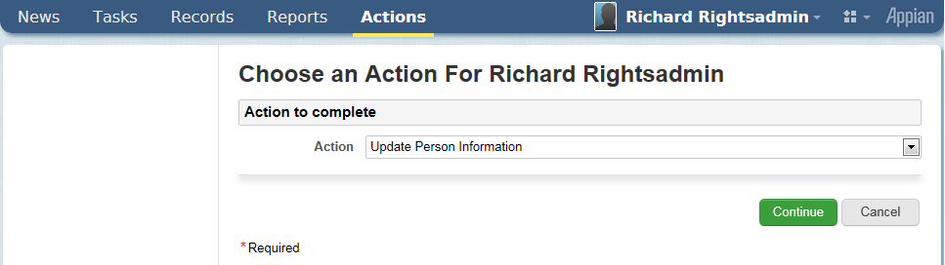
Figure 8-42: Choose an Action Page
The user can then click on the “Continue” button to navigate to the “Update Person Information” page for their person record as shown in the example in Figure 8-43.
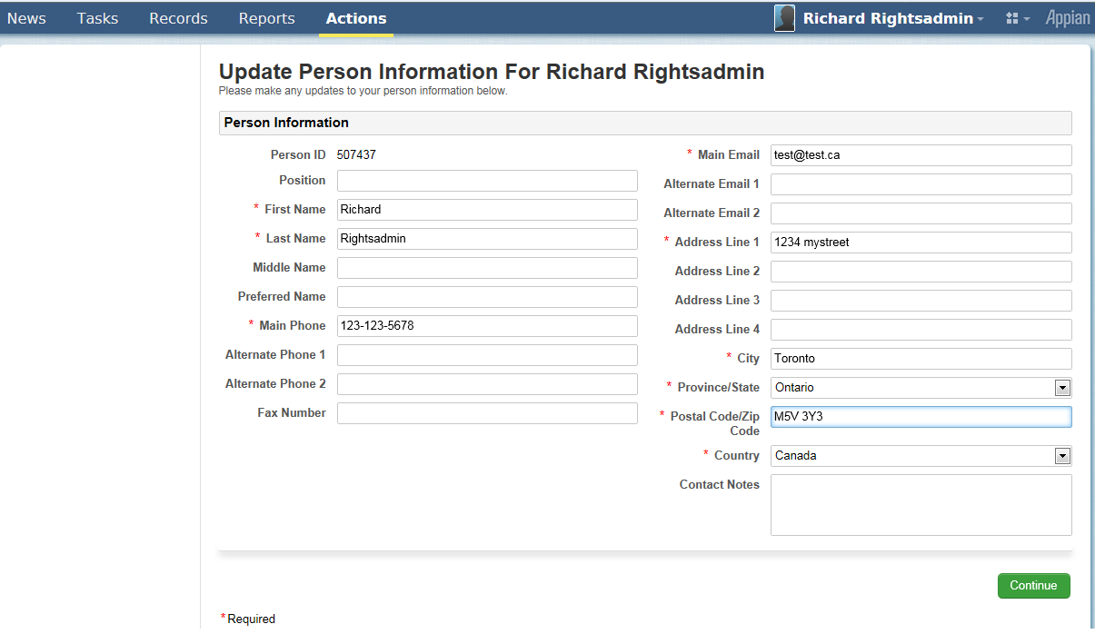
Figure 8-43: Update Person Information Page
The Person information retrieved will be that currently active on the system. However, all changes are maintained in historical records within the system. All of the required mandatory fields will of course be populated and these can be edited with updated information but they cannot be made blank and then saved. It is up to each person to maintain their own person information so that it is current and accurate. Once a Participant contact is satisfied with any updates they can click on the “Continue” button. This will navigate them to a “Confirm Person Information” page as shown by the example in Figure 8-44.
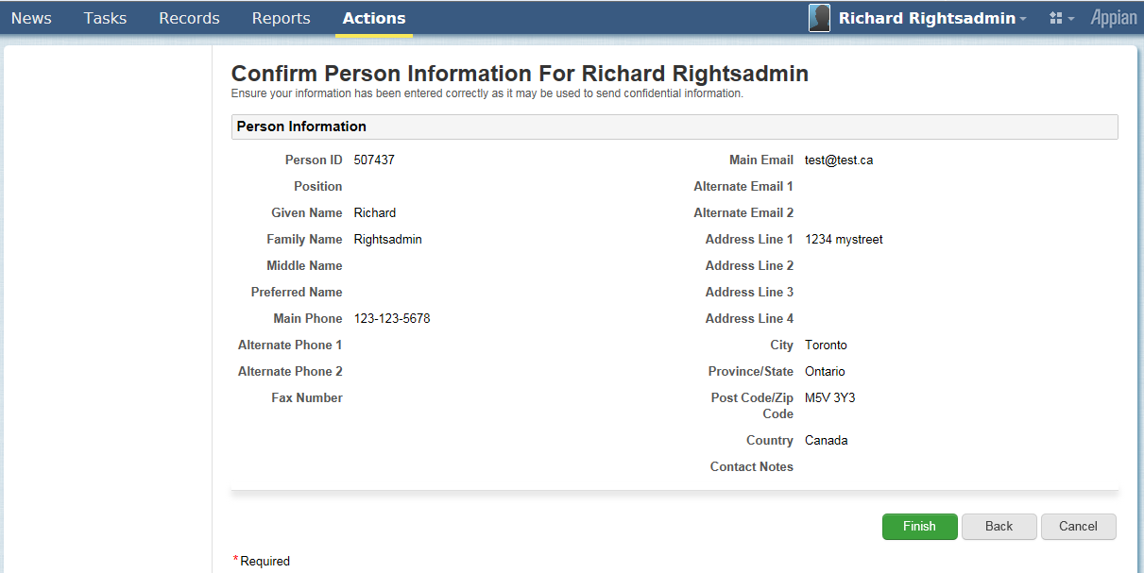
Figure 8-44: Confirm Person Information Page
Where the information shown on the “Confirm Person Information” page is not correct or incomplete the Participant contact can choose to use the “Back” button to go back and edit the data and then use the “Continue” button to go the confirm page.
If the Participant contact is satisfied with the ‘person’ information as shown on the page, they can choose to click on the “Finish” button. This will commit the data to the Online IESO Registration system.
For name, main phone and main email attribute updates committed to the Registration system, the system will automatically and transparently generate a provisioning change request in the background to the IESO Gateway system to update any associated user accounts linked to the person record with those attribute values. This will ensure that any user personal and machine account information is kept up to date immediately as well.
– End of Section –

Use of Account Provisioning Tools

Use of the Password Change & Reset Functions
Passwords used with User Accounts issued for use with the IESO Gateway, Online IESO system, Reports site, Energy Market Interface (EMI), Prudential system and CROW Outage Management system etc. can be changed or reset via four separate methods.
- Password setup on account initialization / first time login to the IESO Gateway Once the password has been setup on login to the Gateway, the account may be used with the Online IESO system, IESO Workspaces (replaces IESO Portal Collaboration and Watchdox), Transmission Rights Auction, Prudential Manager, IESO Reports site, Energy Market Interface, Dispatch Service or CROW Outage Management system etc., depending on the access permissions the user has been granted.
- Password Self Recovery during IESO Gateway system login when a user has forgotten their Password. The user must have already selected their multifactor authentication options and the security question and answer to do this self-recovery.
- Request to the IESO Customer Relations to have their password reset and a new temporary password issued to the user via email.
- Password normal manual change after login via the IESO Gateway ‘Security Profile’ password change capability located on the ‘Security Profile’ user dashboard page.
The IESO Gateway User Guide also provides details on all of the above.
Note: The IESO Gateway, Online IESO, IESO Reports Site, Energy Market Interface and CROW Outage Management System etc. all use common User Accounts. Changes to the password for a User Account within the Gateway for example will automatically be applicable and usable for the Online IESO system, Transmission Rights Auction, Prudential Manager, IESO Reports site, Energy Market Interface, Dispatch Service and CROW Outage Management System etc.
The user will upon account initialization and logging in to the IESO Gateway for the first time, select the multifactor authentication options and a security question and answer to be used for password self-recovery and stronger authentication when login circumstances warrant (i.e. different workstation used than normal or account used at abnormal time of day etc.).
- Multifactor authentication may be presented to the user during each subsequent login to the Gateway depending on circumstances. The method used will be based on what the user selected during account initialization; i.e. Okta Verify or Security Question.
- The security question can be selected from a randomly produced short list from a larger number of possible predefined choices. The choices shown available should meet all users’ possible circumstances.
- Once the MFA options and security question have been selected and answer input, the MFA and question choices can be changed after Gateway logon at any time via the Security Profile page in the IESO Gateway.
- The answer to the security question is not ‘case sensitive’ and can use any ASCII characters. However, the user should the security question that permits them to best enter an answer that has personal meaning in order to be easily remembered but at the same time not easily guessed by someone else.

User Account Initialization
If the user needs to login for the first time to the IESO Gateway system (production or sandbox environment) for access to a secure IESO web server, they will have first received an activation email from the corresponding Gateway system with a link that can be used to initiate the process to activate the account. For IESO Workspaces (or FIT and MicroFIT) the account will be email address based while for all other market facing systems the account will be UserID based.
- The end user should click on the “Activate Account” button in the body of the emailmessage as shown in Figure 9-1. This will navigate the end user to the referenced Gateway environment (Prod or Sandbox) web page to start the process for activating the account.
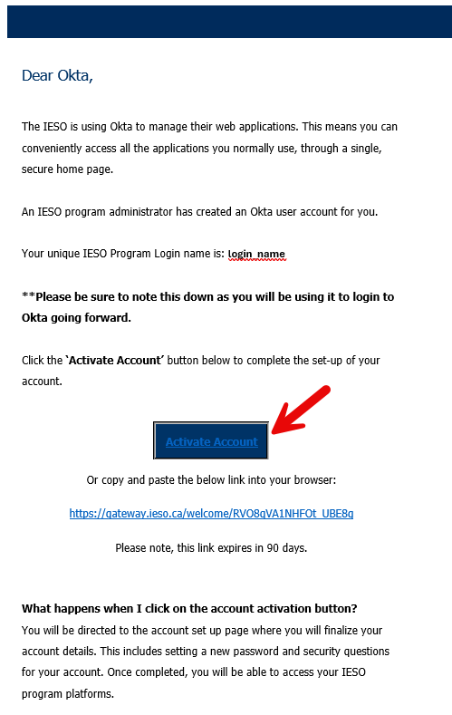
Figure 9-1: Gateway Activation Email – Activate Account Link
- On the Gateway page navigated to, the end user should create a password for their user account thatmeets the requirements listed and then click on the “Create My Account” button at the bottom of the page to proceed as shown in Figure 9-2.
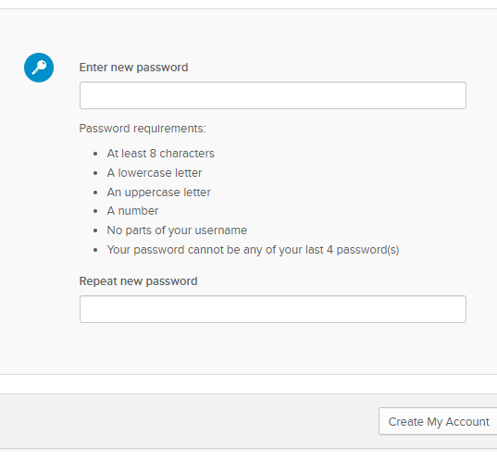
Figure 9-2: Gateway Activation Email – Activate Account Page
- The end user will then need to configure their MFA (multifactor authentication) Options by clicking on the “Configure Factor” button as shown in Figure 9-3.
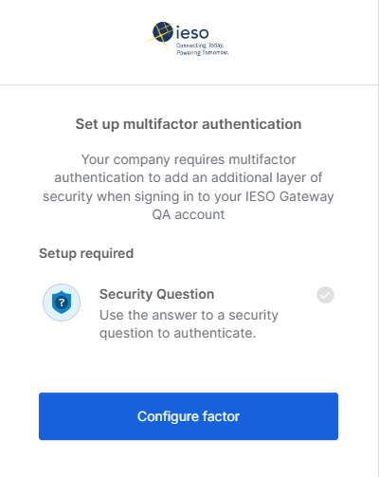
Figure 9-3: Gateway Multifactor Authentication Options Setup
- First choose a secret question from the drop down and set an answer, then click on the “Save” button as shown in Figure 9-4.
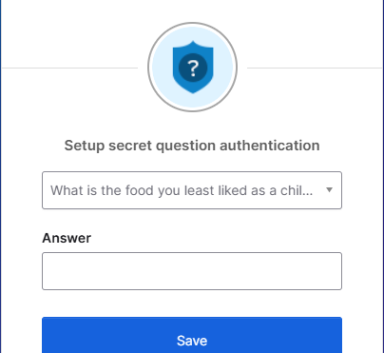
Figure 9-4: Secret Question and Answer Setup
- Confirm Security Question is the Enrolled factor and click "Finish":
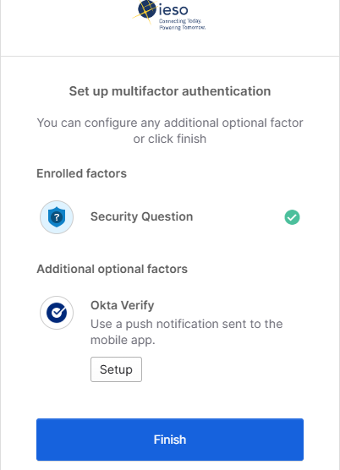
Figure 9-5: Setup Secret Question Verification

6. Once the Multi Factor Authentication Factors are configured, the end user should click on the “Finish” button presented in order to complete login and be navigated to the Gateway User Dashboard.

Self-Service Password Reset
If an end user has forgotten their password, they can attempt a Self-Service password reset via the “Forgot Password?” Link on the login page. There are a couple of options for resetting the password.
- First the user should click the “Need help signing in?” text at the bottom of the login box as shown in Figure 9-6.
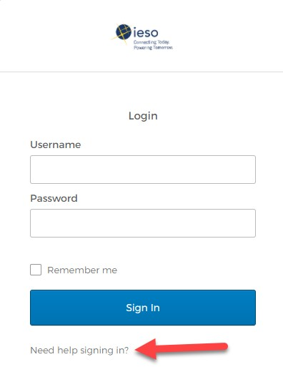
Figure 9-6: Login Page – Need Help Signing in Link
- Next click on the “Forgot password?” link shown in Figure 9-7.
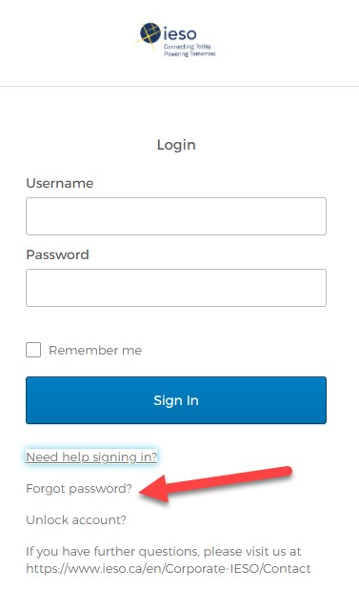
Figure 9-7: Login Page – Forgot Password Link
- The end user should enter their Email or Username in the field specified. Email for email type account (used for IESO Workspaces) or Username for UserID type account (used for Market facing applications).
- Then use the “Reset via Email” button option to use email in the profile to reset the password as shown in Figure 9-8.

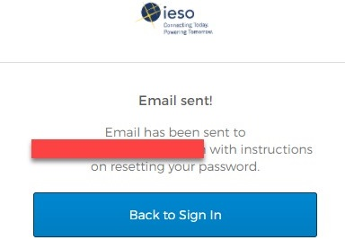
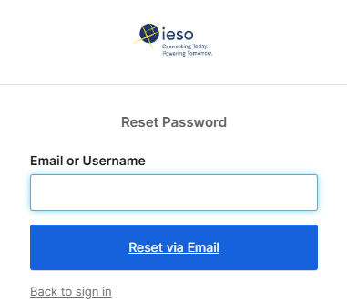

Figure 9-8: Reset Password – Reset Via Email
- The end user can click on the “Reset Password” link in the email received. Then enter a new password that meets the requirements, and click the “Reset Password” Button on the page that is displayed.
- If completed successfully the user will be directed into the IESO Gateway User Dashboard. If not, they should contact IESO Customer Relations.

Temporary Password Change by IESO Customer Relations
There might be a situation where the end user cannot recover their own password and will need to have it reset by an IESO Customer Relations administrator.
**Please note: This option should only be considered after attempts to follow the Self Service Password Reset steps above have failed. Also refer to the Troubleshoot section at the end of this guide.
In order to initiate the “Password Reset by Customer Relations” process, the end user must start by sending an email requesting a password reset to customer.relations@ieso.ca. They should include as much details as possible in this email such as full name, phone number, email address, organization where applicable, registration PersonID value, and account login value, but at minimum the request must include either:
- the Email Address associated with the email based Okta / IESO Gateway Account; or
- the UserID value for the Username based Okta / IESO Gateway Account (if applicable)
This way the Customer Relations administrators will be able to assist the end user as quickly and as efficiently as possible.
Once that is request has been submitted, there are two ways in which a Customer Relations administrator can assist the end user to recover / reset their account password. One of these ways is via the use of a Password reset email to the end user. The other is by providing the end user with a temporary password directly via phone call.

Customer Relations Reset Password Email
When the Customer Relations administrator resets the end user’s password, they should receive an email with a “Reset Password” button.
Upon receipt of this email, the end user can perform the following steps in order to reset their password:
- Click on the “Reset Password” button in the email body as shown in the example in Figure 9-9. Note that the URL in the address provided in the email should start with “https://gateway.ieso.ca” for the production environment or “https://gateway-sbx.ieso.ca” for the sandbox environment. If it does not in the message or the actual page navigated to does not match, then the email should not be considered valid and Customer Relations should be contacted.
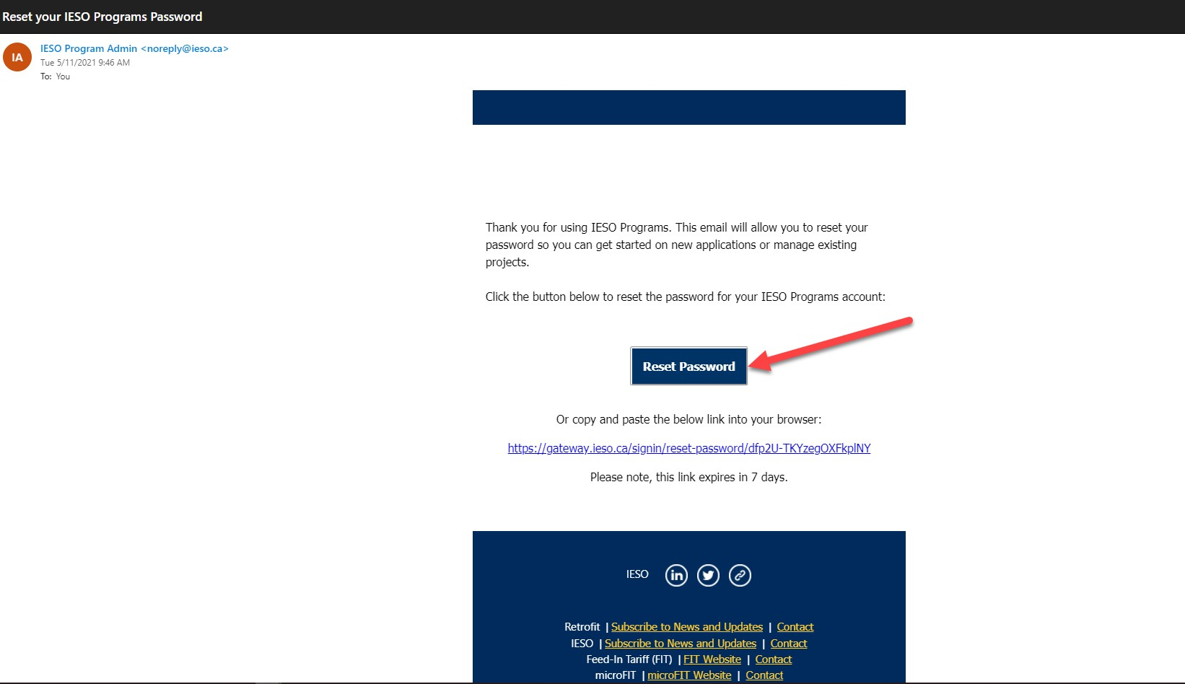
Figure 9-9: Customer Relations Reset Password – Reset Via Email
- When navigated to the web page for the new password entry first validate the URL is valid then type in a new password that meets the rules / requirements listed and click the ‘Reset Password’ button as shown in the example in Figure 9-10.
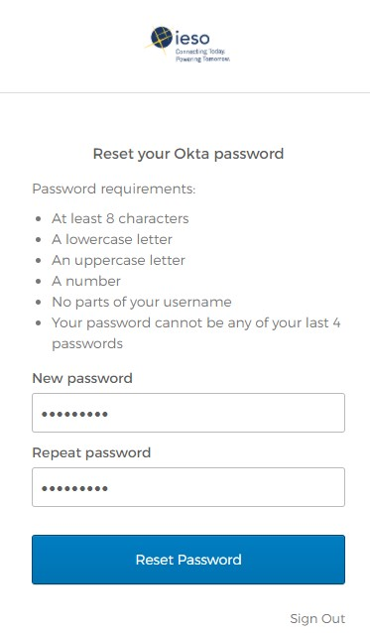
Figure 9-10: Customer Relations Reset Password via Email – Password Reset Page
- Upon entry of the new password value and resetting, the end user’s new password will be set and they will be directed to the IESO Gateway User Dashboard.

Customer Relations Reset Password – Temporary Password
Alternatively, if the end user’s password is reset by a Customer Relations administrator, they will be given a temporary password via phone call which the end user can use one time to set up a permanent password.
When the end user has typed in a temporary password, the system will continue to the “Reset Your Password” page. When creating a new password, the end user must choose one that meets the criteria provided on the page. It should be easy for to remember, but difficult for anyone else to guess. It is good practice to avoid dictionary words in any language and to use a combination of upper case and lower case letters, numbers and symbols. The longer it is the more secure it is.
In order to set a permanent password using the temporary password, the end user should follow these steps:
- Open a web browser and navigate to https://gateway.ieso.ca if a production account is involved. Use https://gateway-sbx.ieso.cahttps://gateway-sbx.ieso.ca/ if a Sandbox account is involved.
**Ensure that an IESO supported browser is being used and operating system as listed on the Supported Client Platform page available on the IESO Corporate website.
- The end user must ‘Sign In’ using the target subject account’s (email or UserID based) username involved and then the temporary password that was provided to them as shown in the example in Figure 9-11.
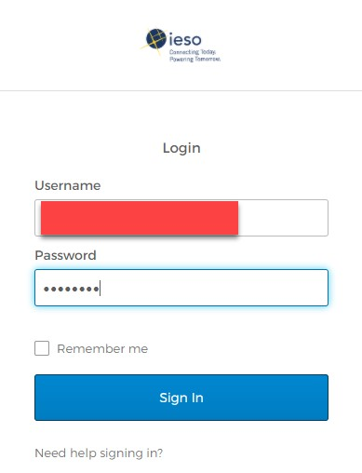
Figure 9-11: Login Page Using Temporary Password
- On the subsequent resulting page presented the end user must ‘enter the temporary password again that was provided to them as shown in the example in Figure 9-12. The system knows that the password is a one-time temporary one and so will prompt the user to do so.
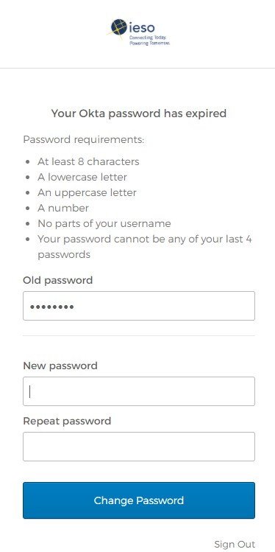
Figure 9-12: Password Reset – Entering Old Temporary Password
- The end user must then enter a new password meeting the rules twice and click on the ‘Change Password’ button as shown in Figure 9-13 to complete the set-up of the new password.
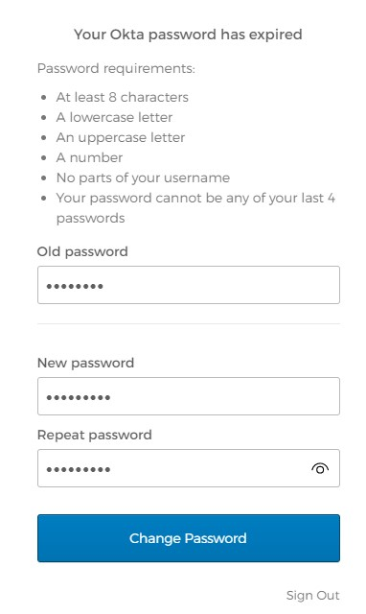
Figure 9-13: Password Reset – Entering New Password

User Security Profile Options
At any time during the lifecycle of the end user’s Identity Provider account, the end user can manage their user security profile options from the IESO Gateway User Dashboard.
- After logging in to the IESO Gateway (Prod or Sandbox) in order to access the profile, the end user can click on their name in the top right hand corner of the Dashboard and then click on the “Settings” button in the dropdown menu as shown in the example in Figure 9-14.
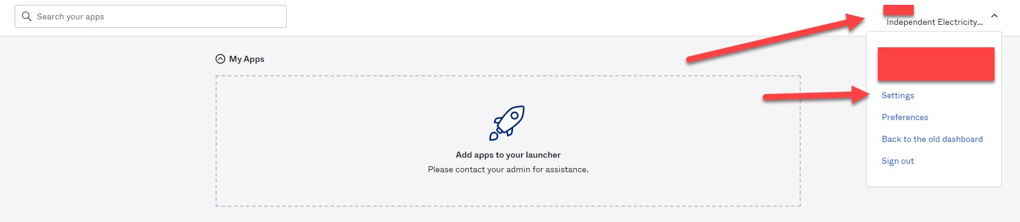
Figure 9-14: IESO Gateway – User Dashboard Settings
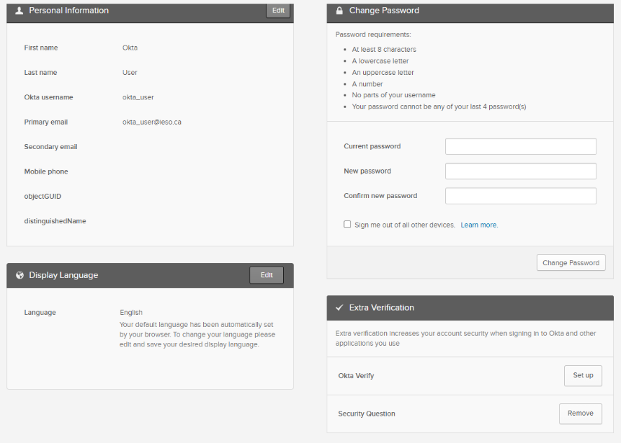
- Here the end user can manage settings such as, change password, some other aspects of their profile information, Display Language and MFA forgot password and other verification options as shown in the example in Figure 9-15.

Figure 9-15: IESO Gateway – User Profile Settings Options

IESO Gateway – Security Profile Change Password
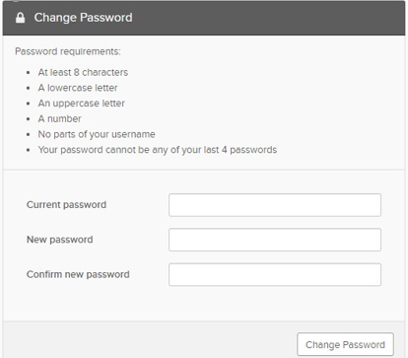
- To change their current password, the end user can enter the current password into the “current password” box as shown in Figure 9-16.

Figure 9-16: Security Profile - Change Password
- Then enter a new password and confirm by entering it again; so that it meets the requirements listed in the “Change Password” window. After clicking on the “Change Password” button, if done correctly the end user will receive a message saying “Password changed Successfully” as shown in Figure 9-17. If the password does not need the rules or is not entered the same twice and appropriate message will be displayed and the end user can try again.
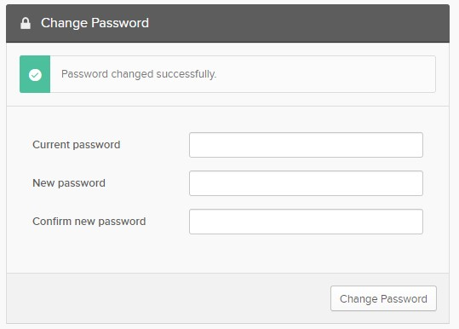
Figure 9-17: Security Profile - Change Password Result

IESO Gateway – Security Profile Additional MFA Options
- To add additional MFA options, the end user can click on the “Set Up” button next to the Multifactor option they wish to configure as shown in Figure 9-18.

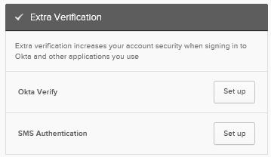
Figure 9-18: Security Profile – Extra Verification Options
- The end user will need to follow the instructions in the prompts for each of the MFA verification options.
** Please note, if using Okta Verify, the end user will need to download the app from the respective App Store (i.e. Apple App Store, Google Play Store) before attempting to setup and use this option factor.

Troubleshooting
If an end user has an IESO User account and they are having problems logging in, they should ensure the following are in place before contacting IESO Customer Relations:
- The end user should use the ‘Sign In’ links located here: Production or Sandbox.
- The end user should ensure that they are using the IESO supported browser and operating system as listed on the Supported Client Platform page available on the IESO Corporate website .
- The end user should ensure that they do not have Caps Lock or Unlock turned on with the keyboard.
- If the end user is unable to access an application once they are navigated to the IESO Gateway landing page / dashboard, they should check with their company’s registered Applicant Representative or Rights Administrator to ensure that they were registered in Online IESO Registration to access the application. Refer to IESO Roles and Responsibilities page on the IESO corporate website for more information.
If the end user is still experiencing issues, they should send any relevant screen shots of the error(s) encountered to customer.relations@ieso.ca with an appropriate explanation of the problem.
For more information or assistance, please contact IESO Customer Relations:
Telephone: (905) 403-6900
Toll Free: 1-888-448-7777
Email: customer.relations@ieso.ca
- End of Section -

Browser Use

Browser Versions
Please refer to the supported client platform page on the IESO corporate website for browser makes and versions.
Refer to the supported client platforms on the corporate website at this address.
– End of Section –

MIM Application Web Services

Introduction
The Market Information Management (MIM) system is one of the Web systems that allow the Participant to interface with the IESO. Specifically, the MIM represents the secure Internet-based client gateway to functionality provided by the IESO energy bidding system.
The market participants can interact with the MIM using the following two methods:
- Edge or Chrome browser to access the Energy Market Interface (EMI) web server via the IESO Gateway. The browser is GUI-based and interprets tag languages such as HTML. It allows client interaction through the keyboard/mouse; and
- The MIM Application Interface (Web Services) package. It allows Clients programmatic access to the MIM functionality via Web Services.

Downloading the MIM Web Services Files
Go to the website Technical Interface Page at this address using the Edge or Chrome browser.
- Choose and click on the “Market Participant Submissions (incl. MIM, EMI & API)" Link.
- Scroll down to find the MIM Web Services listing as shown in Figure 11-1.
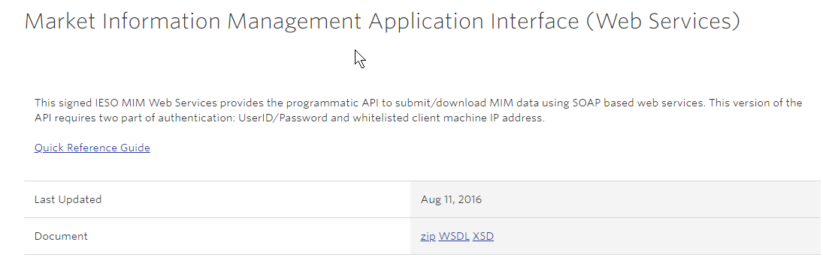
Figure 11-1: Market Information Management Application Interface (Web Services) Download
- Click on the Web Services download link – ZIP as required.
- Click on Save File when the prompt screen appears.
- Using the save as option, choose a directory (ex: C:\Temp) to download the file (e.g.: MIM_WebService_Toolkit.zip) to.
- Click on the Save button.
- Wait for the download to complete.
Once downloaded, the zip file can be extracted to a directory of the developer’s choice. The Web Services Toolkit documentation is in the form of Word Document - MIM Web Service Toolkit (MWT) Guide.docx, which is located in the zip file.
– End of Section –

Appendix A: Account Management Procedural Steps
This section contains detail on the tasks (steps) that comprise the Identity Management procedures. The steps in the following tables are illustrated in section 4 above.
The table contains three columns, as follows:
Ref.
The numerical reference to the task.
Task Name
The task name as identified in Section 2 above.
Task detail
Detail about the task.

A.1. Participant Account Application Scenario
A Participant employee or contractor applies for a user account (personal or machine on Sandbox or Production) and system access roles / permissions via the Participant Rights Administrator.
The steps in the following table are illustrated in the flow diagram entitled Participant User Account Application Scenario.
Table A-1: Participant User Account Application Scenario Task Details
Ref. | Task Name | Task Detail
A.01 | Obtain Internal Approval and communicate contact role and related system access requirement to Applicant Representative. | A Credential Subscriber obtains internal Participant approval as per the Participant’s processes and communicates as required to a Rights Administrator within the Participant, the IESO system access requirements (Sandbox and/or Production environment). The Credential Subscriber should communicate to the Rights Administrator what access permissions they are internally approved for.
A.02 | Submit request for User Account and Contact role(s) via Online IESO Registration System. | The Applicant Representative logs in to the Sandbox and/or Production Online IESO Registration system(s) and performs the person and user account registration and the grant access / contact role(s) process as described in Section 8 of this document for the Credential Subscriber for a new registered person and the associated personal or machine account.
A.03 | Receive and process Grant/ Revoke access request and initiate automated account provisioning for creation of user account. | The IESO Registration system receives the Grant/ Revoke access request from the Applicant Representative. It will validate the request to ensure the account does not already exist (i.e. conflict with another person’s personal or machine account). It will then initiate and automated provisioning request to the IESO Gateway system for a user account for the Credential Subscriber and enroll the account in the required role groups.  The Registration system will issue an email notification to the Credential Subscriber with the User Account Name used.
A.04 | Receive automated account provisioning request for user account. Create account/ enroll in role groups and issue activation email to Credential Subscriber. | The IESO Gateway system will process the account creation and role group enrolment request and issue an activation email to the Credential Subscriber so they can initialize their account.
A.05 | Receive notification email with User Account Name and Activation email with link to IESO Gateway. Continue on to account initialization to set password and configure MFA Options. | The Credential Subscriber will receive a notification email from the registration system with their account UserID and an activation email from the IESO Gateway system. The Credential Subscriber can then proceed to the initialization process to setup their account password and multifactor authentication options as per section 9 of this document.

A.2. Participant Account Change Scenario 1
Requesting a change to Participant Individual Subscriber’s or Application Subscriber’s Information (Sandbox or Production) where the requested change impacts system access roles for Individual or Application Subscriber’s User Account (grant or revoke).
The steps in the following table are illustrated in the flow diagram entitled Participant User Account Change Scenario 1.
Table A-2: Account Change Scenario 1 Task Details
Ref. | Task Name | Task Detail
B.01 | Obtain Internal Approval and communicate Contact roles requirement to Applicant Representative or system access requirement to Rights Administrator. | A Credential Subscriber obtains internal Participant approval as per the Participant’s processes and communicates as required to an Applicant Representative for contact role changes and/or a Rights Administrator within the Participant for IESO system access changes (Sandbox and/or Production environment). The Credential Subscriber should communicate to the Applicant Representative / Rights Administrator the existing user account information, Person ID and what contact roles / access permissions are internally approved for granting or revoking.
B.02 | Submit request for change to a Person’s Contact roles permissions via Online IESO Registration System. | The Applicant Representative submits a grant or revoke request for changes to a Person’s Contact roles permissions via the IESO Online Registration System as per Section 8 of this document and informs the user of those changes. Participation contact role changes made should take effect immediately.
B.03 | Submit request for a change to a user account’s System access permissions via Online IESO Registration System. | The Rights Administrator (or Applicant Representative) submits a grant or revoke request for changes to a user account’s system access permissions (personal or machine account) via the IESO Online Registration System as per Section 8 of this document and informs the user of those changes.
B.04 | Receive Grant/Revoke access request and update access/ contact roles registration and initiate automated account provisioning for changes in user account’s role groups in authentication system. | The IESO Registration System, upon receipt of the Grant/Revoke access request, updates the contact roles and system access registration information for the Credential Subscriber and where required initiates automated account provisioning with the IESO Gateway system for changes to the user account’s role groups.
B.05 | Receive confirmation of access / contact role changes and provisioning results. | The Credential Subscriber will receive confirmation of the access / contact role changes from the IESO Registration system where applicable and feasible.
B.06 | Receive automated account provisioning request for user account. Make changes in role groups in Okta. | The IESO Gateway system will receive the automated account provisioning request for the target user account. It will then make the required changes to the account’s role group memberships in Okta

A.3. Participant User Account Change Scenario 2
Requesting a change to Participant Individual Subscriber’s or Application Subscriber’s Information (Sandbox or Production) where the requested change is a Significant Change that impacts credential attributes for the person’s User Account such as name, machine account custodian change, email address, phone number
The steps in the following table are illustrated in the flow diagram entitled Participant Account Change Scenario 2.
Table A-3: Participant User Account Change Scenario 2 Task Details
Ref. | Task Name | Task Detail
C.01 | Update the person record in the IESO Online Registration System where applicable and confirm the changes in the system. | An Individual or Application Subscriber (“machine account Custodian”) updates their person record in the online Registration System where applicable and commits the changes to the IESO systems.
C.02 | Receive Person change request task in Online IESO Registration. Validate and process person and user account change information. Submit changes to IESO Gateway system. | The IESO Registration System will receive the Person change request task. It will validate the request and process the person and user account changes and submit an automated provisioning request to the IESO Gateway system to update the Credential Subscriber’s user account(s)  A notification email of the changes is sent to the Credential Subscriber
C.03 | Receive automated account changes provisioning request for user account. Make changes to account for name, email address. | The IESO Gateway System receives the automated account changes provisioning request for the target account(s). It will make the required changes to the target account(s), (e.g. person name, email address, phone no.)  The IESO Gateway system sends an email notification to the end user of the implemented changes to the account.
C.04 | Receive confirmation of account attribute changes provisioning results. | The Credential Subscriber receives the account change information notification from the IESO Registration System and IESO Gateway System.

A.4. Participant User Account Deprovisioning / Deactivation Scenario
A Participant Rights Administrator requests a User Account deactivation (Sandbox or Production) for a Participant Individual or Application Subscriber where applicable.
The steps in the following table are illustrated in the flow diagram entitled Participant User Account Deactivation Scenario.
Table A-4: Participant User Account Deactivation Scenario Task Details
Ref. | Task Name | Task Detail
D.01 | Communicate removal of participant contact / access roles and system access permissions and desired account activation with Applicant Representative or Rights Administrator | A Credential Subscriber (or Primary Contact in cases where person has left Participant) communicates the need for removal of the person’s systems access permissions for the selected organization and where desired account deactivation with the Applicant Representative and/or Rights Administrator.
D.02 | Remove selected person’s participant /contact roles for selected organization and, where applicable, request account deactivation via IESO Online Registration System | The Applicant Representative submits a revoke request of the person’s contact role(s) for the chosen organization and, where applicable, request account deactivation via the IESO Online Registration System.  Participation contact role changes made, take effect immediately via the IESO Online Registration System.
D.03 | Remove selected person’s participant system access roles for selected organization via Online IESO Registration System | The Rights Administrator submits a revoke request of all access role(s) for all of the selected person’s user account(s) for the chosen organization via the IESO Online Registration System.
D.04 | Receive Grant/ Revoke change request submitted by Rights Administrator. Validate and update registration records and submit de-provisioning changes to IESO Gateway system. | The IESO Registration System receives the Grant/ Revoke change request(s) from the Applicant Representative / Rights Administrator and validates and updates the registration records. It then submits automated deprovisioning changes to the IESO Gateway system and where applicable deactivation of the person’s user account(s).
D.05 | Receive automated account de-provisioning request for user account. Make changes to account and deactivate account(s) where no longer required. | The IESO Gateway System will receive the automated account deprovisioning request arrange for disabling of the targeted person’s User Account(s) systems access roles / privileges and deactivation of the User Account(s) where applicable.  IESO Access Management will notify the Rights Administrator of the disabling of the User Account(s) systems access roles / privileges for the Participant and deactivation of user account where no longer required where applicable.
D.06 | Receive notification of removal of User Account’s participant systems access and deactivation of account where no longer required | The Rights Administrator will receive notification of removal of User Account’s Participant systems access and deactivation of account where no longer required where feasible and applicable.

A.5. Participant User Account Recovery Scenario 1
A Participant Individual Subscriber or Application Subscriber performs an online recovery of their identity credential (Sandbox or Production) or requests the recovery of their identity credential via IESO Customer Relations.
The steps in the following table are illustrated in the flow diagram entitled Participant User Account Recovery Scenario 1.
Table A-5: Participant User Account Recovery Scenario 1 Task Details
Ref. | Task Name | Task Detail
E.01 | Use Gateway online provisioning tools to recover credentials or replace forgotten identity credentials password using the email recovery option. Else communicate need to recover account password with IESO Customer Relations | An Individual Subscriber or Application Subscriber initiates a self-recovery attempt for their User Account password with the IESO Gateway system’s self-service password reset facility where possible.  If not possible, the person can email or call IESO Customer Relations for support where self-recovery functionality is unsuccessful.
E.02 | Receive account recovery request for user account. Validate request and issue recovery token via email. | The IESO Gateway system receives the account recovery request for the user account. It validates the request and issues a recovery token via email.
E.03 | Arrange for recovery of User Account password so a temporary password or reset email is sent to the Credential Subscriber. Where applicable arrange for unlocking of account if required. | IESO Customer Relations receives the email or phone call request from the Credential Subscriber, validates it is genuine and arranges for recovery of the User Account password so a temporary password or reset email can be sent to the Credential Subscriber.  They will arrange for unlocking of account where required.
E.04 | Receive recovery email link / token for User Account password reset or temporary password from IESO Customer Relations. Reset password via IESO Gateway | The Credential Subscriber will receive the recovery email link / token for a User Account password reset or the temporary password from IESO Customer Relations.  The Credential Subscriber will then reset their password via the IESO Gateway.  Where successful the process ends.
E.05 | Receive account recovery request for user account from Administrator. Validate request and permit temporary password setup | The IESO Gateway system receives the account recovery request for user account from the IESO Customer Relations administrator. It validates the request and permits a password reset for email activation or a temporary password setup.
E.06 | Validate reset of user account password based on email token or IESO issued temporary password | The IESO Gateway system upon triggering by the email reset or temporary password from the Credential Subscriber validates the reset of user account password based on email token or IESO issued temporary password and completes the password reset.

A.6. Participant User Account Recovery Scenario 2
An existing Rights Administrator performs an online recovery of their identity credential (Sandbox or Production) or requests the recovery of their identity credential via IESO Customer Relations:
The steps in the following table are illustrated in the flow diagram entitled Participant User Account Recovery Scenario 2.
Table A-6: Account Recovery Scenario 2 Task Details
Ref. | Task Name | Task Detail
F.01 | Use Gateway online provisioning tools to recover credentials or replace forgotten identity credentials password using the email recovery option. Else communicate need to recover account password to IESO Customer Relations | A Rights Administrator will use the IESO Gateway online provisioning tools to recover credentials or replace a forgotten identity credentials password using their chosen MFA options. If this fails, the Rights Administrator can communicate the need to recover their account password with IESO Customer Relations via email or a phone call providing all necessary details that will let their request be validated.
F.02 | Receive account recovery request for user account. Validate request and issue recovery token via email. | The IESO Gateway system will receive and validate the request to recover Rights Administrator account password and issue a recovery token via email.
F.03 | Arrange for recovery of user Account password so a temporary password is sent to the Rights Administrator. Where applicable arrange for unlocking of account if required. | IESO Customer Relations receives the email or phone call request from the Rights Administrator, validates it is genuine and arranges for recovery of the User Account password so a temporary password or reset email can be sent to the Rights Administrator’s and/or arrange for unlocking of the account where required.
F.04 | Receive recovery email link / token for User Account password reset or temporary password from IESO  Reset password via IESO Gateway | The Rights Administrator will receive the recovery email link / token for a User Account password reset or the temporary password from IESO Customer Relations.  The Rights Administrator will then reset their password via the IESO Gateway.  Where successful the process ends.
F.05 | Receive account recovery request for user account from Rights Administrator. Validate request and permit temporary password setup | The IESO Gateway system receives the account recovery request for user account from the IESO Customer Relations administrator. It validates the request and permits a password reset for email activation or a temporary password setup.
F.06 | Validate reset of user account password based on email token or IESO issued temporary password | The IESO Gateway system upon triggering by the email reset or temporary password from the Rights Administrator validates the reset of user account password based on email token or IESO issued temporary password and completes the password reset.

A.7. Participant Rights Administrator Enrolment Scenario
A Participant Primary Contact is requesting enrolment of a Rights Administrator in either Sandbox and/or Production environments.
The steps in the following table are illustrated in the flow diagram entitled Participant Rights Administrator Enrolment Scenario.
Table A-7: Rights Administrator Enrolment Scenario Task Details
Ref. | Task Name | Task Detail
G.01 | Complete selected person’s Rights Administrator role assignment for selected organization and create user account request via Online IESO Registration System where applicable. | The Primary Contact at a Participant completes the selected person’s Rights Administrator role assignment for the selected organization in Sandbox and/or Production and in the process creates a user account request via the Online IESO Registration System (Sandbox and/or Production) where applicable. If the person already has an IESO user account (Sandbox and/or Production) the process is complete.  If the person enrolled in the Rights Administrator for the Participant does not have an IESO User Account the Registration System will generate a grant/revoke request to the IESO Gateway system to create the account.
G.02 | Receive Grant/ Revoke access request from Primary Contact. Validate grant/revoke information. Update organization /contact roles registration and initiate automated account provisioning where applicable for user account creation and/or role groups in authentication system. | The IESO Registration System will receive a Grant/ Revoke access request from the Primary Contact. It will validate the grant/revoke information, then update the organization /contact roles registration information and initiate automated account provisioning where applicable for user account creation and/or membership in role groups in the IESO Gateway authentication system.  If an account exists, the Participant Rights Administrator enrolment is complete.  A registration notification email is sent to the Rights Administrator.
G.03 | Receive account provisioning request for user account. Create account and provision access roles and Issue activation email. | The IESO Gateway System receives an account provisioning request for a user account. It creates the account and provisions access roles and then issues an activation email to the end user.
G.04 | Receive activation email with User Account Name and link to IESO Gateway. Continue on to account initialization to set password and configure MFA Options | The Rights Administrator receives the registration email plus the activation email from the Registration system /IESO Gateway system with the User Account Name and the link to IESO Gateway system. He or she will continue on to account initialization to set up the account password and configure their MFA Options (Sandbox and/or Production Gateway system as applicable).

A.8. Participant Rights Administrator User Account Change Scenario 1
An existing Rights Administrator is requesting a change to their information where the requested change is a Significant Change that impacts credential attributes for the person’s account such as name, machine account custodian change, email address, phone number.
The steps in the following table are illustrated in the flow diagram entitled Participant Rights Administrator Account Change Scenario 1.
Table A-8: Rights Administrator Change Scenario 1 Task Details
Ref. | Task Name | Task Detail
H.01 | Updates their person record in the Online IESO Registration system where applicable and in the process initiates a provisioning request to update their user account information. | The Rights Administrator Updates their person record in the Online IESO Registration system (Sandbox and Production) where applicable and in the process the Online IESO Registration System initiates a provisioning request to update their user account information.
H.02 | Receive Person change request task in Online IESO Registration. Validate and process person and user account change information. Submit changes to IESO Gateway system. | The IESO Registration system receives the Person change request task. It validates and processes the person and user account change information. It then submits changes to IESO Gateway system to update the user account attributes where required and sends a notification email to the end user.
H.03 | Receive automated account changes provisioning request for user account. Make changes to account for name, email address, phone number. | The IESO Gateway system receives the automated account changes provisioning request for the user account. It then makes changes to account for name, email address, phone no. as required and sends a notification email to the end user of the changes.
H.04 | Receive confirmation of account attribute changes provisioning results | The participant Rights Administrator will receive the confirmation change notification email of his or her credential updates from the IESO Gateway system where possible.

A.9. Participant Rights Administrator User Account Change Scenario 2
An existing Rights Administrator is requesting a change to system access permission changes (Sandbox and/or Production) for themselves or another Rights Administrator.
The steps in the following table are illustrated in the flow diagram entitled Participant Rights Administrator Account Change Scenario 2.
Table A-9: Participant Rights Administrator Account Change Scenario 2 Task Details
Ref. | Task Name | Task Detail
I.01 | Obtain Internal Participant approval for contact role / system access permission changes. | The Rights Administrator obtains internal Participant approval for contact role / system access permission change (Sandbox and/or Production). For contact roles the Rights Administrator has the Applicant Representative make the changes. In many Participants this may be the same person
I.02 | Submit request for change to a Rights Administrator’s contact role permissions via Online IESO Registration System | An Applicant Representative submits a request for change to a Rights Administrator’s (for same Participant) user account’s access roles / contact roles via the Online IESO Registration System (Sandbox and/or Production).  Participation contact role changes made, take effect immediately via the IESO Online Registration System. Some changes may require the Registration system to update the IESO Gateway system.
I.03 | Submit request for a change to a Rights Administrator’s system access permissions via Online IESO Registration System | A Rights Administrator submits a request for change their own or another Rights Administrator’s (for same Participant) user account’s access roles / system access permissions via the Online IESO Registration System (Sandbox and/or Production).  This will require the Registration system to update the IESO Gateway system.
I.04 | Receive Grant/ Revoke access request and update access/ contact roles registration and initiate automated account provisioning for changes in user account’s role groups in authentication system. | The IESO Registration system receives the Grant/Revoke access request and updates access/ contact roles registration records for the Rights Administrator and initiates any automated account provisioning for changes for the user account’s role groups in the IESO Gateway authentication system. This should happen immediately.  An email is sent to the Rights Administrator regarding the changes.
I.05 | Receive confirmation of system access / contact role changes and provisioning results | The Participant Rights Administrator will receive confirmation of the changes (Sandbox or Production) to the access roles / system access permissions for the Rights Administrator user account.
I.06 | Receive automated account provisioning request for user account. Make changes in role groups in Okta | The IESO Gateway system receives the automated account provisioning request for the Rights Administrator’s user account and makes the required changes in memberships for the role groups in Okta.

A.10. Participant Rights Administrator Role Termination Scenario
A Primary Contact is requesting the termination of a Participant Rights Administrator role for a person and potentially removal of access roles and User Account deactivation (Sandbox and/or Production).
The steps in the following table are illustrated in the flow diagram entitled Participant Rights Administrator Role Termination Scenario.
Table A-10: Participant Rights Administrator Role Termination Scenario Task Details
Ref. | Task Name | Task Detail
J.01 | Request removal of selected person’s Rights Administrator role assignment and participant contact roles for the selected organization and where applicable request account deactivation via Online IESO Registration System | A Primary Contact requests removal of the selected person’s Rights Administrator organization role assignment for selected organization in the Registration System (Sandbox and/or Production) and where applicable requests removal of the person’s user account/ access role assignments and potentially account deactivation via the Online IESO Registration System where applicable.
J.02 | Remove selected person’s Rights Administrator role and any requested participant contact roles for the selected organization. Send de-provisioning request for associated role groups and/or deactivation of user account where applicable | IESO Registration system will receive a Grant/ Revoke change request from the Primary Contact (Sandbox or Production). It will then validate the Grant/Revoke information for the organization, contact and access roles to be revoked.  If the person still needs an IESO user account, the process is complete. If an account is no longer needed the Primary Contact can request end dating of the of the user account. Then the Registration System (Sandbox and/or Production) will automatically send an automated provisioning request to the IESO Gateway system to deactivate the user account.
J.03 | De-provision requested access roles for target user account.  Deactivate user account where applicable. | IESO Access Management will arrange for removal of the person’s User Account’s Registration System access and other access privileges (Sandbox or Production) and deactivation of the account where applicable. They will then notify the Primary Contact of deactivation of user account and removal of system access privileges where possible
AA.04 | Receive notification of access role and account de-provisioning results. | Receive notification of access role and account de-provisioning results.

A.11. Credential Subscriber User Account Initialization / Password Reset
Initialization of a Participant Contact’s User Account or reset of the password for that account.
Once the Participant representative is registered for a User Account through the Online IESO Registration System, they will receive a User Account activation email for their IESO Gateway account.
The User Account once activated, by the Credential Subscriber can be used immediately. If required, the Credential Subscriber can request a password reset online or via IESO Customer Relations.
For more information on system functionality relating to the tasks described below, refer to section 9 of this guide.
Table A-11: Credential Subscriber, Account Initialization Task Details
Ref. | Task Name | Task Detail
K.01 | Access the web-based identity management tool at https://gateway.ieso.ca as indicated in the activation / reset password email for initializing or resetting a User Account. | If not already done; upon receipt of User Account activation email for initial issuance or password reset email from IESO Customer Relations for account recovery:  For a User Account / Password identity credential used with the IESO Gateway (Sandbox or Production where applicable); the Participant person shall access the provided IESO Gateway URL (Sandbox or Production) for initializing/using a User Account. The person where required, use the IESO Gateway to perform password self-reset using the IESO Gateway or for resetting a temporary password provided by IESO Customer Relations with one of their own choosing.
K.02 | Use the Gateway web interface to either:  - Activate the user account and set up MFA parameters; or  - Reset the password for an existing account | Use the IESO Gateway system (Sandbox or Production) to:  - Activate the user account and set up MFA parameters via the supplied activation email; or  - Reset the password for an existing account using the IESO Gateway themselves or reset the password via an IESO Customer Relations supplied email or a temporary password provided orally.
K.03 | Validate User Account activation information and permit user to setup password, multifactor authentication security question parameters | The IESO Gateway will validate the User Account activation information and permit the end user to setup an enduring password, plus their multifactor authentication security question parameters.
K.04 | Validate user account self-reset email or IESO Customer Relations reset email parameters | The IESO Gateway system will validate the user account self-reset email or IESO Customer Relations reset email parameters and let the end reset their password.  Note: In the case where a user’s account is locked it will be unlocked by IESO Customer Relations.
K.05 | Login to IESO Gateway to confirm account. Read Legal disclaimer and login. Complete MFA prompt. | The User Account’s successful password change / reset is confirmed within the Gateway login web pages to the end user. The use may have to answer an MFA prompt. The IESO legal disclaimer is available on the Gateway landing page for reference.  When complete the person will be able to use the User Account to login to the IESO Gateway and access the applications the end user is authorized for.

A.12. Periodic Update of Subscriber User Account Password
Table A-12: Update of Account Passwords
Ref. | Task Name | Task Detail
L.01 | Login to the IESO Gateway at https://gateway.ieso.ca with a User Account.  Sandbox URL is https://gateway-sbx.ieso.ca | For the IESO Gateway a User Account and password (Sandbox or Production) are used to login as normal. (Production URL - https://gateway.ieso.ca , Sandbox URL - https://gateway-sbx.ieso.ca) may prompt t
L.02 | Check for password renewal and initiate password update process if required. | Periodically if so configured the IESO Gateway may check for password renewal and initiate the process to do so to the end user
L.03 | No notification of update needed at Gateway login. Use Gateway credentials as required for normal business operations. | If no notification of update is needed at Gateway login the end user can use Gateway credentials as required for normal business operations and the process ends.
L.04 | Gateway identity management system sends User Account password change prompt to end user | Where a password update is needed the IESO Gateway sends the end user a prompt in the GUI login screens to change their password.
L.05 | Change password in Gateway login screen using old password and or MFA options to enable change | The user shall follow the instructions on the IESO Gateway web pages to change their password to a new one that meets the password rules.
L.06 | Validate user account password change with old password / MFA options | The IESO Gateway will validate the end user’s responses using the chosen MFA options and old password to facilitate the password update.  Upon successful password update the process ends or in case of failure the end user can contact IESO Customer Relations.

A.13. Description of Changes

A.13.1. Credential Subscriber Information
Types of Changes
Changes to Credential Subscriber information are differentiated on the basis of their impact on identity credential (User Account / Password).
Contact or Access Role(s) change – The requested change requires changes to a user’s system access permissions (grant or revoke) for any IESO contact or access role that the Participant is valid for through their registered market and program participations. Some contact roles have no assigned system access permissions associated with them.
Person and account information change – The requested change requires a change to the identity credential issued to the requestor including first name, middle name, last name, phone number and email address.
Changes to the User Account password are handled under the password recovery process.
Note: A Significant Change due to actual name change may require re-proofing of the identity of the Credential Subscriber via the Participant internal processes but this is not mandated by the IESO.
When to Submit a Change Request
All Credential Subscriber information retained by the Participant person and Rights Administrator and/or Primary Contact contained within or represented by a User Account should always remain accurate. If a Participant person and Rights Administrator and/or Applicant Representative or Primary Contact are aware of inaccuracies, a Registration system request should be submitted by the Applicant Representative / Rights Administrator.

A.13.2. Rights Administrator Information
Types of Changes
Changes to a Rights Administrator person’s information are differentiated on the basis of their impact to the Rights Administrator role itself and on identity credential (User Account / Password).
Contact / Access Role(s) change
Changes to a person’s Rights Administrator role (adding or removing the role to the person) will impact the person’s Registration System access permissions.
Any other requested change requires changes to a user’s system access permissions (grant or revoke) for any IESO access role that the Participant is valid for through their registered market and program participations.
Person and account information change
The requested change requires a change to the identity credential issued to the requestor including first name, middle name, last name, phone number and email address.
Changes to the User Account password are handled under the password recovery / reset processes.
When to Submit a Change Request
All Rights Administrator information retained by the Participant Rights Administrator and/or Primary Contact contained within or represented by a User Account should always remain accurate. If a Rights Administrator, Applicant Representative or Primary Contact is aware of inaccuracies, a Registration system request should be submitted by the Applicant Representative / Rights Administrator.
– End of Appendix –

Appendix B: Glossary of Terms
The following definitions and acronyms used within this guide are specific to IESO Identity Management.
18 Month and Long-Term Assessments Contact – Person responsible for data submissions for the 18-Month Outlooks and longer-term reliability assessments for their organization.
Access Role Change – is a change that does not impact credentials but impacts system access for a User Account.
Application Subscriber – is the term used for Participant application/server system entity that will be using a User Account identity credential in combination with an API or system for access to an IESO website. An Application Subscriber is any application/server system that is associated with a service level User Account identity credential. Associated with the Application Subscriber is a Custodian.
Bids and Offers Contact – Section to be contacted regarding the real-time market bids or offers for the organization (24/7 - Operations Desk, Energy Trading Floor, Control Centre).
Control Room Section – Control room section for the participant organization.
Credential Subscriber – General term for Individual Subscriber or Application Subscriber.
Custodian – is normally the individual that owns and has rightful possession of the information. If the ownership has been delegated, the delegate has the rightful possession of the information and therefore is the custodian.

Domain – is the community consisting of the Subscribers.

Energy Limited Resource Forecast Contact – Person responsible for submission of the energy limited resource forecast for their organization.
E-Tag Curtailment Contact – Person or Section responsible for receiving notifications regarding the limiting of energy flow on an arranged and/or confirmed interchange transaction for their organization.
IESO Gateway System – Okta-based User Account and Access Management and authentication system is responsible for receiving user Account and system access role /permission requests and for performing account creation and issuance, name changes, access role changes and user Account deactivation and for authentication of all user account logins. Receipts of requests may be from the IESO Registration System via automated provisioning workflows or manually from IESO Access Management or IESO Customer Relations.
Individual Subscriber – is the general term used for IESO Identity Management individual end entities who apply for a User Account. An Individual Subscriber is any entity whose name appears as the subject in a User Account.
Meter Trouble Report Contact – Person or Section responsible for monitoring metering data and the response of the Meter Service Provider, and responding to the late notification of Meter Trouble Reports for their organization.
MSP Revenue Metering Contact – Person responsible for submitting meter registration requests, monitoring in-flight requests and data and viewing the master data for registered meter installations.
Notice of Disagreement Contact – Person responsible for submitting notices of disagreement for settlement statements for their organization.
Message – is a digital representation of a unit of information with a human readable equivalent. For example, a message may be a Participant’s bid or offer for an electrical market, pricing data, email message or a file.
Participant Primary Contact – is an officer of a Participant organization who is authorized by the Participant Authorized Representative to register Participant Rights Administrators on behalf of the Participant organization. The Participant Primary Contact designates and delegates the role of the Participant Rights Administrator.
Participant Rights Administrator – means an employee of a Participant Organization that is appointed by a Participant Primary Contact and is authorized to register for User Accounts and system access role/permissions for Participant Individual Subscribers or Participant Application Subscribers requesting market systems access and an IESO identity credential.
Participant Authorized Representative – a senior officer at a Participant organization who can authorize an officer (i.e., a high-level employee) of the Participant organization to perform the responsibilities of a Participant Primary Contact.
Password Recovery – For a User Account identity credential this is handled by issuance of a new temporary password to the Credential Subscriber or for account used with the MIM Web Services, issuance of a new enduring password to the Credential Subscriber.
Revenue Metering Contact – Person responsible for viewing the master data for registered meter installations and in-flight data submitted during a meter registration request. The Revenue Metering Contact for a transmitter is also responsible for approving Site Registration.
Settlements Contact – Person responsible for issues/questions relating to settlement statements for their organization.
Significant Change – is a change in a user’s credentials including change of first or last name, change of email address, phone number or User Account value is no longer accurate.
– End of Appendix –

References
Document ID | Document Name
RUL-6 to RUL-24 | Market Rules
MAN-108 | Market Manual 1.5: Market Registration Procedures
MAN-146 | Market Manual 3.1: Metering Service Provider (MSP) Registration, Revocation, and De-registration
MAN-165 | Market Manual 6: Participant Technical Reference Manual,  Section 2.0: Participant Workstation, Network & Security

– End of Document –

