This *market manual* is provided for stakeholder engagement purposes.  Proposed changes, to be effective for the December 2022 *capacity auction*, are indicated based on the current version of the *market manual*.  Please note that additional changes to this document may be incorporated as part of future engagement on design enhancements to the *capacity auction* or other IESO activities prior to this *market manual* taking effect.

Disclaimer

The posting of documents on this Web site is done for the convenience of *market participants* and other interested visitors to the *IESO* Web site. Please be advised that, while the *IESO* attempts to have all posted documents conform to the original, changes can result from the original, including changes resulting from the programs used to format the documents for posting on the Web site as well as from the programs used by the viewer to download and read the documents. The *IESO* makes no representation or warranty, express or implied that the documents on this Web site are exact reproductions of the original documents listed. In addition, the documents and information posted on this Web site are subject to change. The *IESO* may revise, withdraw or make final these materials at any time at its sole discretion without further notice. It is solely your responsibility to ensure that you are using up-to-date documents and information.

This *market manual* may contain a summary of a particular *market rule*. Where provided, the summary has been used because of the length of the *market rule* itself. The reader should be aware, however, that, where a *market rule* is applicable, the obligation that needs to be met is as stated in the *market rules*. To the extent of any discrepancy or inconsistency between the provisions of a particular *market rule* and the summary, the provision of the *market rule* shall govern.

**Document ID** MDP_PRO_0033

**Document Name**

**Issue**

**Reason for Issue** Updated for Baseline 46.0

**Effective Date**

Document Change History

| Issue | Reason for Issue | Date |
| --- | --- | --- |
| For change history prior to Issue 57, see Issue 56.0 | | |
| 57.0 | Updated for Baseline 33.1 | June 3, 2015 |
| 58.0 | Updated for Baseline 34.0 | September 9, 2015 |
| 59.0 | Updated for Baseline 34.1 | December 2, 2015 |
| 60.0 | Updated for Baseline 35.0 | March 2, 2016 |
| 61.0 | Updated for Baseline 35.1 | June 1, 2016 |
| 62.0 | Updated for Baseline 36.0 | September 14, 2016 |
| 63.0 | Updated for Baseline 36.1 | December 7, 2016 |
| 64.0 | Updated for Baseline 37.0 | March 1, 2017 |
| 65.0 | Updated in advance of Baseline 37.1 | March 31, 2017 |
| 66.0 | Updated for Baseline 37.1 | June 7, 2017 |
| 67.0 | Updated in advance of Baseline 38.0 | August 1, 2017 |
| 68.0 | Updated for Baseline 38.1 | December 6, 2017 |
| 69.0 | Updated for Baseline 39.0 | March 7, 2017 |
| 70.0 | Updated for Baseline 40.0 | September 12, 2018 |
| 71.0 | Updated in advance of Baseline 40.1 | November 14, 2018 |
| 72.0 | Updated for Baseline 41.0 | March 6, 2019 |
| 73.0 | Updated for Baseline 41.1 | June 5, 2019 |
| 74.0 | Updated for Baseline 42.1 | December 4, 2019 |
| 75.0 | Updated for Baseline 43.0 | March 4, 2020 |
| 76.0 | Updated in advance of Baseline 43.1 to support changes to the Demand Response Auction, effective the commitment period beginning May 1, 2020. | April 23, 2020 |
| 77.0 | Updated in advance of Baseline 43.1 to support changes to the Capacity Auction to be held in June 2020 for the commitment period beginning May 1, 2021. | May 4, 2020 |
| 78.0 | Updated for Baseline 44.0 | September 16, 2020 |
| 79.0 | Updated in advance of Baseline 44.1 | November 25, 2020 |
| 80.0 | Updated for Baseline 44.1 | December 2, 2020 |
| 81.0 | Updated to meet accessibility requirements pursuant to the Accessibility for Ontarians with Disabilities Act. | December 15, 2020 |
| 82.0 | Issued in advance of Baseline 45.0. Updated to include electricity storage participation. | February 26, 2021 |
| 83.0 | Updated for Baseline 45.1 | June 2, 2021 |
| 84.0 | Updated for Baseline 46.0 | September 15, 2021 |

Related Documents

|  |  |
| --- | --- |
| Document ID | Document Title |
| N/A |  |

Table of Contents

Table of Contents ii

List of Figures v

List of Tables vi

Table of Changes vii

Market Manuals 1

Market Procedures 1

1. Introduction 2

1.1 Purpose 2

1.2 Scope 2

1.3 Overview of the *Settlement Statement* Process 3

1.3.1 Issuing the *Preliminary Settlement Statement* 3

1.3.2 Interpreting the *Settlement Statements* and Data Files 5

1.3.3 Submitting Queries 7

1.3.4 Submitting a Notice of Disagreement 7

1.3.5 Issuing the *Final Settlement Statement* 10

1.3.6 Data Files for Transmission Services Charges 11

1.4 Settlement Delays 12

1.4.1 Delay in Issuing Settlement Statements 12

1.4.2 Failure of Communication System 13

1.5 Optional Measurement Data Records 13

1.6 Special Settlement Activities 13

1.6.1 Generation Station Service Rebate 13

1.6.1A Electricity Storage Station Service Rebate 14

1.6.2 Intentionally Left Blank 15

1.6.3 Intentionally Left Blank 15

1.6.4 Intentionally Left Blank 15

1.6.5 Administrative Pricing Event 16

1.6.6 Transmission Service Charges for Embedded Generation 17

1.6.7 Regulated Price Plan, Regulated Generation, NUG Payments and Newly Contracted Generation 18

1.6.8 Limiting CMSC Payments for Exporters and Dispatchable Loads and Electricity Storage Participants 31

1.6.9 Adjustment for Facility-Induced CMSC 32

1.6.10 Real-time Import Failure Charges and Export Failure Charges 36

1.6.11 Standard Offer Program (SOP) 39

1.6.12 CMSC Adjustment for Replacement Offer Events 42

1.6.13 Compensation Resulting from an SPS Activation 43

1.6.14 Northern Industrial Electricity Rate Program (NIERP) 43

1.6.15 Intentionally Left Blank 44

1.6.16 Intentionally Left Blank 44

1.6.17 Conservation Assessment Recovery 44

1.6.18 Intentionally Left Blank 45

1.6.19 Renewable Integration - Forecasting 45

1.6.20 Adjustment for Self-Induced CMSC Earned by Certain Generating Facilities 45

1.6.21 Intentionally Left Blank 48

1.6.22 Limiting Payments to Exports during Negative Prices 49

1.6.23 Smart Metering Entity Charge 49

1.6.24 Intentionally Left Blank 49

1.6.25 Biomass NUG and Energy from Waste (EFW) Contracts 50

1.6.26 Capacity Obligations 50

1.6.27 Transmission Rights Clearing Account Disbursement 61

1.6.28 Limiting Constrained-off CMSC to Interties 61

1.6.29 Ontario Electricity Support Program 62

1.6.30 Adjustment Account Surplus Disbursement 62

1.6.31 Limiting Constrained On CMSC Payments to Generators and Electricity Storage Participants Ramping Down 63

1.6.32 Ontario Rebate for Electricity Consumers Act, 2016 64

1.6.33 Fair Hydro Act, 2017 65

1.6.34 Capacity Exports 67

1.6.35 Dispute Resolution Settlement 67

1.6.36 COVID-19 Energy Assistance Program (CEAP and CEAP-SB) 67

1.7 Roles and Responsibilities 68

1.8 Contact Information 69

2. Procedural Work Flow 70

2.1 Preliminary Settlement Statements 70

2.2 Retrieving Final Settlement Statements 73

2.3 Intentionally Left Blank 75

2.4 Intentionally Left Blank 76

2.5 Intentionally Left Blank 77

2.6 Intentionally Left Blank 78

2.7 Intentionally Left Blank 79

2.8 Declaration of Designated Consumer 80

2.9 Intentionally Left Blank 81

2.10 Submitting Transmission Service Charges for Embedded Generation 82

2.11 Workflow for Submitting NUG Adjustment Amount Information 84

2.12 Workflow for Submitting Embedded Generation and Regulated Price Information 85

3. Procedural Steps 87

3.1 Retrieving Preliminary Settlement Statements 88

3.2 Final Settlement Statements 96

3.3 Designating Facility for Generation Station Service Rebate or Electricity Storage Station Service Rebate 99

3.4 Intentionally Left Blank 101

3.5 Intentionally Left Blank 102

3.6 Intentionally Left Blank 103

3.7 Intentionally Left Blank 104

3.8 Intentionally Left Blank 105

3.9 Declaration of Designated Consumers 106

3.10 Intentionally Left Blank 107

3.11 Submitting Transmission Service Charges for Embedded Generation 108

3.12 Submitting NUG Adjustment Amount Information 110

3.13 Submitting Embedded Generation and Regulated Price Information 111

Appendix A: Forms A–1

Appendix B: Online IESO Notice of Disagreement Form B–1

Appendix C: IESO Charge Types Applicable to the Authorized Charge C–1

Appendix D: Price Bias Adjustment Factors Calculation Method for the Real-Time Import and Export Failure Charge D–1

Appendix E: Expired Settlement Calculations Kept for Purposes of Re-Calculation E–1

Appendix F: OPG Rebate F–1

References 1

List of Figures

Figure 1–1: *Preliminary Settlement Statement* Timeline 3

Figure 2–1: Work flow for Preliminary Settlement Statements 71

Figure 2–1: Work flow for Preliminary Settlement Statements (continued) 72

Figure 2–2: Work flow for Retrieving Final Settlement Statements 73

Figure 2–3: Work flow for Designating Facility for Generation Station Service Rebate 74

Figure 2–4: Intentionally Left Blank 75

Figure 2–5: Intentionally Left Blank 76

Figure 2–6: Intentionally Left Blank 77

Figure 2–7: Intentionally Left Blank 78

Figure 2–8: Intentionally Left Blank 79

Figure 2–9: Work flow for Declaration of Designated Consumer 80

Figure 2–10: Intentionally Left Blank 81

Figure 2–11: Work flow for Submitting of Transmission Service Charges for Embedded Generation 83

Figure 2–12: Workflow for Submitting NUG Adjustment Amount Information 84

Figure 2–13: Workflow for Submitting Embedded Generation and Regulated Price Information 85

Figure B–1: NOD Detailed Records B–1

Figure B–2: NOD Detail Screen – Select Preliminary Settlement Statement B–1

Figure B–3: NOD Detail Screen – Select Preliminary Settlement Statement Line Items B–2

Figure B–4: NOD Detail Screen – Add Missing Line Items B–2

Figure B–5: NOD Detail Screen – Provide Additional Information B–3

Figure E–1: RT-GCG Precedes DA Schedule of Record: No Overlap - No Gap between Events E–17

Figure E–2: RT-GCG Precedes DA Schedule of Record: No Overlap - Gap between Events E–18

Figure E–3: RT-GCG Precedes DA Schedule of Record: With Overlap E–19

Figure E–4: Work flow for Submitting Optional Measurement Data Records E–43

Figure E–5: Work flow for Submitting DRC Exemption Certificate E–47

Figure E–6: Work flow for Submitting Reduced DRC Certification Information E–48

List of Tables

Table 1–1: Data Requirement for Notice of Disagreement Submission 8

Table 1–2: Global Adjustment Charge Types 22

Table 1–3: Failure Reason Codes and Settlement Treatment 37

Table 1–4: Scenarios and Adjustments for Exceptions 60

Table 2–1: Legend for Work Flow Diagrams 70

Table 3–1: Procedural Steps for Retrieving Preliminary Settlement Statements 88

Table 3–2: Procedural Steps for Retrieving Final Settlement Statements 96

Table 3–3: Procedural Steps for Designation of Facility for Generation Station Service Rebate and Electricity Station Service Rebate 99

Table 3–4: Intentionally Left Blank 101

Table 3–5: Intentionally Left Blank 102

Table 3–6: Intentionally Left Blank 103

Table 3–7: Intentionally Left Blank 104

Table 3–8: Intentionally Left Blank 105

Table 3–9: Procedural Steps for Declaration of Designated Consumers 106

Table 3–10: Intentionally Left Blank 107

Table 3–11: Procedural Steps for Submission of Transmission Service Charges for Embedded Generation 108

Table 3–12: Submission of NUG Adjustment Amount Information 110

Table 3–13: Procedural Steps for Submission of Embedded Generation and Regulated Price Information 111

Table C–1: IESO Charge Types Included in the 0.62 Monthly Calculation C–1

Table E–1: Example of Weekly Data File E–31

Table E–2: Performance Set-Off Factors E–35

Table E–3: Buy-Down Rate Calculation E–40

Table E–4: Procedural Steps for Submission of Optional Measurement Data Records E–44

Table E–5: Procedural Steps for Submission of DRC Exemption Certificate E–48

Table E–6: Procedural Steps for Submission of Reduced DRC Certification Information E–49

Table F–1: Summary of Deadlines F–4

Table of Changes

|  |  |
| --- | --- |
| Reference (Section and Paragraph) | Description of Change |
| 1.6.7 | Replaced “*IESO* Portal” with “*IESO* Gateway” under section “Declaration Required for Designated Consumers”. |
| 1.6.26.3.5 | Clarify *capacity charge* applicability during test activations. |
| Appendix E & F | Replaced “*IESO* Portal” with “*IESO* Gateway” where applicable. |
| References | Remove “Guide to the *IESO* Portal”. |

Market Manuals

The *market manuals* consolidate the market procedures and associated forms, standards, and policies that define certain elements relating to the operation of the *IESO-administered markets*. Market procedures provide more detailed descriptions of the requirements for various activities than is specified in the *market rules*. Where there is a discrepancy between the requirements in a document within a *market manual* and the *market rules*, the *market rules* shall prevail. Standards and policies appended to, or referenced in, these procedures provide a supporting framework.

Market Procedures

The “Settlements Manual”is Volume 5 of the *market manuals*, where this document forms “Part 5.5: Physical Markets Settlement Statements”.

A list of the other component parts of the “Settlements Manual” is provided in “Part 5.0: Settlements Overview”, in Section 2, “About This Manual”.

Structure of Market Procedures

Each market procedure is composed of the following sections:

1. **“Introduction”**, which contains general information about the procedure, including an overview, a description of the purpose and scope of the procedure, and information about roles and responsibilities of the parties involved in the procedure.
2. **“Procedural Work Flow”**, which contains a graphical representation of the steps and flow of information within the procedure.
3. **“Procedural Steps”**, which contains a table that describes each step and provides other detail related to each step.
4. **“Appendices”**, which may include such items as lists of forms, standards, policies, and agreements.

Conventions

The *market manual* standard conventions are defined in the "Market Manual Overview" document.

In this document, “we” and “us” refers to the *IESO*; “you” refers to *market participants* unless specifically identified otherwise.

– End of Section –

# Introduction

## Purpose

In this procedure we describe the process to create and issue *preliminary* and *final settlement statements* for the *physical markets*. When we refer to *physical markets* in this procedure, we are describing:

* the *real-time market* for *energy* (RTE), which consists of:
* a market for *energy*; and
* a market for several classes of *operating reserve*;
* *procurement markets*, which consists of:
* markets for *contracted ancillary services*, including: *reactive support* and *voltage control*, *regulation* service and *black start capability*;
* a market for *reliability must-run contracts*; and
* the *transmission rights* (*TR*) market, except for *settlement amounts* relating to the purchase or sale of a *transmission right* in any round of a *TR auction*[1].

In this procedure we also describe the process to follow if you disagree with your *preliminary settlement statement* – we will apply any amendments necessary to your *final settlement statement*.

## Scope

This document provides a summary of the interfaces between parties and the steps involved in issuing *preliminary* and *final settlement statements* for the *physical markets*. The procedural work flows and steps serve as a roadmap and reflect the requirements set out in the *market rules* and *IESO* policies and standards.

This procedure contains three parts:

* Section 1 contains a summary of *settlement statements*;
* Section 2 describes the main actions of the procedure in the procedural work flow; and
* Section 3 presents the procedural steps.

This procedure applies only to the *IESO’*s *physical markets*. The procedures for *IESO* financial market *settlement statements* are provided in “Market Manual 5: Settlements, Part 5.7: Financial Markets Settlement Statements”.

## Overview of the *Settlement Statement* Process

We cover the following topics that comprise the *settlement statements* process:

* issuing and retrieving *preliminary settlement statements*;
* interpreting the *settlement statements* and data files;
* interpreting the *transmission services charge* data files;
* steps to submit queries;
* steps to submit a *notice of disagreement*; and.
* issuing and retrieving *final settlement statements*.

A timeline showing the key activities in issuing a *settlement statement* for the *physical markets* is available in “Part 5.0: Settlements Overview”.

### Issuing the *Preliminary Settlement Statement*

We issue a *preliminary settlement statement* for each *trading day* in the *physical markets* on the date specified in the *IESO Settlement Schedule and Payments Calendars (SSPC*s)*.* See “Part 5.1: Settlement Schedule and Payments Calendars (*SSPC*s)” for details on the *SSPC*s.

Currently, we issue *preliminary settlement statements* 10 *business days* following the *trading day*. They are generated automatically by our Commercial Reconciliation System (CRS) and are available to you by 17:00 EST on the issue date. A sample timeline to produce and issue a *preliminary settlement statement* is shown in Figure 1‑1.

On some *business days* we may issue more than one *settlement statement* for a given *market participant*. This is because *physical markets* trading occurs on Saturdays, Sundays and holidays, which are not considered *business days* under the *market rules*. We issue separate *preliminary settlement statements* for each *trading day* even if *settlement statements* for two or more *trading days* are issued on the same *business day*.

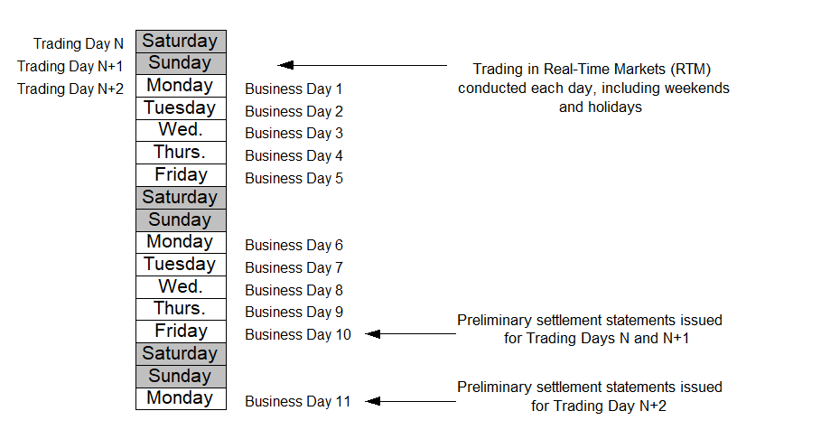

Figure 1–1: *Preliminary Settlement Statement* Timeline

The *preliminary settlement statement* has two parts:

* a *settlement statement* file: This file contains the *settlement amounts*[2] (credit or debit) for your activities in the *physical markets*. It also includes your charges for *transmission services*, which we collect from *market participants* on behalf of the transmission companies. The *settlement statement* file may also contain other charges as required by regulations.
* a companion data file: This file includes *physical bilateral contract data*, zonal prices, schedules, and *bids* and *offers*. This file also includes a number of data files relating to the *transmission services* *settlement* charges that we make available to *transmission customers* and *transmitters*, as described below. An optional data measurement file is also available.

It is your responsibility toretrieve the appropriate files from the IESO Reports site. These include the Settlement Statement Files, Real-Time Market Data Files, Participant Transmission Tariff Data Files, Transmitter Transmission Tariff Data Files and the Transmitter Reconciliation Data Files. We have identified the steps you should follow to download the *settlement statements* in the “Market Participant Graphical User Interface User’s Guide”, “Quick Take 15: Retrieving Reports via the IESO Reports Site”, and tool simulations available on the IESO Marketplace Training web pages.

You will receive a *preliminary settlement statement* for a *trading day* if you were active[3] on that day. You will not receive a *preliminary settlement statement* for a particular *trading day* if you were not active on that day.

We consider that a *preliminary settlement statement* has been issued when we have made it accessible to you on the IESO Reports site. If you fail to receive a *preliminary settlement statement* on the date scheduled in the *SSPC*, it is your responsibility to notify us via IESO Customer Relations. We will assume that you have been able to retrieve the *preliminary settlement statement* file and companion data files from the IESO Reports site unless you notify us to the contrary.

When you notify us that we have not issued a *preliminary settlement statement* for a given *trading day* in accordance with the *SSPC*, we will investigate and provide you an explanation. If necessary, we will re-issue the *preliminary settlement statement*.

Our investigation may show that:

* we issued your *preliminary settlement statement*;
* it was accessible via the IESO Reports site on the date specified in the *SSPC*; and
* you failed to properly retrieve it.

In this situation, we will not extend the period within which you can submit a *notice of disagreement*.

However, our investigation may show that:

* we failed to issue your *preliminary settlement statement* on the date specified in the *SSPC*; or
* some error occurred in our systems that made retrieval of the *settlement statement* impossible.

In this situation, we will consider that you have received your *preliminary settlement statement* on the date on which we made your statement accessible to you, and we will extend the period within which you can submit a *notice of disagreement*.

### Interpreting the *Settlement Statements* and Data Files

Both the *preliminary* and *final settlement statement* files list the *settlement amounts* (credit or debit) for your activities in the *physical markets* for a particular *trading day*. However, they may also contain missing *settlement amounts* or adjustments from prior *trading days*, which may arise from:

* adjustments that have resulted from a *notice of disagreement* (see Section 1.3.5); or
* revisions to *metering data*.

When the *metered market participant* and the *registered market participant* registered for a particular *delivery point* are two different *market participants*,

* the *registered market participant* submits *offers* and receives *dispatches* of *energy* and *operating reserve*; and
* the *settlement amounts* are applied to the *metered market participant.* The *metered market participant* also receives all supporting data with respect to all *charge types* generated for the *delivery point*.

Your *preliminary* and *final settlement statement* files show allocated quantities of *energy* withdrawn or injected by each of your *registered facilities*. The *preliminary* and *final settlement statement* files are composed of four record sections:

1. **Header Record:** The header record identifies the contents of the file. It includes information such as the statement number, statement type (physical or financial market), *settlement* type (preliminary or final), total due amount for *trading day* and the *billing period* total to date.
2. **Summary Records:** These records provide a summary of all *settlement amounts* and manual line item records in the *settlement statement* file (as set out in record sections 3 and 4 below). One record is provided for each *trading day* and for each type of *settlement amount* reflected in the line item records (see below). Each summary record identifies and describes the type of *settlement amount*, specifies the *trading day* and the total net amount for each type of *settlement amount*, and indicates whether the summary record is an adjustment record.
3. ***Settlement* Detail Records**: These records provide the details of each of your individual *settlement* line items that are created by our *settlement* system. *Settlement* detail records include information such as:

* *trading day*;
* relevant hour(s);
* time interval, which is dependent upon the type of *settlement amount*;
* *settlement amounts*;
* the applicable zone and location IDs;
* *settlement* type (preliminary or final);
* quantity of megawatt-hours (MWh) to be billed; and
* price (in $/MWh) at which the quantity of megawatt-hours will be billed.

The *trading day* stipulated for each *settlement amount* will not always match the *trading day* specified in the header record. New *settlement* details for prior *trading days* may be included in your *preliminary settlement statement* file and subsequently on a *final settlement statement*. A number of the fields on the *settlement* detail records may have different meanings when used with different *charge types*.

1. **Manual Line Item Records:** This final section of the *settlement statement* includes records that identify each of your manual line items that we have entered[4].

We will also issue a companion data file with the statement file described above. The data file provides you with the supporting data used to calculate the *settlement amounts* for a particular primary *trading day* in the *physical market*. The data file is composed of the following general sections:

1. A header record providing information such as:

* statement number;
* statement type (physical or financial);
* *settlement* type (preliminary or final); and
* primary *trading day* for the *settlement statement*;

1. Data elements used to calculate the *settlement amounts*:

* *physical bilateral contract data*;
* zonal price data (these records provide the Ontario *energy* prices);
* schedules data (these records contain the market and *dispatch* schedules data); and
* *bid* and *offer* data; and

1. *Optional Measurement Data -* this optional file contains net withdrawal or net injection values for each 5-minute trading interval for each *delivery point* defined for *physical market* charges (seeSection 1.5below).

We provide detailed information about *settlement statements* and *settlement* data files in the document“Format Specifications for Settlement Statement Files and Data Files”. You can find this document and sample files on our web-site.

You can use the reference document “IESO Charge Types and Equations” to find additional information about:

* key *settlement* variables;
* *IESO* *charge types* and equations; and
* the Harmonized Sales Tax (HST).

You can find this document on our web-site.

### Submitting Queries

The *preliminary settlement statement* provides you an opportunity to review, query and formally disagree with the charges or other elements of your statement (except as noted in Section 1.3.5 below).

If you have questions about your *preliminary settlement statement* and data files, you may submit queries to us regarding the file contents (see Section 1.8 below for contact information). Our goal is to respond to your queries within 2 *business days*.

Please note that all queries about the contents of your *settlement statement* and data files are only requests for information. We do not consider queries to represent any formal disagreement with the contents of the *settlement statement* and data files unless you submit a formal *notice of disagreement*. Therefore, we will not modify your *settlement* files if you submit a query.

We will only discuss *settlement statements* queries with contacts registered as “Settlement Statements” or “Main” contacts in our Registration (CDMS) system.

### Submitting a Notice of Disagreement

If you disagree with a *settlement amount* on your *preliminary settlement statement*, you may submita *notice of disagreement* (NOD) within four *business days* after the statement has been issued[5]*.* To submit a NOD, you must complete all required sections of the *notice of disagreement* form available through Online IESO[6]. We encourage you to provide as detailed information as you can in the *notice of disagreement* form, as incomplete submissions may result in a delay of your NOD processing.

To access the *notice of disagreement* form through Online IESO, contact your organization’s applicant representative to register and assign you as a *notice of disagreement* contact. Once you are registered, you will automatically receive a user name and password to access Online IESO.

If you disagree with an item or calculation in your *preliminary settlement statement* for a single *trading day*, you can submit a *notice of disagreement*. You may not submit a *notice of disagreement* regarding the calculation of:

* the 5-minute *energy market* price for any *dispatch interval* in a given *settlement hour*;
* the 5-minute price for any class of *operating reserve* for any *dispatch interval* in a given *settlement hour*; or
* the *hourly Ontario energy price* for a given *settlement hour*.

However, you can submit a *notice of disagreement* with respect to the manner in which any of these prices have been applied in the calculation of your *settlement amounts*.

Your *notice of disagreement* may only pertain to one item (or issue). For example, a disagreement about an AQEI (allocated quantity of *energy* injected) and RSVC (reactive support and voltage control) during the same trading period must be submitted as two separate *notices of disagreement*, so that we can investigate each item or issue. However, when a *notice of disagreement* pertains to input data for multiple *dispatch intervals* on the same *trading day*, you only need to submit one *notice of disagreement*.

The *notice of disagreement* must contain the proposed resolution and supporting documentation.

* If your *notice of disagreement* relates to *metering data*, it must include a *meter* trouble report number. You must enter the *meter* trouble report number (MTR#) under the related meter information section on the Online IESO *notice of disagreement* form. The resolution to the *meter* trouble report provides the proposed resolution and supporting documentation required.
* If your *notice of disagreement* pertainsto “Settlement Amount Adjustments Resulting from Administration of Prices Due to Failure or Planned Outages of Market Systems or Due to Publication of Incorrect Prices”[7], you must provide a completed IMO_FORM_1549 “Administrative Pricing Event Correction” as an attachment to the Online IESO *notice of disagreement* form.
* For other issues, you may provide the proposed correction and supporting documentation as an attachment to the Online IESO *notice of disagreement* form. The attachment may be in the form of a table or spreadsheet. Table 1-1: “Data Requirement for Notice of Disagreement Submission” provides a template for the data you may supply for specified *notice of disagreement* issues. If the information you provide in the *notice of disagreement* is incomplete or invalid, the *notice of disagreement* processing may be delayed.

Table 1–1: Data Requirement for Notice of Disagreement Submission

| Notice of Disagreement  Issue Type | Data Requirements | IESO Data | Participant Data |
| --- | --- | --- | --- |
| *Physical Bilateral Contract* (PBC) | Seller’s *Market Participant* ID |  |  |
| Buyer’s *Market Participant* ID |  |  |
| Location ID of PBC contract |  |  |
| Zone ID |  |  |
| Trading Hour(s) |  |  |
| Trading Interval(s) |  |  |
| NEMSC *Hourly Uplift* Component reallocation flag (Y/N) |  |  |
| ORSC *Hourly Uplift* Component reallocation flag (Y/N) |  |  |
| CAPRSC *Hourly Uplift* Component reallocation flag (Y/N) |  |  |
| CMSC *Hourly Uplift* Component reallocation flag (Y/N) |  |  |
| CRSSD *Hourly Uplift* Component reallocation flag (Y/N) |  |  |
| ORSSD *Hourly Uplift* Component reallocation flag (Y/N) |  |  |
| PBC Percent flag |  |  |
| Traded Quantity (MWh) |  |  |
| Schedules, *Bids* and *Offers, Energy , Operating Reserve*, CMSC, IOG, or day-ahead or real-time intertie failure, or day-ahead production cost guarantee, or real-time generation cost guarantee, or day ahead withdrawal *Settlement Amounts* | Location ID |  |  |
| Market Type (*Dispatch* or Market) |  |  |
| Scheduling Component (*Energy*, 10-minute spinning *Operating Reserve*, 10-minute Non-spinning *Operating Reserve,* 30-minute *Operating Reserve*, *, Schedule of Record,* Hour Ahead Pre-dispatch) |  |  |
| Trading Hour(s) |  |  |
| Trading Interval(s) |  |  |
| Scheduled Quantity (MW) |  |  |
| Tie Point Zone Number |  |  |
| Tie Point Zone ID |  |  |
| Reason Code (TLRE, TLRI, OTH, ORA, MrNh, ADQh, NY90, VGNE, VGE1, AUTO, {NULL}) |  |  |
| *Bid/Offer* Price |  |  |
| *NERC* Tag ID (if an *intertie* transaction) |  |  |

Samples of the Online IESO *notice of disagreement* form appear in Appendix B. You should send supporting materials as attachments to the form when you submit the *notice of disagreement* form to us through Online IESO.

An e-mail confirmation will be sent to you upon your *NOD* submission. The email will include a unique identifier for your submission. You can check the status and the history of your *notice of disagreement,* provide additional information requested by the IESO and respond to decision notification through the Online IESO *notice of disagreement* form. During our initial investigation of the *notice of disagreement,* wewilldetermine whether affected parties exist. For *notices of disagreement* relating *to physical bilateral contracts*, we will notify affected parties that a *notice of disagreement* has been submitted and, following its investigation, any intended actions. Where a *notice of disagreement* relates to a *meter* that is a contributor to a *delivery point* for which the submitting *market participant* is not the *metered market participant*, we will notify the affected party of the proposed resolution when we complete our investigation.

Following our investigation, we will inform you and any affected parties of our intention to undertake one of the following actions:

* if we conclude that no error has occurred in your *preliminary settlement statement*, we will take no further action;
* if we concur fully with your proposed adjustment or correction, we will adjust your corresponding *final settlement statement* if a manual calculation is not required and the deadline for issuing the *final settlement statement* has not arrived;
* if we concur fully with your proposed adjustment or correction and it requires a manual calculation or the deadline for issuing the *final settlement statement* has passed, we will apply the adjustment on the next available month-end *preliminary settlement statement*;
* if we do not concur fully with your proposed adjustment or correction but do conclude that some adjustment is required, we will adjust your corresponding *final settlement statement* if the deadline for issuing the *final settlement statement* has not arrived; or
* if we conclude that some adjustment may be required but that additional time is required to complete our investigation, we will notify you that additional time is required; in addition, within 15 *business days* after we’ve issued the corresponding *final settlement statement*, we will do one of the following:
* if we conclude that no error has occurred in your *preliminary settlement statement*, we will take no further action;
* if we concur fully with your proposed adjustment or correction, we will apply the adjustment on your next available month-end *preliminary settlement statement* accordingly; or
* if we do not concur fully with your proposed adjustment or correction but do conclude that some adjustment is required, we will advise you of the changes we propose to make; we will also adjust your next available *preliminary settlement statement* accordingly.

We will notify you and any affected parties involved of our intended actions. We also provide you with an opportunity to respond to our intended actions by entering a response in the Online IESO *notice of disagreement* form. We consider any response we receive from you and affected parties prior to closing the *notice of disagreement*.

If, with reasonable efforts, we are unable to resolve the *notice of disagreement* with you, we will issue the corresponding *final settlement statement* or the next available *preliminary settlement statement* incorporating our decision. You can then pursue the disagreement through the dispute resolution process[8].

You must settle an *IESO* *invoice* regardless of whether you have raised a *notice of disagreement* against a *settlement statement* addressed by that *invoice[9]*.

If you do not agree with ourdecision on your *notice of disagreement,* you may raise a dispute through the dispute resolution process. Disputes relating to *settlement statements* must be raised within 20 *business days* after the *final settlement statement* has been issued for the *trading day* to which the dispute pertains.

### Issuing the *Final Settlement Statement*

We issue a *final settlement statement* on the date specified in the *SSPC*. This is currently 10 *business days* after we issue the *preliminary settlement statement[10]*. The *final settlement statement* is in the same format as the *preliminary settlement statement* and is available by 17:00 ESTon the issue date. You may download your *final settlement statement* from the IESO Reports site.

Your *final settlement statement* must include:

* all the information in the *preliminary settlement statement*; and
* any adjustments resulting from the *notice of disagreement* process that were resolved before the *final settlement statements* were issued; these adjustments appear as a credit or debit on your *settlement statement* and on the *settlement statement* of each affected *market participant*.

You may not submit a *notice of disagreement* for the *final settlement statement*. However, in some cases an item or calculation in the *final settlement statement* may either:

* consist of an adjustment to the corresponding *preliminary settlement statement* as a result of a *notice of disagreement*, but does not reflect the agreed-to adjustment; or
* differ in amount from the same item or calculation set forth on the corresponding *preliminary settlement statement*, but the item or calculation on the *final settlement statement* does not have an adjustment flag indicating that an adjustment has been made.

In such cases, you may attempt to resolve the disagreement with us on an informal basis, separate from the formal *notice of disagreement* process. If we cannot resolve the disagreement with you, you may submit the matter to the dispute resolution process and may request, in the *notice of dispute,* that the *arbitrator* order that weundertake a *settlement statement re-calculation*.

If you disagree with any other aspect of the *final settlement statement*, you may submit the matter to the dispute resolution process and may request, in the *notice of dispute,* that we undertake a *settlement statement re-calculation*.

You must submit all *notices of dispute* relating to an item or calculation on a *settlement statement* within 20 *business days* after the *final settlement statement* is issued for that item or calculation.

### Data Files for Transmission Services Charges[11]

The *preliminary settlement statement* contains a number of charges relating to *transmission services*, which we collect on behalf of transmission companies[12]. We also make a number of data files available to the *transmission customer*[13] or the *transmitter*, as appropriate, via the IESO Reports site. These data files allow *transmission customers* and *transmitters* to validate the *transmission service charges* that appear on their *settlement statement*.

##### ***Transmission Customers***

We provide two data files with information relevant to *transmission customers*.

* The “Participant Transmission Tariff Data File[14]” is available to *transmission customers*. This file contains the hourly measurements for each *delivery point* defined for transmission network charges or transmission *connection charges* associated with a specific *market participant*.
* The “Transmission Tariff Peak System Demand Data Report” is available to all *market participants*. This report provides the sum of the hourly measurements across all *delivery points* defined for transmission network charges for each Trading Date / Hour in the reporting month. This report provides transparency to *market participants* regarding the measurements that form the basis for our determination of the peak system *demand* used to calculate *transmission charges*[15]*.*

##### ***Transmitters***

We provide two data files with information relevant to *transmitters*:

* the “Transmitter Transmission Tariff Data File” which contains:
  + the hourly measurements for every *delivery point* defined for transmission network charges; or
  + transmission *connection charges* for which the *transmitter* is associated as the *transmitter* during the *meter* registration process; and
* the “Transmitter Reconciliation Data File” which contains debit charge details (the *transmitter* uses the information in this file to verify that the *transmission tariff* credits reflect the appropriate collection of *transmission tariff* charges from every *transmission customer* at every *transmission* *delivery point* as specified by the *transmitter*[16]).

## Settlement Delays

### Delay in Issuing Settlement Statements

We may delay issuing your *preliminary settlement statement* and the subsequent *final settlement statement* for a *trading day* from the dates specified in the *SSPC* where we determine that significant inaccuracies exist. In such a situation, we will *publish* a notice of delay that details:

* the date on which your *preliminary settlement statement* will now be issued;
* the date by which you must raise a *notice of disagreement* with regard to the *preliminary settlement statement,* which will be four *business days* after the date that the *statement* is issued[17];
* the date on which your *final settlement statement* will now be issued; and
* whether we intend to invoke the estimated *invoice* process[18].

If we experience a delay in issuing a *preliminary settlement statement*, it may impact the date that we issue the subsequent *final settlement statement* for that *trading day* as well as *preliminary* and *final settlement statements* for subsequent *trading days*. Where this is the case, we will ensure that the notice of delay applies to the *settlement statements* for each *trading day* impacted by the delay.

The notice of delay will be *published* on our web-site. The notice of delay will also be sent by email to the *settlements* contact of all *market participants*.

### Failure of Communication System

If the communication system fails so that we cannot issue *settlement statements* using the *electronic information system*, we will notify your *settlements* contact (assuming network communication is still functional)[19].We will assess the value and practicality of issuing statements via an alternate means, considering the nature and extent of the communication problem and the forecast time to restore service. If an alternate means is required, we will specify what it is, and we will issue statements in the same electronic file format that is currently used. These alternate modes of transmission may include:

* compact discs via courier; or
* e-mail (if the *market participant* accepts the confidentiality risks and if the size of the attachment file is feasible).

As is required, we will communicate the information related to Section 1.4.1 and the communication method we will use.

## Optional Measurement Data Records

You can request that optional measurement data records[20] be included in your *settlement* data file. These records contain net withdrawal or net injection values for each 5-minute trading interval for each *delivery point* defined for *physical market* charges.

You should be aware that requesting these optional records will increase storage requirements and download times of the data file.

If you are interested in this option, you should send a request to [IESOCustomerRelations@ieso.ca](mailto:IESOCustomerRelations@ieso.ca), indicating that you would like optional measurement data records to be included in your *settlement* data file. Your“Settlement”, “Main”, or “Real Time Market Manager” contact identified in our Registration system must send the request

## Special Settlement Activities

Special exemptions, rebates and *settlement* programs are available to eligible *market participants*. We describe them in the following sub-sections.

### Generation Station Service Rebate

Some *generation facilities* in the *IESO-administered markets* consume *energy* as *generation station service*. *Metered market participants* for certain *generation facilities* are eligible for a reimbursement of the *hourly uplifts* and non-hourly *settlement amounts* related to AQEW consumed as *generation station service*. Refer to Chapter 9, Sections 2.1A.9-2.1A.14 of the *market rules* to find the eligibility requirements and the specific conditions under which this rebate applies.

If you[21] believe that your *generation facility* is eligible for a *generation station service* rebate, you should:

* download IMO_FORM_1419 “Application for Designation of a Facility for Generation Station Service Rebate” from our web site;
* complete all applicable sections; and
* submit the form to us.

We will:

* review your application;
* request additional information in order to assess the application, if necessary;
* determine if your *generation facility* meets the requirements for the rebate designation; and
* notify you in writing of our determination.

If you meet the requirement for the rebate designation, we will adjust the *hourly uplifts* and non-hourly *settlement amounts* that may have accumulated at the *generation station service* *delivery point* during the periods where the eligible *generation facility* was a net injection of *energy* into the *IESO-controlled grid*.

Reimbursement amounts are calculated at month-end and applied to the last *trading day* of the month as a manual line item on the *preliminary settlement statements* and the *final settlement stat*ement for each *generation facility* as *charge type* 119 – Station Service Reimbursement Credit.

The offsetting *charge type* 169 – Station Service Reimbursement Debit is included on the *preliminary settlement statement* and the *final settlement statement* of all load customers for the last *trading day* of the month.

### 1.6.1A Electricity Storage Station Service Rebate

*Electricity storage facilities* in the *IESO-administered markets* consume *energy* as *electricity storage station service*. *Metered market participants* for certain *electricity storage facilities* are eligible for a reimbursement of the *hourly uplifts* and non-hourly *settlement amounts* related to AQEW consumed as *electricity storage station service*. Refer to Chapter 9, Sections 2.1A.13A and 2.1A.13A.3 of the *market rules* to find the eligibility requirements and the specific conditions under which this rebate applies.

If you[22] believe that your *electricity storage facility* is eligible for this rebate, you should:

* download IMO_FORM_1419 “Application for Designation of a Facility for Generation Station Service Station Service Rebate” from our web site;[23]
* complete all applicable sections; and
* submit the form to us.

We will:

* review your application;
* request additional information in order to assess the application, if necessary;
* determine if your *electricity storage facility* meets the requirements for the rebate designation; and
* notify you in writing of our determination.

If you meet the requirement for the rebate designation, we will adjust the *hourly uplifts* and non-hourly *settlement amounts* that may have accumulated at the *electricity storage station service delivery point* during the periods where the eligible *electricity storage facility* was a net injector of *energy* into the *IESO-controlled grid*.

Reimbursement amounts are calculated at month-end and applied to the last *trading day* of the month as a manual line item on the *preliminary settlement statements* and the *final settlement stat*ement for each *electricity storage facility* as *charge type* 119 – Station Service Reimbursement Credit.

The offsetting *charge type* 169 – Station Service Reimbursement Debit is included on the *preliminary settlement statement* and the *final settlement statement* of all load customers for the last *trading day* of the month

### Intentionally Left Blank

1. The section ‘Debt Retirement Charge (DRC)’ has been removed. The archived section can be found in Appendix E.14.

### Intentionally Left Blank

1. The section ‘OPG Rebate Requests for Additional Payments or Returns’ has been removed The archived section can be found in Appendix E.8.

### Intentionally Left Blank

1. The section ‘Real-time Generation Cost Guarantees’ has been removed effective August 1, 2017. Content relating to the GCG program can be found in Market Manual 4: Market Operations Part 4.6: Real-Time Generation Cost Guarantee Program (PRO_324). The archived section can be found in Appendix E.7.

### Administrative Pricing Event

This section applies only when an “Administrative Pricing Event” does not exceed 48 *dispatch intervals* and the *market schedules* and prices were established by the “copy forward/back” methods[24].

For situations where *administrative prices* were applied beyond 48 *dispatch intervals*, please refer to “Market Manual 4.3: Real Time Scheduling of the Physical Markets”.

Where an “Administrative Pricing Event” does not exceed 48 *dispatch intervals*, some *market participants* may not be adequately compensated[25]. Should this occur, you may only submit a *notice of disagreement* within four *business days* after your *preliminary settlement statement* has been issued to request *settlement amount* adjustments.

* For the case where you receive negative CMSC amounts, and all conditions stated in Chapter 7, Sections 8.4A.13 and 8.4A.14 of the *market rules* are met, we will apply *settlement amount* adjustments that offset the original negative CMSC amounts. The adjustments will appear under *charge types* 105, 106, 107 or 108 on the corresponding *final settlement statement.* If the deadline for issuing the *final settlement statement* has passed, the adjustment will appear on the next available month-end *preliminary settlement statement.*
* For the case where you were not compensated enough in the net *energy market settlement*, and all conditions stated in Chapter 7, Section 8.4A.15, 8.4A.16 of the *market rules* are met, we will apply additional compensation adjustments, based on the equations found in the Chapter 7, Section 8.4A.16, as the case may be. Compensation will appear under *charge type* 113 on the corresponding *final settlement statement.* If the deadline for issuing the *final settlement statement* has passed, the adjustment will appear on the next available month-end *preliminary settlement statement,* andit will appear with a separate item listed for each *delivery point,* and *dispatch interval.*  In the same *preliminary settlement statement,* we will recover all paid compensations from the market (on a pro-rata basis across all withdrawals), under *charge type* 163.

Sections 8.4A.13 and 8.4A.15 of the *market rules* further specify that we are not required to perform the analysis if either the CMSC adjustment or the additional compensation adjustment is not material.

The total hourly CMSC adjustment or the total hourly additional compensation for a given *delivery* *point* must equal or exceed a materiality threshold amount of $ 50.00 per hour, per *delivery point* and the submission total must exceed $400.00 for each administrative pricing event request.

Specifically, in cases where the CMSC adjustment request or the additional compensation request falls below the threshold amount, we will not perform any further analysis and will not apply any adjustments.

Please refer to the Section 1.5 “Submitting a *Notice of Disagreement”* in this *market manual* for a description of guidelines and supporting documentation (the *market participant* must submit IMO_FORM_1549 along with a *notice of disagreement*) that must be provided as part of the *notice of disagreement* process*.*

### Transmission Service Charges for Embedded Generation

If, as a host *transmission customer*, you have an *embedded* *generation facility* that:

* was approved after October 30, 1998;
* is not separately registered as a *generation facility* in the *IESO-administered markets*;
* meets the applicable Ontario Transmission Rate Schedule requirement; and
* is rated at greater than or equal to 1 MW (2 MW for renewable *generators*[26]) and less than 20 MW,

then you may choose to meet the existing wholesale *metering installation* standards or to use the alternative standard in Chapter 6 Section 4.5 of the *market rules*. The alternative standard allows the host *transmission customer* to register a *meter point* for the *embedded generation* *facility* without a corresponding wholesale physical *meter*.

A *transmission customer* that chooses the alternative *metering installation* standard for *embedded generation* must determine the annual adjustment dollar value for the applicable *transmission service charges*. The adjustment amount must be agreed to by the *transmitter* and submitted to us. In the event that we do not receive this information in a timely manner, we will use the installed *maximum continuous rating* (as registered) for the *embedded generation facilities* to determine an adjustment amount.

#### Calculation Methodology

Line and transformation connection service charges need to be calculated monthly for all *delivery points* with *embedded generation facilities* registered under the Alternative Metering Installation Standards for Embedded Generation Facilities (Chapter 6, Section 4.5 of the *market rules*).

On a monthly basis, the host *transmission customer* will:

* download the *participant* *transmission tariff* data file;
* add the hourly generation values for the *embedded generator* to the hourly demand data for the *delivery point* associated with the *embedded generation*; and
* determine the new monthly maximum hourly peak value for the *delivery point* and compare it to the settled monthly maximum hourly peak value; if the new peak is higher, then:
* calculate the incremental line connection service charges (if applicable) by multiplying the line connection tariff by the incremental peak value; and
* calculate the incremental transformation connection service charges (if applicable) by multiplying the transformation connection tariff by the incremental peak value.

On an annual basis, the host *transmission customer* must sum all monthly line and transformation connection service charges and obtain agreement of the *transmitter* to the proposed adjustment, if any. Submit the totals to us via the Submit Settlement Claim action available through Online IESO within the month of April following calendar year end.

### Regulated Price Plan, Regulated Generation, NUG Payments and Newly Contracted Generation

The *Electricity Restructuring Act, 2004* (Bill 100) introduced a number of important changes to the electricity market that affect both the *IESO* and *market participants*. These changes include:

* the establishment of the former *Ontario Power Authority* (*OPA*);
* a regulated payment to *generators* prescribed byregulations;
* payments to *Ontario Electricity Finance Corporation (OEFC)* for non-utility *generator* (NUG) contract amounts;
* payments to the IESO (former *OPA)* for renewable generation and for clean generation and demand-side projects awarded as a result of a Request for Proposal (RFP) process;
* the establishment of regulated *consumer* prices beginning in April 2005, known as the Regulated Price Plan (RPP) (RPP prices are set by the *Ontario Energy Board (OEB)* from time to time); and
* the creation of a “Global Adjustment” amount, which is the difference between the contract amounts and market payments for OPG regulated generation, NUG generation and RFP contracted generation and demand-side management.

Implementing these changes required the creation of new *charge types* within the IESO’s *settlements* system. The *charge types* are listed in the “IESO Charge Types and Equations” document and are comprised of charges that are payable to or from *market participants* with, in most cases, the corresponding offsets payable by the IESO.

Ontario Regulation 398/10 made under the *Electricity Act, 1998* which amended O. Reg. 429/04 significantly changed the Global Adjustment, creating two classes of *market participants* with different approaches to the distribution of the global adjustment costs. The regulation further added the costs related to *distributor* developed conservation and demand management programs to the Global Adjustment pool.

#### Regulated OPG Nuclear and Baseload Hydroelectric Generation

Under the *Electricity Restructuring Act, 2004* and subsequent regulations, OPG’s nuclear and baseload hydroelectric assets will receive a regulated price. OPG’s regulated assets include:

* DeCew Falls I and II;
* the Niagara River plants – Sir Adam Beck I, II, and Pumped Generating Station;
* the R.H. Saunders Hydroelectric Generating Station on the St. Lawrence River;
* the Pickering Nuclear Generating Station consisting of Pickering A and Pickering B; and
* the Darlington Nuclear Generating Station.

We have created two *charge types* to implement the adjustments for nuclear generation and for baseload hydroelectric generation. The adjustments are the difference between:

* the *market prices* paid to regulated hydroelectric generation and nuclear generation using the existing *settlements* process; and
* the regulated fixed rate that the regulated nuclear generation and a portion of output of the regulated hydroelectric generation should receive.

In essence, the adjustment is the difference between the amount OPG would have received at *market prices* and the amount calculated at regulated prices. The *settlement* of the hydroelectric generation assets includes an adjustment based on the average *market prices* for the month. We use c*harge type* 144 “Regulated Nuclear Generation Adjustment Amount” to adjust payments to OPG with respect to the regulated nuclear generating stations, and *charge type*145 “Regulated Hydroelectric Generation Adjustment Amount” to adjust payments to OPG with respect to the regulated hydroelectric generating stations.

Amounts calculated under *charge types* 144 and 145 will be set off against the IESO*,* using the corresponding *charge types* 194 and 195 respectively. The regulated nuclear generation amounts (i.e., *charge* *types* 144 and 194) are automatically generated by CRS and appear as *settlement* details on both OPG’s and the IESO’s *preliminary* and *final settlement statements*. The regulated hydroelectric generation amounts (i.e., *charge types* 145 and 195) are calculated monthly and included as manual line items on both OPG’s and the IESO’s *settlement statements*.

#### OEFC Adjustment

Section 78.2 of Bill 100 states that the *OEFC* will be paid contract amounts for all NUG output. We use current *settlemen*t processes to pay *OEFC* at wholesale *market prices* for all NUG output delivered to the *IESO-controlled grid*. The difference between the monies paid out by *OEFC* to all NUGs and the monies received from us and *distributors* (embedded NUGs) for all NUG output is submitted to us on a monthly basis using the settlement form “NUG Adjustment Amount Information” available within Online IESO.

The monthly amount submitted by *OEFC* is included as a manual line item on *OEFC’s* *preliminary* *settlement statement* and *final settlement statement* for the last *trading day* of the month. Any amount submitted as a post final adjustment will be settled on the *preliminary settlement statement* for the last *trading day* of the month. The *charge type* used is 143 “NUG Contract Adjustment Settlement Amount”.

To balance the market, the corresponding setoff, *charge type* 193 “NUG Contract Adjustment Balancing Amount”, is entered as a manual line item on the IESO’s *preliminary* *settlement statement* and *final settlement statement* for the last *trading day* of the month.

#### Clean Generation and Demand-Side Projects Settlement

The IESO has entered into procurement contracts with certain suppliers for clean *energy* supply and demand-side management or demand response, to promote the use of clean *energy* and to assist the government in achieving its goals in electricity conservation.

The difference between the contracted price and the wholesale *market price*, with respect to the clean generation or load reduction contracts, is settled by the *IESO*. It is included as a manual line item on the IESO’s *preliminary settlement statement* and *final settlement statement* for the last *trading day* of the month. The *charge type* is 1400 “OPA Contract Adjustment Settlement Amount”.

The corresponding setoff, *charge type* 1450 “*OPA* Contract Adjustment Balancing Amount”, is entered as a manual line item on the *IESO’s preliminary* *settlement statement* and *final settlement statement* for the last *trading day* of the month to balance the market.

#### Renewable Generation Settlement

The *IESO* has entered into procurement contracts for renewable generation with certain suppliers. The difference between the contracted price and the wholesale *market price*, with respect to the renewable generation contracts, is settled by the *IESO*.

#### Renewable Generation Connection Compensation

Details relating to the implementation of a new cost recovery framework established by the Green Energy Act are set out in Ontario Regulation 330/09. This new framework allows local distribution companies to recover certain costs associated with the connection of new renewable generation to their local *distribution system* from all electricity *consumers* in Ontario (i.e., renewable generation contracted after the *OEB* issued its revised cost responsibility rules on October 21, 2009). These costs are approved by the *OEB*.

The portion of aggregate renewable generation connection compensation that you are charged is determined by your net volume of electricity withdrawn (AQEW) from the *IESO-controlled* *grid* during the month, plus, if you are a licensed *distributor*, the volume of embedded generation you are reporting using the settlement form available within Online IESO, divided by the sum of all amounts (net electricity withdrawn and embedded generation) for every *market participant*. (The volume of electricity supplied to Fort Frances Power Corporation Distribution Inc. by Abitibi-Consolidated Inc. is excluded from the calculation).

The portion of aggregate renewable generation connection compensation that each eligible *distributor* receives is determined by the *OEB*.

*Charge type* 1413 “Renewable Generation Connection - Monthly Compensation Settlement Credit” will appear on the *preliminary* *settlement statement* and *final settlement statement* of each eligible local distribution company for the last *trading day* of the month.

The corresponding debit, *charge type* 1463 “Renewable Generation Connection - Monthly Compensation Settlement Debit”, is included on the *preliminary* *settlement statement* and *final settlement statement* of all load customers for the last *trading day* of the month to balance the compensation credit.

#### Conservation and Demand Management Programs

Under section 78.5 of the *Ontario Energy Board Act, 1998*, the *IESO* must make payments to a *distributor* (or LDC) for amounts approved by the *OEB* relating to conservation and demand management (CDM). Specifically, these payments relate to the recovery of costs for Board-approved CDM initiatives that are undertaken by LDCs to meet the CDM targets set out in their licenses, and to associated performance incentives. The *IESO* will make these payments, as directed by the *OEB*, through *charge type* 1416 “Conservation and Demand Management – Compensation Settlement Credit”. These payments will be recovered through the Global Adjustment.

*Charge type* 1416 “Conservation and Demand Management – Compensation Settlement Credit” will appear on the *preliminary settlement statement* and *final settlement statement* of each eligible LDC for the last *trading day* of the month.

#### Regulated Price Plan

The Regulated Price Plan is an *OEB-*mandated pricing mechanism for low-volume and designated *consumers*. There are two distinct Regulated Price Plans – one for customers with conventional *meter* systems and another for customers with time-of-use (or “smart”) *meters*.

The conventional *meter* plan sets a lower fixed price for *energy* consumption up to a monthly threshold amount, with consumption above this level at a higher price. The *OEB* adjusts both the threshold amount and prices every six months. The two six-month periods are referred to as the winter season (November 1 – April 30) and the summer season (May 1 – October 31).

The smart *meter* plan establishes prices for *energy* based on when the *energy* is consumed. The basic unit is a week. As with the conventional *meter* RPP, the *OEB* adjusts prices every six months to coincide with the winter and summer seasons. *Energy* consumption during a week falls into three categories with respect to both prices and consumption times.

The three categories are:

* On-peak;
* Mid-peak; and
* Off-peak.

1. On-peak times reflect those times on weekdays when average *demand* is highest. The on-peak periods are weekdays from 7:00 to 11:00 and from 17:00 to 21:00 in the winter and from 11:00 to 17:00. in the summer.
2. Mid-peak consumption refers to the shoulder periods between on-peak and off-peak times. The mid-peak periods are weekdays from 11:00 to 17:00 in the winter and weekdays from 7:00 to 11:00 and from 17:00 to 21:00 in the summer. All other times (weekdays from 21:00 to 7:00, on weekends and holidays) are off -peak.
3. Generally, off-peak times refer to consumption overnight on weekdays, and on weekends and holidays.

*Distributors* must calculate the difference between the payments received from regulated *consumers* subject to RPP and the wholesale cost of power, including the amount of the Global Adjustment allocated to the RPP portion of a *distributor*’s load. Submissions by *distributors* to us are processed as manual line items in *settlement* *statements* and monthly *invoices*. We use *charge type 142* “Regulated Price Plan Settlement Amount”for processing *distributor* submissions. RPP eligible *consumers* are defined by regulation.

*Distributors* that are *market participants* must submit the information to us online noting the amount of the claim for each category. The settlement form available within Online IESO is used to submit all information required from the *distributor*, embedded *distributor* or participating *retailer* to balance the market. *Settlement* data must be submitted to us monthly, as soon as possible after the last *trading day* of the month and no later than the 4th *business day* after the last *trading day* of the month. We process this information so that the *preliminary settlement statement* for the last *trading day* of the month indicates a *charge type* 142, with the category noted in the Comments field. If any changes are required to the amounts submitted during the preliminary submission period, final adjustments can be submitted during the 11th to 14th *business day* after the last *trading day* of the month. The adjustments will be reflected on the *final settlement statement* for the last *trading day* of the month. Furthermore, post final adjustments can be submitted through Online IESO for any previous settlement period. Any amount submitted as a post final adjustment will be settled on the *preliminary settlement statement* for the last *trading day* of the current settlement month.

We adjust *settlement amounts* for directly *connected* *consumers* who are eligible for the RPP for the net volume of electricity withdrawn from the *IESO-controlled grid* not covered by *physical bilateral contracts*.

The corresponding setoff, *charge type* 192 “Regulated Price Plan Balancing Amount” is entered as manual line items on the IESO’s *preliminary* *settlement statement* and *final settlement statement* for the last *trading day* of the month to balance the market.

**Declaration Required for Designated Consumers**

“Regulations 435/02, 43/04 and 433/02” define ‘designated *consumer*’. Wholesale *market participants* who qualify as ‘designated *consumers*’, must inform usby submitting the on-line form “Declaration of Designated Consumer” located on the *IESO* Gateway. *Market participants* who satisfy us that they qualify as designated *consumers* are settled at the RPPrate.

**Opt-Out Provisions**

Eligibility of *market participants* to opt out of the RPP is based on the following provision:

* directly-*connected* load-consuming *market participants* meeting the regulated definition of “low-volume *consumers*” or “designated *consumers*” may opt out of RPP for all *registered facilities* for which they play the role of a *metered* *market participant* provided the *facilities* have interval metering.

*Market participants* must inform us in writing if they wish to exercise this option.

#### Global Adjustment

We make adjustments to settlement amounts monthly to reflect the portion of the Global Adjustment allocated to each *market participant* with load in Ontario. The total Global Adjustment for a month is the sum of the charges shown below in Table 1.2.

For further certainty, and without otherwise affecting its interpretation, for the purposes of this section 1.6.7.8, references to *load facilities* includes the withdrawing component of *electricity storage facilities.*

Table 1–2: Global Adjustment Charge Types

| **Charge Type #** | **Charge Type Name** |
| --- | --- |
| 143 | OEFC Adjustment Settlement Amount |
| 144 | Regulated Nuclear Generation Adjustment Amount |
| 145 | Regulated Hydroelectric Generation Adjustment Amount |
| 1400 | OPA Contract Adjustment Settlement Amount |
| 1410 | Renewable Energy Standard Offer Program Settlement Amount |
| 1411 | Clean Energy Standard Offer Program Settlement Amount |
| 1412 | Feed-In Tariff Program Settlement Amount |
| 1414 | Hydroelectric Contract Initiative Settlement Amount |
| 1416 | Conservation and Demand Management – Compensation Settlement Credit |
| 1418 | Biomass Non-Utility Generation Contracts Settlement Amount |
| 1419 | Energy from Waste (EFW) Contracts Settlement Amount |
| 1421 | Capacity Agreement Settlement Credit |
| 1422 | Capacity Agreement Penalty Settlement Amount |
| 1423 | Energy Sales Agreement Settlement Credit |
| 1424 | Energy Sales Agreement Penalty Settlement Amount |
| 1425 | Hydroelectric Standard Offer Program Settlement Amount |

**Market Participant Load Facility Classification**

Your portion of the Global Adjustment depends on the amount of load you withdraw from the *IESO controlled grid* at each of your *load facilities*. There are two methods for the distribution of the Global Adjustment.

**Method 1A - Class A Market Participant Load Facilities**

Class A *Market Participant* *Load Facilities* are defined by the following criteria:

* The *market participant* is neither a licensed *distributor* nor a regulated *consumer.*
* The *market participant* was a *market participant* throughout the applicable Base Period.
* The total volume of electricity, as determined by the *IESO*, supplied by the *market participant* to the *IESO*-controlled grid or to the distribution systems of licensed *distributors* during the applicable Base Period did not exceed the total volume of electricity the *market participant* withdrew from the *IESO-controlled grid* or the distribution systems of licensed *distributors* during that Base Period.
* The maximum hourly demand[27] for electricity for each *load facility* in a month, determined independently, exceeds an average of 5 megawatts for the applicable Base Period.

**Method 1B – Optional Class A Market Participant Load Facilities**

For Adjustment Periods commencing on or after July 1, 2017, optional Class A *Market Participant* *Load Facilities* are defined by the following criteria:

* The *market participant* is neither a licensed *distributor* nor a regulated *consumer.*
* The *market participant* was a *market participant* throughout the applicable Base Period.
* The *market participant* elects to be a Class A *market participant* for the *load facility* for the applicable Adjustment Period, or has made such an election for a prior Adjustment Period and the election has not been revoked. Written notice of the election must be made to the IESO no later than June 15 of the calendar year in which the Adjustment Period begins.
* The total volume of electricity, as determined by the *IESO*, supplied by the *market participant* to the *IESO*-controlled grid or to the distribution systems of licensed *distributors* during the applicable Base Period did not exceed the total volume of electricity the *market participant* withdrew from the *IESO-controlled grid* or the distribution systems of licensed *distributors* during that Base Period.
* The maximum hourly demand for electricity for each *load facility* in a month, determined independently, exceeds an average of 1 megawatt but is less than or equal to an average of 5 megawatts for the applicable Base Period.

**Global Adjustment – Base and Adjustment Periods**

There are two periods that relate to the eligibility and *settlement* of the Global Adjustment for Class A *Market Participant Load Facilities*. The Base Period is the period during which the load pattern of the *market participant* will determine potential Class A qualification. The Adjustment Period is the *settlement* period over which that Class A qualification will be applied. The Base Periods and related Adjustment Periods for 2012 and beyond are shown below:

|  |  |
| --- | --- |
| **Base Period** | **Adjustment Period** |
| **May 1, 2011 to April 30, 2012** | **July 1, 2012 to June 30, 2013** |
| **May 1, 2012 to April 30, 2013** | **July 1, 2013 to June 30, 2014** |
| **May 1, (Year X) to April 30, (Year X+1)** | **July 1, (Year X+1) to June 30, (Year X+2)** |

**Method 2 - Class B Market Participant Load Facilities**

All other *Market Participant Load Facilities* that consume electricity, excluding licensed *distributors*, are considered Class B load.

**Exception**

All registered *load facilities* associated with *market participants* that were deemed to be Class A in the May 1, 2011 to April 30, 2012 Base Period will be treated as Class A if the aggregated maximum hourly demand for electricity of all registered *load facilities* in a month exceeds an average of 5 megawatts in future Base Periods.

**Opt Out**

*Market Participant Load Facilities* eligible for Class A treatment based on the eligibility criteria noted above for any Base Period may elect to deem the *load facility* as Class B for the related Adjustment Period. This election must be made annually via written notice to the *IESO* on or before June 15th in any year.

**Global Adjustment - Settlement**

**Class A Market Participant Load Facilities and Distributors with Class A Consumers**

Class A *market participant load facilities* and *distributors* with Class A *consumers* will be apportioned their share of the total Global Adjustment amount each month in a defined Adjustment Period based on a “Peak Demand Factor” calculation based on their load pattern in the related Base Period.

The *IESO* will determine, for the appropriate Base Period, the five hours where *market participants* (including *distributors*) withdrew the greatest total net volume of electricity from the *IESO-controlled grid*. These hours must be on different days. The determination of the peak hour will be based on hourly Allocated Quantity of Energy Withdrawn (AQEW) from the *IESO-controlled grid* net of several adjustments. The adjustments include:

1. the net volume withdrawn at the Sir Adam Beck Pump Generating Station;
2. the net volume withdrawn by Fort Frances Power Corporation under its *physical bilateral contract* with Abitibi-Consolidated Hydro Limited Partnership; and
3. the net volume withdrawn by *market participants* in the course of providing *ancillary services* in accordance with the *market rules*.

The Peak Demand factor for a Class A *market participant* will be based on their consumption coincident with the five peak hours identified for the Base Period. The Peak Demand Factor will be calculated as follows:

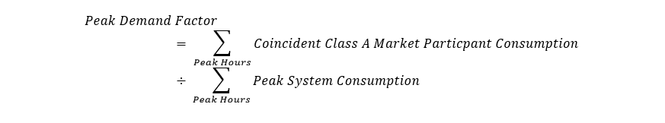

Where

Peak System Consumption for the Peak Hour

= AQEW + *Embedded Generation offsetting the load of* licensed *distributors* - Beck Pump Generating Station AQEW - Fort Frances Power Corporation *physical bilateral contract* amount – AQEW related to the provision of *ancillary services* as defined in the *market rules*.

The coincident peak consumption amounts for Class A *market participants* or for *distributors* with Class A *consumers* will be determined from AQEW values derived for *settlement* in the Base Period. *Distributors* will be asked to submit the amount of Class A *consumer* load coincident with peak hours at the end of the appropriate Base Period along with the *embedded generation* that has offset the load in their distribution territory coincident with the peak hours. Note:

* Injections to the *IESO-controlled grid* during the peak hours should not be included in the *distributor*’s *embedded generation* data submission to the *IESO*.
* *Distributors* are not required to provide the *IESO* with peak hour volumes for *generation facilities* that are eligible for net metering (Ontario Regulation 541/05) if that volume has offset the related load. If the volume is greater than the related load, the amount injected to the *distribution system* should be submitted to the *IESO*.
* The submission includes *embedded generation* volumes for all non-contracted *generation facilities* and all contracted *generation facilities* (Renewable Energy Standard Offer Program, Hydroelectric Contract Initiative and Feed-In Tariff Program). The contracted *embedded generation* volumes are reported for the peak hour they are metered, regardless of the contract approval status.

The Global Adjustment assigned to a Class A *market participant* *load facility* or *distributors* with Class A *consumers* for a month in the Adjustment Period will be determined by multiplying the Peak Demand Factor by the total Global Adjustment for the month.

**Class B Market Participant Load Facilities and Distributors**

Class B *market participant load facilities* will be assigned a portion of the total Global Adjustment for any month based on the net volume of electricity withdrawn from the *IESO-controlled grid* for the month.

All *generators* will be considered Class B *market participant load facilities* when consuming electricity from the *IESO controlled grid*. Some *generators* that consume electricity either when providing *ancillary services* or for consumption related to the Beck Pump Generating Station will have this amount netted off their total consumption.

*Distributors* will be assigned a portion of the Global Adjustment based on the net volume of electricity withdrawn from the *IESO-controlled grid* for the month plus embedded generation that has offset the load in their territory less Class A *consumer* consumption in the month.

The *distributor* data submission to the *IESO* for each month includes embedded generation offsetting load, total embedded generation, Class A *consumer* consumption, and electricity storage injections/withdrawals. The data submission must be completed by the fourth *business day* after the month-end, using the” Embedded *Generation Energy Storage and Class A Load” [28]* form available within Online IESO. If any changes are required to the amounts submitted during the preliminary submission period, final adjustments can be submitted during the 11th to 14th *business day* after the last *trading day* of the month. The adjustments will be reflected on the *final settlement statement* for the last *trading day* of the month. Note:

* *Distributors* should not submit injections/generation or withdrawal/load from IESO *market participants*.
* The submission must include embedded generation volumes for all non-contracted *generation facilities* and all contracted *generation facilities* (Renewable Energy Standard Offer Program, Hydroelectric Contract Initiative and Feed-In Tariff Program). The contracted embedded generation volumes are reported for the month they are metered, regardless of the contract approval status.
* *Distributors* are not required to provide the *IESO* with volumes for *generation facilities* that are eligible for net metering (Ontario Regulation 541/05) if that volume has offset the related load. If the volume is greater than the related load, the amount injected to the *distribution system* should be submitted to the *IESO*. This applies to the submission of embedded generation offsetting load, total embedded generation and electricity storage injections/withdrawals.
* Injections to the *IESO-controlled grid* should not be included in the *distributor*’s embedded generation offsetting load data submission to the *IESO*.

The total amount of Global Adjustment assigned to all Class B *market participants* and licensed *distributors* will exclude the Global Adjustment allocated to Class A *market participants* and licensed *distributors* with Class A *consumers*.

The total Class B consumption for the month will be calculated as follows:

$Total Class B Load=Total AQEW+$ Embedded Generation offsetting the load of licensed *distributors* - Beck Pump Generating Station AQEW - Fort Frances Power Corporation under its *physical bilateral contract* amount – AQEW related to providing *ancillary services* – AQEW of Class A *market participant load facilities* and LDC Class A *consumers.* –Electricity Storage Injections from *Class B market participant* and *consumer* electricity storage facilities.

**Class B Rates**

The *IESO* will be calculating and posting a Class B Global Adjustment rate for *distributors* to use in settling with their Class B *Consumers*. This rate will be published in a given month three times which are as follows:

1. First Estimate – Calculated on the last *business day* of the previous month.
2. Second Estimate – Calculated on the last *business day* of the month.
3. Actual Class B rate – Calculated on the 10th *business day* of the following month.

The estimated rates will be based on estimates of the Class B Global Adjustment amounts and Class B consumption. The final rate will be calculated based on actual values for the month.

Corrections from a prior period due to embedded generation or Class A load amounts will be recovered from the market using Class B current settlement month load quantities. Note, the prior period Class B load quantities relating to the period of correction are not being used for recovery.

The estimated Class B Global Adjustment amount and Class B Consumption will be calculated as shown below for the First Estimate.

|  |  |
| --- | --- |
|  |  |

| **Class B Global Adjustment Amount** | **Class B Consumption** |
| --- | --- |
| Estimated Global Adjustment for the previous month (e.g. for March use estimate for February) | Estimated Load for the month |
| Plus/Minus corrections for the estimates used in previous month calculations |  |
| Multiplied by [1- Total Peak Demand Factors for current Adjustment Period] | Plus Embedded Generation values used in the settlement of the month two months prior (e.g. estimate for March based on submission for January) |
|  | Minus Class A Market Participant Load Facility and Consumer load used in the settlement of the month two months prior |
|  | Minus Fort Frances load for the month |
|  | Minus Sir Adam Beck PGS load used in the settlement of the month two months prior |
|  | Minus Load associated with the provision of Ancillary Services used in the settlement of the month two months prior |
|  | Minus Class B Market Participant and Consumer Electricity Storage Facility Injections used in the settlement of the month two months prior |

The rate will be calculated (to the nearest cent) as:

**Class B Global Adjustment Amount ÷ Class B Consumption**

The estimated Class B Global Adjustment amount and Class B Consumption will be calculated as shown below for the Second Estimate.

| **Class B Global Adjustment Amount** | **Class B Consumption** |
| --- | --- |
| Estimated Global Adjustment for the month | Estimated Load for the month |
| Plus/Minus Final Adjustment of previous months Global Adjustment |  |
| Plus/Minus corrected Global Adjustment for prior periods (results from Global Adjustment distributions corrections related to revenue metering adjustments for prior periods) | Plus Embedded Generation values used in the settlement of the previous month |
| Multiplied by [1- Total Peak Demand Factors for current Adjustment Period] | Minus Class A Market Participant Load Facility and Consumer load used in the settlement of the previous month |
|  | Minus Fort Frances load for the month. |
|  | Minus Sir Adam Beck PGS load used in the settlement of the previous month. |
|  | Minus Load associated with the provision of Ancillary Services used in the settlement of the previous month. |
|  | Minus Class B Market Participant and Consumer Electricity Storage Facility Injections used in the settlement of the previous month |

The rate will be calculated (to the nearest cent) as:

**Class B Global Adjustment Amount ÷ Class B Consumption**

The Class B Global Adjustment amount and Class B Consumption will be calculated as shown below for the Actual rate.

| **Class B Global Adjustment Amount** | **Class B Consumption** |
| --- | --- |
| Preliminary Global Adjustment for the month | Preliminary Settlement Load for the month |
| Plus/Minus Final Adjustment of previous months Global Adjustment |  |
| Plus/Minus corrected Global Adjustment for prior periods (results from Global Adjustment distributions corrects  ions related to revenue metering adjustments for prior periods) | Plus Embedded Generation values used in the settlement of the month |
| Multiplied by [1- Total Peak Demand Factors for current Adjustment Period] | Minus Class A Market Participant Load Facility and Consumer load used in the settlement of the month |
|  | Minus Fort Frances load for the month |
|  | Minus Sir Adam Beck PGS load used in the settlement of the month |
|  | Minus Load associated with the provision of Ancillary Services used the settlement of the month. |
|  | Minus Class B Market Participant and Consumer Electricity Storage Facility Injections used in the settlement of the month |

The rate will be calculated (to the nearest cent) as:

**Class B Global Adjustment Amount ÷ Class B Consumption**

**Electricity Storage Injection Reimbursement**

As per Ontario Regulation O. Reg 516/17 (amending O. Reg 429/04), effective July 1, 2018, Class B *market participants* and *consumers* with *electricity* storage facilities are to be reimbursed Class B Global Adjustment amounts each month based on the amount of energy they inject into the IESO-controlled grid (for *market participants*) or the grid of their *distributor* (for *consumers*) in that month.

*Distributors* are compensated based on the volume of energy storage injections they report in the *Embedded Generation, Energy Storage, and Class A Load* form on Online IESO.

**Class A Market Participant/Consumer Changes in the Adjustment Period**

There are a number of potential situations that can impact the classification of Class A *consumers* and Class A *market participant load facilities* and their Global Adjustment treatment over the Adjustment Period.

1. Class A customer or *load facility* ceases operation.
2. Class A *load facility* moves either from being a *market participant* to a *distributor* customer or vice-versa.
3. A Class A *load facility* changes ownership.
4. A Class A *load facility* elects to become a Class B customer due to “Extraordinary Circumstances” under provisions set out in the regulation.

In the event that any of these situations occur, the owner of the Class A *load facility* must inform the *IESO* or their licensed *distributor*. Depending on the situation the *distributor* must inform the *IESO*, or alternatively, the *IESO* must inform the *distributor*, as soon as possible so the proper treatment of the Global Adjustment can be determined.

**Monthly Settlement**

The *settlement amount* for *market participants* with eligible Class A *load facilities* or *distributors* with Class A *consumers* will be included on the *preliminary settlement statement* and *final settlement statement* for the last *trading* *day* of the month under *charge type* 147 “Class A Global Adjustment Settlement Amount”.

The *settlement amount* for Class B *market participants* or *distributors* will be included on the *preliminary settlement statement* and *final settlement statement* for the last *trading day* of the month under *charge type* 148 “Class B Global Adjustment Settlement Amount”.

Any prior period corrections for *charge type* 148 “Class B Global Adjustment Settlement Amount” resulting from post-final changes to input data (e.g. embedded generation, electricity storage or load quantities) will be settled for the impacted *market participant* under *charge type* 2148 “Class B Global Adjustment Prior Period Correction Settlement Amount”. In addition, post-final changes to input data impacting charge type 6148 “Class B Global Adjustment Deferral Recovery Amount” will be settled for the impacted *market participant* under charge type 6148. In turn, these corrective settlements will be balanced to the Class B market using Class B current settlement month load quantities.

The *settlement amount* relating to electricity storage injection reimbursement for Class B *market participants* or *distributors* will be included on the *preliminary settlement statement* and *final settlement statement* for the last *trading day* of the month under *charge type* 1148 “GA Energy Storage Injection Reimbursement”.

The corresponding set-offs are *charge type* 196 “Global Adjustment Balancing Amount” and *charge* *type* 197 “Global Adjustment - Special Programs Balancing Amount”. *Charge type 196* is included on the IESO’s *preliminary settlement statement* and *final settlement statement* for the last *trading day* of the month. *Charge type* 197 is balanced by the *IESO* at the end of the month for special programs relating to conservation and demand management.

#### Intentionally Left Blank

1. The section ‘OPA Administration Charge’ has been removed. The OPA Administration Charge was last settled on the December 2016 settlement statements and invoice. For more details, refer to Appendix E.6, where the archived section can be found.

### Limiting CMSC Payments for Exporters and Dispatchable Loads and Electricity Storage Participants

Exporters and *dispatchable loads* and dispatchable *electricity storage facilities* that withdraw may be eligible for CMSC payments from the marketplace when they submit negative bids and are *constrained on* by the *IESO*. To minimize uplift costs for Ontario *consumers*, the *IESO,* under Section 3.5.6A, Chapter 9 of the *market rules,* may adjust any bid price associated with an exporter or *dispatchable load facility* for calculating CMSC payments under the following conditions:

1. The bid price is less than the replacement bid prices determined by the *IESO* (i.e. -$125/MWh for exporters and -$15/MWh for *dispatchable loads*); and
2. The bid price is less than the applicable *energy* market price (i.e. the zonal clearing price at the *intertie* for exporters or the Ontario market clearing price for *dispatchable loads*).

When these two conditions are met, the *IESO* may adjust the negative bid price to the *lesser* of the replacement bid prices determined by the *IESO* and the applicable *intertie* or Ontario market clearing price.

Exporters may submit a *notice of disagreement* and a suggested replacement price to recover their costs in cases where,

1. the negative bid is adjusted to the replacement bid price set by the *IESO* (i.e. -$125/MWh); and
2. the export transaction is settled in the neighbouring market at a negative price that is less than the replacement bid price set by the *IESO*; and
3. the total value of unrecovered costs (i.e. CMSC not paid due to the replacement bid) for the trade date that is the subject of the submitted *notice of disagreement* exceeds $1,000.

*Dispatchable loads* and dispatchable *electricity storage facilities* that withdraw may submit a *notice of disagreement* for any trade date in a month where,

1. the combined preliminary hourly and daily uplifts for a trade date reported on the *IESO* website exceeds $2.50/MWh; and
2. the negative bid is adjusted to the replacement bid price set by the *IESO* (i.e. -$15/MWh); and
3. the total value of unrecovered costs (i.e. CMSC not paid due to the replacement bid) for the trade date that is the subject of the submitted *notice of disagreement* exceeds $1,000.

The *notice of disagreement* should provide details of the transaction including evidence to support the suggested replacement price and the value of the requested compensation.

### Adjustment for Facility-Induced CMSC

Under Section 3.5.1A of Chapter 9 of the *market rules,* a *market participant* is not entitled to congestion management *settlement* credits (CMSC) where these are the result of the *facility’s* own equipment or operational limitations under certain circumstances. Such situations include a *dispatchable load facility* or a dispatchable *electricity storage facility* that withdraws which does not fully or accurately respond to *dispatch* *instructions* or where the bid ramp rate is below the specified threshold. The *market rules* enable us to:

* avoid making the CMSC payments entirely; or
* completely recover such payments after the fact from the *dispatchable load* or dispatchable *electricity storage facility* that withdraws.

This procedure describing recovery of deviation-induced CMSC also applies when the *dispatchable load* has a bid price equal to the *maximum market clearing price* (*MMCP*). With respect to *dispatchable loads* in particular, not only is a *dispatch* deviation the likely cause of the *dispatch*, but according to Section 3.3.18 of Chapter 7 of the *market rules,* this price indicates the load is to be treated as *non-dispatchable* and, therefore, it is not eligible for CMSC. In addition, and for further certainty, a *market participant* registered as an *electricity storage facility* is not entitled to change its load status as per Market Manual 4: Market Operations, Part 4.2: Submission of Dispatch Data in the Real-Time Energy and Operating Reserve Markets, section 2.4.1.

#### Assessment

The following business rules identify the criteria we use when recovering constrained-off CMSC paid to *dispatchable load facilities* or *electricity storage facilities* that withdraw*.*

* Business Rule 1 – Materiality

Constrained-off CMSC is allowed for an interval if the total amount of CMSC paid during that *trading day* to that *dispatchable load* or *electricity storage facility* that withdraws is less than a specified threshold. The daily total includes negative CMSC. The threshold is currently set at $0 removing any exemptions and which replaces the previously set threshold of $4000.

* Business Rule 2 – *Non-Dispatchable* Portion of Load

Constrained-off CMSC is not allowed for an interval if it is paid for portions of the schedule where the load has *bid* +*MMCP*, indicating that it is *non-dispatchable* in that range. This business rule applies unless CMSC is allowed because of materiality (Business Rule 1).

* Business Rule 3 – *Dispatch* Deviation

Constrained-off CMSC is not allowed for an interval if the current 5-minute constrained schedule exceeds the *revenue meter* value in the previous interval plus 2.5 minutes of ramping. This business rule will be applied unless CMSC is allowed because:

* of materiality (Business Rule 1); or
* the load or dispatchable *electricity storage facility* that withdraws has been constrained-off economically (see Definition 1 below); or
* *operating reserve* has been activated (see Definition 2 below); or
* the load or dispatchable *electricity storage facility* that withdraws is ramping (see Definition 3 below); or
* the load or dispatchable *electricity storage facility* that withdraws has been manually dispatched down for *reliability* (see Definition 4).
* Business Rule 4 – *Facility* Off-Line or Unable to Follow *Dispatch Instructions*

Constrained-off CMSC is not allowed for an interval if the constrained schedule is 0 MW and consumption is less than 1 MW, or if consumption is 0 MW. This business rule will be applied unless CMSC is allowed because:

* of materiality (Business Rule 1); or
* the load or dispatchable *electricity storage facility* that withdraws has been constrained-off economically (see Definition 1); or
* *operating reserve* has been activated (see Definition 2); or
* the load or dispatchable *electricity storage facility* that withdraws has been manually dispatched down for *reliability* (see Definition 4).

The business rules are supported by the following definitions:

* Definition 0 – *constrained off event*.

A *constrained off event* comprises one or more consecutive intervals where:

* *market schedule* > constrained schedule; and
* *market schedule* > AQEW.
* Definition 1 – economically *constrained off*

A *dispatchable load* or a dispatchable *electricity storage facility* that withdraws is considered to be ‘economically constrained-off’ in an interval if the relevant nodal price is greater than or equal to the *bid* price for either the current interval, the next interval or the previous interval. The inequality is applied to the last MW constrained-off.

* Definition 2 – *operating reserve* activation (ORA)

A *dispatchable load* or a dispatchable *electricity storage facility* that withdraws is considered to be *dispatched* in an interval as part of an activation of *operating reserve* if:

* its constrained schedule is labelled with the reason code ‘ORA’; or
* the interval is 1-3 intervals in advance of an interval where its schedule is labelled with the ‘ORA’ code; or
* the interval is 1-3 intervals after an interval where its schedule is labelled with the ‘ORA’ code.
* Definition 3 – ramping

A *dispatchable load* or a dispatchable *electricity storage facility* that withdraws is considered to be ‘ramping’ in an interval if it is one of the first 3 intervals of the second hour when ramping-up, or if it is one of the last 3 intervals of the first hour when ramping down. A *generation unit* is considered to be ramping up or ramping down in an hour when the unconstrained schedule differs between consecutive hours.

* Definition 4 – manually *constrained off* for *reliability*

A *dispatchable load* or a dispatchable *electricity storage facility* that withdraws is considered to be ‘manually *constrained off* for *reliability*’ if our control room logs indicate that we needed to constrain off the load for system or local requirements.

#### Timing of the Facility-Induced CMSC Processing and Adjustment

Effective December 1, 2007, the CMSC adjustment for a *dispatchable load* or a dispatchable *electricity storage facility* that withdraws will be calculated for each interval and applied to the *preliminary settlement statement* for that *trading day* via *charge type* 1050 “Self-Induced Dispatchable Load CMSC Clawback”.

#### Limiting Constrained Off CMSC for Dispatchable Loads and Dispatchable Electricity Storage Facilities that Withdraw

If you are the *market participant* for a *dispatchable load* or a dispatchable *electricity storage facility* that withdraws, you are not entitled to *constrained off* CMSC payments related to ramping, if you change your operating behavior as a result of conditions and/or actions at your *dispatchable load facility* or dispatchable *electricity storage facility* that withdraws, and not due to conditions on the *IESO-controlled grid.* Under sections 3.5.1D and 3.5.2, Chapter 9 of the *market rules*, the withholding of *constrained off* CMSC payments is limited to *bid* changes that result in changes to the *facility*’s *market schedule* and targets *constrained off* CMSC that is as a result of the *dispatchable load* or dispatchable *electricity storage facility* that withdraws ramping up or down.

The decision rules for ramping up or down are as follows:

A *dispatchable load* or a dispatchable *electricity storage facility* that withdraws is considered to be ramping down if:

1. There is a decrease in the constrained schedule between interval 9 and 12 of the current hour; and
2. The unconstrained schedule in interval 12 of the current hour is greater than the unconstrained schedule in interval 1 of the next hour; and
3. There is a change in the *bid* lamination between the current and the next hour.

A *dispatchable load* or a dispatchable *electricity storage facility* that withdraws is considered to be ramping up if:

1. There is an increase in the constrained schedule between interval 12 of the previous hour and interval 3 of the current hour; and
2. The unconstrained schedule in interval 12 of the previous hour is less than the unconstrained schedule in interval 1 of the current hour; and
3. There is a change in the *bid* lamination between the previous and next hour.

These rules apply unless CMSC is allowed for the hour because of:

* Materiality (defined in Section 1.6.9.1 by ‘Business Rule 1 – Materiality’); or
* The load has been *constrained off* economically in an interval (defined in Section 1.6.9.1 by Business Rule 4, ‘Definition 1 – economically constrained off’); or
* *Operating reserve* has been activated (defined in Section 1.6.9.1 by Business Rule 4, ‘Definition 2 – *operating reserve* activation’); or
* The load has been manually dispatched down for *reliability* (defined in Section 1.6.9.1 by Business Rule 4, ‘Definition 4 – manually constrained off for *reliability*’).

Under section 3.5.1D Chapter 9 of the *market rules*, the *IESO* will recover *constrained off* CMSC payment related to ramping of any remaining portion of *constrained off* CMSC payment net of “Self-Induced Dispatchable Load CMSC Clawback” *charge type* 1050 to *dispatchable loads* or dispatchable *electricity storage facilities* that withdraw. The business rules in Section 1.6.9.1 will continue to recover *constrained off* CMSC on an interval basis with the charges appearing on the *preliminary settlement statement* for that *trading day*. The remaining *constrained off* CMSC for *dispatchable loads* or dispatchable *electricity storage facilities* that withdraw will be recovered through manual adjustments (*charge type* 1050) appearing on the month-end *settlement statements*.

#### Adjustment for Self-Induced CMSC Earned for Dispatchable Loads

Self-induced CMSC payments, also considered inappropriate, occur as the result of actions taken by the *dispatchable* *load* and/or conditions at, or involving, the *dispatchable* *load facility* and not by conditions on the *IESO-controlled grid*. If you are the *market participant* for a *dispatchable load facility* the *IESO* may recover inappropriate CMSC payments from *dispatchable loads* under the following scenarios, in accordance with section 3.5.6G of Chapter 9 of the *market rules*:

* A *dispatchable* *load facility* that either:
  1. is unable to follow *IESO* *dispatch* *instructions* for safety, legal, regulatory, environmental or equipment damage reasons; and/or
  2. is constrained on or constrained off by the *IESO*, at the request of the *dispatchable* *load facility*, for safety, legal, regulatory, environmental or equipment damage reasons.

CMSC earned by the *dispatchable load facility* in these scenarios is considered inappropriate as these payments are not consistent with the original intent of CMSC.

*IESO* staff will investigate these instances on an on-going basis and will notify the *market participant* for a *dispatchable load facility* of the applicable CMSC recovery. A *market participant* for a *dispatchable load* *facility* will have 5 *business days* to respond to the *IESO’s* notification if the *market participant* disagrees. If the *market participant* does not respond within 5 *business days*, the CMSC included in the *IESO’s* notice shall be recovered.

The CMSC recovery is applied as a manual entry to *charge type* 124 “SEAL Congestion Management Settlement Credit Amount” on your *preliminary settlement statement* and *final settlement statement* for the last *trading day* of the month. The adjustment is rebated back to *market participants* as a single manual entry to *charge type* 155 “Congestion Management Settlement Uplift” on the *preliminary settlement statement* and *final settlement statement* for the last *trading day* of the month.

### Real-time Import Failure Charges and Export Failure Charges

The *market rules* no longer treat *intertie* transaction failures as solely a compliance matter. You will be assessed a *settlement* charge for import and export failures to compensate the market for *intertie* transaction failures that fail for reasons that are within your control, i.e., not “bona fide and legitimate”. The *market rules* allow for compliance actions which may include both imposing a financial penalty or recovering any *settlement amounts* (such as *transmission rights* payments, congestion management *settlement* credits or other *settlement amounts*) that were inappropriately gained or avoided by a *market participant.* When *intertie* transaction failures are for bona fide and legitimate reasons, you are exempt from failure charges.

The Day-Ahead Commitment Process (DACP) includes a day-ahead import failure *settlement* charge (DA-IFC), a day-ahead export failure charge (DA-EFC) and a day-ahead linked wheel failure charge (DA-LWFC). Refer to “Market Manual 9: Part 9.5 Settlement of the DACP” for details on the DA-IFC, DA-EFC and DA-LWFC, and Chapter 7, Section 7.5.8B and Chapter 9, Sections 3.8B, 3.9 and 4.8 of the *market rules*.

#### Intertie Transaction Reason Codes and Resultant Settlement Treatment

When we manually alter an import or export schedule, we apply one of seven ‘reason codes’ to apply the appropriate *settlement* treatment. These reason codes are defined in Table 3–5 of the *IESO* Technical Interface document “Format Specifications for Settlement Statement Files and Data Files” (IMP_SPEC_0005). Refer to “Market Manual 4: Market Operations, Part 4.3: Real-time Scheduling of the Physical Markets” for more information regarding the application of reason codes to import and export schedules.

Table 1–3 contains the reason codes and the resulting treatment of CMSC, the day-ahead and real-time failure charges and day-ahead IOG.

For failed imports and exports:

* “Yes” indicates a failure meeting the criteria of a bona fide and legitimate reason for failure as described in Chapter 7, Section 7.5.8B in the *market rules* allowing the transaction to be exempt from the failure charge; and
* “No” indicates a failure not meeting the criteria of a bona fide and legitimate reason as described in the *IESO market rules*, exposing the transaction to the failure charge.

Table 1–3: Failure Reason Codes and Settlement Treatment

| **Code Entered** | **DSO[29] Treatment** | **CMSC Treatment** | **DA IFC Exempt (Import)** | **DA EFC Exempt (Export)** | **DA LWFC Exempt** | **RT IFC Exempt (Import)** | **RT EFC Exempt (Export)** | **DA-IOG Component #2** |
| --- | --- | --- | --- | --- | --- | --- | --- | --- |
| **OTH** | Constrained Schedule equal to Market Schedule | No | No | No | No | No | No | No |
| **TLRe** | Constrained Schedule equal to Market Schedule | No | Yes | Yes | Yes | Yes | Yes | No |
| **TLRi** | Constrained Schedule not necessarily equal to Market Schedule | Yes or No based on DSO schedules | Yes | Yes | N/A | Yes | Yes | Yes |
| **ORA** | Constrained Schedule not necessarily equal  to Market Schedule | Yes or No based on DSO schedules | Yes or No based on RT Offer Price Test (1) | Yes or No based on RT Offer Price Test(1) | N/A | N/A | Yes | Yes |
| **MrNh** | Constrained Schedule equal to Market Schedule | No | No | No | N/A | Yes | Yes | No |
| **ADQH** | Constrained Schedule equal to Market Schedule | No | Yes or No based on RT Offer Price Test(1) | Yes or No based on RT Offer Price Test (1) | N/A | Yes | Yes | Yes |
| **NY90** | Constrained Schedule not necessarily equal to Market Schedule | Yes or No based on DSO schedule | Yes or No based on RT Offer Price Test (1) | Yes or No based on RT Offer Price Test (1) | N/A | N/A | N/A | Yes |
| **AUTO** | Constrained Schedule not necessarily equal to Market Schedule | Yes or No based on DSO schedule | Yes or No based on RT Offer Price Test (1) | Yes or No based on RT Offer Price Test (1) | Yes or No based on RT Offer Price Test (1) | N/A | N/A | Yes |

1. RT Offer Price Test: IF DA Import Scheduled quantity is offered in RT at –MMCP then DA-IFC, DA-EFC is exempt.

Characteristics of the real-time import and *real-time export* failure charges include the following.

1. RT import failure charges and RT export failure charges apply to all import/export transactions on all *IESO* interfaces that fail between hour-ahead pre-*dispatch* and real-time. The intertie failure charge is limited, in the case of imports, to the Ontario real-time *energy* *market price*, and in the case of exports, to the pre-*dispatch* Ontario price. The import failure charge is the mirror image of the export failure charge.
2. The import transaction may be exempted from these failure charges if we determine or you demonstrate that the failure of the day-ahead import transaction to flow in real-time is caused by bona fide and legitimate reasons. Generally, these reasons for import failure are beyond your control or due to our errors or actions or those of an external system operator. These reasons may be determined by our operations, or you can submit them to us for assessment through the *notice of disagreement* (NOD) process. Refer to Section 1.5.
3. We calculate the real-time import failure charge to a maximum import charge capped at a value proportional to the Ontario Market Clearing price for the interval. It is triggered when the adjusted real-time price is greater that the pre-*dispatch* price during the hour of failure.
4. We calculate the real-time export failure charge to a maximum export charge capped at a value proportional to the pre-*dispatch* Ontario price for the hour. It is triggered when the adjusted real-time price is less than the pre-*dispatch* price during the hour of failure.
5. We calculate an hourly applicable price bias adjustment factor used in both the real-time import and export failure charges. The price bias adjustment factor compensates for systematic differences between the pre-*dispatch* and real-time price. For example, there are systematic differences between the pre-*dispatch* and real-time price as a result of using Ontario *demand* forecast peak in PD versus the average in real-time price calculations. See Appendix D for a description of the methodology we use to calculate the bias adjustment factor.

**For example:**

Real-time Import Failure Charge: = Min [Max[0, ((RT Ont MCP + Import Bias Adjustment factor) – PD Ont MCP) * MWh deviation], Max (0, RT Ont MCP) * MWh deviation]

Real-time Export Failure Charge: = Min[Max[0, ((PD Ont MCP – RT Ont MCP – Export Bias Adjustment factor) * MWh deviation], Max (0, PD Ont MCP) * MWh deviation]

**Example 1:** PD price = $100

RT price = $120

Adjustment factor = $5

Volume failed = 100 MW

**RT Import Failure Charge** = minimum of [$120+$5-$100]*100 MW or ($25*100 MW)

= $2500

**Example 2:** PD price = $100

RT price = $80

Adjustment factor = $5

Volume failed = 100 MW

**RT Export Failure Charge** = minimum of [$100–$80–$5]*100 MW or ($100*100 MW)

= $1500

1. The *settlement amount* is only payable from you to the *IESO-administered markets*. Payments of these *settlement amounts* to you under any other circumstances are not allowed. These *settlement amounts* are administered under *charge types* 135 “Real-time Import Failure Charge” and 136 “Real-time Export Failure Charge”.
2. Wedistribute *settlement amounts* collected under these charges on a pro-rata basis to *market participants* with allocated quantities of *energy* withdrawn (AQEW, including export transactions) at the time for which the charge was assessed. This is distributed as a new component of *hourly uplift* in *charge type* 186 “Intertie Failure Charge Rebate”. Refer to Chapter 9, Sections 3.9 and 4.8 of the *market rules*.
3. The *intertie* failure charge rebate is a new *charge type* that submits a new component of *hourly uplift* for distribution to the market. It distributes proceeds from the RT import failure charge (RT-IFC), the RT export failure charge (RT-EFC) and the DA import failure charge (DA-IFC) (net of any reductions for the *intertie* failure charge reversal (IFC-REV)).
4. This *hourly uplift* can be transferred as part of a *physical bilateral contract*. Refer to “Market Manual 5, Settlements, Part 5.3: Submission of Physical Bilateral Contact Data”.

### Standard Offer Program (SOP)

#### Renewable Energy Standard Offer Program (RESOP)

The OPA, as predecessor to the IESO, and *Ontario Energy Board* (*OEB*) developed a Renewable Energy Standard Offer Program (RESOP) for small *generators* that use renewable resources. These *generators* *connect* to electricity *distribution systems* at *distribution* voltages (50kV or less). Standard offer program projects have a maximum size of 10 megawatts (MW), and may include any renewable resource type that qualifies as a renewable resource in the Renewable Energy Supply II RFP including wind, small hydro-electric, solar, and some bio-mass. No minimum project size was proposed.

As of October 1, 2009, the RESOP was replaced by the Feed-in Tariff (FIT) Program) under the Green Energy Act[30]. New renewable *energy* supply projects will come under the umbrella of the new FIT Program and the *IESO* will no longer accept new RESOP applications. Projects that have already been approved under RESOP will continue according to their contracts. The terms and conditions of executed contracts, including the rates, will be unaffected by the new FIT Program.

This section sets out how the *IESO* settles the RESOP. To the extent of any inconsistency between the provisions of the RESOP rules and this section, the RESOP rules shall govern.

The Standard Offer Program provides a “standard price” which eligible *generators* receive by simply complying with the eligibility criteria. Contract terms are typically for 20 years. For the first year of commercial operation, all eligible renewable resource type projects (except solar photovoltaic) will be paid a base rate of 11.13 cents per kilowatt hour for all kilowatt hours delivered. Projects that can demonstrate *generation* control are eligible for an additional 3.52 cents per kilowatt hour for all electricity delivered during on-peak hours. For solar photovoltaic projects, a price of 42 cents per kilowatt hour is established to conduct price discovery on this technology.

Under the Standard Offer Program, *generators* are paid directly for every kilowatt hour of electricity produced at the price set out in their standard offer contract. *Distributors* must calculate the difference between the contracted payments to standard offer program participants and the wholesale *market price* for the same volume of electricity. *Distributors* submit this difference to us monthly via the settlement form available within Online IESOnoting the amount of the claim for each category. Information required from both the *distributor* and embedded *distributor* is submitted via the settlement form available within Online IESO.

Submit Standard Offer Program claims to us monthly as soon as possible after the last *trading day* of the month and no later than the fourth *business day* after the last *trading day* of the month. This submission is made using the settlement form “Renewable Energy Standard Offer Program” available within Online IESO. We process this information as a manual line item so that the *settlement statements* for the last *trading day* of the month and monthly *invoices* indicates a *charge type* 1410 “Renewable Energy Standard Offer Program Settlement Amount” with the category noted in the comment field. If any changes are required to the amounts submitted during the preliminary submission period, final adjustments can be submitted during the 11th to 14th *business day* after the last *trading day* of the month. The adjustments will be reflected on the *final settlement statement* for the last *trading day* of the month. Furthermore, post final adjustments can be submitted through Online IESO for any previous settlement period. Any amount submitted as a post final adjustment will be settled on the *preliminary settlement statement* for the last *trading day* of the current settlement month.

The corresponding setoff, *charge type* 1460 “Renewable Energy Standard Offer Program Balancing Amount”, is entered as a manual line item on the IESO’s *settlement statements* for the last *trading day* of the month to balance the market.

#### Feed-in Tariff Program (FIT)

The IESO has entered into procurement contracts under the Feed-in Tariff (FIT) Program with certain suppliers to encourage renewable *generation* to participate in a variety of technologies and their respective applications. The FIT Program will support renewable *energy* generating alternatives including wind, biomass, small hydro and solar photovoltaic. For suppliers that are directly *connected* to the *IESO-controlled grid*, the *IESO* will settle these contracts directly. For suppliers (i.e., *generators*) embedded within a *distribution system*, the *distributors* will settle these contracts with the *embedded* *generators*.

This section sets out how the *IESO* settles the FIT Program. To the extent of any inconsistency between the provisions of the FIT Program Rules and this section, the FIT Program Rules shall govern.

*Distributors* must calculate the difference between the amount paid to the supplier for electricity produced calculated at wholesale *market prices*, and the amount calculated at the contract price. The adjustment can be either positive or negative, charged or paid to the *distributors* who will settle the contracts with the individual suppliers. *Distributors* submit this difference to us monthly via the settlement form “Feed-in Tariff Program” available within Online IESO.

Submit FIT Program claims to us monthly as soon as possible after the last *trading day* of the month and no later than the fourth *business day* after the last *trading day* of the month. This submission is made using the settlement form “Feed-in Tariff Program” accessible via Online IESO. We process the information as a manual line item so that the *settlement statements* for the last *trading day* of the month and monthly *invoices* indicates a *charge type* 1412 “Feed-in Tariff Program Settlement Amount” with the category noted in the comment field. If any changes are required to the amounts submitted during the preliminary submission period, final adjustments can be submitted during the 11th to 14th *business day* after the last *trading day* of the month. The adjustments will be reflected on the *final settlement statement* for the last *trading day* of the month. Furthermore, post final adjustments can be submitted through Online IESO for any previous settlement period. Any amount submitted as a post final adjustment will be settled on the *preliminary settlement statement* for the last *trading day* of the current settlement month.

The corresponding setoff, *charge type* 1462 “Feed-in Tariff Program Balancing Amount”, is entered as a manual line item on the IESO’s *settlement statements* for the last *trading day* of the month to balance the market.

#### Hydroelectric Contract Initiative (HCI)

The IESO has entered into procurement contracts under the Hydroelectric Contract Initiative (HCI) with qualified existing hydroelectric *generation facilities* to increase Ontario’s supply of clean, renewable *generation*. The HCI supports new contracts for hydroelectric *facilities* that are *connected* to the *IESO*-*controlled grid* but not owned by OPG. For large *facilities* (generally ≥ 10 MW) that are directly *connected* to the *IESO-controlled grid*, the *IESO* will settle these contracts directly. For small *facilities* (generally < 10 MW) embedded within a *distribution system*, the *distributors* will settle these contracts with the participating *embedded* *generators*.

This section sets out how the *IESO* settles the HCI. To the extent of any inconsistency between the provisions of the HCI rules and this section, the HCI rules shall govern.

*Distributors* must calculate the difference between the amount paid to the participating *embedded* *generators* for electricity produced calculated at wholesale *market prices*, and the amount calculated at the contract price. The adjustment can be either positive or negative, charged or paid to the *distributors* who will settle the contracts with the individual *generators*. If you are a *distributor* who has a participating *generation facility*, please contact *IESO* Customer Relations for instructions on submitting HCI claims at: [customer.relations@ieso.ca](mailto:customer.relations@ieso.ca).

Submit HCI claims to us monthly as soon as possible after the last *trading day* of the month and no later than the fourth *business day* after the last *trading day* of the month. This submission is made using the settlement form “Hydroelectric Contract Initiative” available within Online IESO. We process the information as a manual line item so that the *settlement statements* for the last *trading day* of the month and monthly *invoices* indicate a *charge type* 1414 “Hydroelectric Contract Initiative Settlement Amount”. If any changes are required to the amounts submitted during the preliminary submission period, final adjustments can be submitted during the 11th to 14th *business day* after the last *trading day* of the month. The adjustments will be reflected on the *final settlement statement* for the last *trading day* of the month. Furthermore, post final adjustments can be submitted through Online IESO for any previous settlement period. Any amount submitted as a post final adjustment will be settled on the *preliminary settlement statement* for the last *trading day* of the current settlement month.

The corresponding setoff, *charge type* 1464 “Hydroelectric Contract Initiative Balancing Amount”, is entered as a manual line item on the IESO’s *settlement statements* for the last *trading day* of the month to balance the market.

#### Hydroelectric Standard Offer Program

The IESO has entered into agreements under the Hydroelectric Standard Offer Program (HESOP) to support the continued development of hydroelectric capacity in Ontario. Procurements under HESOP have concluded. The HESOP program has been developed in two separate streams:

* Municipal Stream: new-build waterpower projects larger than 500 kilowatts (kW) that were the subject of an application to the Feed-in Tariff Program submitted before June 5, 2010.
* Expansion Stream: incremental hydroelectric capacity projects at non-utility generation (NUG) facilities under contract with the Ontario Electricity Financial Corporation, and incremental hydroelectric capacity projects at facilities under contract with the IESO as part of the Hydroelectric Contract Initiative (HCI).

Submit HESOP claims to us monthly via Online IESO as soon as possible after the last *trading day* of the month and no later than the fourth *business day* after the last *trading day* of the month. We process the information as a manual line item so that the *settlement statements* for the last *trading day* of the month and monthly *invoices* indicate a *charge type* 1425 “Hydroelectric Standard Offer Program Settlement Amount”. If any changes are required to the amounts submitted during the preliminary submission period, final adjustments can be submitted during the 11th to 14th *business day* after the last *trading day* of the month. The adjustments will be reflected on the *final settlement statement* for the last *trading day* of the month. Furthermore, post final adjustments can be submitted through Online IESO for any previous settlement period. Any amount submitted as a post final adjustment will be settled on the *preliminary settlement statement* for the last *trading day* of the current settlement month.

The corresponding setoff, *charge type* 1475 “Hydroelectric Standard Offer Program Balancing Amount”, is entered as a manual line item on the IESO’s *settlement statements* for the last *trading day* of the month to balance the market.

### CMSC Adjustment for Replacement Offer Events

*Generators* who experience a *forced outage* at a hydroelectric *generation facility* or who experience a *forced outage* of a gas turbine at a combined cycle *generation facility*, an *enhanced combined cycle facility*, or a *cogeneration facility* are allowed to submit revised *dispatch data* for a related *generation facility*. We expect to receive revised *dispatch data* for the next *dispatch hour*. In some instances, the revised *dispatch data* will not be effective until the subsequent *dispatch hour* if the *forced outage* occurs too near the end of the current *dispatch hour* to meet timelines for *dispatch data* submission.

In the interim period before the revised *dispatch data* is processed by market systems, we must accept the replacement *energy* from the related *generation facility* for the *facility* that has been forced out, provided there is no adverse impact on the *reliability* of the *IESO-controlled grid*. The replacement *energy* is limited to the original *energy* as scheduled for the *facility* experiencing the *forced outage*.

Any congestion management *settlement* credit payments to the related *generation facility* during the interim period will be limited to an estimate of what would have been received by the *generation facility* experiencing the *forced outage[31]*.We take the following steps in estimating the amount of CMSC that would have been received by the *facility* experiencing the *forced outage* and in applying the CMSC adjustments during a replacement offer event.

* Determine the ‘reference interval’.

The reference interval is the interval during a replacement offer event immediately before the interval where:

* the *market schedule* or the constrained schedule declines in response to the failure of the original *generation facility*; or
* the related *generation facility* is constrained on,

whichever comes first.

* Determine the ‘CMSC limit’.

The CMSC limit is the total CMSC paid to the original *generation facility* and the related *generation facility* during the reference interval.

* Determine the ‘End of the replacement offers period’.

The replacement offers period ends when the market tools process the revised *dispatch data*. Typically, we expect this to be at the end of the current *dispatch hour*. In some instances, the *forced outage* occurs too near the end of the current hour to allow new *offers* to be submitted, and the replacement offers period will extend to the end of the next *dispatch hour.*

* Determine the ‘CMSC paid’.

The CMSC paid includes the amount of CMSC paid to the original *generation facility* and the amount paid to the related *generation facility* during each interval from the first interval after the reference interval until the end of the replacement offers period.

* Calculate and apply the CMSC adjustment.

The CMSC adjustment in each interval is the difference between the ‘CMSC paid’ and ‘CMSC limit’ during the replacement offer event according to:

CMSC (adj) = Min (0, - (CMSC paid – CMSC limit))

1. when ‘CMSC paid’ > ‘CMSC limit’, then the difference is clawed back;
2. when ‘CMSC limit’ > ‘CMSC paid’, then the CMSC adjustment is zero and no entry appears on your *settlement statement*.

The adjustment is applied as a manual entry to *charge type* 105 “Congestion Management Settlement Credit for Energy” for each applicable interval of the replacement resource. The adjustment is rebated back to *market participants* as a single manual entry to *charge type* 155 “Congestion Management Settlement Uplift” for each replacement offer event.

### Compensation Resulting from an SPS Activation

If you are a *market participant* with a *dispatchable generation facility* or dispatchable *electricity storage facility* that is not a *quick start facility* and that is part of a *Special Protection System (SPS)*, you may apply to the *IESO* for compensation if that *facility* is tripped offline as a result of the activation of the *SPS*.

The amount of compensation that may be claimed is the equivalent of up to the first two hours of constrained off congestion management *settlement* credit payments that would otherwise be calculated if the *facility* had been constrained down to zero and its circuit breaker had remained closed.

We calculate an *SPS* compensation amount for up to 24 intervals starting with the interval in which your *generation facility* was tripped offline. We will perform a CMSC-like calculation for each interval of the 24 consecutive compensation intervals using the *market schedule* set to the value in the interval preceeding the trip and the constrained schedule set to 0 MW. We will take into account any CMSC that was already paid (or charged in the case of negative CMSC) during the compensation period.

To apply for compensation if your *generation facility* is tripped offline following an *SPS* activation, submit your claim by email directly to [customer.relations@ieso.ca](mailto:customer.relations@ieso.ca).

### Northern Industrial Electricity Rate Program (NIERP)

The Ministry of Northern Development and Mines (MNDM) has created and administers the northern industrial electricity rate program (NIERP) to assist Northern Ontario’s largest industrial electricity *consumers* by providing a rebate incentive for the development and implementation of long term efficiency and sustainability measures. NIERP replaces the Northern Pulp and Paper Electricity Transition Program (NPPETP) that concluded on September 30th, 2010

NIERP is a rebate incentive program with an average annual investment of $150 million per year over three fiscal years (starting April 1, 2010 ending March 31, 2013). NIERP participants enter a conditional funding agreement with MNDM and rebates are subject to meeting and maintaining all eligibility and program requirements. The program has been extended for the period of April 1, 2013 to March 31, 2016.

The *IESO* is contracted by MNDM to provide *settlement* services. We use *charge type* 121 “Northern Industrial Electricity Rate Program Settlement Amount” for the NIERP payments to participants and we recover NIERP payments from the MNDM through *charge type* 171 “Northern Industrial Electricity Rate Program Balancing Amount”[32].

Refer to the NIERP program rules for eligibility requirements and payment conditions available on the MNDM web site at:

[http://www.mndm.gov.on.ca/en/northern-development/business-support/northern-industrial-electricity-rate-program](http://www.mndm.gov.on.ca/en/northern-development/business-support/northern-industrial-electricity-rate-program" \o "MNDM Website Link)

### Intentionally Left Blank

1. The section ‘OPA’s Demand Response (DR3) Program’ has been removed. The DR3 program was last settled on the April 2015 settlement statements and invoice. For more details, refer to Appendix E.3, where the archived section can be found.

### Intentionally Left Blank

1. The section ‘OPA’s Demand Response (DR2) Program’ has been removed. The DR2 program was last settled on the February 2015 settlement statements and invoice. For more details, refer to Appendix E.4, where the archived section can be found.

### Conservation Assessment Recovery

The *IESO* is introducing a “Conservation Assessment Recovery” charge as a result of a recent Ontario government regulation. The regulation allows the *IESO* to recover the amount it is assessed with respect to the expenses incurred and expenditures made by the Ministry of Energy and Infrastructure for its *energy* conservation and renewable *energy* programs. The assessed amount shall be recovered in three payments on the month-end *settlements* for April, May and June 2010 from non-local distribution company (non-LDC) loads.

We are collecting the assessed amount through *charge type* 1415 “Conservation Assessment Recovery”. The amounts charged to each affected *market participant* will be pro-rated based on their total Allocated Quantity of Energy Withdrawn (AQEW) for 2009 and the AQEW of all affected *market participants*.

### Intentionally Left Blank

1. The section ‘Ontario Clean Energy Benefit’ has been removed. The archived section can be found in Appendix E.9.

### Renewable Integration - Forecasting

The *IESO* has established forecasting services as a procured service to accommodate *variable generation* from wind and solar resources. Forecasting services relating to *variable generation* implements one of the key principles of the *IESO*’s ‘Renewable Integration Initiative’ to integrate the influx of renewable generation into the *IESO-administered markets*.

The *settlement* of the forecasting charges follows the *IESO’s* existing *physical market* invoicing process and timelines. Costs paid to the forecasting entities are treated as a procured service charge and recovered through a month-end non-hourly uplift charge to *consumer* loads and exports. *Charge type* 1600 “Forecasting Service Settlement Amount” will appear on the forecasting entity’s *preliminary settlement statement* and *final settlement statement* for the last trading day of the month. The corresponding setoff, *charge type* 1650 “Forecasting Service Balancing Amount”, is included as an automatic charge on the *settlement statements* of all load and export customers for the last *trading day* of the month.

For more information on the *IESO’s* Renewable Integration Initiative, refer to the following link: <http://www.ieso.ca/-/media/files/ieso/document-library/engage/completed/renewable-integration_completed-engagement.pdf>.

### Adjustment for Self-Induced CMSC Earned by Certain Generating Facilities

If you are the *market participant* for a dispatchable *generating facility* or a dispatchable *electricity storage facility* that injects, the *IESO* may recover “self-induced” congestion management *settlement* credit (CMSC) payments from *generators* or *electricity storage participants* that inject under three specific scenarios in accordance with sections 3.5.6B, 3.5.6C and 3.5.6D of Chapter 9 of the *market rules* (but for clarity, *electricity storage participants* are only affected by the second scenario below*)*. Self-induced CMSC payments occur as the result of actions taken by the *generator* or *electricity storage participant* and/or conditions at, or involving, the *generation facility* or *electricity storage facility* and not by conditions on the *IESO-controlled grid*. As such, these CMSC payments are not consistent with the intent of CMSC payments. The three scenarios are:

* A *generation facility* that is eligible for a real-time generation cost guarantee (RT-GCG), disqualifies itself for the guarantee but could receive self-induced CMSC payments as a result;
* A *generation facility* or a dispatchable *electricity storage facility* that injects that either:
  1. is unable to follow *IESO* *dispatch* instructions, and/or
  2. is *constrained on* or *constrained off* by the *IESO*, at the request of the *generator* or *electricity storage participant*, for safety, legal, regulatory, environmental or equipment damage reasons; could receive self-induced CMSC payments as a result.
* A *generation facility* (e.g. a steam turbine) fueled by another *generation facility* (e.g. a gas turbine) could receive self-induced CMSC payments as a result of the relationship between the facilities’ *offer* prices and constraints applied by the *IESO* to recognize the operational dependencies of the two facilities. More specifically, this occurs when the steam unit *offer* is higher than the *offer* of the unit fuelling the steam unit.

CMSC earned by the *generating facility* or a dispatchable *electricity storage facility* that injects in these specific scenarios is considered inappropriate as these payments are not consistent with the original intent of CMSC.

*IESO* staff will investigate these instances on an on-going basis and will notify you of the applicable CMSC recovery. You will have 5 *business days* to respond to the *IESO’s* notification if you disagree. If you do not respond within 5 *business days*, the CMSC included in the *IESO’s* notice shall be recovered.

The CMSC recovery is applied as a manual entry to *charge type* 124 “SEAL Congestion Management Settlement Credit Amount” on your *preliminary settlement statement* and *final settlement statement* for the last *trading day* of the month. The adjustment is rebated back to *market participants* as a single manual entry to *charge type* 155 “Congestion Management Settlement Uplift” on the *preliminary settlement statement* and *final settlement statement* for the last *trading day* of the month.

#### Calculation of CMSC Payment Recovery for Steam Unit Offers

When the *IESO* identifies a situation involving an inappropriate CMSC payment made to a *market participant* resulting from high steam unit *offers*, the *IESO* may recover that CMSC payment. If the *IESO* intends to recover the CMSC payments made to the steam unit, the *IESO* will prorate each output MW of the steam unit back to the *price-quantity pair* of the contributing combustion turbine unit to calculate the appropriate steam unit *offer*. The *IESO* will then recalculate the appropriate amount of CMSC based on the appropriate steam unit *offer,* and recover the inappropriate CMSC. The method by which the steam unit *offer* is calculated is identified below:

Steam Turbine (ST) is constrained to its operational minimum based on the number of combustion turbines (CTs) synchronized for Real-time Generation Cost Guarantee (RT-GCG)

* If one CT unit is offered/running at *minimum loading point* (MLP)
  + ST is operating at 1X1 MLP, the *offer* price should be no more than the CT MLP *offer* price
* If one CT unit is offered/running at above MLP
  + If the ST is operating above 1X1 MLP because the CT is operating above MLP, the *offer* price should be the CT MLP *offer* up to the ST MLP, then the next lamination of steam MWs should be offered at the next lamination of the CT *offer*.
* If two CT units are offered/running at MLP
  + The lowest cost combustion turbine unit (CT1) MLP price would be used up to the ST 1X1 MLP, and the next lowest combustion turbine unit (CT2) MLP price would be used up to the ST 2X1 MLP.
* If two CT units are offered/running at above MLP, causing steam injections above the 2X1 MLP:
  + The lowest cost combustion turbine (CT1) MLP *offer* would be used up to the ST 1X1 MLP, and the next lowest cost combustion turbine unit (CT2) MLP price would be used up to the 2X1 MLP.
  + Above the 2X1 MLP, both CTs are considered to contribute equally to the steam injections, therefore above the 2X1 MLP; a weighted average price of the two contributing CTs would be used.

**Example**

CT1: gas unit, 100 MW MLP. *Offer* 100 MW @ $50, and up to 150 MW @ $54

CT2: gas unit, 100 MW MLP. *Offer* 100 MW @ $52, and up to 150 MW @ $56

ST: steam unit, 1X1 MLP 60 MW, 2X1 MLP 100 MW, max 160 MW. *Offer* $200 for all injections.

The steam unit is considered to be fuelled by the lowest cost resource running.

* Figure 1 - If one combustion turbine (CT1) is offered/running at MLP
  + ST is operating at 1X1 MLP (60 MW)
  + *offer* price should be no more than the CT1 MLP *offer* price = $50

Figure showing example of one combustion turbine (CT1) which is offered/running at MLP

* Figure 2 - If one combustion turbine (CT1) is offered/running at above MLP
  + ST is operating above 1X1 MLP (say 100 MW for example)
  + *Offer* price up to 1X1 MLP (60 MW) should be no more than the CT1 MLP *offer* price of $50
  + *Offer* price for the 40 MW above 1X1 MLP should be the next lamination of CT1 *offer* ($54)
  + Weighted average *offer* price for ST becomes [($50*60MW)+($54*40MW)]/(60MW+40MW)= $51.60

Figure showing example of one combustion turbine (CT1) which is offered/running at above MLP

* Figure 3 - If two combustion turbines are offered/running at MLP.
  + Up to 1X1 MLP (60 MW) the ST *offer* price should be $50 (CT1)
  + Up to the 2X1 MLP (100 MW) the ST *offer* price should be $52 (CT2)
  + Weighted average *offer* price for steam unit becomes [($50*60MW)+($52*40MW)]/(60MW+40MW)= $50.80

Figure showing example of two combustion turbines which are offered/running at MLP

* Figure 4 - If two combustion turbines are offered/running at above MLP, causing steam injections above the 2X1 MLP (CT1=150MW, CT2=110 MW, steam injections of 140 MW)
  + Up to the 2X1 MLP of 100 MW, the *offer* price for the steam unit would be $50.80 as above.
  + Above the 2X1 MLP, both combustion turbines are considered to contribute equally to the steam injections. The weighted average CT1 and CT2 price is [($54*50MW)+($56*10MW)]/(50MW+10MW) = $54.33
  + The weighted average ST *offer* would be[( $50.80*100MW)+($54.33*40MW)]/140 = $51.81

Figure showing example of two combustion turbines which are offered/running at above MLP, causing steam injections above the 2X1 MLP

### Intentionally Left Blank

1. The section ‘Limiting Constrained off CMSC Payments to Importers Injecting into Designated Chronically Congested Areas’ has been removed as per market rules amendment MR-00423. For more details, refer to Appendix E.5, where the archived section can be found.

### Limiting Payments to Exports during Negative Prices

Under certain system conditions an export can receive payments when withdrawing from the *IESO controlled grid*. This occurs when the *intertie* zonal price is negative. As of October 1, 2012, these payments to exports will be limited to a *settlement* floor price as determined by the *IESO* which has been stakeholdered with *market participants*. This is consistent with the *market rules* under Chapter 9, section 3.3.21.1 A, 3.5.6F and 3.8A.3.3.

Specifically, this limited payment to exports applies when the following conditions exist:

1. The *intertie* zonal price is less than the *settlement* floor price; and
2. The *intertie* is not import congested; and
3. The export is not part of a linked wheel.

As of February 1, 2013 the *settlement* floor price is -$2,000/MWh.

#### How Energy Payments Are Settled for Exports

The net *energy settlement* for an export transaction based on the conditions stated above will be the greater of:

* *Energy* market clearing price at the applicable *intertie zone*; and
* *Settlement* floor price as determined by the *IESO*.

This limiting payment to exports will be applied as a month-end manual adjustment against *charge type* 100 on the *preliminary settlement statement* on the last *trading day* of the month.

#### Limiting IOG Payments

Export quantities that are settled at the *settlement* floor price are excluded from the IOG offset process to be consistent with the treatment of negative price for exports. Refer to “Market Manual 9: Part 9.5 Settlement of the DACP” for details on the IOG Offset process.

### Smart Metering Entity Charge

The Smart Metering Entity (SME) manages the meter data management /repository (MDM/R) to collect, manage, store and retrieve information related to the metering of electricity use in Ontario.

Effective May 1, 2013, the costs of developing and operating the MDM/R will be recovered by a Smart Metering Entity charge levied and collected from all licensed *distributors* (LDCs) identified in the *OEB*’s annual “Yearbook of Electricity Distributors”. The Smart Metering Entity charge is the *OEB* approved rate per month for each LDC’s Residential and General Service (<50 kW) customers. The latest Yearbook of Electricity Distributors available on January 1st is used to determine the Residential and General Service (<50 kW) customers for each LDC for that calendar year.

The Smart Metering Entity charge is applied monthly and includes the charges for the following month. C*harge type* 9980 “Smart Metering Charge” will appear on the *preliminary settlement statement* and *final settlement statement* of each eligible LDC for the last *trading day* of the month.

### Intentionally Left Blank

1. The section ‘Capacity Based Demand Response Program’ has been removed. The archived section can be found in Appendix E.10.

### Biomass NUG and Energy from Waste (EFW) Contracts

The IESO has entered into individual procurement contracts for renewable generation supplied by Biomass Non-Utility Generation (NUG) and Energy from Waste (EFW) suppliers.

These contracts are not part of any pre-existing IESO programs. Each contract will be settled directly by the respective Local Distribution Company (LDC). The LDC will submit the difference between the contracted price and the wholesale market price to the *IESO* on a monthly basis. The information will be processed as a manual line item for the last *trading day* of the month.

Biomass NUG claims will be represented under *charge type* 1418 “Biomass Non-Utility Generation Contracts Settlement Amount” with the corresponding balancing *charge type* 1468 “Biomass Non-Utility Generation Contracts Balancing Amount”.

Energy from Waste claims will be represented under *charge type* 1419 “Energy from Waste (EFW) Contracts Settlement Amount” with the corresponding balancing *charge type* 1469 “Energy from Waste (EFW) Contracts Balancing Amount”.

The contract payments will be recovered through the global adjustment.

For more information on these contracts, refer to the following links:

Biomass Non-Utility Generation Contracts:

http://www.powerauthority.on.ca/about-us/directives-opa-minister-energy-and-infrastructure

Energy from Waste Generation:

http://www.powerauthority.on.ca/current-electricity-contracts/efw

http://www.powerauthority.on.ca/sites/default/files/page/8662_dec_19_08.pdf

### Capacity Obligations

The *settlement* of *capacity obligations* and non-performance charges in this section apply only to *capacity market participants (CMPs)* with *capacity obligations* acquired through a *capacity auction, or* via a full or partial *capacity obligation* transfer. For more information about the *capacity auction*, please refer to Market Rules Chapter 7 and Market Manual, Part 12: Capacity Auctions.

#### Settlement Timelines

*CMPs* with *capacity obligations* will be settled for payments and non-performance charges using the *physical markets* *settlement process*. All *settlement* charges described in section 1.6.26 for a commitment month (i.e. a month within the *obligation period*) will appear on the month-end *preliminary settlement statement* following such commitment month, resulting in a one-month lag. For example, the *settlement* for the month of May would be settled on the June 30th *preliminary settlement statement*. The one-month lag is necessary in order to allow *CMPs*, who are required to submit measurement data (see section 1.6.26.3.3 Administration Charges), sufficient time to provide their data for *settlement* purposes.

Any charges related to a buy-out process will be settled using the *physical markets* *settlement process* and will be settled on the next available month-end *preliminary settlement statement*.

#### Availability Payments

*CMP*s with *capacity obligation* will be paid a monthly availability payment based on their *capacity obligation* for providing *auction capacity*. The IESO uses *charge type* 1314 “Capacity Obligation – Availability Payment” to settle the availability payments to *CMPs*.

#### 1.6.26.2A Out of Market Payments for Dispatch Test Activations and Emergency Operating State Activations

*Hourly demand response* *resources* will be compensated when they are activated out of market to provide *demand response capacity* either for a *capacity auction dispatch test* activation or an activation leading up to or during an *emergency operating state* pursuant to Market Rules, Chapter 9, Section 4.7J.5.

Please refer to the IESO Charge Types and Equations and the section 1.6.26.3.1 below for the calculation of these payments.

For each hour of the *capacity auction dispatch test* activation or an activation leading up to or during an *emergency operating state*, the *capacity auction resource* will receive a payment based on the measured *demand response capacity*. Payments related to *capacity auction dispatch test* activations will be based on a pre-determined rate and the measured *demand response capacity*. Payments related to an out of market activation leading up to or during an *emergency operating state* will be based on the measured *demand response capacity* and the difference between submitted *real-time* *demand response energy bids* cost and *Hourly Ontario Energy Price* as applicable for each hour of the activation.

The measured *demand response capacity* for each hour shall be capped at the lesser of the *capacity obligation*, the *HDR resource’*s registeredcapability, the maximum quantity of the *demand response energy bid* for the resource, and the quantity of *auction capacity* that the resource was activated for*.*

For greater clarity, if measurement data for any interval is missing (i.e. measurement data was not submitted to the IESO), the payment for that hour will be $0.

The IESO uses *charge type* 1320 “Capacity Obligation – Out of Market Activation Payment” to compensate *HDR resources* when they are activated for a *capacity auction dispatch test* or event *emergency operating state activation*.

#### Non-Performance Charges

Non-performance charges apply when *CMP*s with *capacity obligations* fail to fulfil the *energy market* participation requirements as described in Section 5.3 of Market Manual, Part 12: Capacity Auctions. This sub-section 1.6.26.3 outlines how the *IESO* determines and calculates the following non-performance charges:

* Availability charges (i.e. when availability requirements are not met);
* Augmented availability charges (i.e. when availability requirements are not met to the *cleared UCAP* for a declaration or a potential declaration of an emergency operating state or after an HDR resource has received a standby notification*)*;
* Administration charges (i.e. when measurement data are not submitted by the deadline);
* Dispatch charges (i.e. when *dispatch instructions* were not followed); and
* Capacity charges (i.e. when failing to deliver capacity in the *energy market* during a *capacity auction capacity test* - to the *cleared ICAP*).
* Capacity call failure charge (i.e. when failing to deliver capacity in response to a capacity call)
* Capacity deficiency charge (i.e. when MWs secured under the *capacity obligation* are otherwise committed during the *obligation period)*

*CMPs* with *capacity obligations* are eligible to receive an availability charge true-up payment to compensate for their availability charge as detailed in section 1.6.26.3.2A

Although all non-performance charges are detailed in this sub-section, not all charges apply to all participating resources. Below is a list of non-performance charges applicable to the resources with a *capacity obligation*:

* *Capacity dispatchable load resources* and *capacity generation resources* (subject to availability charges, augmented availability charges, and capacity charges); and
* *Hourly demand response* (HDR) *resources*:
  + C&I HDR: Consisting of industrial, commercial, institutional (C&I) class and/or non-dispatchable contributor loads (subject to all non-performance charges); and
  + Residential HDR: Consisting of residential class contributor loads (subject to availability charges, augmented availability charges, administration charges and capacity charges).
* *System-backed capacity import resources* (subject to availability charges, augmented availability charges, and capacity charges)
* *Generator-backed capacity import resources* (subject to availability charges, augmented availability charges, capacity charges, administration charges, capacity call failure charges, and capacity deficiency charges)
* *Capacity storage resources* (subject to availability charges, augmented availability charges, and capacity charges)

| **Resource Type** | **Payments** | | | **Non-Performance Charges** | | | | | | |
| --- | --- | --- | --- | --- | --- | --- | --- | --- | --- | --- |
|  | Availability Payments | Out of Market Payment (for Capacity Auction Dispatch Test Activations / Emergency Operating State Activations) | Availability Charge True-Up Payment | Availability Charge | Augmented Availability Charge | Administration Charge | Dispatch Charge | Capacity Charge | Capacity Call Failure Charge | Capacity Deficiency Charge |
| *capacity dispatchable load resources* | Yes | No | Yes | Yes | Yes | No | No | Yes | No | No |
| *hourly demand response resources* | Yes | Yes | Yes | Yes | Yes | Yes (only for *HDR*s with virtual *demand response contributors*) | Yes (only for C&I *HDR*s) | Yes | No | No |
| *capacity generation resource* | Yes | No | Yes | Yes | Yes | No | No | Yes | No | No |
| *capacity storage resources* | Yes | No | Yes | Yes | Yes | No | No | Yes | No | No |
| *system-backed capacity* *import* *resources* | Yes | No | Yes | Yes | Yes | No | No | Yes | No | No |
| *generator-backed capacity import resources* | Yes | No | Yes | Yes | Yes | Yes | No | Yes | Yes | Yes |

##### **1.6.26.3.1 Hourly Demand Response (HDR) Baselines**

Due to how *HDR resources* participate and deliver into the *energy market*, baselines are required to determine *settlements* for each *HDR resource* when they are activated to provide *demand* *response* *capacity*. A baseline is an approximation of a resource’s consumption profile that is used to estimate what the resource would have been consuming had an activation not taken place. For C&I *HDR resources*, it is calculated by using the measurement data from historical period that meet the criteria of suitable *business days* (refer to Standard Baseline: High 15 of 20 with in-day adjustment below). For residential HDRs, baselines are determined using measurement data from a set of residential contributors pre-selected as part of the control group (refer to Market Manual, Part 12: Capacity Auctions for more details). For greater clarity, if the data is missing (i.e. measurement data was not submitted), we will assume that the consumption for the interval is zero (0) when calculating the baseline. We will calculate baselines for each HDR resource for the hours in which there were activations. Baselines are used in the assessment of capacity charges and dispatch charges.

**Baseline Methodology for C&I HDR Resources:**

**Suitable Business Days:**

Suitable *business days* are any *business days* where a C&I HDR resource:

* Has placed at least one *demand response energy bid* (or “*DR energy* *bid*”) for at least one hour within the *availability window* for the day; and
* Was not activated to provide *demand* *response capacity*.

*Business days* prior to the C&I HDR resource’s participation start date (in fulfilling a *capacity obligation*) shall be deemed as suitable *business days*, irrespective of the aforementioned definition of suitable *business days*. For example, when settling the month of May and assuming the C&I HDR resource was registered to participate as of May 1, then, all *business days* in April will be deemed as suitable *business days*.

The C&I HDR baseline calculation below uses the last twenty (20) suitable *business days* from a range of *business days* that go back to a maximum of thirty-five (35) *business days* prior to the day in which the C&I HDR resource was activated. If there are less than twenty (20) suitable *business days* available, then we will use all available suitable *business days* within the maximum of thirty-five (35) *business days* to calculate the baseline.

**Baseline Calculation:**

For each hour of an activation event to deliver a *capacity obligation* acquired through a *capacity auction*, the C&I HDR baseline shall be calculated as follows:

$${C\&I HDR Baseline}_{h}={Standard Baseline}_{h}x In­Day Adjustment Factor$$

and for an interval basis as follows:

$${C\&I HDR Baseline}_{i}=\frac{{HDR Baseline}_{h}}{12}$$

Where:

* “h” is an hour within the activation event.
* “i” is an interval within the hour “h”.
* “Standard Baseline” is one of two components of the C&I HDR baseline and is calculated as described below.
* “In-Day Adjustment Factor” is one of two components of the C&I HDR baseline and is calculated as described below.

**Standard Baseline: High 15 of 20**

The standard baseline is the average of the highest fifteen (15) measurement data values for the same hour that was activated in the last twenty (20) suitable *business days* prior to the activation.

**In-Day Adjustment Factor**

The in-day adjustment factor is calculated as follows:

$$In­Day Adjustment Factor=A ÷B$$

Where:

* “A” is the average actual consumption during the adjustment window hours on the actual activation day.
* “B” is the average actual consumption during the adjustment window hours in the past highest fifteen (15) of twenty (20) suitable *business days* prior to the activation day.

The adjustment window is the three (3) hour window occurring one (1) hour before an activation event. The in-day adjustment factor can only be as low as 0.8 and as high as 1.2. For greater clarity, the in-day adjustment factor will be rounded either up or down if calculated as being less than 0.8 or greater than 1.2 respectively.

**Baseline Methodology for Residential HDR Resources:**

**Baseline Calculation:**

For each hour of an activation event to deliver a *capacity obligation* acquired through a *capacity auction*, the residential HDR baseline shall be calculated as follows:

$${Adjusted Control Group Load}_{h}=\frac{{Total Consumption}_{h} }{{Number of Contributors in Control Group}_{m}} x Same­Day Adjustment$$

Where:

* “h” is an hour within the activation event.
* “m” is the month in which the activation event takes place.
* “Total Consumption” is the measurement data for the control group for the hour.
* “Same-Day Adjustment” is calculated as described below.

**Same-Day Adjustment**

$$Same­Day Adjustment=C÷D$$

Where:

* “C” is the average actual consumption during the adjustment window hours on the activation day for the treatment group divided by the number of contributors in the treatment group.
* “D” is the average actual consumption during the adjustment window hours on the activation day for the control group divided by the number of contributors in the control group.
* “adjustment window” is the three (3) hour window occurring one (1) hour before an activation event.

##### **1.6.26.3.2 Availability Charges**

Availability charges apply when *CMP*s with *capacity obligations* fail to submit their *demand response energy* *bids or energy offers,* as applicable*,* for the day-ahead commitment process or in the *real-time market* for *auction capacity* up to their *capacity obligation*. The charge is settled monthly and is calculated for each hour within the *availability* window of the *obligation period* for each *capacity auction resource*. The total *auction capacity* delivered for each hour shall be capped in the assessment of availability charges at the *capacity obligation* amount. The charge is applied using *charge type* 1315 “Capacity Obligation – Availability Charge”.

**Assessment for Demand Response Resources (Capacity Dispatchable Load Resources and HDR Resources)**

A *demand response energy* *bid* signals to the *IESO* a *demand response resource’s* availability to provide *auction* *capacity* and the *dispatch algorithm* uses the *demand response energy* *bids* to *dispatch* (i.e. a *capacity* *dispatchable load resource*) or activate (i.e. an *HDR resource*) a *demand response resource* for delivering *demand response capacity*.

The *IESO* will apply an availability charge to any hour within the *availability window* where a *demand response energy* *bid* for the amount of the *capacity obligation* is not submitted and maintained from the day-ahead commitment process through to real-time. The quantity of *auction* *capacity* assessed for availability is the lesser quantity of the *demand response energy* *bids* submitted from day-ahead commitment process through to pre-dispatch and until real-time (for an hour within the *availability window*). For each resource, the quantity of the *demand response* *energy bid* used towards the quantity of *auction* *capacity* assessment is capped at the resource’s registered capability. ***Additional Considerations for HDR Resources***

*HDR resources* must have *demand response* *energy* *bids* that are part of a block of four (4) consecutive hours or more. *Demand response* *energy* *bids* for hours that are not part of at least four (4) consecutive hours will be treated as if no *demand response* *energy* *bids* were submitted for the hours and such hours will contribute to the availability charge for the day.

Furthermore, the quantity of *auction capacity* assessed for availability will be considered as zero for any hours in which no *demand response* *energy* *bids* were submitted or deemed to not have been submitted (specific to *HDR resources*). When the *IESO* has issued a standby notice, all *demand response* *energy* *bids* submitted after 7am of the *dispatch day* will be used in the availability assessment of *auction* *capacity*. Details on standby notices and submission of *dispatch data* in the *energy market* can be found in Market Manual 4.2: Submission of Dispatch Data in the Real-Time Energy and Operating Reserve Markets and Market Manual 4.3: Real-time Scheduling of Physical Markets.

**Assessment for *Capacity Generation Resources***

An *energy offer* signals, to the *IESO,* a generator’s availability to provide energy in order to meet its *capacity obligation*. The *dispatch algorithm* uses the *energy* *offer* to *dispatch* a resource for delivering *auction capacity.*

The IESO will apply an availability charge to any hour within the *availability window* where a *CMP* participating with a *capacity generation resource* fails to submit an *energy offer* for their *capacity generation resource* with a quantity greater than or equal to their *capacity obligation* quantity in the following periods:

* 1. in the day-ahead commitment process
  2. in *pre-dispatch* for each *pre-dispatch* run up to an hour specific to each *capacity generation resource* relative to each hour of availability.

The last feasible availability assessment in *pre-dispatch* relative to each hour of availability within the *availability window* will be resource-specific for each generator *CMP*. The assessment timeframe will be based on the generator characteristics and will reflect the greater of: 1) the generator’s registered elapsed time to dispatch[33], 2) the generator’s minimum generation block down time[34], and 3) 2-hour mandatory window.

**Assessment for** *System-Backed* ***Capacity Import Resources* and *Generator-Backed Capacity Import Resources***

The IESO will apply an availability charge to any hour within the *availability window* where an *energy offer* for the amount of the *capacity obligation* is not submitted and maintained from the day-ahead commitment process through to pre-dispatch. The quantity of *auction capacity* assessed for availability is the lesser quantity of the *energy offers* submitted from day-ahead commitment process through to pre-dispatch (for an hour within the availability window).

**Assessment for Capacity Storage Resources**

The IESO will apply an availability charge to any hour within the *availability window* where an *energy offer* for the amount of the *capacity obligation* is not submitted and maintained from the day-ahead commitment process through to pre-dispatch and until real-time.

The availability assessment will not be conducted for any remaining hours after the *capacity storage resource* receives a non-zero *energy* *dispatch instruction* within the *availability window* for the applicable *business day*.

The quantity of *auction capacity* assessed for availability is the lesser quantity of the *energy offers* submitted from day-ahead commitment process through to pre-dispatch and until real-time (for an hour within the *availability window*).

##### **Availability Charges True-Up Payments**

Eligible *CMPs* with *capacity obligations* will receive an availability charge true-up payment if on average, over the *obligation period*, the availability of a *capacity auction resource* is determined to be greater than or equal to its *capacity obligation*.

Eligible *capacity auction resources* will receive a true-up payment based on the quantity of *auction capacity* in excess of their *capacity obligation* made available during applicable hours of day-ahead, through to the last hour of pre-dispatch and real-time as outlined in the section 1.6.26.3.2*.*

*Resource available capacity* used to calculate the true-up payment for each applicable hour is capped at the minimum of:

* resource *energy bids or energy offers as applicable,*
* *capacity auction resource’s* *cleared ICAP,*
* 115% of a *capacity auction resource’s* *capacity obligation,*
* *capacity auction resource’s* registered capability(applicable only to *HDR*s)

Theavailability charge true-up payment will be calculated and settled at the end of each *obligation period*. The true-up payment is capped to the sum of the availability charges incurred to the *capacity auction resource* during the applicable *obligation period*; i.e., no extra payment for over availability.

The *IESO* uses *charge type* 1321 “Capacity Obligation – Availability Charge True-Up Payment” to settle the true-up*.*

##### **1.6.26.3.2B** **Augmented Availability Charge**

In order to signal the importance of performance at times of system need, a higher availability charge will be applied to all *CMPs* with *capacity obligations* that fail to make their *cleared UCAP* available during the following conditions:

1. Where and when the IESO has issued an advisory notice for the potential declaration of an *emergency operating state*. The augmented availability charge will remain in place until the expiration stated on the advisory notice for a potential declaration of an *emergency operating state,*
2. Where and when an *HDR resource* has been put on standby and the charge will continue to be in place until the end of the availability window for that day.

For the settlement of this charge, the non-performance factor (NPF), used to calculate the normal availability charge CT1315, will be increased by an additional NPF for the augmented availability charge so that the net NPF is 10 for both availability charges. The augmented availability charge will be applicable for the hours of availability from the next run of PD through to real-time.

The *IESO* uses *charge type* 1322 “Capacity Obligation – Augmented Availability Charge” to settle this charge*.*

##### **1.6.26.3.3 Administration Charges**

Administration charges applywhen *CMP*s with *HDR resources* that are not revenue-metered by the *IESO* or with *generator-backed capacity import resources* fail to provide:

1. for C&I *HDR*s, monthly measurement data for the month in which there was at least one activation and corresponding historical measurement data,
2. for residential *HDR*s, measurement data only for activation days, and;
3. for g*enerator-backed* c*apacity import resources*, a data submission to confirm the capability of each *generation unit* associated with the *generator-backed capacity import* *resource* for a *capacity auction capacity test* as described in Market Manual 12: Capacity Auctions

In all cases, measurement data or data submissions must be provided on/by the sixth (6th) *business day* before the end of the month following the month in which the monthly data relates. For example, if there was at least one activation of an *HDR resource* during the month of May, then the measurement data for the month of May and historical data (i.e. 35 *business days* prior) are due six (6) *business days* before the end of June. If there was a *capacity auction capacity test* for a *generator-backed capacity import resource* during the month of May, the measurement data for the month of May is due six (6) *business days* before the end of June.

Upon *IESO*’s notification of errors or discrepancies with the data submitted by the deadline, *CMP*s who re-submit measurement data (without errors) by the re-submission deadline can avoid an administration charge. However, failure to provide error-free measurement data (refer to Section 5.3 of Market Manual, Part 12: Capacity Auctions) by the re-submission deadline will result in an administration charge.

The administration charge will also be applicable to a *CMP* with a virtual *HDR resource* if the submitted measurement data is determined to be inaccurate during an audit conducted by the *IESO*. We use *charge type* 1316 “Capacity Obligation – Administration Charge” for applicable *CMP*s who failed to provide the required measurement data by the deadline (6th *business day* before the end of the month) or (if applicable) the re-submission deadline, as applicable.

##### **1.6.26.3.4 Dispatch Charges**

The dispatch charge is a non-performance charge applicable only to C&I *HDR resources* that have failed to follow their dispatch instruction. A fifteen percent (15%) dead band of the dispatch instruction will be used in this assessment. The dispatch charge applies to the *dispatch hour* when a C&I *HDR resource* fails to meet their dispatch instruction within the specified dead band for any 5-minute interval within the *dispatch hour*.

The C&I HDR resource is deemed to have failed in meeting its dispatch instruction if the following condition is true:

$${Baseline}_{i}- {Actual Consumption}_{i}< 85\% x {(Total Bid Qty}_{i}- {Schedule}_{i })$$

Where:

* “i” is an interval within the *dispatch hour* within the activation event.
* “Baseline” is the calculated C&I HDR baseline for the interval (see section 1.6.26.3.1).
* “Actual Consumption” is the measurement data for the interval.
* “Total Bid Qty” is the maximum quantity of the *demand response* *energy* *bid* converted to an interval equivalent.
* “Schedule” is the real-time constrained schedule quantity amount for the interval.

For greater clarity, if measurement data for the interval required for “Actual Consumption” is missing (i.e. measurement data was not submitted), Baselinei - Actual Consumptioni, in the above formula is 0. We use *charge type* 1317 “Capacity Obligation – Dispatch Charge” to settle the dispatch charge when a C&I HDR resource failed to follow its dispatch instruction.

##### **1.6.26.3.5 Capacity Charges**

The capacity charge is applicable to all participating *capacity auction resources* when they fail to deliver capacity up to their *cleared ICAP* during a *capacity auction capacity test* . The capacity charge for failed *capacity auction capacity test* activations is equal to one month’s availability payment. *Charge type* 1318 “Capacity Obligation – Capacity Charge” is used to settle the capacity charges

**Assessment for *Capacity Dispatchable Load Resources*, *Capacity Storage Resources*, *Capacity Generation Resources*, and *Generator-Backed Capacity Import Resources***

The capacity charge is applicable when the resource fails to deliver capacity up to its *cleared ICAP* during a *capacity auction capacity* *test* . The assessment for a *capacity auction capacity test* is further outlined in Market Manual 12. A five percent (5%) threshold of the *cleared ICAP* will be used in the assessment.

**Assessment for *Generator-Backed Capacity Import Resources***

The capacity charge is applicable when the resource fails to both deliver capacity up to its *cleared ICAP* and successfully schedule a corresponding intertie transaction for the *cleared ICAP* during a *capacity auction capacity* *test*. The assessment for a *capacity auction capacity test* is further outlined in Market Manual 12. A five percent (5%) threshold of the *cleared ICAP* will be used in the assessment.

**Additional Consideration for *Generator-Backed Capacity Import Resources* and *System-Backed Capacity Import Resources***

For *generator-backed capacity import resources* and *system-backed capacity import resources*, the charge applies if the scheduled intertie transaction is curtailed partially or in full during *real-time* after being scheduled during a *pre-dispatch* run during a *capacity auction capacity test*; the *CMP* will be exempt from the capacity charge where the curtailment reason is one of the following: TLRi, TLRe, ADQh[35].

If supporting data required as part of the *capacity auction capacity test* is missing (i.e. data was not submitted), then the MW delivered by the *generator backed capacity import resource* is assumed to be 0 and a capacity charge will apply.

**Assessment for HDR Resources**

The charge applies when the resource fails to deliver *demand response capacity* up to its *cleared ICAP* into the *energy market* during a *capacity auction capacity test.*

A ten percent (10%) dead band of the *cleared ICAP* will be used in the assessment. We will assess C&I and residential HDR resources differently as described below.

**Capacity Charge Assessment for C&I HDRs:**

A C&I HDR resource will be deemed to have failed to provide capacity if the following condition is true for the *capacity auction capacity test* activation:



 Where:

* “i” is an interval within the activation event.
* “C&I HDR Baseline” is the calculated C&I HDR baseline for the interval (see section 1.6.26.3.1).
* “Actual Consumption” is the measurement data for the interval.
* “Total Bid Qty” is the maximum quantity of the *demand response* *energy* *bid* converted to an interval equivalent.
* “Schedule” is the real-time constrained schedule quantity amount for the interval.

For greater clarity, if measurement data for the interval required for “Actual Consumption” is missing (i.e. measurement data was not submitted), C&I HDR Baselinei - Actual Consumptioni, in the above formula is 0.

**Capacity Charge Assessment for Residential HDRs:**

A residential HDR resource will be deemed to have failed to provide capacity if the following condition is true for the *capacity auction capacity test* activation:

$Average ({Adjusted Control Group Load}_{h}- {Treatment Group Load}_{h}$) x m <

Where:

* “h” is an hour of the test activation event.
* “m” is the month in which the test activation event takes place.
* “Adjusted Control Group Load” is the calculated residential baseline (see section 1.6.26.3.1).
* “Treatment Group Load” is the measurement data for the hour divided by the number of contributors in the treatment group for the month.
* “Total Bid Qty” is the maximum quantity of the *demand response energy* *bid*.
* “Schedule” is the real-time constrained schedule quantity amount.

For greater clarity, if measurement data for the hour required are missing (i.e. measurement data was not submitted or the resource failed a subsequent IESO audit), or monthly residential contributor information was not submitted, ${Adjusted Control Group Load}_{h}- {Treatment Group Load}_{h}$ in the above formula is zero (0).

##### **1.6.26.3.6 Capacity Call Failure Charge**

(Market Rules: Section 4.7J.2.7)

A capacity call failure charge will apply to *generator-backed capacity import resources* thatfail to deliver the MWs called upon in response to a capacity call in accordance with the process outlined in “Market Manual 4.3: Real-time Scheduling of the Physical Markets”. The charge applies if the scheduled intertie transaction is curtailed partially or in full during *real-time* after being scheduled during a *pre-dispatch* run during the capacity call; the *CMP* will be exempt from the capacity call failure charge where the curtailment reason is one of the following: TLRi, TLRe, and ADQh[36].

The capacity call failure charge will be equal to 2 times the availability payment for the month of the capacity call.

The *IESO* uses *charge type* 1323 “Capacity Obligation – Capacity Call Failure Charge” to settle this charge.

##### **1.6.26.3.7 Capacity Deficiency Charge**

(Market Rules: Section 4.7J.2.8)

A capacity deficiency charge will apply to a *generator-backed capacity import resource* if the *IESO* determines all or a portion of the *cleared ICAP* is contracted or otherwise provided to the *IESO,* the OEFC, or another *control area operator* during the *obligation period*.

The capacity deficiency charge will be equal to 1.5 times the availability payment for the entire *obligation period* function of the MWs that were overcommitted.

The *IESO* uses *charge type* 1324 “Capacity Obligation – Capacity Deficiency Charge” to settle this charge.

#### Non-Performance Charge Exceptions

*CMPs* with *capacity obligations* are subject to non-performance charges if the *CMP* does not satisfy the requirements of its *capacity obligation*. However, in limited circumstances, a *CMP* may request a reduction or reversal of a previously levied availability charge, dispatch charge, and capacity charge.

##### **1.6.26.4.1 Adjustment Request Requirements**

In order to request an adjustment to a non-performance charge, all requests must be completed using the *notice of disagreement* (NOD) process. Supporting documentation and evidence must be provided along with your NOD submission before the NOD deadline. For greater clarity, supporting documentation to support a claim must contain evidence of the allowable exception. NOD submissions made without any supporting documentations or requests made after the NOD deadline shall be rejected.

##### **1.6.26.4.2 Allowable Scenarios and Adjustments**

Non-performance charge exceptions may, upon *IESO* review, apply to the following sample scenarios:

**Scenario 1**: Inability of an otherwise available resource to submit *demand response* *energy* *bids or energy offers,* as applicable*,* for some or all of the *capacity obligation* due to the *outage* of a third party *market participant* (e.g. a transmission *outage*):

* Availability charges will be charged to the *CMP*. The *CMP* must use the existing NOD process to request a reversal of the portion of the availability charge caused by the third party *market participant’s* *outage* and provide proof, originating from that third party *market participant*, to the *IESO* that the failure to provide capacity was due to the actions of that third party *market participant*.
* Dispatch charge and capacity charge – not applicable for the portion impacted by the *outage* since no *demand response energy* *bids/energy offers* were submitted.

**Scenario 2**: Inability for a resource associated with a *capacity obligation* to provide *auction* *capacity* due to a *force majeure event*. For a *force majeure event*, a *CMP* must notify the *IESO* prior to *dispatch*, if possible, so that *demand response energy bids/energy offers* can be withdrawn for the resource and the resource will not be scheduled:

* Availability charge will be charged to the *CMP*. The *CMP* must first adhere to the stringent force majeure requirements (Chapter 1, section 13.3) of the *market rules*, and then make a claim via the NOD process to request an adjustment to an availability charge, dispatch charge or capacity charge as applicable through the existing force majeure provision in Chapter 1, section 13.3 and prove that a force majeure condition was met. If the *IESO* is satisfied that the *CMP* has met the notification requirements for a *force majeure event*, and that force majeure conditions have been met, the *IESO* will reduce the non-performance factor to 1.0 so that any availability charge that exceeded the availability payment earned during the *force majeure event* will be reimbursed to the *CMP*.

Example:

o *Force majeure event* takes place in July (subject to verification by *IESO*)

o Availability payment of $100

o *CMP* does not submit *demand response* *energy* *bid* or *energy offer*– levied an availability charge of $200 ($100 * non-performance factor of 2.0 for July)

o CMP must prove adherence to the force majeure requirements in the *market rules* and submit a NOD

o If force majeure conditions are met, *IESO* will reduce the availability charge to $100 ($100 * non-performance factor of 1.0 for July)

* Dispatch charge and capacity charge– If the *CMP* cannot contact the *IESO* prior to the force majeure then the *CMP* will receive the dispatch and capacity charges. Similar to the force majeure claim for the availability charge, the *CMP* will need to utilize the NOD process for a charge reversal.

In instances where a *force majeure event* overlaps with non-compliance with *dispatch instructions* during an event related to the safety of any person, damage to equipment, or violation of any *applicable law*, if the force majeure requirements and conditions are met as determined by the *IESO*, any adjustments made will be consistent with force majeure treatment as noted above in Scenario 2.

The following table summarizes the scenarios allowed for non-performance charge exceptions and how each non-performance charge will be adjusted.

Table 1–4: Scenarios and Adjustments for Exceptions

| **Scenarios** | **Adjustments** | | |
| --- | --- | --- | --- |
| **Availability Charges** | **Dispatch Charges** | **Capacity Charges** |
| **1 - *IESO* verifies External/Third Party *Outage*, documentations and NOD requirements met** | The affected resource is deemed to have submitted *demand response energy* *bid/energy offer* and the charge is re-assessed using the impacted quantity assessed by the *IESO*. | Not applicable for the portion impacted by the *outage* since no *bids* were submitted. | Not applicable for the portion impacted by the *outage* since no *bids/offers* were submitted. |
| **2 - *IESO* determines Force Majeure conditions, documentation and NOD requirements met** | The charge is re-calculated using a non-performance factor of 1.0. | The charge will be reversed (applicable to HDRs only). | The charge will be reversed after verification by the *IESO*. |

#### Buy-Out Charges

Upon *IESO*’s acceptance of your buy-out request (refer to the buy-out process as detailed in Section 7 of Market Manual 12) we will calculate a buy-out charge. We use *charge type* 1319 “Capacity Obligation – Buy-Out Charge” as the *settlement* of a buy-out request. If the buy-out capacity is not your entire *capacity obligation* amount, then we will settle the remainder of the *obligation period* with the revised *capacity obligation* amount (i.e. original *capacity obligation* minus the buy-out capacity).

#### Cost Recovery

The cost recovery for the *settlement* of the *capacity obligations* will be allocated to *consumers* on a monthly basis through an uplift charge with the same allocation methodology used for the Global Adjustment. All *capacity obligation* *settlement amounts* are added together for the month and recovered through the following two charges:

* 1350 “Capacity Based Recovery Amount for Class A Loads”
* 1351 “Capacity Based Recovery Amount for Class B Loads”

Refer to section 1.6.7.8 for details on the determination or allocation for Class A and Class B loads for the Global Adjustment.

### Transmission Rights Clearing Account Disbursement

The *IESO* will review the Transmission Rights Clearing account (TRCA) balance on a semi-annual basis and disburse the surplus funds when the balance exceeds the Reserve Threshold by at least $5M, or as directed by the *IESO Board*.

As per section 4.7 of Chapter 9, the surplus funds will be split into two classes based on the proportion of total provincial transmission service charges (*Charge Type* 650, 651 and 652) and total export transmission service charges (*Charge Type* 653) collected from the market during the six (6) month period immediately preceding the month-end on which it will be disbursed (“balance period”), or as directed by the *IESO Board*. For example, the surplus funds at the end of April 30, 2021 will be split among the loads and exporters based on the total dollar amount of provincial transmission charges and export transmission charges collected from the market from November 1, 2020 to April 30, 2021. Similarly, the surplus funds at the end of October 31, 2021 will be split based on the total dollar amount of provincial transmission charges and export transmission charges collected from the market from May 1, 2021 – October 31, 2021.

Each class of funds will then be settled as a single payout based on the total allocated quantity of *energy* withdrawn over a six (6) month prior period (“look-back period”), or as directed by the *IESO Board*. The surplus funds allocated to loads are distributed based on the *energy* withdrawn at all *RWM*s excluding any *intertie metering* *points.* The surplus funds allocated to exporters are distributed based on the *energy* withdrawn at all *intertie metering points*. The disbursement will be distributed to *market participants* as a non-hourly *settlement amount* on a month-end *preliminary* and *final settlement statement* as *charge type* 102 “TR Clearing Account Credit” as per Chapter 9, section 4.7 of the *market rules*.

For example, disbursement of the surplus funds available at the end of April 30, 2021 will be applied to the *market participants*’ May 31, 2021 *preliminary settlement statement*, based on their total allocated quantity of *energy* withdrawn over the six (6) month look-back period of December 1, 2020 to May 31, 2021. Similarly, disbursement of the surplus funds at the end of October 31, 2021 will be applied to *market participants’* November 30, 2021 *preliminary* and *final settlement statements* based on their total allocated quantity of *energy* withdrawn over the six (6) month look-back period of June 1, 2021 to November 30, 2021.

### Limiting Constrained-off CMSC to Interties

If you are a *market participant* that has offered to inject or withdraw *energy* over an *intertie*, you may have been constrained offby the *IESO* and may be eligible for constrained offcongestion management *settlement* credit (CMSC) payments from the Ontario marketplace. Under section 3.5.10, Chapter 9 of the *market rules*, the *IESO* will withhold or recover these *constrained-*off CMSC payments if the *intertie* transaction was constrained-off in the final pre-dispatch run prior to the *dispatch hour*. However, a *market participant* will continue to receive constrained-off CMSC for an *intertie transaction* if the *intertie transaction* was constrained-off manually by the *IESO* for the purpose of Ontario *reliability* after the final pre-dispatch run.

#### Interaction between Negative CMSC and IOG

Negative CMSC currently offsets *intertie* *offer* guarantee (IOG) payments for eligible import transactions when constrained-off. Therefore, if you are a *market participant* that has offered to inject over an *intertie* and have received an IOG payment as defined in Chapter 9, section 3.8A of the *market rules*, you will continue to receive any applicable negative constrained-off CMSC charges.

If the import transaction was part of an implied linked wheel and you did not receive an IOG payment, you will continue to receive any applicable negative constrained-off CMSC charges as per section 3.5.10, Chapter 9 of the *market rules*.

### Ontario Electricity Support Program

The Ontario Electricity Support Program (OESP) was established by the Ministry of Energy to provide assistance to eligible low-income electricity *consumers* following the conclusion of the Ontario Clean Energy Benefit (OCEB) on December 31, 2015. Based on income level and household size, the qualified low-income electricity *consumers* will receive a predetermined credit on their electricity bills.

As described in the [Ontario Regulation 314/15](https://www.ontario.ca/laws/regulation/150314), the *IESO* will distribute funds to *distributors* and unit sub-meter providers for the OESP credits they have applied to eligible *consumers*’ bills and compensate service providers[37] for the administrative costs for OESP.

The disbursed funds will be settled as a manual line item on the *preliminary settlement statement* and *final settlement statement* for the last trading day of the month under *charge type* 1420 “Ontario Electricity Support Program Settlement amount”.

*Distributors* and unit sub-meter providers that are *market participants* must submit OESP claims to us via the on-line form “Ontario Electricity Support Program – LDC & USMP”. Licensed *distributors* will submit OESP claims both for themselves and also on behalf of the embedded *distributors*. In order to obtain reimbursement from the *IESO*, service providers must be registered as program participants and submit OESP claims to the *IESO* using the settlement form “Ontario Electricity Support Program – Service Providers” which is accessible via Online IESO. All OESP claims for the current *settlement* month must be received by the *IESO*, no later than the fourth *business day* after the last trading day of the month.

If any changes are required to the amounts submitted during the preliminary submission period, final adjustments can be submitted during the 11th to 14th *business day* after the last *trading day* of the month. The adjustments will be reflected on the *final settlement statement* for the last *trading day* of the month. Furthermore, post final adjustments can be submitted through Online IESO for any previous settlement period. Any amount submitted as a post final adjustment will be settled on the *preliminary settlement statement* for the last *trading day* of the current settlement month.

### Adjustment Account Surplus Disbursement

The *IESO* will review, at least annually, the allocation of any credit balance in the *IESO adjustment account* as directed to by the IESO Board. The IESO Board may direct that some or all of the credit balance (surplus) be distributed to *market participants* as a rebate. The disbursement will be settled as a single payout based on the total allocated quantity of *energy* withdrawn over a prior period as determined by the IESO Board. The disbursement will be distributed to *market participants* as a non-hourly *settlement amount* on a month-end *preliminary* and *final* *settlement statement* under *charge type* 9920, “Adjustment Account Credit” as per Chapter 9, section 6.18.6.3 of the *market rules*.

For example, if the disbursement of a credit balance (surplus) is to be applied to the February 29, 2016 *preliminary settlement statement* for the preceding six (6) month prior period, the credit balance will be distributed to *market participants* based on their total allocated quantity of *energy* withdrawn over the prior period of September 1, 2015 to February 29, 2016.

### Limiting Constrained On CMSC Payments to Generators and Electricity Storage Participants Ramping Down

In order to signal its desire to come offline, a *generator* must submit an *offer* price that exceeds the shadow price at its node, but which may not represent the *generator’s* cost. The *generator* is dispatched down incrementally, according to the *generator’s* *offered* ramp-down rates, until the *generator* receives a *dispatch* schedule of zero. During the ramp-down intervals, the *generator* is constrained-on and may receive CMSC for the implied shortfalls in operating profit. There is potential for a *generator* or *electricity storage participant* that injects to earn significant self-induced CMSC during ramp-down. As such, as of December 8, 2016, non-quick start *generators* and non-quick start *electricity storage participants* will no longer be eligible for CMSC during intervals where the *facility* is constrained-on while ramping down to come offline, unless activated for *operating reserve* or constrained under a GCG or PCG during the ramp-down interval.

The IESO will withhold or recover all CMSC during the ramp-down period; however, the *generator* or *electricity storage participant* will receive compensation in the form of a ramp-down *settlement amount* (RDSA) representing the cost of ramping down during the ramp-down period. This is consistent with the *market rules* under Chapter 9, section 3.5.1G and 3.5A.1.

The RDSA is calculated as the lesser of the CMSC withheld or recovered and the calculated ramp-down compensation (RDC), as per Chapter 9, section 3.5A.1 of the *market rules*.

A ramp down period is defined as a set of consecutive intervals that meet one of the following criteria and ends when there is no *dispatch* or a zero MWh *dispatch* instruction

* Ramp-down rate limited (RDRL) [38];
* *Dispatch* instruction is below the registered *minimum loading point*; or
* Revised *dispatch* instruction is sent due to *dispatch* deviation,

The start of the ramp-down period is the first interval in the set of consecutive intervals.

The ramp-down factor (RDF) is a factor used in the calculation of RDC to adjust the *generator’s* or *electricity storage participant’s offer* for the *settlement hour* immediately preceding the hour in which the ramp-down began; this adjusted *offer* is then used to calculate RDC for all ramp-down intervals. The RDF is intended to provide the *generator* with reasonable compensation to drive efficient operation while mitigating self-induced CMSC. The RDF is defined as follows:

* 1.0, when *dispatch* is equal to or greater than the registered MLP; and
* 1.3, when *dispatch* is below registered MLP.

The calculation of RDSA will be limited to the ramp-down intervals for the *trading day* in which the *generator* went offline. In the event that a ramp-down period crosses over from the previous *trading day*, any CMSC earned in the previous *trading day* will not be adjusted. If a *generator* or *electricity storage participant* comes online but does not reach MLP before going offline any CMSC earned during ramp-down will not be adjusted.

### Ontario Rebate for Electricity Consumers Act, 2016

The *Ontario Rebate for Electricity Consumers Act, 2016* (“OREC”) has been established by the Ministry of Energy, Northern Development and Mines to provide financial assistance for certain Ontario electricity *consumers* in respect of electricity costs. As described in the Act and Ontario Regulations 363/16 and 364/16, consumerswith eligible accounts receive a reduction in the amount payable before tax under their electricity accounts for each billing period. The Act and the regulations have been in force as of January 1, 2017.

Ontario Regulation 363/16 requires the *IESO* to reimburse licensed distributors that are *market participants* for the financial assistance they have provided to consumersthat have eligible accounts with: the distributor; any wholly-embedded distributors of which the licensed distributor is the host distributor; and any licensed retailers that use retailer-consolidated billing for financial assistance and that conduct business in the licensed distributor’s service area or the service area of a wholly-embedded distributor for whom the licensed distributor is the host distributor. The regulations also requires the *IESO* to reimburse unit sub-meterproviders[39] for the financial assistance they have provided to consumersthat are entitled to receive financial assistance. A consumerwho is a *market participant* and has an eligible account is entitled to have a credit equal to the applicable financial assistance appear on their invoice for each billing period.

Licenseddistributorsand unit sub-meterproviders that are *market participants* must submit their claims for reimbursement to *IESO* monthly no later than the fourth *business day* after the last *trading day* of the month. The *settlement amount* for licensed distributorsand unit sub-meterproviders will be included on the *preliminary settlement statement* for the last *trading day* of the month.

If any changes are required to the amounts submitted during the preliminary submission period, final adjustments can be submitted during the 11th to 14th *business days* after the last *trading day* of the month. The adjustments will be reflected on the *final settlement statement* for the last *trading day* of the month. Furthermore, post-final *settlement statement* adjustments can be submitted through Online IESO for any previous settlement period. Any amount submitted as a post-final *settlement statement* adjustment will be settled on the *preliminary settlement statement* for the last *trading day* of the current settlement month.

#### Settlement of Ontario Rebate for Electricity Consumers (OREC) Claims

The 8% reduction of the base invoice amount under the OREC for eligible consumers was in effect for the billing periods from January 1, 2017 to October 31, 2019.

Licenseddistributorsand unit sub-meterproviders that are *market participants* must submit their OREC claims to *IESO* via the settlement form “Ontario Rebate for Electricity Consumers (OREC) – LDC & USMP” as post-final adjustments.

The OREC *settlement amount* for licensed *distributors* and unit sub-*meter* providers will be included on the *preliminary settlement statement* for the last *trading day* of the current settlement month through *charge type* 9982 “Ontario Rebate for Electricity Consumers (8% Provincial Rebate) Settlement Amount”.

The corresponding set-off is *charge type* 1467 “Ontario Rebate for Electricity Consumers (8% Provincial Rebate) Balancing Amount” on Ministry of Energy, Northern Development and Mines *preliminary* and *final settlement statements*.

#### Settlement of Ontario Rebate for Electricity (OER) Claims

The 33.2% reduction of the base invoice amount under the OER for eligible consumers is in effect for the billing periods beginning November 1, 2020.

Licenseddistributorsand unit sub-meterproviders that are *market participants* must submit their OER claims to *IESO* via the settlement form “Ontario Electricity Rebate (OER) – LDC & USMP”.

The OER *settlement amount* for licensed *distributors* and unit sub-*meter* providers will be included on the *preliminary settlement statement* for the last *trading day* of the month under *charge type* 9983 “Ontario Electricity Rebate Settlement Amount”.

The corresponding set-off is *charge type* 1457 “Ontario Electricity Rebate Balancing Amount” on Ministry of Energy, Northern Development and Mines *preliminary* and *final settlement statements*.

#### Settlement of OREC-OESP Variance

Unit sub-*meter* providers that submitted both OREC and OESP claims for the billing periods from January 1, 2017 to October 31, 2019 on behalf of eligible consumers must remit OREC-OESP variance to *IESO* via the settlement form “OREC-OESP Variance – USMP” as post-final adjustments.

The OREC-OESP variance *settlement amount* for unit sub-*meter* providers will be included on the *preliminary settlement statement* for the last *trading day* of the current settlement month through *charge type* 9982 “Ontario Rebate for Electricity Consumers (8% Provincial Rebate) Settlement Amount”.

The corresponding set-off is *charge type* 1467 “Ontario Rebate for Electricity Consumers (8% Provincial Rebate) Balancing Amount” on Ministry of Energy, Northern Development and Mines *preliminary* *settlement statements*.

#### Settlement of OER-OESP Variance

Unit sub-*meter* providers that submitted both OER and OESP claims for the billing periods effective November 1, 2019 on behalf of eligible consumers must remit OER-OESP variance to *IESO* via the settlement form “OER-OESP Variance – USMP” as post-final adjustments.

The OER-OESP variance *settlement amount* for unit sub-*meter* providers will be included on the *preliminary settlement statement* for the last *trading day* of the current settlement month through *charge type* 9983 “Ontario Electricity Rebate Settlement Amount”.

The corresponding set-off is *charge type* 1457 “Ontario Electricity Rebate Balancing Amount” on Ministry of Energy, Northern Development and Mines *preliminary* *settlement statements*.

### Fair Hydro Act, 2017

The *Fair Hydro Act, 2017* (Bill 132) makes amendments to the *Electricity Act, 1998*, and the *Ontario Energy Board Act, 1998,* implementing a variety of initiatives broadly targeting residential customers along with some small businesses and farms. Additional programs being implemented under the *Act* specifically relate to residential customers in rural or remote areas and First Nations reserves.

#### Intentionally Left Blank

1. The section ‘Global Adjustment Modifier’ has been removed as per amendment to regulation. For more details, refer to Appendix E.13, where the archived section can be found.

#### First Nations On-reserve Delivery Credit

As part of the *Fair Hydro Act, 2017*, the First Nations On-reserve Delivery Credit (FNDC) provides a credit to a customer of a licensed distributor that occupies residential premises located on or within a reserve and has a residential-rate account with that distributor. The amount of the delivery credit is prescribed in Ontario Regulation O. Reg 197/17.

Licensed *distributors* must submit their claims for reimbursement of the FNDC credits paid to their eligible customers. These claims must be submitted monthly to the IESO no later than the fourth *business day* after the last *trading day* of the month. The *settlement amount* for licensed *distributors* will be included on the *preliminary settlement statement* and *final settlement statement* for the last *trading day* of the month under *charge type* 705 “Ontario Fair Hydro Plan First Nations On-reserve Delivery Amount”. The corresponding set-off is *charge type* 755 “MOE - Ontario Fair Hydro Plan First Nations On-reserve Delivery Balancing Amount”.

#### Distribution Rate Protection

As part of the *Fair Hydro Act, 2017*, the Distribution Rate Protection (DRP) program sets maximum monthly base distribution charges for eligible residential customers of certain utilities. The eligibility requirements can be found in Ontario Regulation O. Reg 198/17. The maximum monthly base distribution rate is set at least once a year by the Ontario Energy Board (OEB). As the DRP program caps the base distribution charges, distributors must calculate the actual total base distribution charge and compare this to the maximum charge approved by the OEB and charge no more than the maximum amount.

Licensed *distributors* must submit their claims for reimbursement of the DRP credits paid to their eligible customers. This claim must be submitted monthly to the IESO no later than the fourth *business day* after the last *trading day* of the month. The *settlement amount* for licensed *distributors* will be included on the *preliminary settlement statement* and *final settlement statement* for the last *trading day* of the month under *charge type* 706 “Ontario Fair Hydro Plan Distribution Rate Protection Amount”. The corresponding set-off is *charge type* 756 “MOE - Ontario Fair Hydro Plan Distribution Rate Protection Balancing Amount”.

#### Intentionally Left Blank

1. The section ‘Financing Entity’ has been removed as per amendment to regulation. For more details, refer to Appendix E.13, where the archived section can be found.

#### Intentionally Left Blank

1. The section ‘Regulatory Asset’ has been removed as per amendment to regulation. For more details, refer to Appendix E.13, where the archived section can be found.

### Capacity Exports[40]

A Capacity Seller is not eligible for any congestion management *settlement* credit payments in respect of an *energy* bid from a *boundary entity* for a *called capacity export*. The IESO may withhold or recover any congestion management *settlement* credits paid in respect of *called capacity exports* and will redistribute any recovered payments in accordance with Chapter 9, Section 4.8.2 of the *market rules*.

Refer to “Market Manual 9: Part 9.5: Settlement for the Day-Ahead Commitment Process” for details on DA-PCG *settlement amounts* for a Capacity Resourcethat has committed its capacityto an external *control area*.

Refer to “Market Manual 4: Market Operations Part 4.6: Real-Time Generation Cost Guarantee Program” for details on RT-GCG *settlement amounts* for a Capacity Resourcethat has committed its capacityto an external *control area*.

### Dispute Resolution Settlement

After the successful resolution of a dispute between the IESO and a *market participant*, any *settlement amount* due to or owed by the market participant will be settled under *charge type* 700 “Dispute Resolution Settlement Amount” on the *preliminary settlement statement* for the last *trading day* of a subsequent month.

The dispute resolution *settlement amount* will be fully balanced by one of the following, depending on the nature of the dispute and the associated resolution:

* Charge type 750 “Dispute Resolution Balancing Amount (IESO)”, which will be due to or owed by IESO Adjustment Account; or
* Charge type 1750 “Dispute Resolution Balancing Amount (Market)”, which will be due to or owed by market participants as a volumetric uplift charge based on load and export quantities.

### COVID-19 Energy Assistance Program (CEAP and CEAP-SB)

The COVID-19 Energy Assistance Program was established by the Ministry of Energy, Northern Development and Mines as an expansion of the Low Income Energy Assistance Program (LEAP) to provide assistance to residential customers, small business customers, and registered charities who are struggling to pay their energy bills or are in arrears on their bills as a result of COVID-19. This program has been extended for the fiscal year 2021-22 by the ENDM - see “1.6.36.3 COVID-19 Energy Assistance Program 2021-22 (CEAP 2021-22)” and the letter, “[OEB CEAP and CEAP-SB Funding Allocation](https://www.oeb.ca/sites/default/files/OEBltr-IESO-CEAP-Funding-20210326.pdf)”. The Ministry has entered into a transfer agreement with the *IESO* to reimburse, up to a cap specified by the OEB, licensed *distributors* and unit sub-meter providers for CEAP credits that they have provided to consumers that have eligible accounts with: the licensed *distributor*; and wholly-embedded distributors of which the licensed *distributor* is the host distributor; and unit sub-meter providers that are serving residential customers under CEAP and small business customers and registered charities under CEAP-SB.

Licensed *distributors* and unit sub-meter providers registered with the *IESO* must submit their claims for reimbursement to the *IESO* monthly on a monthly basis no later than the fourth *business day* after the last *trading day* of the month. The *settlement amount* for licensed *distributors* and unit sub-meter providers will be included on the *preliminary settlement statement* for the last *trading day* of the month in which the claims were processed.

#### Settlement of COVID-19 Energy Assistance Program (CEAP) Claims

In order to maximize the ability of CEAP to provide the intended benefits, the OEB has determined that CEAP must be available to residential electricity customers prior to the end of the winter disconnection ban July 31. Therefore, license *distributors* and unit sub-meter providers must start accepting applications for CEAP as of July 13, 2020.

Licensed *distributors* and unit sub-meter providers must submit their CEAP forms to *IESO* via the settlement form “COVID-19 Energy Assistance Program”.

The CEAP *settlement amount* for licensed *distributors* and unit sub-meter providers will be included on the *preliminary settlement statement* for the last *trading day* of the month under *charge type* 1477 “COVID-19 Energy Assistance Program (CEAP) Settlement Amount”.

The corresponding set-off is *charge type* 9984 “COVID-19 Energy Assistance Program (CEAP) Balancing Amount” on the Ministry’s *preliminary settlement statements*.

#### Settlement of COVID-19 Energy Assistance Program – Small Business (CEAP-SB) Claims

Licensed *distributors* and unit sub-meter providers must submit their CEAP-SB claims to *IESO* via the settlement form “COVID-19 Energy Assistance Program – Small Business”.

The CEAP-SB *settlement amount* for licensed *distributors* and unit sub-meter providers will be included on the *preliminary settlement statement* for the last *trading day* of the month under *charge type* 1477 “COVID-19 Energy Assistance Program (CEAP) Settlement Amount”.

The corresponding set-off is *charge type* 9984 “COVID-19 Energy Assistance Program (CEAP) Balancing Amount” on the Ministry’s *preliminary settlement statement*.

#### COVID-19 Energy Assistance Program 2021-22 (CEAP 2021-22)

The *IESO* will begin accepting CEAP 2021-22 submissions by licensed *distributors* and unit sub-meter providers beginning May 1, 2021.

Licensed *distributors* and unit sub-meter providers must submit their residential and small business claims to *IESO* via the settlement form “COVID-19 Energy Assistance Program 2021-22”.

The CEAP 2021-22 *settlement amount* for licensed *distributors* and unit sub-meter providers will be included on the *preliminary settlement statement* for the last *trading day* of the month under *charge type* 1477 “COVID-19 Energy Assistance Program (CEAP) Settlement Amount”.

The corresponding set-off is *charge type* 9984 “COVID-19 Energy Assistance Program (CEAP) Balancing Amount” on the Ministry’s *preliminary settlement statement*.

## Roles and Responsibilities

Responsibility for *settlement statements* is shared among:

* *market participants*, who are responsible for:
* downloading and reviewing *preliminary* and *final settlement statement* files and companion data files;
* notifying us if a *preliminary* or *final settlement statement* file and the companion data files are not issued following the schedule identified in the *SSPC*;
* identifying errors in the *preliminary settlement statements* and data files and providing a *notice of disagreement*; and
* downloading and submitting required documentation for special exemptions, rebates and refunds.
* the *IESO*, which is responsible for:
* processing the special exemptions, rebates and refunds;
* issuing *preliminary settlement statement* files and companion data files for each *trading day* of the *physical markets*;
* responding to queries received from the *market participants* pertaining to the *preliminary settlement statement* files and companion data files;
* investigating and responding to a *notice of disagreement* received from a *market participant*;
* applying adjustments as required to the *preliminary settlement statement* files and companion data files;
* issuing *final settlement statements* for each *trading day* of the *physical markets*; and
* dealing with inquiries related to adjustments as shown in *final settlement statements*.

## Contact Information

As part of the participant authorization and registration process, applicants identify contacts within their organization that address specific areas of market operations. For real-time *energy* *settlement statements*, this contact will most likely be the *Settlements Statements* Market Contact Type as indicated by Registration in the MPI (MP Contacts screens). If you have not identified a specific contact, we will try to contact the ‘main contact’ identified during the participant authorization process.

We will try to contact these individuals for activities within this procedure, unless alternative arrangements have been set up between us and the *market participant*. For more information on MPI Registration and the participant authorization process, see “Part 1.5 Market Registration Procedures”*.*

If youwish to contact us, youcan reach our *Customer Relations* department at [customer.relations@ieso.ca](mailto:customer.relations@ieso.ca) or via telephone, mail or courier to the numbers and addresses on our web site ([www.ieso.ca](http://www.ieso.ca/)- or click on 'Have a question?' to go to the 'Contacting the IESO' page). If *Customer Relations* is closed, you can leave telephone messages or emails, which will be answered as soon as possible by Customer Relations staff.

Appendix A lists the forms you need for this procedure – most forms are available on our web site. Please send signed forms and supporting documentation to us by mail or courier, using the address on our web site or on the form. Please identify the subject as: **Physical Markets Settlements Statements.**

– End of Section –

# Procedural Work Flow

The diagrams in this section represent the flow of work and information related to the *physical markets settlement statement* procedure between the *IESO* and *market participants*.

|  |  |
| --- | --- |
| Table 2–1: Legend for Work Flow Diagrams | |
| Legend | Description |
| Oval | An event that triggers task or that completes task. Trigger events and completion events are numbered sequentially within procedure (01 to 99) |
| Task Box | Shows reference number, party responsible for performing task (if “other party”), and task name or brief summary of task. Reference number (e.g., 1A.02) indicates procedure number within current *market manual* (1), sub-procedure identifier (if applicable) (A), and task number (02) |
| Solid horizontal line | Shows information flow between the *IESO* and external parties |
| Solid vertical line | Shows linkage between tasks |
| Broken line | Links trigger events and completion events to preceding or succeeding task |

## Preliminary Settlement Statements

Each *business day* (10 *business days* after each *trading day* in the *physical markets* in accordance with the *SSPC*), our Commercial Reconciliation System generates the *preliminary settlement statement* for that *trading day*. The steps in the following diagram describe how we issue the *preliminary settlement statement*, and the process for you to review and submit a *notice of disagreement* to us regarding the statement.

Figure 2-1 is described in detail in Section 3.1, Table 3-1.

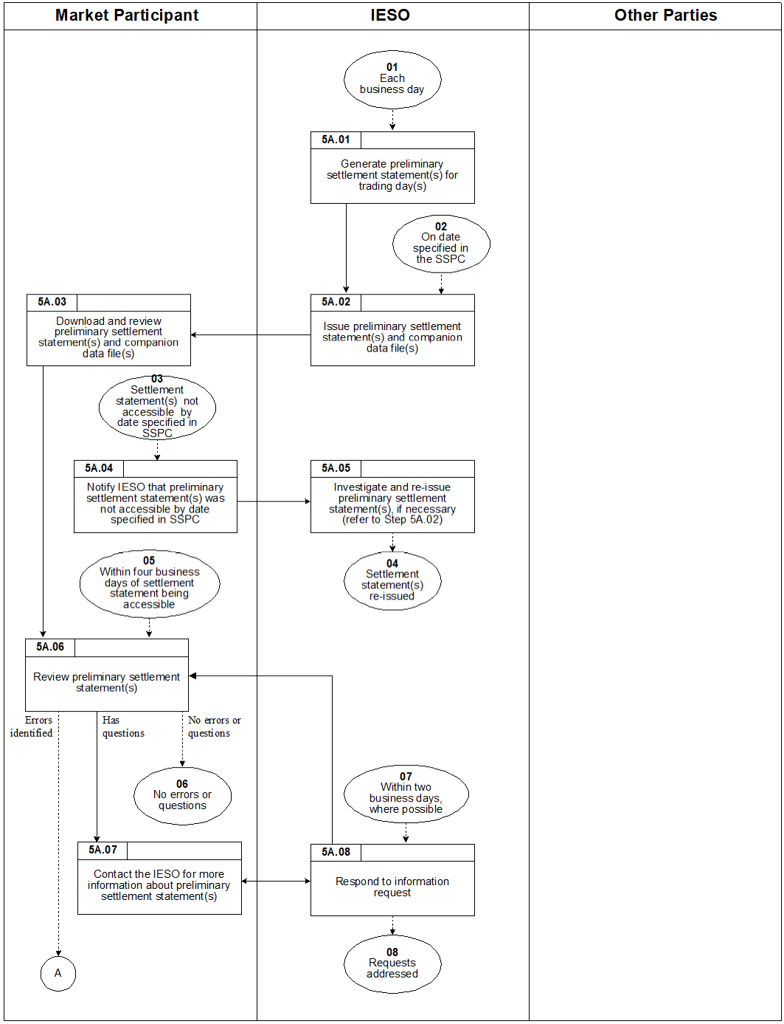

Figure 2–1: Work flow for Preliminary Settlement Statements

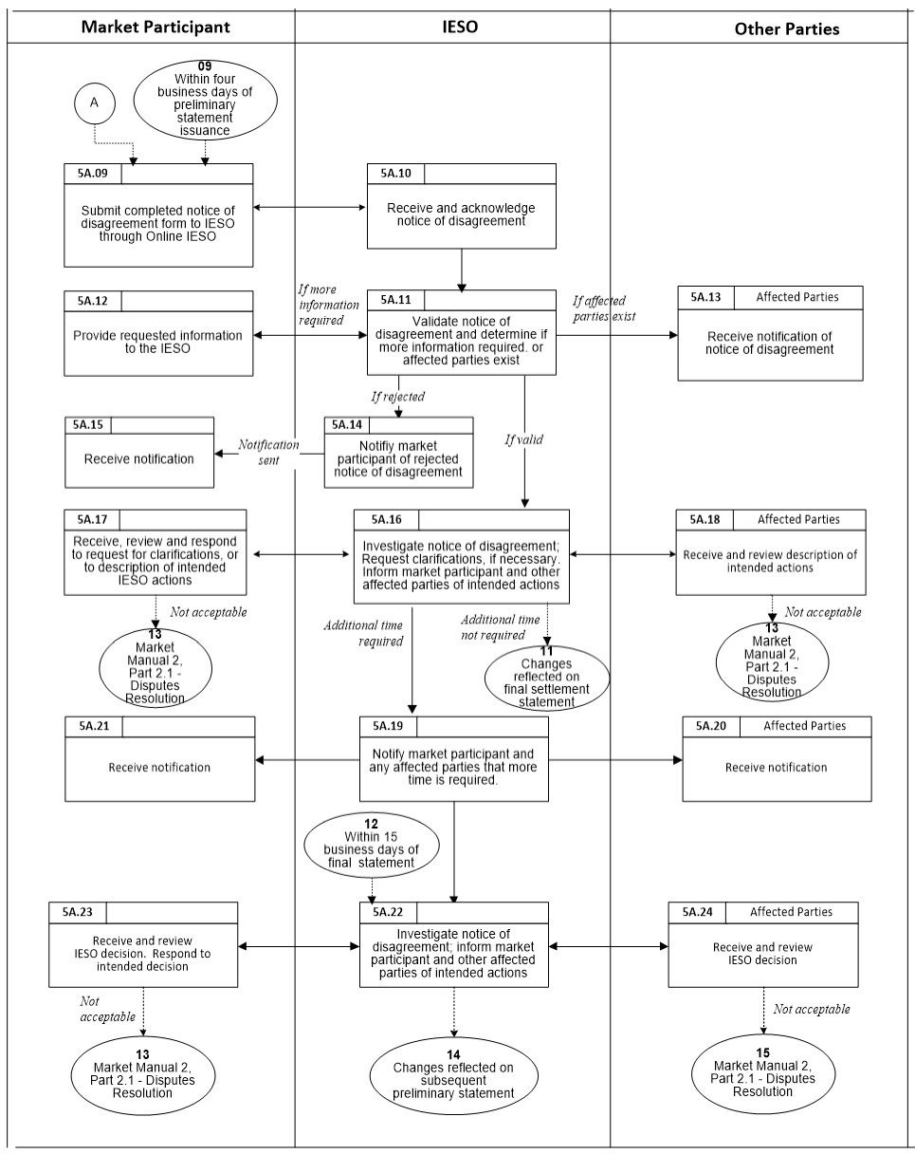

Figure 2–1: Work flow for Preliminary Settlement Statements (continued)

## Retrieving Final Settlement Statements

Each *business day*, in accordance with the *SSPC*, ourCommercial Reconciliation System generates a *final settlement statement* for a *trading day* in the *physical markets*. The *final settlement statement* contains all of the *settlement* line items provided in the *preliminary settlement statement* plus any adjustment line items to the *preliminary settlement statement*. The steps in Figure 2-2 illustrate the process involving issuing and receiving the *final settlement statement*, and are described in detail in Section 3.2, Table 3-2.

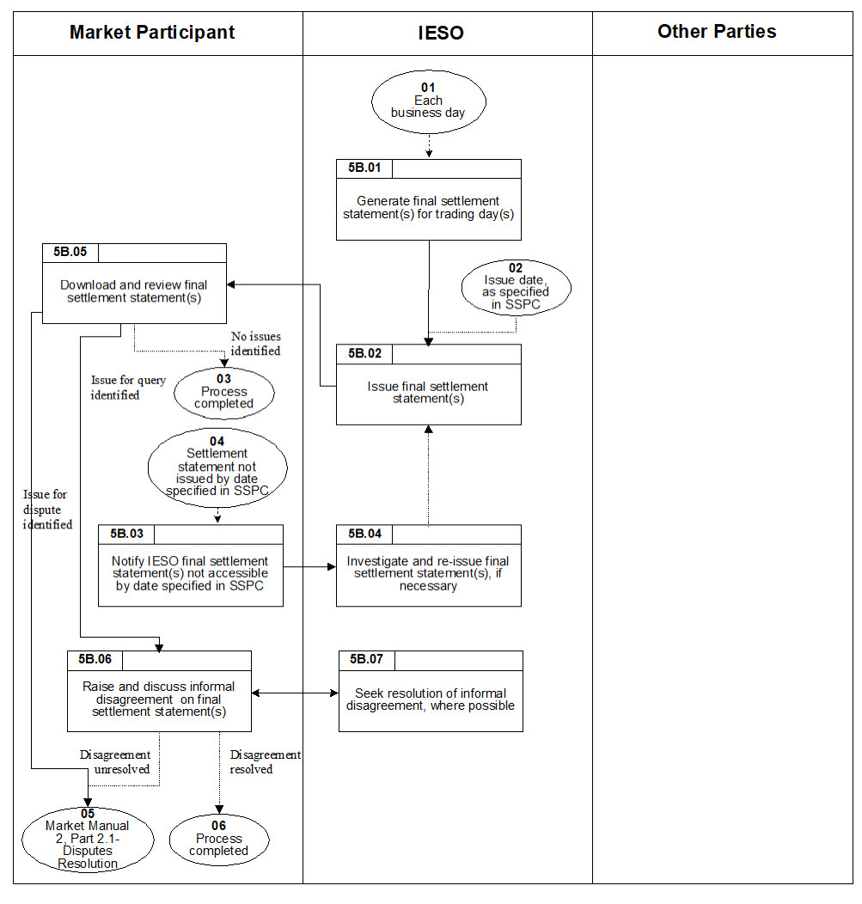

Figure 2–2: Work flow for Retrieving Final Settlement Statements

Designating Facility for Generation Station Service or Electricity Storage Station Service Rebate

*Metered market participants* must apply for the designation of *generation facility* or *electricity storage facility* as eligible for the Generation Station Service and Electricity Storage Station Service Rebate. The steps in Figure 2-3 illustrate the process for designating a *generation facility* or *electricity storage facility* as eligible for Generation Station ServiceRebate or Electricity Storage Station Service Rebate, and are described in detail in Section 3.3, Table 3-3.

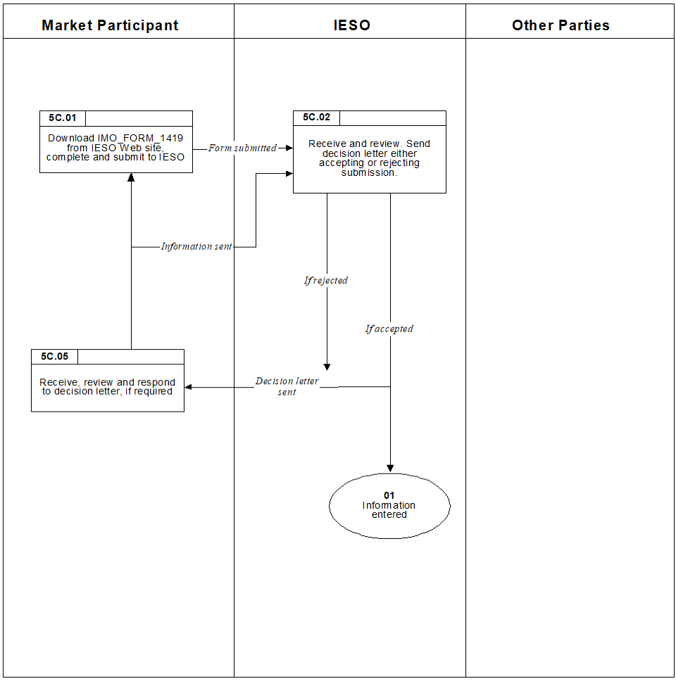

Figure 2–3: Work flow for Designating Facility for Generation Station Service Rebate

## Intentionally Left Blank

Figure 2–4: Intentionally Left Blank

## Intentionally Left Blank

Figure 2–5: Intentionally Left Blank

## Intentionally Left Blank

Figure 2–6: Intentionally Left Blank

## Intentionally Left Blank

Figure 2–7: Intentionally Left Blank

## Intentionally Left Blank

Figure 2–8: Intentionally Left Blank

## Declaration of Designated Consumer

If you meet the criteria for a ‘designated consumer’, as defined in “Bill 4 *An Act to amend the Ontario Energy Board Act 1998 with respect to energy pricing*” and regulations, you must make a declaration to us*.* The steps in Figure 2-9 illustrate the process for notifying us of such an assignment(s) and are described in detail in Section 3.9, Table 3-9.

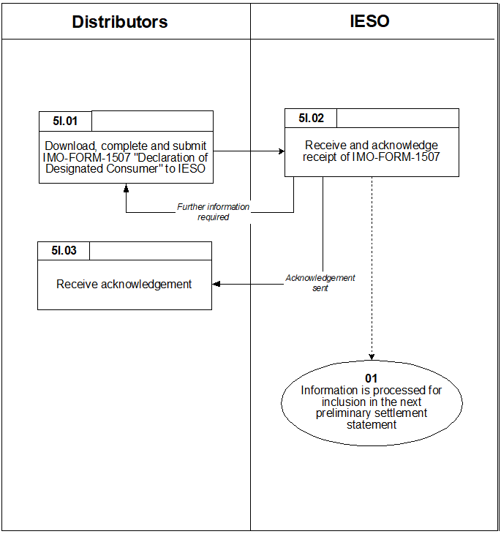

Figure 2–9: Work flow for Declaration of Designated Consumer

## Intentionally Left Blank

Figure 2–10: Intentionally Left Blank

## Submitting Transmission Service Charges for Embedded Generation

Annually, *transmission customers* must, for each *embedded generation facility* for which a *metering point* has been registered under the Alternative Metering Installation Standards for Embedded Generation Facilities (Chapter 6, Section 4.5 of the *market rules*), submit annual adjustment dollar values for the applicable *transmission service charges*. Submit via Online IESO within three months of the calendar year end. If we do not receive this information in a timely manner, we will use the installed *maximum continuous rating* (as registered) for the *embedded generation facilities* to determine an adjustment amount. The steps in Figure 2-11 illustrate the process for notifying us of such an assignment(s) and are described in detail in Section 3.11, Table 3‑11.

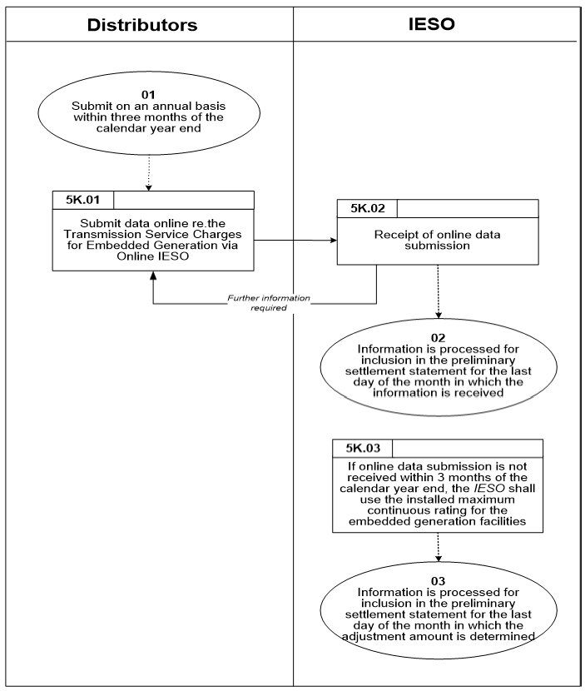

Figure 2–11: Work flow for Submitting of Transmission Service Charges for Embedded Generation

## Workflow for Submitting NUG Adjustment Amount Information

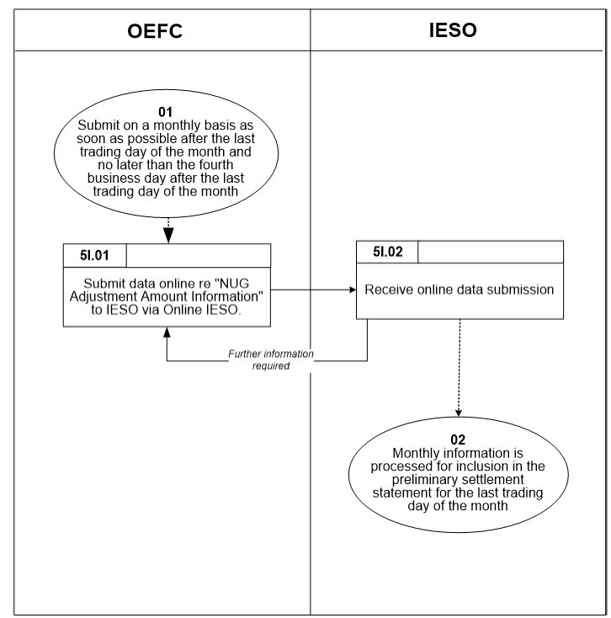

Figure 2–12: Workflow for Submitting NUG Adjustment Amount Information

## Workflow for Submitting Embedded Generation and Regulated Price Information

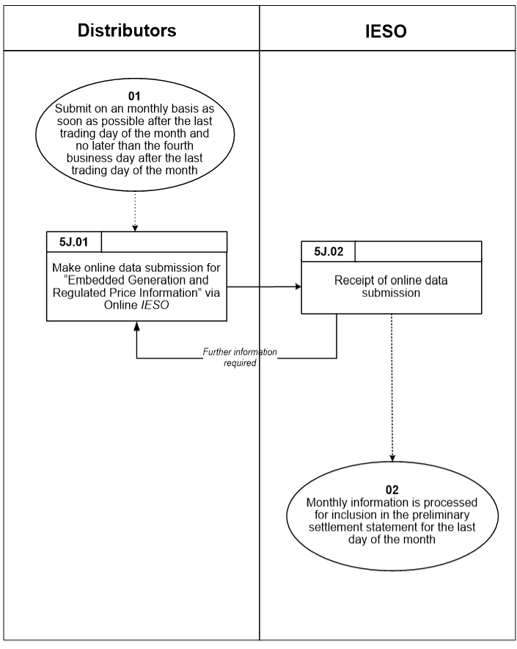

Figure 2–13: Workflow for Submitting Embedded Generation and Regulated Price Information

– End of Section –

# Procedural Steps

This section contains detail on the tasks (steps) that comprise the *settlement statements* procedure. The steps in the following tables are illustrated in Section 2.

The tables contain seven columns, as follows:

Ref

The numerical reference to the task.

Task Name

The task name as identified in Section 2.

Task Detail

Detail about the task.

When

A list of all the events that can trigger the task to begin.

Resulting Information

A list of the information flows that may or must result from the task.

Method

The format and method for each information flow.

Completion Events

A list of all the circumstances in which the task is considered complete.

## Retrieving Preliminary Settlement Statements

Each *business day*, *market participants* should retrieve the *preliminary settlement statement* and data files and review them to determine whether possible errors exist.

Steps shown in the following table are illustrated in Section 2.1, Figure 2-1.

Table 3–1: Procedural Steps for Retrieving Preliminary Settlement Statements

| Ref. | Task Name | Task Detail | When | Resulting Information | Method | Completion Events |
| --- | --- | --- | --- | --- | --- | --- |
| 5A.01 | Generate *preliminary settlement statement(s)* for *trading day(s)*. | We generate the *preliminary settlement statement* file(s) and companion data files for each *trading day* for each *market participant*.  *Preliminary settlement statements* may be issued for more than one *trading day* on a given *business day*. | Every *business day*. | None. | None. | *Preliminary settlement statement* generated. |
| 5A.02 | Issue *preliminary settlement statement(s)* and companion data files(s). | We issue the *preliminary settlement statement* file(s) and companion files which have a non-zero *settlement amount* for that *trading day(s)*. | By 17:00 EST on the date specified in the *SSPC*. | *Preliminary settlement statement* file and companion data files. | Via the *IESO* Report Site [41] | *Preliminary settlement statement* issued. |
| 5A.03 | Download and review *preliminary settlement statement(s)* and companion data files. | The *market participant* downloads the *preliminary settlement statement* file(s) and companion data files from the IESO Report site and reviews the data. | After Step 5A.02. | None. | None. | *Preliminary settlement statement* file(s) and companion data files downloaded to the *market participant’s* system. |
| 5A.04 | Notify us that *preliminary settlement statement(s)* was not accessible by date specified in *SSPC*. | The *market participant* notifies our *Customer Relations* that the *preliminary settlement statement* file(s) and companion data files were not issued, or otherwise accessible, within the established timeframe. | *Preliminary settlement statement(s)* not issued in established timeframe. | Notification that *preliminary settlement statement(s)* not issued. | E-mail or telephone. | Notification that *preliminary settlement statement(s)* not issued received by the *IESO*. |
| 5A.05 | Investigate and re‑issue *preliminary settlement statement(s)*, if necessary (refer to Step 5A.02). | We investigate and re‑issue the *preliminary settlement statement* file(s) and companion data files for a given *trading day* if the investigation determines that this is necessary. | After Step 5A.04. | *Preliminary settlement statement* file(s) and companion data files. | *IESO* Report site[42] or e-mail | *Preliminary settlement statement(*s) issued and verified by the *market participant*. |
| 5A.06 | Review *preliminary settlement statement(s)*. | The *market participant* reviews the *preliminary settlement statement* file(s) and companion data files to identify possible errors. | Following Step 5A.03. | None. | None. | Review of *preliminary settlement statement(s)* completed by the *market participant* and any errors or queries identified. |
| 5A.07 | Contact us for more information about *settlement statement(s)*. | The *market participant* submits a query to our *Customer Relations* requesting additional information pertaining to the *preliminary settlement statement* file(s) and companion data files. | After Step 5A.06 if the *market participant* has questions. | Query. | Via the *IESO Customer Relations*:  (905) 403-6900; or [customer.relations@ieso.ca](mailto:customer.relations@ieso.ca) | Query regarding *settlement statement(s)* submitted to us. |
| 5A.08 | Respond to information request. | We respond to the query submitted by the *market participant*. | After Step 5A.07 and within two *business days,* where possible. | Query response. | E-mail or telephone. | Query response given to *market participant*. |
| 5A.09 | Submit completed *notice of disagreement* form through the Online IESO. | If an error is found in the *preliminary settlement statement*, the *market participant* completes and submits the *notice of disagreement form* through Online IESO. See Appendix B for examples of the interface. The *market participant* will receive an e-mail confirmation upon submission. | After Step 5A.06 if the *market participant* has found errors and within four *business days* of issuing of *preliminary settlement statement*. | Completed *notice of disagreement* form. | Online IESO | *Notice of disagreement* submitted to us. |
| 5A.10 | Receive & acknowledge *notice of disagreement*. | We receive and acknowledge receipt of the *notice of disagreement* submitted by the *market participant*. | After Step 5A.09. | Acknowledgement of *notice of disagreement.*  (NOD ID number, date and time of receipt stamp.) | Email notification. | We acknowledge receipt of *notice of disagreement.* |
| 5A.11 | Validate *notice of disagreement* and determine if more information is required or if affected parties exist. | We validate the *notice of disagreement* submitted by the *market participant* and either reject, request additional information or go to 5A.16 investigate. We reject the submission if it does not address aspects of the *settlement statement* on which a *notice of disagreement* can be raised.  We may request additional information or clarifications from the *market participant* during its preliminary review of the *notice of disagreement.*  We also determine if other *market participants* are potentially affected by the *notice of disagreement* and notify them by email | After Step 5A.10. | A determination whether:   * the *notice of disagreement* is valid or invalid; * additional information is required; and * affected parties exist. | If additional information is required: we send an E-mail requesting additional information through Online IESO *notice of disagreement* form.  If affected parties: we notify them by email of our intended actions. | We send a notification to the *market participant* if the *notice of disagreement* is invalid or if further information is required (Step 5A, 12).  We send a notification to any affected parties (Step 5A.13). |
| 5A.12 | Provide requested information to us through Online IESO. | The *market participant* must provide any requested information of clarifications to us within the timeframe specified in the notification. *Market participants* who fail to provide the requested information within the required timeframe may invalidate their *notice of disagreement*. | After Step 5A.11, if additional information or clarifications required. | Requested information or clarifications. | Provide requested information and attach any supporting documents through Online IESO *notice of disagreement* form. | *Market participant* submit requested information or clarifications to us. |
| 5A.13 | Receive and review *notice of disagreement* details. | The affected *market participant*(s) reviews the notification. | After Step 5A.11, if affected parties exist. | Notification of *notice of disagreement.* | Email or Online IESO. | Affected party receives notification from us describing *notice of disagreement* and our intended actions*.* |
| 5A.14 | Notify *market participant* of rejected *notice of disagreement*. | We determine the submission is not valid and notify the *market participant* it is rejected. | After Step 5A.11. | Notification of rejection of *notice of disagreement.* | Online IESO *notice of disagreement* form.  Email reminder to view decision notification in the Online IESO *notice of disagreement* form. | *Market participant* notified of rejected *notice of disagreement.* |
| 5A.15 | Receive notification. | The *market participant* receives rejection notification. | After Step 5A.14. | Notification of rejection of *notice of disagreement.* | Online IESO | *Market participant* received notification of rejected *notice of disagreement.* |
| 5A.16 | Investigate *notice of disagreement*. Request clarifications, if necessary. Inform *market participant* and other affected parties of intended actions. | We request clarification from the *market participant*, if required, as part of our investigation. The *market participant* must provide any requested information or clarifications to us within the timeframe specified in the notification. *Market participants* who fail to provide the requested information within the required timeframe may invalidate their *notice of disagreement*.  We use the information provided in the *notice of disagreement*, and any other available information, to investigate the subject matter of the disagreement and inform the *market participant* of its intended actions in response to the *notice of disagreement*. We also notify any affected parties of its intended actions.  We may also request additional time to investigate the *Notice of Disagreement.* | After Step 5A.11. | * We request clarifications, if required. * We issue decision on *notice of disagreement*. * Adjustments, if any, for disputed *trading da*y. * Where applicable, a determination that additional time is required to investigate the *notice of disagreement*. | If additional information or additional time is required: Online IESO is used and an e-mail reminder to provide additional information or to view decision notification in the *notice of disagreement* form*.*  If affected parties: decision notification sent to affected parties through email or Online IESO.  Adjustments, if any, resulting from our investigation of the *Notice of Disagreement*, and *Market Participant* feedback (5A.17 and 5A.18), appear on the *final settlement statement* for the disputed *trading day* disagreement. | Our notification of decision for *notice of disagreement.*  Adjustments, if any, on *final settlement statement*.  Where additional time is required to process the *notice of disagreement,* anotification to the *market participant* and any affected parties (5A.19). |
| 5A.17 | Receive, review, and respond to, description of intended actions. Respond to intended decision. | The *market participant* receives a description of our intended actions, and has an opportunity to respond to the decision. | Simultaneous with Step 5A.16. | Response. | Online IESO *notice of disagreement* form.  Respond via Online IESO *notice of disagreement* form. | Intended actions accepted, provide comments to us if disagree, or disagreement pursued through Dispute Resolution process. |
| 5A.18 | Receive and review description of intended actions. | Affected parties receive a description of our intended actions and have an opportunity to respond to our decision. | Simultaneous with Step 5A.16. | Response. None. | Response via email or Online IESO. | Intended actions accepted, provide comments to us if disagree, or disagreement pursued through Dispute Resolution process. |
| 5A.19 | Notify *market participant* and any affected parties that more time is required. | If additional time is required to investigate the *notice of disagreement*, thenwe notify the *market participant* and any affected parties that more time is required. | Following Step 5A.18. | Additional time notification to market participant and affected parties. | E-mail reminder to view decision notification in the Online IESO *notice of disagreement* form. | We send notification that additional time is required to *market participant* and any affected parties. |
| 5A.20 | Receive notification. | Other affected partiesreceive notification that more time is required. | Following Step 5A.19. | None. | E-mail reminder to view decision notification that additional time is required in Online IESO the *notice of disagreement* form | Receipt of notification that additional time is required. |
| 5A.21 | Receive notification. | *Market participant* receives notification that more time is required. | Following Step 5A.19. | None. | E-mail reminder to view decision notification that additional time is required in Online IESO the *notice of disagreement* form. | Receipt of notification that additional time is required. |
| 5A.22 | Investigate *notice of disagreement*; inform *market participant* and other affected parties of intended actions. | We use the information provided in the *notice of disagreement*, and any other available information, to investigate the subject matter of the disagreement and inform the *market participant* of its intended actions in response to the *notice of disagreement*.  We also notify any affected parties of its intended actions.  Adjustments, if any, resulting from our investigation of the *notice of disagreement*, and *market participant* feedback (5A.23 and 5A.24), appear on the next available *preliminary settlement statement*. | After Step 5A.19.  When we require additional time, it must communicate its decision within 15 *business days* of the *final settlement statement* for the disputed *trading day*. | *IESO* decision on *notice of disagreement.*  Adjustments, if any, for disputed *trading day*. | E-mail reminder to view decision notification in the Online IESO *notice of disagreement* form. | Our notification of decision for *notice of disagreement.*  Adjustments, if any, on next available *preliminary settlement statement*. |
| 5A.23 | Receive and review ourdecision. Respond to intended decision. | The *market participant* receives a description of our intended actions, and has an opportunity to respond to our decision. | Simultaneous with Step 5A.22. | Response. | Response via the Online IESO *notice of disagreement* form. | Opportunity to response to our decision provided |
| 5A.24 | Receive and review decision. | Affected parties receive a description of our intended actions and have an opportunity to respond to our decision. | Simultaneous with Step 5A.22. | Response. | Email or response via the Online IESO *notice of disagreement* form. | Opportunity to respond to our decision provided. |

## Final Settlement Statements

*Market participants* should retrieve the *final settlement statement*. The steps shown in the following table are illustrated in Section 2.1, Figure 2-2.

Table 3–2: Procedural Steps for Retrieving Final Settlement Statements

| Ref. | Task Name | Task Detail | When | Resulting Information | Method | Completion Events |
| --- | --- | --- | --- | --- | --- | --- |
| 5B.01 | Generate *final settlement statement(s)* for *trading day*(s). | We generate a *final settlement statement(s)*, incorporating any final adjustments.  *Final settlement statements* may be issued for more than one *trading day* on a given *business day*. | Each *business day*. | None. | None. | *Final settlement statement(s)* issued. |
| 5B.02 | Issue *final settlement statement(s)*. | We issue the *final settlement statement(s)* for a given *trading day(s)* for each *market participant* who has a non-zero *settlement amount* for that *trading day(s)*. | By 17:00 EST on the date specified in the *SSPC*. | *Final settlement statements* file(s) and companion data files. | IESO Report site[43] | *Final settlement statement(s)* issued. |
| 5B.03 | Notify us *final settlement statement(s)* not accessible by date specified in *SSPC*. | The *market participant* notifies us that the *final settlement statement*(s) was not issued or otherwise accessible in the established timeframe. | After Step 5B.02 if *final settlement statement(s)* not issued by date specified in *SSPC*. | Notification that *final settlement statement(s)* not issued. | E-mail or telephone. | Notification that *final settlement statement(s)* not issued submitted to the *IESO*. |
| 5B.04 | Investigate and re‑issue *final settlement statement(s)*, if necessary. | We investigate and re‑issue the *final settlement statement(s)* for a given *trading day*, if the investigation determines that this is necessary. | After Step 5B.03. | *Final settlement statements* file(s) and companion data file. | IESO Report site[44]. | *Final settlement statement(s)* re‑issued by the *IESO*. |
| 5B.05 | Download and review *final settlement statement(s)*. | The *market participant* downloads the *final settlement statement(s)* from the IESO Report Site and reviews the statement for issues.  Where an issue is identified that consists of an adjustment to the corresponding *preliminary settlement statement* resulting from a *notice of disagreement* and that does not reflect the agreement between us and the *market participant* as to the adjustment; or differs in amount from the same item or calculation set forth on the corresponding *preliminary settlement statement* and is not an item or calculation identified on the *final settlement statement* as being associated with an adjustment flag (indicating that an adjustment has been made), the *market participant* may raise an inquiry with us.  Alternatively, where an issue is not resolved, the *market participant* may raise a dispute, within 20 *business days* of the issue date of the *final settlement statement*. | After Step 5B.05. | None. | None. | *Final settlement statement(s)* downloaded.  See “Market Manual 2: Market Administration, Part 2.1 Dispute Resolution”for details of the dispute resolution process. |
| 5B.06 | Raise and discuss informal disagreement on *final settlement statement(s)*. | The *market participant* raises an informal disagreement on the *final settlement statement(s)* (as outlined in Step 5B.05) with us and discusses this with us.  If the issue is resolved, no further action is taken by the *market participant*.  If the issue is not resolved, the *market participant* may decide to pursue the issue through the dispute resolution process, within 20 *business days* of the issue date of the *final settlement statement*. | Following Step 5B.05, when a disagreement is identified. | Informal Disagreement, if required. | Telephone, e-mail, fax. | Issue resolved or submitted for dispute resolution.  See “Market Manual 2: Market Administration, Part 2.1 Dispute Resolution”for details of the dispute resolution process. |
| 5B.07 | Seek resolution of informal disagreement, where possible. | We seek a resolution of the informal disagreement raised by the *market participant*. | Following Step 5B.06. | Discussion with *market participant*. | Telephone, e-mail, fax. | Issue resolved or submitted for dispute resolution.  See “Market Manual 2: Dispute Resolution”for details of the dispute resolution process. |

## Designating Facility for Generation Station Service Rebate or Electricity Storage Station Service Rebate

*Metered market participants* should retrieve IMO_FORM_1419 “Application for Designation of a Facility for Generation Station Service Rebate” in order to apply for a rebate. The steps shown in the following table are illustrated in Section 2.3, Figure 2-3.

Table 3–3: Procedural Steps for Designation of Facility for Generation Station Service Rebate and Electricity Station Service Rebate

| Ref. | Task Name | Task Detail | When | Resulting Information | Method | Completion Events |
| --- | --- | --- | --- | --- | --- | --- |
| 5C.01 | Download IMO_FORM_1419 from ourweb site, complete and submit to us*.* | *Metered market participant* downloads “Application for Designation of a Facility for Generation Station Service Rebate” (IMO_FORM_1419) from our web site. The *metered market participant* completes the form and submits it to us. | When the *metered market participant* believes a *generation facility* or *electricity storage facility* is eligible for rebate of *generation station service* or *electricity storage station service* | *Metered market participant* has applied for designation of a *facility* as eligible for rebate of *generation station service* or *electricity storage station service* | Fax, mail or courier. | Form submitted. |
| 5C.02 | Receive and review. Send decision letter either accepting or rejecting submission. | We receive, review and send a letter to the *metered market participant* indicating whether the submission is complete or information is required (acceptance or rejection). | After Step 5C.01. | Application for designation of a *facility*. | Fax. | Form received and reviewed. A decision letter is sent to the *metered market participant* either accepting or rejecting the submission. |
| 5C.03 | Receive, review and respond to decision letter, if required. | *Metered market participant* receives and reviews our decision. If more information is required, the *metered market participant* resubmits the application. | After receiving the decision letter. | None. | Fax, if required. | *Metered market participant* received letter accepting or rejecting designation for *generation station service* rebate or *electricity storage station service* rebate. |

## Intentionally Left Blank

Table 3–4: Intentionally Left Blank

## Intentionally Left Blank

Table 3–5: Intentionally Left Blank

## Intentionally Left Blank

Table 3–6: Intentionally Left Blank

## Intentionally Left Blank

Table 3–7: Intentionally Left Blank

## Intentionally Left Blank

| Table 3–8: Intentionally Left Blank |
| --- |

## Declaration of Designated Consumers

*Market participants* meeting the ‘designated consumer’ criteria (as defined in “Bill 4 *An Act to amend the* *Ontario Energy Board Act, 1998* *with respect to energy pricing*” and the regulations) may inform usof this.

The steps shown in the following table are illustrated in Section 2.9, Figure 2-9.

Table 3–9: Procedural Steps for Declaration of Designated Consumers

| Ref. | Task Name | Task Detail | When | Resulting Information | Method | Completion Events |
| --- | --- | --- | --- | --- | --- | --- |
| 5I.01 | Download, complete and submit IMO_FORM_1507 “Declaration of Designated Consumer” to us*.* | *Market participants* download IMO_FORM_1507 from our web site, complete the Form and submit it to us.  The sender ensures the proper signatures are included. | As a *market participant* becomes eligible. | Declaration of designated consumer is made. | Email, followed by Fax with signature of signing authority. | Declaration information is sent to us. |
| 5I.02 | Receive and acknowledge receipt of IMO_FORM_1507. | We receive and send an acknowledgement of receipt of the IMO_FORM_1507 from eligible *market participants*.  In the event further information is required, the *market participant* is requested to re-submit the form. | Upon receipt of information. | Acknowledgement. | Email. | Information received by usand acknowledgement sent to *market participant.* |
| 5I.03 | Receive acknowledgement. | *Market participants* receive acknowledgement of our receipt of IMO_FORM_1507. | After step 5I.02. | None. | Email. | Acknowledgementreceived. |

## Intentionally Left Blank

| Table 3–10: Intentionally Left Blank |
| --- |

## Submitting Transmission Service Charges for Embedded Generation

For each *embedded generation facility* for which a *metering point* has been registered under the Alternative Metering Installation Standards for Embedded Generation Facilities (Chapter 6, Section 4.5 of the *market rules*) *transmission customers* will submit adjustment dollar values for the applicable *transmission service charges*. *Settlement* data must be submitted via Online IESO within three months of the calendar year end. In the event that the *IESO* does not receive this information in a timely manner, we will use the installed *maximum continuous rating* (as registered) for the *embedded generation facilities* to determine an adjustment amount.

Steps shown in the following table are illustrated in Section 2.11, Figure 2-11.

Table 3–11: Procedural Steps for Submission of Transmission Service Charges for Embedded Generation

| Ref. | Task Name | Task Detail | When | Resulting Information | Method | Completion Events |
| --- | --- | --- | --- | --- | --- | --- |
| 5K.01 | Submit Transmission Service Charges for Embedded Generation online via Online IESO. | *Transmission Customers* submit information via the Submit Settlement Claim action available through Online IESO.  Line and Transformation Connection Service Charges need to be calculated for all *delivery points* with *embedded generation facilities* registered under the Alternative Metering Installation Standards for Embedded Generation Facilities.  The sender ensures adjustment amounts are agreed to by the *transmitter*. | Annually, as soon as possible after the last day of the calendar year and no later than three months after calendar year end. | Annual adjustment dollar values for the applicable *transmission service charges* associated with *embedded generation facilities* registered under the Alternative Metering Installation Standards for Embedded Generation Facilities. | Submitted via Online IESO. | Annual adjustment information is sent to us. |
| 5K.02 | Receipt of online data submission. | We receive the online data submission from *transmission customers*.  In the event further information is required, the *distributor* is requested to re-submit the form. |  |  | *Online IESO*. | Information received by us. |
| 5K.03 | If the online data submission is not received within 3 months of the calendar year end, we will use the installed *maximum continuous rating* for the embedded *generation facilities.* | In the event that we do not receive a data submission within three months of the calendar year end, We will use the installed *maximum continuous rating* for the *embedded generation facilities* (provided to us at the time of the *meter point* registration) to calculate the applicable *transmission service charges*. | Annually, as soon as possible after the expiration date (three months after calendar year end) for *transmission customer* submissions has expired. | Annual adjustment dollar values for the applicable *transmission service charges* associated with *embedded generation facilities* registered under the Alternative Metering Installation Standards for Embedded Generation Facilities | Internal *IESO* calculation. | Annual adjustment information is calculated by us. |

## Submitting NUG Adjustment Amount Information

Each month, *OEFC* submits information to the *IESO* for the difference between NUG contract costs and wholesale marketpayments for NUGs.

Steps shown in the following table are illustrated in Section 2.12, Figure 2-12.

Table 3–12: Submission of NUG Adjustment Amount Information

| Ref. | Task Name | Task Detail | When | Resulting Information | Method | Completion Events |
| --- | --- | --- | --- | --- | --- | --- |
| 5I.01 | Submit “NUG Adjustment Amount Information” via Online IESO. | *OEFC* submits information via the Submit Settlement Claim action available through Online IESO. | Within four *business* *days* after the last *trading day* of every month. | Monthly adjustment for any differences between the contract price for NUG output and the *market price* for NUG output for the previous month.  Monthly forecast NUG rate in $/MWh for the current month.  Monthly forecast NUG production in MW for the current month. | Online *IESO*. | Declaration information is sent to us. |
| 5I.02 | Receipt of online data submission. | We receive the online data submission from *OEFC.*  In the event further information is required, the *OEFC* is requested to re-submit the data. | Upon receipt of information. | Acknowledgement. | Online *IESO*. | We receive information. |

## Submitting Embedded Generation and Regulated Price Information

Each month, *distributors* submit information to us for residual differences between the regulated price and the wholesale *market price* plus global adjustment for regulated *consumers* within the *distribution system*. The *distributor* also must submit information provide by *retailers* and embedded *distributors*.

Steps shown in the following table are illustrated in Section 2.13, Figure 2-13.

Table 3–13: Procedural Steps for Submission of Embedded Generation and Regulated Price Information

| Ref. | Task Name | Task Detail | When | Resulting Information | Method | Completion Events |
| --- | --- | --- | --- | --- | --- | --- |
| 5J.01 | Submit data for Embedded Generation and Regulated Price Information via Online IESO. | *Distributors* submit information online via the Submit Settlement Claim action available through Online IESO.  *Distributors* enter amounts for various differences to make them and the following agents whole:  •Embedded *distributors*,  •Participating *retailers* using *distributor*-consolidated billing,  •Participating *retailers* using retailer-consolidated billing.  *Distributors* must report embedded generation and distribution to Class A *consumers*. | Within four *business* *days* after the last *trading day* of every month. | Monthly adjustments for any differences between:   * the regulated price and *market price* plus global adjustment for regulated *consumers*; * the *market price* and contract priceforparticipating *retailers* with *distributor*-consolidated billing; * the regulated price and contract price for participating *retailers* with *retailer*-consolidated billing; and * the daily global adjustment and the monthly global adjustment.   Monthly amount distributed to Class A *consumers* for the previous month and forecast amount of embedded generation distributed to Class A *consumers* for the current month. | Submitted via Online *IESO*. | Monthly adjustment information is sent to us. |
| 5J.02 | Receive online data submission. | We receive the *settlement* data submitted online from *distributors* via Online IESO.  In the event further information is required, the *distributor* is requested to re-submit via Online IESO. |  |  | Online *IESO*. | Information received by the *IESO*. |

– End of Section -

Forms

This appendix contains a list of forms used in the *physical markets* *settlement statements* process, which are available on the *IESO* Web site ([http://www.ieso.ca](http://www.ieso.ca/)). The forms included are as follows:

|  |  |
| --- | --- |
| Form Name | Form Number |
| Application for Designation of a Facility for Generation Station Service Rebate | IMO_FORM_1419 |
| Declaration of Designated Consumer | IMO_FORM_1507 |
| Administrative Pricing Event Correction | IMO_FORM_1549 |

**Note:** *Electricity storage participants* are required to use the above forms. These forms are expected to be updated if and as necessary to include language specific to *electricity storage facilities* and *electricity storage participants*. Until such time, any questions from *electricity storage participants* relating to how to fill out the forms correctly may be addressed by IESO Customer Relations.

– End of Section –

Online IESO Notice of Disagreement Form

The following screen captures show the Online IESO *notice of disagreement* forms that *market participants* use to register and track a *notice of disagreement*.

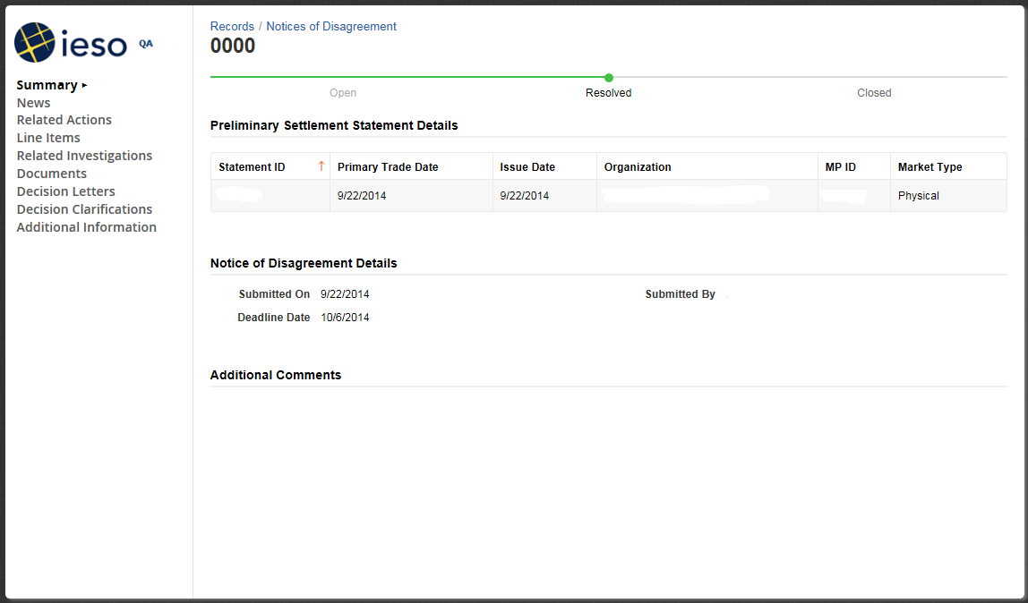

Figure B–1: NOD Detailed Records

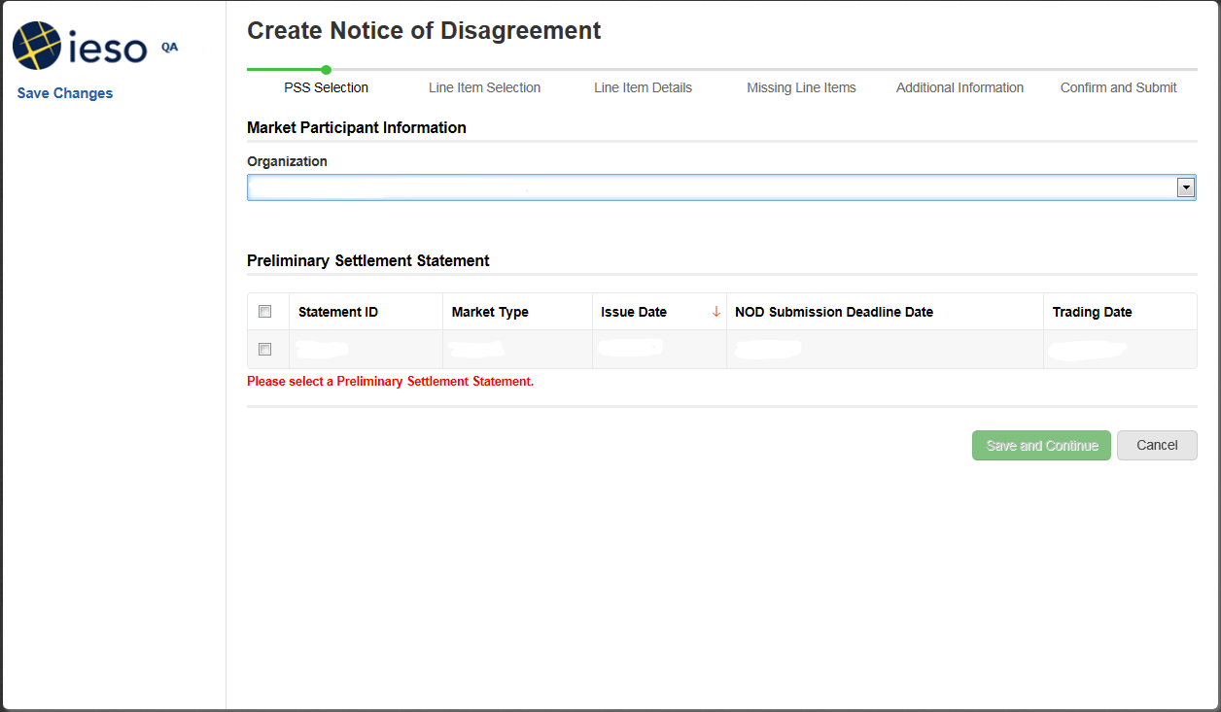

Figure B–2: NOD Detail Screen – Select Preliminary Settlement Statement

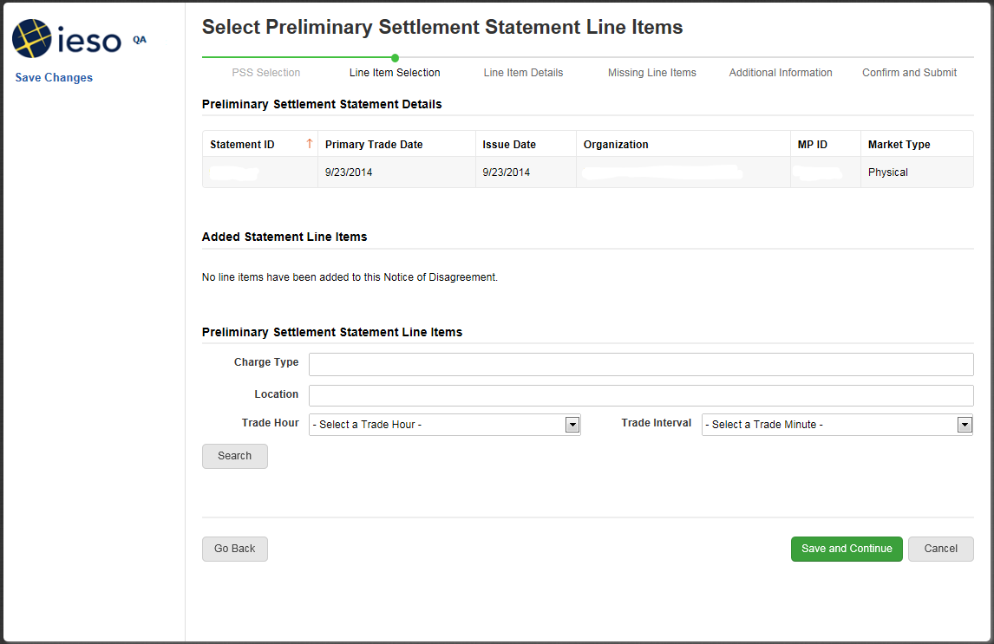

Figure B–3: NOD Detail Screen – Select Preliminary Settlement Statement Line Items

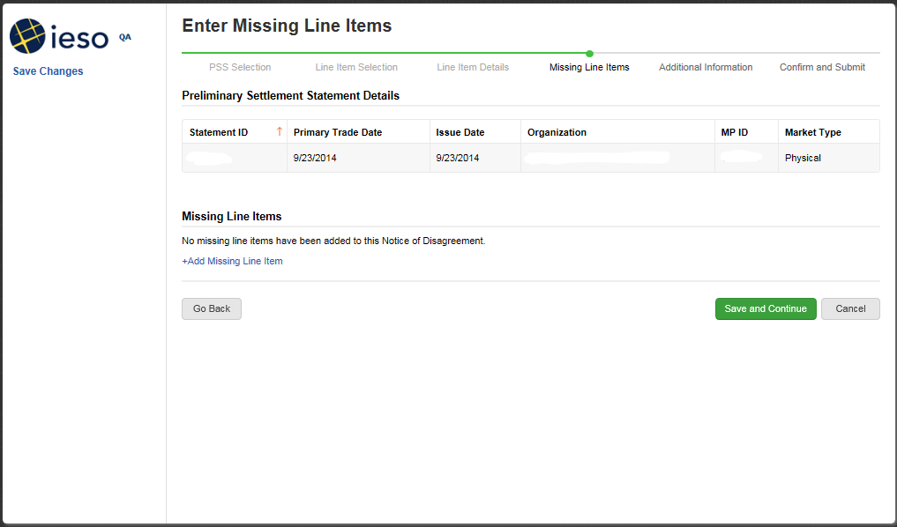

Figure B–4: NOD Detail Screen – Add Missing Line Items

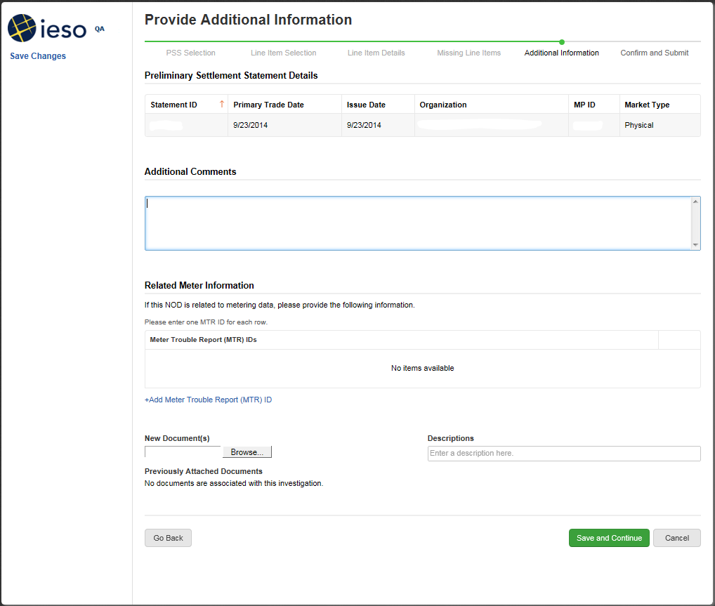

Figure B–5: NOD Detail Screen – Provide Additional Information

– End of Section –

IESO Charge Types Applicable to the Authorized Charge

1. The provisions of this appendix do not apply for any period beginning after March 31, 2005. The provisions of this appendix have been retained in the event that a re-calculation of the *energy* uplifts for any period prior to April 1, 2005 is necessary.

This appendix contains a list of *IESO* *charge types* included in the authorized charge defined in “Ontario Regulation 436/02”. This set of charges is derived from the “IESO Charge Types and Equations” excluding:

* charges that are payable as defined by “Ontario Regulation 436/02 2(3)” (commodity charge, the *Debt Retirement Charge* and the *Transmission Services Charges*);
* charges identified by the Ontario *Energy* Board (deemed non-recurrent wholesale market service charges);
* charges payable to *market* *participants*;
* charges applicable to specific participants for products supplied to us; and
* charges not active in the market.

Table C–1: IESO Charge Types Included in the 0.62 Monthly Calculation

| Charge Type Number | Charge Type Name |
| --- | --- |
| 0150 | Net Energy Market Settlement Uplift |
| 0155 | Congestion Management Settlement Uplift |
| 0168 | TR Market Shortfall Debit |
| 0170 | Local Market Power Rebate |
| 0182 | Hour-Ahead Dispatchable Load Offer Guarantee |
| 0183 | Generation Cost Guarantee Recovery Debit |
| 0184 | Demand Response Debit |
| 0250 | 10 Minute Spinning Market Reserve Hourly Uplift |
| 0252 | 10 Minute Non-Spinning Market Reserve Hourly Uplift |
| 0254 | 30 Minute Operating Reserve Market Hourly Uplift |
| 0450 | Black Start Capability Settlement Debit |
| 0452 | Reactive Support and Voltage Control Settlement Debit |
| 0454 | Regulation Service Settlement Debit |
| 0550 | Must-Run Contract Settlement Debit |
| 0753 | Rural Rate Settlement Charge |
| 9990 | IESO Administration Charge |

– End of Section –

Price Bias Adjustment Factors Calculation Method for the Real-Time Import and Export Failure Charge

The real-time failure charge calculation for imports and exports includes the difference between the pre-*dispatch* and the real-time Ontario *energy* prices during the hour of the failure. Including transaction failures, there are many factors that contribute to the pre-*dispatch* to real-time price differences. The purpose of the price bias adjustment factors is to adjust this charge by the forecast value of the difference between the pre-*dispatch* and the real-time Ontario *energy* price that is due to the systematically caused differences (C. 9, S. 3.8C.7).

The following methodology does not specifically isolate the price difference due to the systematic differences, but we will use it as a proxy until we are technically able to isolate this contribution or improve on the present methodology to meet this goal.

We provide these price bias adjustment factors to help you assess your exposure to the *settlement* charge for the upcoming *settlement* periods.

The following calculation method produces twenty-four hourly factors that apply for a three-month period. These three-month periods are aligned with the seasons. New factors will apply to the next calendar year.

The periods are:

* the winter factors apply to December, January, and February;
* the spring factors apply to March, April, and May;
* the summer factors apply to June, July, and August; and
* the autumn factors apply to September, October, and November.

Effective time for each three-month block starts at the first hour of the first day of the month and ends at the twenty-fourth hour of the last day of the third month in the block.

We use the following methodology to calculate the price bias adjustment factors:

**Data Set**

The total data set used to calculate the price bias adjustment factors includes all pre-*dispatch* to real-time Ontario *energy* price differences, including those differences which are zero, positive, and negative. This total data set includes all differences from the start of the Ontario market (May 1, 2002) until the present calendar year.

We calculate the price bias adjustment factors using a subset of the total data set. All the price differences are divided into those which occurred in each hour of the day during each seasonal block defined above. The price bias adjustment factors are calculated using the corresponding hours in the corresponding months. For example, the spring factor for hour 1 is calculated using all the price differences from hour 1 for the months of March, April, and May of each year since market opening. This results in data sets that are hourly, seasonal, and yearly.

Frequency distributions for these data sets are created. We determine the median values of the frequency distributions. The median value is defined as the middle value of this distribution. More specifically, there are the same numbers of observations to the left and to the right of the median value of the frequency distribution.

**Weighting Factors**

Each yearly median value is assigned a weighting factor from 0 to 1. A year with a weighting factor of zero results in that year’s median value not contributing to the determination of the price bias adjustment factor. Conversely, a year assigned a weighting factor of 1 will solely be considered at the exclusion of all other years. After taking into account the weighing factors, we determine a price bias adjustment for each hour of the day for a three month block.

The use of weighing factors allows us to establish the best forecast by enabling the price bias adjustment factors to reflect short term and long term influences on the pre-*dispatch* to real-time Ontario *energy* price differences. The weighting factor assignments are at our discretion.

These calculations result in twenty-four hourly price bias adjustment factors for each season of the year. These factors are the same for the import and export *settlement* charge.

We will post the price bias adjustment factors on our web site in advance of their effective *trading day*.

− End of Section 

Expired Settlement Calculations Kept for Purposes of Re-Calculation

Fixed Energy Rate Program

1. The provisions of this section do not apply for any period beginning after March 31, 2005. The “Electricity Restructuring Act, 2004” (also referred to as Bill 100) replaced the Fixed Energy Rate Program described below, with *charge types* 140/190 being replaced by *charge types* 142/192. The provisions of this section have been retained in the event that a re-calculation of the *energy* rate for any period prior to April 1, 2005 is necessary.

“Bill 4 An Act to amend the *Ontario Energy Board Act, 1998*” with respect to electricity pricing and regulations passed pursuant to “Bill 4”, fix the commodity price for *energy* at 4.7 cents per kilowatt hour up to and including 750 kWh per month and 5.5 cents per kilowatt hour in excess of the 750 kWh (net of any *energy* purchased under *physical bilateral contracts*)(uncovered *energy*) for “low-volume *consumers*” and “designated *consumers*” (as defined in “Bill 4”). A fixed *energy* rate will not take the place of the *hourly Ontario energy price (HOEP)* or *energy market price* (EMP) for existing calculations. The fixed *energy* rate will be implemented via a supplementary process which consists of a calculation of the offset necessary to adjust the commodity price to the equivalent of 4.7 cents per kilowatt hour up to and including 750 kWh per month and 5.5 cents per kilowatt hour in excess of the 750 kWh. This offsetting amount is included as a new item on *preliminary* and *final* *settlement statements* and monthly *invoices* under *charge type* 140, “Fixed Energy Rate Settlement Amount”. (Chapter 9, Sections 1.2.1 and 1.2.2 of the *market rules*)

All charges associated with *charge type* 140 require a corresponding off-set *charge type* in order to balance the market. This corresponding new *charge type* 190 “Fixed Energy Rate Balancing Amount” will be debited or credited to the Ontario Electricity Financial Corporation (*OEFC*). (Refer to “IESO Charge Types and Equations” and “Format Specifications for Settlement Statement Files and Data Files”, located on the Technical Interfaces page of the *IESO* Web site, for details of these *charge types*.) *Market participants’ settlement statements* will reflect additions of new Manual Line Items as detailed in these two new *charge types*.

Declaration Required for Designated Consumers

A ‘designated consumer’ has been defined in “Bill 4” and “Regulations 435/02, 43/04 and 433/02”. Wholesale *market participants* who qualify as ‘designated consumers*’* must inform usby completing and submitting a declaration using IMO_FORM_1507 “Declaration of Designated Consumer” located on our web site. *Market participants* who satisfy us that they qualify as designated consumers will be settled at the fixed *energy* rate of 4.7 cents per kilowatt hour up to and including 750 kWh per month and 5.5 cents per kilowatt hour in excess of the 750 kWh and a fixed 0.62 cents per kWh for the designated chargesprescribed by government regulation (described in Section E.2 below).

IESO Market Participants that are Low-Volume or Designated Consumers

Fixed *energy* rate adjustments for eligible *market participants* covered under *charge type* 140 apply to net *energy* withdrawals, not covered by a *physical bilateral contract,* from the *IESO-administered market*. The net *settlement amount* results in an effective rate equivalent to the fixed price for all eligible uncovered *energy* transactions. Eligible *market participants’ settlement statements* will be adjusted as follows:

* CRS will create a 140 detailed (DP) record that is incorporated in the *settlement statement* that will, together with the 101 detailed (DP) record, apply an effective fixed rate of 5.5 cents per kWh; and
* a manual adjustment is applied at the end of the month to apply a rate of 4.7 cents per kWh for *energy* withdrawals up to 750 kWh.

Distributor Claims

Regulations have been passed that provide for month-end adjustments for *distributors*. The purpose of the adjustments will be to offset the differences that arise from *distributors* settling with us at the *market price* and charging 4.7 cents per kilowatt hour up to and including 750 kWh per month and 5.5 cents per kilowatt hour in excess of the 750 kWh to low-volume *consumers* and designated *consumers*.

Eligible *distributors* that are *market participants* must submit the relevant information to us using IMO_FORM_1562 “Bill 4 Submission of Information Required for Monthly Fixed Prices” denoting the amount of the claim for each category. This form is used for all the information required from the *distributor*, embedded *distributor[45]* or participating *retailer[46]* to balance the market. IMO_FORM_1562 must be submitted on a monthly basis to us as soon as possible after the last *trading day* of the month and no later than the fourth *business day* after the last *trading day* of the month. We process this information so that the *preliminary settlement statement* for the last *trading day* of the monthwill indicate a *charge type* 140 entry with the Comments field noting the relevant category as follows:

* adjustment for low-volume and designated *consumers* billed by a *distributor*;
* adjustment for low-volume and designated *consumers* supplied by embedded generation billed by a *distributor*;
* adjustment for low-volume and designated *consumers* billed by an embedded *distributor*;
* adjustment for low-volume and designated *consumers* supplied by embedded generation billed by an embedded *distributor*;
* adjustment for participating *retailers* using *distributor*-consolidated billing;
* adjustment for participating *retailers* using *distributor*-consolidated billing, within an embedded *distributor*;
* adjustment for participating *retailers* using *retailer*-consolidated billing; and
* adjustment for participating *retailers* using *retailer*-consolidated billing, within an embedded *distributor.*

Opt Out Provisions

Eligibility of *market participants* to opt out of the Fixed Energy Rate Program is based on the following provision:

* directly-*connected* load-consuming *market participants* meeting the regulated definition of “low-volume *consumers*” or “designated *consumers*” may opt out of the Fixed Energy Rate Program for all *registered facilities* for which they play the role of a *metered* *market participant* provided they have interval *metering*.

*Market participants* must inform us in writing if they wish to exercise this option.

Authorized Charge for the Operation of the IESO‑Administered Markets

1. The provisions of this section do not apply for any period beginning after March 31, 2005, as their operation expired as of that date. Accordingly, *charge types* 141 & 191 are no longer applicable for any such period. The provisions of this section have been retained in the event that a re-calculation of the authorized charge for any period prior to April 1, 2005 is necessary.

Effective December 2002, “Regulation 436/02” establishes a fixed charge of 0.62 cents per kWh for the operation of the *IESO-administered markets*, operation of the *IESO-controlled grid* and the rate protection provided under Section 79 of the “*Ontario Energy Board Act, 1998*” for rural and remote *consumers* (defined as the ‘authorized charge’). The authorized charge applies to *distributors,* low-volume *consumers* and designated *consumers* who are *market participants*. The relevant *IESO charge types* (refer to Appendix C: “IESO Charge Types Applicable to the Authorized Charge”) will continue to appear on daily *settlement statements* in the usual manner. On the *preliminary* and *final settlement statement* for the last *trading day* of the month, we will total these specified charges and apply an adjustment for the month to ensure that the authorized charge of 0.62 cents per kWh has been applied for all AQEW.

The authorized charge is applied to *settlement statements* as follows:

* CRS will calculate a monthly value that is incorporated into *preliminary* and *final settlement statements* for thelast *trading day* of the month as detailed (DP) records.

*Distributors* are required to submit to us the wholesale market charges associated with the *energy* purchased from *embedded generators*. Again, IMO_FORM_1562 “Bill 4 Submission of Information Required for Monthly Fixed Prices” must be submitted on a monthly basis to us as soon as possible after the last *trading day* of the month and no later than the fourth *business day* after the last *trading day* of the month.

The adjustment to the uplift charges will appear on the *settlement statements* for the last *trading day* of each month. This offsetting amount is included as a new item on *settlement statements* and *invoices* under *charge type* 141 “Fixed Wholesale Charge Rate Settlement Amount”.

All charges associated with *charge type* 141 require a corresponding off-set *charge type* in order to balance the market. This corresponding new *charge type* 191 “Fixed Wholesale ChargeRate Balancing Amount” will be debited or credited to the Ontario Electricity Financial Corporation (*OEFC*). *Market participants’ settlement statements* will reflect additions of new manual line items as detailed in these two new *charge types*.

OPA’s Demand Response (DR3) Program[47]

The IESO implemented a contractual load reduction program for *market participants*, LDC-*connected* participants and aggregators who are capable of providing a net electricity load reduction of at least 5 MW and, for aggregators, 25 MW. Refer to the *OPA*’s DR3 Contract, Program Rules and related Manuals on their web site for full details.

This section sets out how the *IESO* settles the DR3 Program. To the extent of any inconsistency between the provisions of the DR3 Program rules and this section, the DR3 Program rules shall govern.

DR3 participants are paid a monthly Availability Payment for being available to reduce their load during the Hours of Availability and a Utilization Payment for their actual load *curtailment* when directed by us. Given that as a DR3 participant, you may have more than one DR3 Contract Schedule for a given Settlement Account; your payment will be based on the total Monthly Contracted MWs for all such DR3 Contact Schedules and the weighted average of each of the applicable rates.

The DR3 program also includes an Availability Over-Delivery Payment to encourage higher than contracted *demand* reduction in response to an Open Standby Notification.

*Settlement* payments are subject to Performance Set-Offs for both Availability and Utilization for failure to comply with DR3 Contract terms including:

* maintaining a Reliability Rate of at least 85% for each interval;
* confirming in a timely manner when required by us to do so; or
* confirming at least 85% of the Monthly contacted MW for a Confirmed Hour.

Additionally, DR3 participants will be subject to an Availability Payment Set-Off for:

* not being fully available for *curtailment*;
* any days that they declare a planned non-performance event; or
* failing to deliver *meter* data in a timely manner.

Settlement of Demand Response Payments

How Availability Payments Are Settled

Each month, you will receive an Availability Payment for each Settlement Account based on the Hours of Availability, Monthly Contracted MW and the Adjusted Availability Rate as described in the DR3 Contract. The Adjusted Availability Rate is the weighted average of the rates for all Contract Schedules for a given Settlement Account and adjusted for premium zones and discount zones.

We calculate Availability Payments once a month in the month following the contract month and apply them as a manual line item to the last *trading day* of the month following the contract month. We use *charge type* 1340 “On behalf of *OPA* for the DR3 Program - Availability Payment Settlement Amount” for Availability Payments to participants.[48]

Where you have multiple DR3 Contract Schedules at a given Settlement Account, these DR3 Contract Schedules are aggregated into one manual line item for *settlement* purposes.

We recover availability payments through *charge type* 1390 “Demand Response 3 Availability Payment Balancing Amount”.

How Availability Over-Delivery Payments Are Settled

When you receive an Open Standby Notification, you may respond to us that you are available to deliver more MWs or reduce load for a longer period than agreed to in your DR3 Contract Schedule. In this case, you are entitled to receive an Over-Delivery Payment for each over-delivery hour in a Contract Month.

In each hour, the Confirmed MWs are limited to the lesser of the Monthly Contracted MW plus 15 MW or 130% of the Monthly Contracted MW. In addition, the number of activations is limited to an additional 7 times if the Maximum Contract Hours is 100 and an additional 14 times if the Maximum Contract Hours is 200, for each calendar year.

We calculate Availability Over-Delivery Payments once a month in the month following the Contract Month and apply them as a manual line item to the last *trading day* of the month following the Contract Month.

We use *charge type* 1341 “On behalf of *OPA* for the DR3 Program - Availability Over-Delivery Payment Settlement Amount” for the monthly Availability Over-Delivery Payments to participants[49].

We recover Over-Delivery Payments through *charge type* 1391 “Demand Response 3 Availability Over-Delivery Balancing Amount”.

How Utilization Payments Are Settled

You are paid for the amount of load reduction you actually provide for a DR3 activation for each Settlement Account based on the Actual Activated MWh and the Utilization Rate as described in the Contract.

The Actual Activated MWhs are the metered reduction for the Activation Period. We will calculate your load reduction and *settlement* from the data you submit, according to your M&V Plan. For load reduction payments, the total reduction cannot exceed the confirmed reduction for the period plus the lesser of an additional 15 MWh or 15% of the Activation MW per hour of the Activation Period. In addition, the number of activations is limited to an additional 7 times if the Maximum Contract Hours is 100 and an additional 14 times if the Maximum Contract Hours is 200, for each calendar year.

We calculate Utilization Payments once a month in the month following the contract month and apply them as a manual line item to the last *trading day* of the month following the contract month. We use *charge type* 1343 “On behalf of *OPA* for the DR3 Program - Utilization Payment Settlement Amount” for Utilization Payments to participants.[50]

Utilization Payments are not made when an Activation Notice is sent by us and you are using one of the Planned Non-Performance Events at the Settlement Account.

Utilization Payments are recovered through *charge type* 1393 “Demand Response 3 Utilization Payment Balancing Amount”.

How We Process Your Meter Data

As part of the DR3 application, participants submit an M&V Plan for each Settlement Account. We calculate a Baseline for each and every Activation Hour. For DR3 participants that are not *IESO administered market participants*, we will use:

* your weekly retail revenue *meter* data submitted by 15:00 EST on the first *business day* of the following week; and
* revisions to the weekly data received by 15:00 EST on the last *business day* of the month following the completed contract month.

For DR3 participants that are *market participants*, we will use your revenue metering data that we’ve collected as part of our market *settlement process*.

The Baseline calculation may be adjusted using the measured *demand* prior to the *Curtailment* hour as described in Exhibit B of the DR3 Contract.

We verify the actual *metering data* against the M&V Plan and our calculations.

Calculating Performance Set-Offs

Delivery of your load reduction amount is subject to performance criteria. Performance criteria consist of:

1. **Reliability**: If you do not achieve an average reduction (Reliability Rate) during any 5-minute interval in the hour of at least 85% of the Activated MW, or if you are Not Fully Available for Curtailment you will be subject to reliability Performance Set-Offs. Performance Set-Offs for below-standard reliability applies to both availability and utilization payments whereas not being fully available for *curtailment* applies only to the availability payment.

**Calculating Your Reliability Rate:**

Due to the importance of reliable load reduction for assessing and managing the *IESO-controlled grid*, you are required to maintain a Reliability Rate for each Settlement Account of at least 85% for each interval of an Activation Hour. The Reliability Rate is calculated for each 5-minute interval and the rate for any interval cannot exceed 100%.

For Settlement Accounts that include more than one contract schedule, your Reliability Rate is based on your actual *curtailment* as a percentage of the aggregated Activation MW.

1. **Timely Confirmation**: If a Confirmation is required by us and you do not submit or submit a Confirmation late, both availability and utilization payments are subject to set-offs. The severity of the set-off will depend on how late the Confirmation is received.
2. **Low Confirmation**: If the Confirmed MWs are less than 95% of the Monthly Contracted MW for a Confirmed Hour, a Performance Set-Off will be calculated for each confirmed hour. This Set-Off will apply even if the actual load reduction is equal to or greater than the Monthly Contracted MW.

If more than one of the set-offs listed above apply to a Settlement Account, only the highest availability set-off amount shall be applied against your availability payment and similarly, only the highest Utilization Set-Off shall be applied against your Utilization Payment.

A Performance Set-Off Factor is included in the performance set-off calculations and is described in the *OPA* DR3 Contract.

We calculate Performance Set-Offs to be applied once a month at month-end as a manual line item for the last *trading day* of the month. We use *charge type* 1342 “On behalf of *OPA* for the DR3 Program - Availability Set-Off Payment Settlement Amount” to recover Availability Payments from participants and *charge type* 1344 “On behalf of *OPA* for the DR3 Program - Utilization Set-Off Payment Settlement Amount” to recover Utilization Payments from participants.[51]

We use *charge type* 1392 “Demand Response 3 Availability Set-Off Payment Balancing Amount” and *charge type* 1394 “Demand Response 3 Utilization Set-Off Payment Balancing Amount” to balance Performance Set-Off amounts.

Additional Availability Set-Offs

In addition to the Performance Set-Offs described above wherein only the highest availability set-off amount shall be applied against your availability payment there are two availability set-offs that will be applied independently of whether or not other set-offs exist.

1. **Planned Non-Performance Availability Set-Off:** The Planned Non-Performance Availability Set-Off is calculated based on the impact to the *electricity system* of a DR3 participant’s planned unavailability. The severity of the set-off will depend on whether the participant would have been asked to curtail on the day they chose to be unavailable for *curtailment*.

We calculate the Planned Non-Performance Availability Set-Offs to be applied once a month at month-end as a manual line item for the last *trading day* of the month. We use *charge type* 1345 “On behalf of *OPA* for the DR3 Program - Planned Non-Performance Event Set-Off Settlement Amt” to recover Availability Payments from participants. We use *charge type* 1395 “Demand Response 3 Planned Non-Performance Event Set-Off Balancing Amount” to balance Planned Non-Performance Set-Off amounts.

1. **Meter Data Set-Off:** The Meter Data Set-Off will be applied against the Availability Payment if a complete set of weekly data for a Settlement Account is not received by the *IESO* by 15:00 EST of the first *business day* of the following week. The amount of the Set-Off for the first occurrence will be 20% of the Availability Payment prorated for the week and will increase in severity thereafter.

We use *charge type* 1346 “On behalf of *OPA* for the DR3 Program - Meter Data Set-Off Settlement Amount” to recover Availability Payments from participants. Meter Data that is not received by the fourth week after the deadline shall be considered to be a Performance Breach. We use *charge type* 1396 “Demand Response 3 Meter Data Set-Off Balancing Amount” to balance Meter Data Set-Off amounts.

Breach of Contract

Material Non-Performance Events leading to a Performance Breach are described in the DR3 Program Rules in Section 5.4. In the event of a Performance Breach, the Availability Payment for the Contract Month following the month in which the Performance Breach occurs shall be withheld.

For further details with respect to breaches in performance, refer to your *OPA* DR3 Contract.

OPA’s Demand Response (DR2) Program[52]

The *IESO* implemented a contractual load shifting program for participants who are capable of shifting a load of between 5.0 MW and 125.0 MW from the On-Peak Period to the off-peak period. Participants in DR2 will choose to load shift for a four to twelve hour period.

This section sets out how the *IESO* settles the DR2 Program. To the extent of any inconsistency between the provisions of the DR2 Program rules and this section, the DR2 Program rules shall govern.

The On-Peak Period refers to the hours between 7:00 am and 7:00 pm EPT [53] during business days only. You may select a time period of four to twelve consecutive hours for your “On-Peak Contract Period”. Refer to the *OPA*’s DR2 Program Rules for full details.

As a DR2 participant, you are paid a monthly Availability Payment for being available for load shifting. In addition to the Availability Payment, you are also entitled to Utilization Payments when your *energy* savings from load shifting are less than the guaranteed *energy* savings threshold set by the *OPA*. The *OPA* will publish, from time to time, the minimum weekly *HOEP* differential rates between each hour on-peak and the average off-peak price.

As a DR2 participant, you are obliged under your contract with the *OPA*, to load shift according to your DR2 Schedule(s). Each DR2 Schedule specifies the quantity of MW that you have contracted to load shift, your on-peak contract period, the term of the schedule (one, three or five years), and the relevant *settlement* account to be used for the purposes of *settlement*. The *settlements* of DR2 Schedules are based on the total contracted MW for all DR2 Schedules at the same *settlement* account and the applicable compensation rates.

*Settlement* payments are subject to Performance Set-Offs for both Availability and Utilization for failure to comply with DR2 Contract terms including:

* maintaining a Required Reliability Ratio of at least 90% during the shoulder seasons and at least 95% during the summer and winter seasons;
* failing to confirm, or confirming late, as required by us; or
* confirming less than 90% during the shoulder seasons and 95% during the summer and winter seasons of the contacted MW for an hour.

Additionally, DR2 participants will be subject to an Availability Payment Set-Off for:

* any days that they declare a planned non-performance event; or
* failing to deliver *meter* data in a timely manner.

Note: *Generation* is not permitted as a means of contributing towards load shifting under DR2.

Settlement of Demand Response Payments

How Availability Payments Are Settled

Each month, you will receive an Availability Payment for each Settlement Account based on your Contracted MWs and the Availability Rate as described in the DR2 Program Rules. Should a participant have multiple DR2 Schedules for the same Settlement Account, the Availability Rate applicable is the weighted average of the availability rates for all of the DR2 Schedules and similarly, the Contracted MWs are the sum total of all your contract schedules.

We calculate Availability Payments once a month in the month following the contract month and apply them as a manual line item to the last *trading day* of the month following the contract month. We use *charge type* 1330 “On behalf of *OPA* for the DR2 Program - Availability Payment Settlement Amount” for Availability Payments to participants.[54]

Where you have multiple DR2 Schedules at a given Settlement Account, these DR2 Schedules are aggregated into one manual line item for *settlement* purposes.

We recover availability payments through *charge type* 1380 “Demand Response 2 Availability Payment Balancing Amount”.

How Utilization Payments Are Settled

In addition to your monthly availability payment, you are entitled to receive a Utilization Payment if your weekly *energy* savings are less than the guaranteed minimum amount published by the *OPA*. The payment is based on your actual load reduction during each On-Peak contract period, and the difference between the Minimum Weekly HOEP Differential Rate and the Actual Weekly HOEP Differential.

Utilization Payments are limited to the lesser of the confirmed MWhs or actual load reduction up to the total contracted MWhs.

We calculate Utilization Payments once a month in the month following the contract month and apply them as a manual item to the last *trading day* of the month following the contract month. We use *charge type* 1332 “On behalf of *OPA* for the DR2 Program - Utilization Payment Settlement Amount” for Utilization Payments to participants.[55]

We recover utilization payment through *charge type* 1382 “Demand Response 2 Utilization Payment Balancing Amount”.

How We Process Your Meter Data

As part of the DR2 application, participants must submit a Measurement & Verification Plan (M&V Plan) for each Settlement Account. Load shifting is determined by comparing your actual on-peak consumption to your baseline consumption. The calculation of your baseline is described in the *OPA* DR2 Program Rules.

All load shifting must be metered using wholesale or retail revenue meters that meet Measurement Canada standards. For DR2 participants that are not *IESO* *administered market participants*, we will use:

* your retail revenue hourly *meter* data submitted by 15:00 EST on the first *business day* of the following week; and
* revisions to the metering data received by 15:00 EST on the last *business day* of the contract month following the event.

For DR2 *participants* that are *market participants*, we will use your revenue metering data that we’ve collected as part of our market *settlement* process.

We verify the actual *metering data* against the M&V Plan and our calculations.

Calculating Performance Set-Offs

Shifting load from the On-Peak Contract Period to the Off-Peak Period is a contractual obligation and subject to performance criteria. Performance criteria consist of:

1. **Reliability**: You are required to provide a minimum level of reliability with respect to load shifting of 95% during the summer and winter seasons and 90% during the Shoulder Seasons. This applies to each Settlement Account for both an Actual MW Reliability Ratio for each On-Peak Contract hour and an Actual MWh Reliability Ratio for each On-Peak Contract Period. Any reliability ratios less than the seasonal rates of 95% and 90% are subject to both availability and utilization payment set-offs.
2. **Timely Confirmation**: Confirmation of the contracted MW for each On-Peak contract hour is only required if there is a change in the quantity of MW and/or the duration of the contract period. If a Confirmation is required by us and you fail to notify us or if you notify us after the Confirmation deadline, you are subject to availability and utilization payment set-offs. The severity of the set-off will depend on how late the Confirmation is received.
3. **Low Confirmation**: If your Confirmed MWs are less than 95% of the contracted MW during the summer and winter seasons and 90% of the contracted MW during the shoulder seasons for one or more On-Peak Contract Hours, a Performance Set-Off will be calculated for each applicable On-Peak Contract Hour. This Set-Off will apply even if the actual quantity of MW is equal to or greater than the Contracted MW.
4. **Non-Performance:** A Performance Set-Off will be calculated based on the operating state of the *electricity system* when a DR2 participant takes a Planned Non-Performance event. Unlike items 1 through 3 above, however, Planned Non-Performance set-offs apply only to the availability payment.

If more than one of the set-offs listed above apply to a *settlement* account, only the highest availability set-off amount shall be applied against your availability payment (one of items 1 – 4) and similarly, only the highest utilization set-off (one of items 1 – 3) shall be applied against your utilization payment.

We calculate Performance Set-Offs to be applied once a month at month-end as a manual line item for the last *trading day* of the month. We use *charge type* 1331 “On behalf of *OPA* for the DR2 Program - Availability Set-Off Settlement Amount” to recover Availability Payments from participants and *charge type* 1333 “On behalf of *OPA* for the DR2 Program - Utilization Set-Off Settlement Amount” to recover Utilization Payments from participants.[56]

We use *charge type* 1381 “Demand Response 2 Availability Set-Off Balancing Amount” and *charge type* 1383 “Demand Response 2 Utilization Set-Off Balancing Amount” to balance Performance Set-Off amounts.

Processing Meter Data Set-Offs

In addition to the Performance Set Offs, a Meter Data Set-Off will be applied against the Availability payment for a Settlement Account if you fail to submit the weekly *meter* data for a Settlement Account to us by 15:00 EST on the first *business day* of the following week. The amount of the Set-Off for the first occurrence will be 20% of the Availability Payment pro-rated for the week and will increase in severity thereafter.

We use *charge* type 1334 “On behalf of *OPA* for the DR2 Program - Meter Data Set-Off Settlement Amount” to recover Availability Payments from participants. Meter data not received by the fourth week after the deadline shall be considered a Performance Breach. We use *charge type* 1384 “Demand Response 2 Meter Data Set-Off Balancing Amount” to balance Meter Data Set-Off amounts.

Total Monthly Payment

The total amount payable each month, (i.e., the sum of all Availability payments and Utilization payments less any Set-Offs) to each DR2 participant is adjusted by multiplying the monthly total by the Implied Load Shift Ratio. Details for determining the Implied Load Shift Ratio, including the Load Shift Credit, are in Section 7.5 of the DR2 Program Rules.

Breach of Contract

Material Non-Performance Events leading to a Performance Breach are described in the DR2 Program Rules in Section 6.7. In the event of a Performance Breach, the Availability Payment for all of the DR2 Schedules at that Settlement Account for the Contract Month following the month in which the Performance Breach occurs shall be withheld.

For further details with respect to breaches in performance, refer to the *OPA* DR2 Program Rules.

Limiting Constrained Off CMSC Payments to Importers Injecting into Designated Chronically Congested Areas

If you are a *market participant* that has offered to inject *energy* over an *intertie*, you may have been *constrained off* by the *IESO* and may be eligible for *constrained off* congestion management *settlement* credit (CMSC) payments from the marketplace.

Certain areas within Ontario have a persistent excess of internal supply, and it is unlikely that any imports offered into these areas will flow. These areas are identified as “Designated Chronically Congested Areas”. *Constrained off* CMSC payments under these circumstances will be clawed back if the *constrained off* event appears in the *pre-dispatch schedule* used to determine the *interchange schedule*. The definition for *designated chronically congested area* is as follows:

**Designated Chronically Congested Area**

A *designated chronically congested area* is an area of oversupply due to transmission constraints, for which persistent excess of internal supply results in little chance for imports to flow, causing *constrained off* CMSC payments. A *designated chronically congested area* is currently defined as an area designated as a *constrained off* watch zone (for injections). Refer to Market Manual 2.12 for more information on the COWZ designation process.

Effective October 1, 2012 with the implementation of *market rule* amendment MR-00395-R00, the Northwest, including the Manitoba and Minnesota *interties*, is identified as a *designated chronically congested area* through its designation as a *constrained off* *watch zone*.

If the definition of *designated chronically congested area* needs to be revised or an additional area of oversupply needs to be added, the appropriate analysis will be presented to the Inter-Jurisdictional Trading Standing Committee for stakeholder review. *Market manual* revisions will then be posted for stakeholder comment on the Change Notification Listing page of the *IESO* website, following which the *IESO* will respond to each submission and post modified language based on the submissions.

The CMSC recovery is applied as a manual entry to *charge type* 105 “Congestion Management Settlement Credit for Energy” on your *preliminary settlement statement* and *final settlement statement* for the last *trading day* of the month. The adjustment is rebated back to *market participants* as a single manual entry to *charge type* 155 “Congestion Management Settlement Uplift” on the *preliminary settlement statement* and *final settlement statement* for the last *trading day* of the month.

OPA Administrative Charge

The “OPA Administration Charge”, charge type 754, is a fee levied against all load in Ontario based on AQEW. Every market participant who has AQEW attributed to it during the preceding month pays the OPA Administration Charge based on its AQEW and the OPA fee. The OEB sets the OPA fee annually. Charge type 754 appears on your preliminary and final settlement statements for the last trading day of the month.

The corresponding setoff, *charge type* 704 “OPA Administration Credit”, is payable to the IESO on its *preliminary* *settlement statement* and *final* *settlement statement* for the last *trading day* of the month.

Real-time Generation Cost Guarantees

The Real-Time Generation Cost Guarantee (RT-GCG) program, commonly referred to as Spare Generation On-line (SGOL), guarantees start-up costs and *minimum run-time* costs to *market participants* who otherwise might not start up their *generation units* in times when they are not certain they will be dispatched sufficiently to recover those costs. RT-GCG is authorized and governed under the *market rule*s – refer to sections 2.2, 5.7, and 6.3 of Chapter 7; and section 4.7B of Chapter 9.

In order to qualify for an RT-GCG payment you must pass certain eligibility criteria related to how you:

1. offer your *generation unit* for *dispatch*; and

2. operate your *generation unit* in *real time*.

The *settlement* of an RT-GCG event involves the comparison of certain eligible costs to some market revenues your *generation unit* has received for operating at the *minimum generation block run-time* specified for your *generation unit.* If the market revenue is not sufficient to cover the eligible costs, you are compensated for the amount of the shortfall by way of a RT-GCG payment. The details of eligibility and *settlement* are outlined in the following paragraphs.

The Day-Ahead commitment process and related *settlement* payment includes a Production Cost Guarantee (DA-PCG) payable to eligible *generators* that satisfy their Schedules of Record. The DA-PCG which is described in *Market Manual* 9 replaced the previous Day-Ahead Generation Cost Guarantee.

Sections 1.6.4.1 to 1.6.4.3 below describe the RT-GCG submission, eligibility and *settlement*. Section 1.6.4.4 outlines scenarios where the new PCG can interact with a RT-GCG including how *settlement* and eligibility for the RT-GCG are affected.

RT-GCG Submission

Your participation in the RT-GCG program is voluntary. To participate, you must provide additional registration data for your *generation facilities*. You can find the registration eligibility requirements in Chapter 7 Sections 2.2, 5.7 and 6.3A of the *market rules* and in “Market Manual 9: Day-Ahead Commitment Process”.

Specifically, the required registration data you must submit for each of your *generation units* to participate in the RT-GCG program is:

* the *minimum loading point;*
* the *minimum generation block run-time;* and
* the *minimum run-time.*

The RT-GCG program allows you to recover certain costs called *combined guaranteed costs* associated with start-up, and operation to the end of the *minimum generation block run-time*, provided that you have not recovered these costs through other market revenues.

To be considered for compensation under RT-GCG, you must provide all of the required information through the “generation cost guarantee” on line data entry screen available on the *IESO* Gateway. You must submit the following information for an RT-GCG event:

* the trade date;
* the event type (select RT for RT-GCG);
* the *generation unit* name;
* the intended synchronization hour ending (EST) at the time you requested qualification of a RT-GCG start;
* the number of actual ramp intervals required to achieve *minimum loading point* after synchronization. The number of ramp intervals represents the number of five minute intervals used to reach *minimum loading point* from synchronization. For example, if your actual ramp time is 3.25 hours, you would submit 39 intervals.
* the fuel costs for start-up and for ramping to *minimum loading point*; and
* the incremental operation and maintenance (O&M) costs associated with start-up and ramping to *minimum loading point*.

Incremental O&M is a cost associated with breaker close and unit operation. These costs are avoidable if the unit does not start. Incremental O&M excludes costs that are independent of unit operation such as lighting, security, and so on. Incremental O&M costs can be broken down according to the reason they are incurred:

1. For startup and ramp: If the cost is incurred because the unit has started and ramps to *minimum loading point*, this lump sum amount can be submitted.
2. For continuing ongoing production: If there is an additional cost for each hour run or per MWh up to *minimum loading point*, related to injections during *minimum generation block run-time*, this cost should be included in your *minimum generation block run-time* *offer*.

This submission is due by 17:00 on the sixteenth *business day* following the day of synchronization. The *market rules* allow us to audit any information you submit related to an RT-GCG claim if you receive an RT-GCG payment.

In the event it becomes clear the committed unit will not be able to synchronize, ramp to MLP and remain at MLP for the duration of its registered MGBRT, the Replacement Energy Offer Program (REOP) may be used and a different unit, at the same facility and also registered in the RT-GCG program may take its place. If necessary, the mandatory window will be opened so the offers on the replacement unit can be changed to match those of the original. The information submitted through the “generation cost guarantee” on-line data entry screen available on the *IESO* Gateway must relate to the replacement unit, rather than the original. The RT-GCG eligibility criteria will apply to the replacement unit except as noted.

We use the submitted information and the registration information for the *generation unit* when evaluating the RT-GCG eligibility and when we calculate the *settlement*.

RT-GCG Eligibility

RT-GCG eligibility criteria can be broken down into two distinct phases of the event as follows:

1. Pre-dispatch Scheduling Eligibility Criteria

We will review the submission and determine if the *generation unit* meets the pre-*dispatch* scheduling requirements as follows:

* the *generation unit* is not already synchronized at the time of publication of the applicable *pre-dispatch schedule*. If the REOP is used, the replacement unit must also not already be synchronized;
* you notified the *IESO* control room, of your intent to qualify for an RT-GCG start, and your intent to synchronize in a particular hour ending and run for at least your *minimum generation block run-time*;
* the *price-quantity pair* *offer* price corresponding to the *minimum loading point* for all hours of the *minimum generation block run-time* must be the same, until after the *IESO* has constrained the *generation unit*;
* the *generation unit* must be scheduled in any *pre-dispatch schedule* determined within three hours ahead of the *dispatch hour (i.e.* PD-3, PD-2 or PD-1 published at approximately 12 minutes after the hour) for at least half of *minimum generation block run-time*,rounded up, at *minimum loading point* or high*er*, during the period from the intended synchronization hour endinguntil the end ofthe *minimum generation block run-time*, or the end of the *minimum run time,* whichever is earlier; and
* If the REOP is used, the pre-dispatch schedule eligibility criteria will only apply to the original unit, except as noted above.

1. Real-time Scheduling and Operations Eligibility Criteria

We will review the submission and determine if the *generation unit* *m*eets the *real-time* scheduling and operational requirements as follows:

* the *offer* prices corresponding to the *minimum loading point* for the *minimum generation block run-time* are not increased after notifying the *IESO* of your intention to synchronize or after the *IESO* has applied a manual constraint. If the REOP is used, the offer prices corresponding to the *minimum loading point* for the *minimum generation block run-time* of the replacement unit must not exceed those of the original unit;
* you synchronize your *generation unit* no later than the end of the *dispatch hour*; and
* you run your *generation unit* until the end of the *minimum generation block run-time*.

We identify a *generation unit* start-up for *settlement* purposes by using *revenue metering* results for the applicable *trading day*. The metering results must indicate a change from zero in one interval to a sustained positive value for four consecutive intervals. After a valid start-up has been identified, your *generation unit* is determined to be on-line in an interval where your *revenue metering* results show a positive value.

The *minimum generation block run time,* as defined in the *market rules* Chapter 11, is the minimum number of hours your *generation unit* must operate at *minimum loading point.* You are expected to follow *dispatch*, including operating to *minimum loading point*.

If we de-commit a *generation unit* for *reliability* reasons after synchronization, the *generation unit* is still eligible for guarantee payments. Youshould still submit all the information noted above for the RT-GCG event. The costs submitted should represent the costs incurred prior to de-commitment. However, you are not eligible for guarantee payments if the *generation unit* fails to run until the end *minimum generation block run-time* for any other reason.

We evaluate the eligibility of an RT-GCG claim when the *settlement* data for the *final settlement statement* are available in the Commercial Reconciliation System.

RT-GCG Settlement

**RT-GCG Payments - Costs**

The *settlement* of an RT-GCG event involves the comparison of certain eligible costs to some market revenues your *generation unit* has received for operating to the end of the *minimum generation block run-time* specified for your *generation unit*. Chapter 9, Section 4.7B of the *market rules* describes the calculation of the costs, revenues, and the RT-GCG payment.

The total *combined guaranteed costs* will be calculated by the *IESO* and will be the sum of the following costs:

* the submitted fuel costs and incremental O&M costs for start-up and ramp to *minimum loading point*; and
* the *offer* priceassociated with the real-time *dispatch* multiplied by the *energy* injected, to a maximum of the *minimum loading point,* during the period from the beginning of the *minimum generation block run-time* until the earlier of the end of the *minimum generation block run-time*, or the end of the *minimum run time*.

The *minimum generation block run-time* starts with the first interval after we add the submitted number of actual ramp hours to the valid start-up interval.

**RT-GCG Payments - Revenues**

Revenues are calculated for the period from start-upuntil the earlier of the end of the *minimum generation block run-time*, or the *end* of the *minimum run time*. The end of the *minimum generation block run-time* is the first interval after we add the submitted number of actual ramp intervals and the *minimum generation block run-time* to the valid start-up interval.

The revenues included in the calculation are:

* revenue from *energy* sales up to the *minimum loading point*[57] and
* *congestion management settlement credits* (CMSC) associated with Allocated Quantity of Energy Injected (AQEI) up to the *minimum loading point[58]*.

When costs exceed the revenues associated with a start, you are paid the difference as an RT-GCG payment.

The RT-GCG *settlement amounts* are calculated at month-end, and applied as a manual line item on the next applicable *preliminary settlement statement* using the *charge type* 133 “Real-time Generation Cost Guarantee Payment”. RT-GCG calculations are only included in the current *invoice* for days that have gone final since the last *invoice* was prepared. RT-GCG payments are recovered through an uplift charged to loads and exports through *charge type* 183 “Generation Cost Guarantee Recovery Debit”.

Interaction between RT-GCG and PCG

In some cases, the day-ahead schedule may interact with a RT-GCG event. These independent events may link back to one *generation unit* start-up. In these situations, some additional evaluations and calculations will be required for the RT-GCG event. Below are three scenarios and their respective treatment with respect to eligibility and *settlement*.

**Scenario 1: RT-GCG Precedes DA Schedule of Record: No Overlap**

In this scenario, a *generation unit* starts-up before the first hour of their day-ahead Schedule of Record with sufficient time to complete a RT-GCG run immediately or shortly prior to the first hour of the day-ahead Schedule of Record. In this situation, the end of the RT-GCG event can match exactly with the start of the day-ahead Schedule of Record or the *generation unit* can stay on line for a period between the RT-GCG event and the start of the day-ahead Schedule of Record. In either case both events can be tied back to a single *generation unit* start-up. Figures E-1 and E-2 below depict the two possible situations in this scenario.

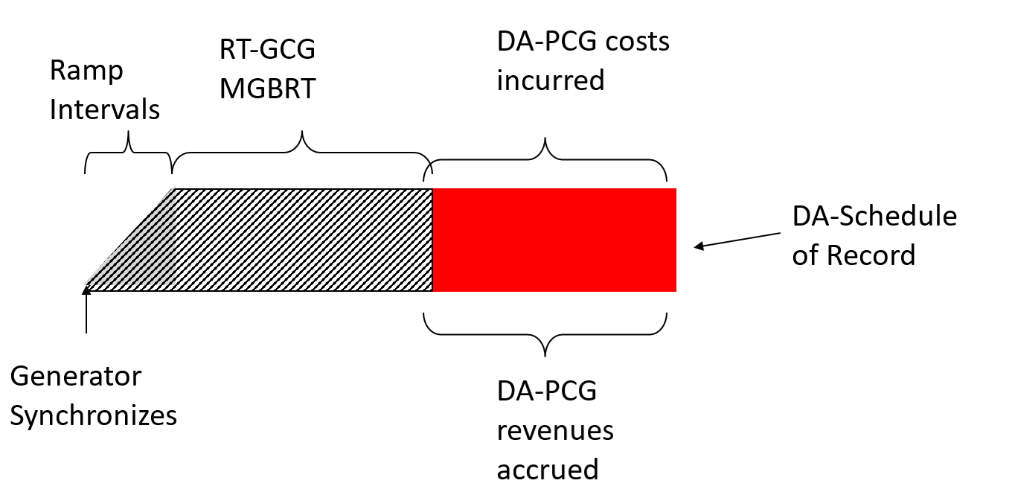

Figure E–1: RT-GCG Precedes DA Schedule of Record: No Overlap - No Gap between Events

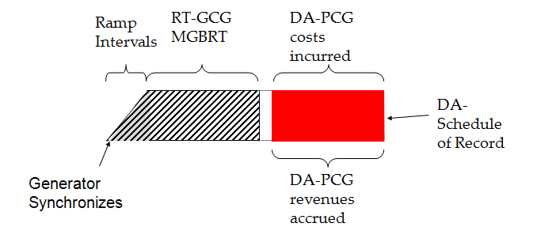

**Scenario 2: RT-GCG Precedes** DA Schedule of Record**: With Overlap**

In this scenario, a *generation unit* starts-up before the first hour of their day-ahead Schedule of Record, however, the combination of ramp time and *minimum generation block run-time* means the RT-GCG event will overlap with the day-ahead Schedule of Record. In this scenario both events can be tied back to a single *generation unit* start-up. Figure E-2 below depicts this scenario.

Figure E–2: RT-GCG Precedes DA Schedule of Record: No Overlap - Gap between Events

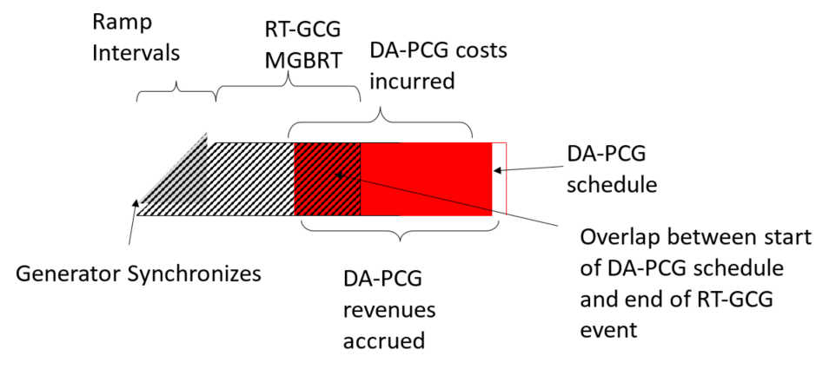

Figure E–3: RT-GCG Precedes DA Schedule of Record: With Overlap

**Scenario 3: RT-GCG Interacts with Withdrawn Schedule of Record**

This scenario is similar to Scenarios 1 and 2 such that the *generation unit* starts ahead of the Schedule of Record in order to participate in the RT-GCG program, however, in this scenario the *generator* has taken the appropriate actions to withdraw from the day-ahead Schedule of Record and the withdrawal is for reasons within the *generator’s* control. This withdrawal may be for all or a portion of the day-ahead Schedule of Record, the result being that the *generator* is not eligible for a DA-PCG *settlement* and further may be subject to a Day Ahead Generator Withdrawal Charge. If the withdrawal of the *generation unit* is for reasons not within the control of the *generator,* then the *generator* continues to be eligible for the DA-PCG *settlement* for the completed hours of the day-ahead schedule, resulting in *settlement* treatment comparable to scenarios 1 or 2 above.

**Principles for Eligibility and Settlement:**

1. The outcome of the day-ahead process is a Schedule of Record for the next day based on the three part day-ahead bids. These schedules are carried forward into real-time processes with constraints up to *minimum loading point* applied. Similar to manual constraints that are applied in real-time, usually as a result of invoking a RT-GCG start, these PCG constraints will not be considered in RT-GCG Pre-dispatch eligibility.
2. In scenarios 1 and 2 above, where both the DA-PCG event and the RT-GCG event can be tied to the same *generation unit* start-up, and the fuel costs for start-up and ramping to *minimum loading point* along with the related incremental O&M costs are eligible for inclusion in the DA-PCG *settlement*, these costs will not be considered in the assessment of the RT-GCG *settlement*.

The *generator* will indicate zero for these costs in the RT-GCG submission through the *IESO* in this situation. In the event that the RT-GCG event interacts with a DA-PCG event under scenarios 1 and 2 as described above, and the submitted start-up fuel and O&M costs submitted are not zero, these submitted costs will be deemed as unreasonable and *settlement* of the RT-GCG event will not include these costs, unless strong evidence exists to the contrary.

If the fuel costs for start-up and ramping to *minimum loading point* along with the related incremental O&M costs are not eligible for inclusion in the DA-PCG *settlement*, these costs will be considered in the assessment of the RT-GCG *settlement* and submitted through the *IESO* Gateway.

1. In scenario 3 above, where the *generation unit* is not eligible for a DA-PCG *settlement*, the fuel costs for start-up and ramping to *minimum loading point* along with the related incremental O&M costs will be included in the assessment of the RT-GCG *settlement*. These costs will be submitted as part of the RT-GCG claim in the *IESO* Gateway.

The table below provides the details for the *submission,* eligibility, and *settlement* of the any RT-GCG claim under the three potential scenarios where there is interaction with a Day-Ahead PCG event.

|  |  | **RT-GCG Precedes day-ahead Schedule of Record: *No Overlap***  **(Scenario 1)** | **RT-GCG Precedes day-ahead Schedule of Record: With *Overlap***  **(Scenario 2)** | **RT-GCG Precedes withdrawn day-ahead Schedule of Record**  **(Scenario 3)** |
| --- | --- | --- | --- | --- |
| **RT-GCG Submission** | * the trade date; * the event type (select RT for RT-GCG); * the *generation unit* name; | No change | No change | No change |
| * the intended synchronization hour ending (EST) | No change | No change | No change |
| * the number of actual ramp intervals required to achieve *minimum loading point* | No change | No change | No change |
| * the fuel costs of start-up and of ramping to *minimum loading point*; * the incremental O&M costs associated with start-up and ramping to *minimum loading point*. | The treatment and submission of fuel costs for start-up and for ramping to *minimum loading point* are outlined in Principle (2) above. | The treatment and submission of fuel costs for start-up and for ramping to *minimum loading point* are outlined in Principle (2) above. | No change |
| **Eligibility** | * the *generation unit* is not already synchronized at the time of *publication* of the applicable *pre-dispatch schedule*; | No change | No change | No change |
| * you notified the *IESO* control room, of your intent to qualify for an RT-GCG start, and run for at least your *minimum generation block run-time*; | No change | No change | No change |
| * the *price-quantity pair* *offer* price corresponding to the *minimum loading point* for all hours of the *minimum generation block run-time* must be the same | No change | No change | No change |
| * the *generation unit* must be scheduled in any *pre-dispatch schedule* determined within three hours ahead of the *dispatch hour (i.e.* PD-3, PD-2 or PD-1) for at least half of *minimum generation block run-time*,at *minimum loading point* hour endingat the end of *the minimum generation block run-time*, or the end of the *minimum run time,* whichever is earlier | *Pre-dispatch Schedules* with either manual or PCG constraints applied will not be considered | *Pre-dispatch Schedules* with either manual or PCG constraints applied will not be considered | *Pre-dispatch Schedules* with either manual or PCG constraints applied will not be considered |
| * the *offer* prices corresponding to the *minimum loading point* for the *minimum generation block run-time* are not increased after notifying the *IESO* of your intention to synchronize or after the *IESO* has applied a manual constraint; | No change | No change | No change |
| * you synchronize your *generation unit* no later than the end of the *dispatch hour*; and | No change | No change | No change |
| * you run your *generation unit* until the end of the *minimum generation block run-time*. | No change | No change | No change |
| **RT-GCG Cost** | * the submitted fuel costs and incremental O&M costs for start-up and ramp to *minimum loading point*; | The treatment and submission of fuel costs for start-up and for ramping to *minimum loading point* are outlined in Principle (2) above. | The treatment and submission of fuel costs for start-up and for ramping to *minimum loading point* are outlined in Principle (2) above. | No change |
| * the *offer* priceassociated with the real-time *dispatch* multiplied by the *energy* injected, to a maximum of the *minimum loading point,* during the period from the beginning of the *minimum generation block run-time* until the earlier of the end of the *minimum generation block run-time*, or the end of the *minimum run time* | No change | Cost from start of MGBRT to start of DA-PCG event | No change |
| **RT-GCG Revenues** | * Revenues are calculated for the period from start-upuntil the earlier of the end of the *minimum generation block run-time*, or the *end* of the *minimum run time including:* * *energy* sales up to the *MLP* * CMSC associated with AQEI up to the *MLP* | No change | Revenue from start up to start of DA-PCG event | No change |

OPG Rebate Requests for Additional Payments or Returns

The OPG Rebate was paid to eligible *market participants* for the period from May 1, 2006 to April 30, 2009, if the average price of *energy* for OPG’s non-prescribed assets was above a specified price during the applicable *settlement* period. The final payment of the OPG Rebate appeared under *charge type* 112 “Ontario Power Generation Rebate” on the May 31, 2009 *preliminary settlement statement*.

*Distributors* were required to pass OPG Rebate amounts through to their non-Regulated Price Plan (RPP) customers. Eligible *market participants* received a pro rata share of the OPG Rebate Amount based on their load (AQEW) for the applicable *settlement* period. Payments for these OPG Rebates were based on *distributor* submissions made through the online form “OPG Rebate Quarterly Distribution” that is no longer available as of May 1, 2009.

If you are a *distributor* who made an error in the information that was submitted to us for the distribution of the OPG Rebate and you now require additional funds to pass through to your customers, you may submit a request to us.

If you are a *distributor* and you have received funds that you are unable to distribute to your customers, or that have been returned to you by your customers, you must return these funds to us. Please notify us of the amounts to be returned via the “OPG Rebate Returned to IESO” online *settlements* data entry screen, available on the *IESO* Gateway.

Ontario Clean Energy Benefit

The Ontario Clean Energy Benefit (OCEB) was established by the Ministry of Energy to provide financial assistance to Ontarians to help them with the increased costs of upgrading and modernizing the *energy* infrastructure. The OCEB provides *consumers* with eligible accounts with a monthly 10% rebate off the applicable portion of their electricity bills as described in the *Ontario Clean Energy Benefit Act, 2010*, and [Ontario Regulation 495/10](http://www.e-laws.gov.on.ca/html/source/regs/english/2010/elaws_src_regs_r10495_e.htm). The rebate applies for a five-year period from January 1, 2011 to December 31, 2015.

Ontario Regulation 495/10 directs the *IESO* to reimburse *market participant* *distributors* for the 10% financial assistance that is provided to *consumers* that have eligible accounts with them; with any of their wholly-embedded *distributors*; and with any licensed retailers that use retailer-consolidated billing and that conduct business in their service area or the service area of any of their wholly-embedded *distributors*. This regulation also directs the *IESO* to reimburse unit sub-*meter* providers[59] for the 10% financial assistance provided by them on their fees and charges for unit sub-metering that appear on invoices issued by them to *consumers* that are entitled to receive financial assistance.

*Market participant distributors* and unit sub-*meter* providersmust submit their claims for reimbursement to us monthly no later than the fourth business day after the last *trading day* of the month. The *settlement* amount for *market participant distributors* and unit sub-*meter* providers will be included on the *preliminary settlement statement* and *final settlement statement* for the last *trading day* of the month under *charge type* 9992 “Ontario Clean Energy Benefit (-10%) Program Settlement Amount”. The corresponding set-off is *charge type* 1465 “Ontario Clean Energy Benefit (-10%) Program Balancing Amount”. *Charge type* 1465 is balanced by the *IESO* through a charge to the Ministry of Energy on their *preliminary settlement statement* and *final settlement statement* for the last *trading day* of the month.

*Distributors* that are *market participants* must submit OCEB claims to us via the on-line form “Ontario Clean Energy Benefit (-10%) – LDC”. In order to obtain reimbursement from the *IESO,* unit sub-*meter* providers must be registered in the wholesale electricity market and submit OCEB claims to us using the on-line form “Ontario Clean Energy Benefit (-10%) – Unit Sub-Meter Provider” that is also accessible on the *IESO* Gateway. A guide to help unit sub-*meter* providers to prepare their OCEB claims is available at. <http://ieso.ca/-/media/files/ieso/document-library/training/guide-to-online-data-submission.pdf>

Capacity Based Demand Response Program

The *capacity based demand response* (CBDR) *program* is designed to bridge the period from the Demand Response 3 contract expiration to the delivery date of the first demand response auction. This section describes the Measurement & Verification Plan process and how the IESO settles the CBDR program.

All capitalized terms used in this section are defined in the “Glossary of Terms for Capacity Based Demand Response” document available on the Market Rules & Manuals Library webpage. Rates mentioned in this section can be found in the CBDR Program Operational Information and Rates document available on the *Capacity Based Demand Response* *Program* webpage for informational purposes only.

Measurement & Verification Plan

*Demand response market participants* (DRMPs) participating in the CBDR program must submit a Measurement & Verification Plan (or “M&V Plan”) for each Demand Response Account (or “DR Account”) to the IESO for review and approval. The M&V Plan shall describe the data acquisition procedure and the analytical methodology that will be used by the DRMP to determine the delivery of Demand Response Curtailment (or “DR Curtailment”) by the Project. The M&V Plan should be simple, easy to understand and implement, and provide predictability and consistency. The measurement and verification methodology should be accurate and verifiable.

An M&V Plan may be submitted to: [CBDR.MV@ieso.ca](mailto:CBDR.MV@ieso.ca) at any time. To make changes or updates including but not limited to measurement and verification methodology, addition, deletion or substitution of *demand response contributors* (or “contributors”) within a pre-existing Contract Schedule*.*

* + - 1. Submission and Approval of the M&V Plan

Upon receipt of amended M&V Plans, the IESO will review and assess the submission within the timeline indicated on the CBDR Processing Timelines document available on the *Capacity Based Demand Response Program* webpage. If the M&V Plan is completed to the satisfaction of the IESO, the IESO will approve it. If the M&V Plan does not meet IESO’s requirements, the IESO may request additional information or reject the M&V Plan at IESO’s discretion. The IESO will notify DRMPs of the results of the M&V Plan reviews.

No proposed amendment or modification to an existing M&V Plan including any addition, deletion or substitution of any contributor to any such Project during its respective Schedule Term is effective without written acceptance of the IESO.

The IESO shall have the right to verify and audit all technical, financial, and operational data and systems for the Project and for any contributor. The IESO shall have the right to visit contributor and/or DRMP site(s) to ensure that there is no Project Amendment that has not been consented to as required in this section. *Demand response aggregators* (or “aggregators”) must maintain records of measurement data for all contributors and Activation Notices sent to their contributors specifying the start time, stop times and dates of DR Activations as well as a record of contributors demonstrating the eligible portion of the Monthly Contracted MW that the contributor is providing to the aggregator.

* + - 1. M&V Plan Information

The content of M&V Plan submission must meet the following requirements:

1. Each M&V Plan submission shall be complete.
2. Each DRMP must supply sufficient information in order for the IESO, in its sole discretion, to review the M&V Plan, including the following:
   1. the names, telephone numbers, and e-mail addresses of the DRMP’s contact person(s) with respect to the M&V Plan;
   2. a description of the Project;
   3. reference to a pre-existing Contract Schedule and DR Account;
   4. a description of how the DR Curtailment will reduce demand on the IESO-controlled grid, directly or indirectly;
   5. a description of the physical location, names and description of the contributor(s) included;
   6. a single line diagram (SLD) if specifically requested by the IESO and whenever, in the discretion of the IESO, the Load can be transferred to another source that is not set out in the M&V Plan;
   7. where the capacity of a Behind the Meter Generator exceeds the annual peak demand of the Load in which the Behind the Meter Generator is embedded, a declaration that the appropriate technology is in place to prevent electricity generated from being injected into the IESO controlled grid or Local Distribution System;
   8. for *demand response direct participants* (or “direct participants”), two years of historical data to support any request for an Extended Period Planned Non-Performance Event and to support the capacity of each contributor to the Project to provide its portion of the Monthly Contracted MW;
   9. for aggregators, one year of historical data aggregated into one stream of data for all contributors and one year of historical data from each contributor to support the capacity of each contributor to the Project to provide its portion of the Monthly Contracted MW; and
   10. with respect to each contributor (whether to an aggregator or a direct participant):
       1. meter type, model and firmware version, Measurement Canada approval reference;
       2. meter reference number (badge);
       3. IESO reference number (where appropriate);
       4. brief description of the Interruptible Load or Behind the Meter Generator measured;
       5. feeder number (where appropriate);
       6. meter seal expiry date(s);
       7. confirmation of ability to deliver Interval measurement data;
       8. instrument transformer information, including model numbers, Measurement Canada approval references, ratios, accuracy; and
       9. Verification Report which compares the independent source measurement data (hourly) and contributor measurement data (hourly).

The DRMP shall acknowledge within the M&V Plan, for each contributor where some portion of the required information is not readily available and reasonable efforts have been undertaken to secure such information, that such information shall be subject to acceptance or rejection at the sole and absolute discretion of the IESO.

1. The IESO will create a settlement map which represents the DR Account. The IESO will:
   1. map all kWh delivered and received meter point data streams to the DR Account; and
   2. issue site registration reports (SRR) to the DRMP for signature and confirmation of their acceptance of the settlement map.

Not all combinations of measurement data submission will be allowed by the IESO. Direct participants who participate in the Ontario wholesale electricity markets will be considered by the IESO to have Class 1 measurement data, aggregators will be considered by the IESO to have Class 2 measurement data and direct participants who participate in the Ontario retail electricity markets will be considered by the IESO to have Class 3 measurement data. The allowable forms and combinations of measurement data submission with respect to a DR Account will be as follows:

* only one of Class 1n, Class 2n, or Class 3n measurement data; or
* Class 1n and Class 3n which may be aggregated measurement data, where 1n means Class 1 measurement data from 1 to n sources and 3n means Class 3 measurement data from 1 to n sources.

1. The following additional principles shall apply to the development and evaluation of the M&V Plan:
   1. measurement error correction of the data is not permitted for Class 2 and Class 3 measurement data;
   2. loss adjustment of measurement data is not permitted; and
   3. all Load reductions must be metered using a revenue meter that complies with Measurement Canada standards; statistical methods, operational meters, SCADA (supervisory control and data acquisition) and other non-meter means are not permitted.

Contributor Management

DRMPs may not increase their Monthly or Daily Contracted MW in any given month above their total aggregated MW zonal cap for each IESO CBDR Resource. Each DRMP will be provided a DR Zonal MW cap at the start of the CBDR program for each IESO CBDR Resource for which they have active DR Accounts and Contract Schedules. The zonal cap will be the maximum amount of MW that a DRMP can subscribe on aggregate within an IESO CBDR Resource.

Contributor changes will fall under two categories: Remove or Add. DRMPs must state the existing DR Account and Contract Schedule that any contributor is being removed from or added to when submitting their changes. Changes must be communicated to [CBDR.MV@ieso.ca](mailto:CBDR.MV@ieso.ca) using the CBDR Contributor Form (available on the Market Rules and Manuals page). No new DR Accounts or Contract Schedules will be created under CBDR. Contributor management must follow the CBDR Processing Timelines document available on the *Capacity Based Demand Response Program* webpage. Contributor changes will occur in the order requested by the DRMP in the contributor change email and the following rules will apply under each scenario.

* + - 1. Removing a Contributor

Removing a contributor will reduce the Monthly Contracted MW under a DRMP’s IESO CBDR Resource for some or all months and so, will be accepted under all conditions. The contributor will be removed from the Contract Schedule and will reduce the aggregate MW subscription for the CBDR Resource – leaving space for DRMPs to add contributors. Removing a Contributor will not reduce the participant’s zonal cap; it will reduce subscription and will create space for capacity to be added.

* + - 1. Adding a Contributor

Adding a contributor will only be accepted if the addition does not put a DRMPs aggregate zonal DR capacity subscription over its set DR Zonal MW Cap. Since participants may oversubscribe contributors in a Contract Schedule, the IESO will add the contributor to a Contract Schedule but will only allow the affected Contract Schedule’s Monthly Contracted MW to increase to the CBDR Resource’s maximum capacity and any remaining contracted capacity of the contributor will be deemed as oversubscription.

Upon transitioning into the CBDR program, CBDR Contract Schedules were established using terms that reflected the quantities, expiry dates and Availability Rates of DR3 Contract Schedules that had existed under the DR3 Program. In addition, each CBDR Contract Schedule has a monthly DR capacity quantity, referred to as the Contractual MW, established to provide a reference threshold for the addition and removal of contributors to aid DRMPs in managing contributors across their Contract Schedules.

For greater clarity, contributor changes that impact CBDR Contract Schedules are subject to the following rules:

1. A Contract Schedule’s Monthly Contracted MW can be increased to accommodate the addition of a contributor up to its Contractual MW quantity.
2. A Contract Schedule’s Monthly Contracted MW may be increased beyond its Contractual MW quantity if:
   * 1. The increase does not exceed the difference between the DR Zonal MW Cap and the sum of Monthly Contracted MW of all Contract Schedules in that CBDR Resource for that month; and
     2. All Contract Schedules in that CBDR Resource for the DRMP have been subscribed to a Monthly Contracted MW equal to or greater than its Contractual MW.

Should the amount of DR capacity provided by contributors to a Contract Schedule fall below its Contractual MW either through the removal of a contributor or through Contributor Loss, the DRMP must replace that contributor to return the Contract Schedule to at least its Contractual MW. Otherwise, Contract Schedules whose Monthly Contracted MW have been increased above the Contractual MW will be reduced back to the Contractual MW value until such time as condition 2 (ii) above is satisfied.

* + - 1. Contributor Loss

DRMPs must notify the IESO as soon as possible by emailing: [cbdr@ieso.ca](mailto:cbdr@ieso.ca) to advise the IESO that they have suffered a Contributor Loss. The email should identify both the contributor and the capacity that was lost as well as identify which DR Account and Contract Schedule the contributor belonged to. The IESO will update the DRMPs Monthly Contracted MW to reflect the capacity that has been lost. A DRMP should consider a Contributor Loss to be any sudden loss of capacity that needs to be communicated to the IESO in order to keep an accurate record of actual available capacity.

The Contributor Loss notice allows DRMPs to communicate lost contributors more urgently than the CBDR timelines for removing a contributor allow. In addition to filing the Contributor Loss, the DRMP will have to remove that contributor via a M&V Plan update at the next available opportunity according to the CBDR Processing Timeline. Removal of a contributor is described above. The reduced MW may be replaced at any time before the expiry of the CBDR schedule term, but those MW must be replaced within the same CBDR Resource or ‘zone’ that they were removed from in order to respect the modelling of resource capacity within the IESO system.

Demand Response Measurement Data

To allow the IESO to determine the CBDR Baseline, performance set-offs, performance breaches, and settlement, weekly submission of demand response (DR) Class 2 and Class 3 measurement data is required. A week starts on a Saturday and ends on a Friday. M&V Plans will be used to verify measurement data for accuracy and ensure adherence to the Market Rules.

For DRMPs that have registered Class 1 measurement data, we will use the revenue measurement data that is collected as part of our market settlement process. When applicable, such DRMPs are to provide After Deadline Outage Day for each DR Account by 15:00 EST on the first business day of the second week following the week to which the data relates. DRMPs may take one After Deadline Outage Day per week.

For DRMPs that have registered Class 2 or Class 3 measurement data, you will be required to submit to: [CBDR.Datafiles@ieso.ca](mailto:CBDR.Datafiles@ieso.ca) the following:

* Upon request, a data file consisting of an initial set of 35 business days by 15:00 EST on the first business day of the first week of the program month (initial baseline data).
* On a weekly basis, weekly retail revenue measurement data (i.e. weekly data file), and After Deadline Outage Day for each DR Account by 15:00 EST on the first business day of the second week following the week to which the data relates (V1 measurement data). DRMPs may take one After Deadline Outage Day per week.
* If applicable, revisions to the weekly measurement data files can be submitted by 15:00 EST on the last business day of the month following the month for which the data relates (V2 measurement data). You will need to indicate which Intervals have been edited and why.

The IESO has three (3) business days from the V1 measurement data submission deadline (as per the CBDR Processing Timelines document) to process the submitted data file(s) and will notify the DRMP if and only if there are any data file discrepancies or errors found. Upon such notification, the weekly data files containing the data file discrepancies or errors will be deemed as not having been received by the IESO (i.e. undelivered) and the DRMP will be required to resubmit the weekly data without errors. A measurement data set-off will apply. More details on the measurement data set-off can be found in Section 1.6.24.6.5.

In addition to the above noted measurement data, aggregators must submit a log by DR Account, of each contributor that was requested by the aggregator to Curtail by 15:00 EST on the last Business Day of the month following the activation month only for the days when CBDR was Activated. The log shall contain the following information, the date and time of the request, duration of request, amount (in MW) of such request, and the contributor’s name. This log will be assessed by the IESO periodically to validate that the DR Curtailment plans are followed through as defined in the M&V Plan.

* + - 1. Measurement Data Specification

This section applies to DRMPs that have Class 2 and Class 3 measurement data.

DR measurement data is a feed of two channels of validated, edited, and estimated (VEE) data for each aggregated Facility (Class 2 measurement data) and direct Facility (Class 3 measurement data) for each DR Account at 5 minute Interval. For CBDR, VEE consists of the following checks performed by the IESO and any problems (i.e. data file discrepancies or errors) will be communicated to DRMP:

* Data does not have gaps (i.e. any 5 minute Interval missing from the data file),
* Data does not have overlaps (i.e. any 5 minute Interval that is a duplicate in the data file), and
* File format as defined below.

Measurement data must be provided in a CSV (comma separated values) compatible with the IESO’s meter data collection application[60]. The CSV file shall contain two channels of 5 minute engineering unit values. The unit of measurement is kWh delivered (withdrawn from the grid) for channel 1 and kWh received (injected into the grid) for channel 2. The CSV file shall adhere to the following format corresponding to each column name:

* Date: “YYYY/MM/DD”
* Time: “HH:MM”
* Ch1: Numeric “##.###” in kWh up to three decimal places
* Ch2: Numeric “###.###” in kWh up to three decimal places

Table E–1: Example of Weekly Data File

| Date | Time | Ch1 | Ch2 |
| --- | --- | --- | --- |
| 2014/03/28 | 00:20 | 749.305 | 0 |
| 2014/03/28 | 00:25 | 748.455 | 0 |
| 2014/03/28 | 00:30 | 745.455 | 0 |

The data file must contain 288 rows of data per day, having a beginning time of 00:05 and an end time of 24:00. The time reference shall be in eastern standard time (EST).

M&V Baseline Methodology

DR Curtailment will be calculated for each hour of Activation as the difference between the Project's calculated CBDR Baseline and the Project's measured consumption (or net production) of electricity, subject to adjustment of an in-day adjustment. A CBDR Baseline will be calculated for each DR Account by aggregating all measurement data for all contributors of that DR Account.

* + - 1. Suitable Business Day

A suitable business day is any business day where DR measurement data has been submitted and is available to the IESO, excluding days where:

* an Interruptible Load underwent a Planned Non-Performance Event;
* a DRMP undergo a DR Forced Outage;
* a DRMP claimed an After Deadline Outage Day which was accepted by the IESO;
* the IESO issued an Activation Notice;
* the DRMP has responded to the IESO with a Confirmation Notice for less than the Monthly Contracted MW; or
* the DRMP has responded to the IESO with a Confirmation Notice for less than the Contracted Dispatch Period.
  + - 1. Capacity Based Demand Response Baseline

For each hour of a DR Activation event, the CBDR Baseline shall be calculated as follows:

**CBDR Baseline = Standard Baseline × In-Day Adjustment Factor**

Both the standard baseline and the in-day adjustment calculation for any Confirmed Hour of an Activation shall go back to a maximum of thirty-five (35) business days prior to the day of the Activation to establish twenty (20) suitable business days.

If there are insufficient suitable business days within the previous thirty-five (35) business days to establish a standard baseline, then the IESO may elect to utilize only the available suitable business days within the previous thirty-five (35) business days. For example, if less than twenty (20) suitable business days was available then all those suitable business days will be used to calculate the standard baseline.

**Standard Baseline: High 15 of 20**

The standard baseline for any Confirmed Hour of an Activation is the average of the highest fifteen (15) values for the same hour as those of the Activation, in the last twenty (20) suitable business days prior to the Activation.

**In-Day Adjustment Factor**

The in-day adjustment factor is equal to A ÷ B, where:

A = Average actual consumption during the adjustment window hours on the actual Activation day.

B = Average actual consumption during the adjustment window hours in the past highest fifteen (15) of twenty (20) suitable business days prior to the Activation.

The adjustment window is the three (3) hour window occurring one (1) hour before an Activation event. The in-day adjustment factor can only be as low as 0.8 and as high as 1.2.

* + - 1. Contributor Baseline Considerations

**Interruptible Load**

The CBDR Baseline for direct participant Interruptible Load will be calculated as set out in 1.6.24.4.2. The CBDR Baseline for aggregator Interruptible Load will be calculated as set out in 1.6.24.4.2

**Behind the Meter Generators**

The CBDR Baseline for DR Accounts with contributor(s) that are Behind the Meter Generator(s) has the following considerations:

1. where a Project consists entirely of Non-Submetered Generators, the calculation is as set out in 1.6.24.4.2;
2. where a Project consists entirely of Sub-Metered Generators, the calculation is as set out in 1.6.24.4.2 except that the average calculations for the standard baseline and the in-day adjustment will use the ‘lowest’ fifteen (15) values instead of the ‘highest’ fifteen (15) values; or
3. where a DR Account consists of multiple installations comprised of a mixture of Interruptible Loads, Non-Submetered Generators, and/or Sub-Metered Generators, the calculation shall use the sum of the meters involved.

Settlement of Availability and Utilization Payments

DRMPs are paid a monthly Availability Payment for being available to reduce Load during the Hours of Availability and a Utilization Payment for actual Load DR Curtailment when directed by the IESO. Also, DRMPs will be entitled to receive an Availability Over-Delivery Payment for each hour that the DRMP is available to either reduce more than the registered demand reduction or reduce Load for a longer period than registered, in response to an Open Standby Notification.

For settlement purposes, all Contract Schedules will be aggregated and payment will be made at the DR Account level. Where rates are different for the applicable Contract Schedules within the DR Account, an amount will be calculated based on the weighted average of each rate as weighted by the Monthly Contracted MWs for each Contract Schedule.

* + - 1. Availability Payment

Each month, DRMP will receive an Availability Payment for each DR Account based on the Hours of Availability, Monthly Contracted MW and a weighted average of all the availability rates or adjusted availability rates (which is adjusted for premium zones and discount zones).

The Availability Payment for a DR Account for a given month is calculated as follows:

$$Availability Payment={HA}_{H} x {MCMW}_{h} x AAR$$

**Where:**

* ‘**HA**’ (Hours of Availability) means those hours within which a DRMP shall maintain a Contracted Dispatch Period to be available for potential DR Curtailment of that DRMP’s Monthly Contracted MW.
* ‘**MCMW**’ (Monthly Contracted MW) means the MW of demand reduction capacity for a specific program month as identified in one or more Contract Schedule(s).
* ‘**AAR**’ (Adjusted Availability Rate), means an amount equal to the Availability Rate, expressed in /MWh, as increased by the Availability Premium or as decreased by the Availability Discount, as the case may be.
* ‘**H**’ is the total hours a DRMP is available in a month.

We use *charge type* 1300 “Capacity Based Demand Response Program Availability Payment Settlement Amount”.

* + - 1. Availability Over-Delivery Payment

Over-delivery for an Open Standby Notification will result in an Availability Over-Delivery Payment for each hour that exceeded the Monthly Contracted MW or Contracted Dispatch Period.

In each hour, the Confirmed MWs are limited to the lesser of the Monthly Contracted MW plus 15 MW or 130% of the Monthly Contracted MW.

The Availability Over-Delivery Payment for a DR Account for a given month is calculated as follows:

**Availability Over-Delivery Payment** = ∑H (CMWh – MCMWh) × AODRh

**Where:**

* ‘**CMW**’ (Confirmed MW), means the number of MW available for DR Curtailment by the DRMP.
* ‘**MCMW**’ (Monthly Contracted MW) as defined above.
* ‘**AODR**’ (availability over-delivery rate), means the over delivery rate.
* ‘**H**’ is the set of all hours ‘h’ in the month where the ‘CMW’ exceeded the ‘MCMW’.

We use *charge type* 1301 “Capacity Based Demand Response Program Availability Over-Delivery Settlement Amt”.

* + - 1. Utilization Payment

DRMPs will be paid for the amount of Load reduction the DRMP actually provided for a DR Activation for each DR Account based on the Actual Activated MWh and the utilization rate.

The Actual Activated MWhs are the metered reduction for the Activation Period. The Actual Activated MWh amount can be a positive or negative number.

For Load reduction payments, the total reduction cannot exceed the product of the Activiation MW and the Activation Period, plus the lesser of an additional 15 MW per hour of the Activation Period or 15% of the Activation MW per hour of the Activation Period. Utilization Payments will not be paid during periods of Planned Non-Performance Events even if the IESO issued an Activation Notice.

The Utilization Payment for a DR Account for a given month is calculated as follows:

**Where:**

* ‘**AAM**’ (Actual Activated MWh), means the number of MWh Curtailed by a DRMP when requested by the IESO, as measured through the use of electricity meter(s). DR Curtailment shall not exceed the product of the Activation MW and the Activation Period, plus the lesser of an additional 15% of the Activation MW per hour of the Activation Period or 15 MW per hour of the Activation Period.
* ‘**UR**’ (utilization rate), means the rates, expressed in $/MWh.
* ‘**NG**’ (net generation), means the MWh of net electricity generated by any contributor that is a Behind the Meter Generator.
* ‘**HOEP**’ (*Hourly Ontario Energy Price*) as defined in the Market Rules.
* ‘**H**’ is the total hours ‘h’ a DRMP is Activated in a month.

We use *charge type* 1303 “Capacity Based Demand Response Program Utilization Payment Settlement Amount”**.**

Settlement of Performance Set-Offs

DRMPs are relied upon by the IESO when assessing adequacy, forecasting demand, and managing system performance. DRMPs are required to maintain a reliability rate of at least 85% for each and every Interval of an Activation Hour for each DR Account, and fulfill other requirements set out below, in order to avoid the imposition of performance set-offs.

The reliability rate with respect to such Interval “*i*” shall be calculated as follows:

${Reliability Rate}_{i}=\frac{Actual Activated MWh per Interval}{Activation MW x \frac{1}{12} of an hour}$**x 100**

The resulting reliability rate for an Interval shall not exceed 100%.

Where there is more than one Contract Schedule in a given DR Account, the reliability rate will be calculated on the aggregated Actual Activated MWh and Activation MWs of all the Contract Schedules in that DR Account.

* + - 1. Performance Set-Off Factors

The table below sets out the performance set-off factors to be applied to availability set-off and utilization set-off calculations where performance set-off factor is used.

Table E–2: Performance Set-Off Factors

| **Performance Set-Off Factor** | **Circumstances in which the Performance Set-Off Factor is to be applied** |
| --- | --- |
| 2.0 | * The reliability rate in any one or more Intervals is less than 85%; or * If a Confirmation is required, the IESO has not received such Confirmation three or more hours prior to the commencement of the Activation Period to which the Standby Notification relates. This shall not apply to a Confirmation for more than the Monthly Contracted MW in response to an Open Standby Notification; or * The DRMP has advised the IESO, less than three hours prior to the commencement of the Activation Period to which the Standby Notification relates, that the DRMP if not fully available for Curtailment; or * The IESO has determined that the DRMP was not fully available for Curtailment in relation to the Activation Period to which the Standby Notification relates. |
| 1.50 | * If a Confirmation is required, the IESO has received such Confirmation more than 30 minutes late, but more than three hours prior to the commencement of the Activation Period to which the Standby Notification relates, and the Confirmed MW for any one or more Confirmed Hours within the Contracted Dispatch Period is less than 95% of the Monthly Contracted MW. This shall not apply to a Confirmation for more than the Monthly Contracted MW in response to an Open Standby Notification; or * The DRMP has advised the IESO, three or more hours prior to the commencement of the Activation Period to which the Standby Notification relates, that the DRMP is not fully available for Curtailment. |
| 1.25 | * If a Confirmation is required, the IESO has received such Confirmation 30 minutes late or less. This shall not apply to a Confirmation for more than the Monthly Contracted MW in response to an Open Standby Notification; or * If a Confirmation is required, the Confirmed MW for any one or more Confirmed Hours within the Contracted Dispatch Period is less than 95% of the Monthly Contracted MW. |

* + - 1. Availability Set-Off

The availability set-off applied to a DR Account will be the greatest of (i) the availability set-off (reliability), (ii) availability set-off (timely Confirmation), and (iii) availability set-off (low Confirmation) for each DR Activation event (as calculated below). In the event that the availability set-off exceeds the Availability Payment, then the excess is considered owed by the DRMP to the IESO.

**Availability Set-Off (Reliability)**

Where the reliability rate for a given DR Account is less than 85% during any Interval of an Activation Hour, or where the DR Account is not fully available for Curtailment[61], an availability set-off (reliability) for each such Activation Hour in the Activation Period shall be calculated as follows:

**Availability Set-Off (Reliability)** = ∑H PSOh x AAR x MCMWh

**Where:**

* For each Interval, the reliability rate at a DR Account is defined as the actual reduction divided by the requested reduction; however, the reliability rate cannot exceed 100%.
* ‘**PSO**’ (performance set-off factor) refers to the set of factors defined in section 1.6.24.6.1.
* ‘**AAR**’ (adjusted availability rate) as defined above.
* ‘**MCMW**’ (Monthly Contracted MW) as defined above.
* ‘**H**’ is the set of all Activation Hours ‘h’ for the Activation Period.

**Availability Set-Off (Timely Confirmation)**

If the DRMP, regardless of Activation, fails to deliver or delivers late, one or more required Confirmations, then an availability set-off (timely Confirmation) shall be calculated as the sum of the availability set-off (timely Confirmation) for all hours of that Contracted Dispatch Period as follows:

**Availability Set-Off (Timely Confirmation) =** PSO x AAR x MCMWh x CDP

**Where:**

* ‘**CDP’** (Contracted Dispatch Period) means the four consecutive hours. Each Activation Period shall occur within the Hours of Availability, and shall occur within and no more than once in accordance with the Daily Schedule.
* ‘**PSO**’ as defined above.
* ‘**AAR**’ as defined above.
* ‘**MCMW**’ as defined above.

**Availability Set-Off (Low Confirmation)**

Availability set-off (low Confirmation) applies when the Confirmed MW are less than 95% of the Monthly Contracted MW for a Confirmed Hour of the Contracted Dispatch Period. The calculation is as follows:

**Availability Set-Off (Low Confirmation)** = ∑H (PSOh x AAR x (MCMWh – CMW))

**Where:**

* ‘**PSO**’ as defined above.
* ‘**AAR**’ as defined above.
* ‘**MCMW**’ as defined above.
* ‘**CMW**’ (Confirmed MW) means the number of MW available for DR Curtailment by the DRMP.
* ‘**H**’ is the set of all Confirmed Hours when the Confirmed MWs are less than 95% of the Monthly Contracted MW for the Contracted Dispatch Period.

We use *charge type* 1302 “Capacity Based Demand Response Program Availability Set-Off Settlement Amount”.

* + - 1. Utilization Set-Off

Similar to the availability set-off, the utilization set-off will be the greatest of (i) the utilization set-off (reliability), (ii) utilization set-off (timely Confirmation) and (iii) utilization set-off (low Confirmation) for each DR Activation event (as calculated below). In the event that the utilization set-off exceeds the Utilization Payment, then the excess is considered owed by the DRMP to the IESO.

**Utilization Set-Off (Reliability)**

The utilization set-off (reliability) applies when the reliability rate for a given DR Account is less than 85% during any Interval of an Activation Hour. The calculation is as follows:

**Utilization Set-Off (Reliability)** = $\sum_{H}{{PSO}_{H} x UR x {MCMW}_{H}}$

**Where:**

* For each Interval, the reliability rate at a DR Account is defined as the actual reduction divided by the requested reduction; however, the reliability rate cannot exceed 100%.
* ‘**PSO**’ (performance set-off factor) refers to the set of factors defined in section 1.6.24.6.1.
* ‘**UR**’ (utilization rate) as defined above.
* ‘**MCMW**’ (Monthly Contracted MW) as defined above.
* ‘**H**’ is the set of all Activation Hours ‘h’ for the Activation Period.

**Utilization Set-Off (Timely Confirmation)**

If the DRMP, regardless of Activation, fails to deliver or delivers late, a Confirmation that is required by the IESO, a utilization set-off will be calculated for each hour of the Contracted Dispatch Period as follows:

**Utilization Set-Off (Timely Confirmation) = $PSO x UR x {MCMW}_{h }x CDP$**

**Where:**

* ‘**CDP**’ as defined above.
* ‘**PSO**’ as defined above.
* ‘**UR**’ as defined above.
* ‘**MCMW**’ as defined above.

**Utilization Set-Off (Low Confirmation)**

Utilization set-off (low Confirmation) applies when the Confirmed MW are less than 95% of the Monthly Contracted MW for a Confirmed Hour of the Contracted Dispatch Period. The calculation is as follows:

**Utilization Set-Off (Low Confirmation) = $\sum_{H}{(PSO x UR x ({MCMW}_{H}-CMW)}$**

**Where:**

* ‘**PSO**’ (performance set-off) as defined above.
* ‘**UR**’ (utilization rate) as defined above.
* ‘**MCMW**’ (Monthly Contracted MW) as defined above.
* ‘**CMW**’ (Confirmed MW) as defined above.
* ‘**H**’ is the set off all Confirmed Hours when the Confirmed MWs are less than 95% of the Monthly Contracted MW for the Contracted Dispatch Period.

We use *charge type* 1304 “Capacity Based Demand Response Program Utilization Set-Off Settlement Amount”.

* + - 1. Planned Non-Performance Availability Set-Off

The planned non-performance availability set-off is another group of performance set-off. This set-off applies to any business day for which a Planned Non-Performance Event was considered or requested as part of either a single day Planned Non-Performance Event or as part of an Extended Period Planned Non-Performance Event.

There are two different formulas depending on whether the IESO sent any Activation Notices for the DR Account on the day in which such non-performance event was taken. The monthly set-off calculation will be the sum of all planned non-performance availability set-offs **(PNPAS)** as follows:

**PNPASm** = Non-Activation Day Non-Performance Availability Set-Off + Activation Day Non-Performance Availability Set-Off

**Non-Activation Day Non-Performance Availability Set-Off**

For any Planned Non-Performance Events requested during which the IESO does not send any Activation Notices for a DR Account, then the non-Activation day non-performance availability set-off shall be calculated as follows:

**Non-Activation Day Non-Performance Availability Set-Off** = (AAR x MCMWh x HANEh)

**Where:**

* ‘**AAR**’ as defined above.
* ‘**MCMW**’ as defined above.
* ‘**HANE**’ (Hours of Availability for a Planned Non-Performance Event), represents the sum of Hours of Availability for each day in the month for which a Planned Non-Performance Event is requested and for which an Activation Notice is not received by the DRMP.

**Activation Day Non-Performance Availability Set-Off**

For any Planned Non-Performance Events requested during which the IESO sends an Activation Notice for a DR Account, then the Activation day non-performance availability set-off shall be calculated as follows:

**Activation Day Non-Performance Availability Set-Off** = (OH x AAR x MCMWh x NEWF)

**Where:**

* ‘**OH**’ (opportunity hours), means (i) 64 for DR Account with Option A or (ii) 32 for DR Account with Option B.
* ‘**AAR**’ as defined above.
* ‘**MCMW**’ as defined above.
* ‘**NEWF**’ (non-performance event weighting factor), means 100%, unless the Actual Activated MWh per Interval calculated using the standard baseline, as averaged over all of the Intervals in the Contracted Dispatch Period for the Activation, is greater than or equal to the product of the Monthly Contracted MW and 1/12 of an hour in which case ‘NEWF’ means 50%.

We use *charge type* 1305 “Capacity Based Demand Response Program Planned Non-Performance Event Set-Off Amt”.

* + - 1. DR Measurement Data Set-Off

A DR measurement data set-off will be applied against the Availability Payment for a DR Account if a complete set of weekly measurement data and any DR Forced Outage(s) for that DR Account is not received by the IESO by 15:00 EST on the first business day of the second week following the week for which the data relates.

The DR measurement data set-off is calculated as follows:

**DR Measurement Data Set-Off $=MDSF x ({HA}_{H} x {MCMW}_{H} x AAR)$**

**Where:**

* ‘**MDSF**’ (measurement data set-off factor), is an increasing factor for every week that the full data remains undelivered. The factor is equal to:
  + 20% for the first week that the full data remains undelivered;
  + 33% for the second week that the full data remains undelivered;
  + 50% for the third week that the full data remains undelivered; and
  + 100% for the fourth week that the full data remains undelivered.
* ‘**HA**’ (Hours of Availability) as defined above.
* ‘**MRMW**’ (Monthly Contracted MW) as defined above.
* ‘**AAR**’ (adjusted availability rate) as defined above.
* ‘**H**’ is the total hours a DRMP is available for the applicable week.

We use *charge type* 1306 “Capacity Based Demand Response Program Measurement Data Set-Off Settlement Amt”.

Buy-Downs

Where an event occurs which reduces the Project’s ability to Curtail, was not caused by the DRMP, and could not have been reasonably prevented by the DRMP using Commercially Reasonable Efforts, the DRMP shall have one opportunity in the Schedule Term to request for a reduction referred to as buy-down by:

1. Reducing the Monthly Contracted MW to a number of MW that is not less than 5.0 MW, or reducing it entirely to 0 MW; or
2. Designating up to three Daily Schedules per week to be excluded from the days on which the DRMP is required to be available to participate.

To obtain a buy-down, DRMPs will be required to pay the applicable buy-down amount for each Contract Schedule. Each Daily Schedule that is part of a buy-down will be considered as a single day Planned Non-Performance Event and will be subject to the applicable planned non-performance availability set-off. The calculation used is dependent on the type of reduction requested. Calculations for the buy-down amount are defined below. Buy-down rates (R1 and R2) are available on the *Capacity Based Demand Response Program* webpage for informational purposes only.

The buy-down rate used in the buy-down amount is calculated as one of the following based on the Schedule Term of each Contract Schedule:

Table E–3: Buy-Down Rate Calculation

| **Schedule Term up to (Year)** | **Buy-Down Rate is calculated as** |
| --- | --- |
| 1 | Buy-Down Rate = R1 x number of months remaining in the Schedule Term |
| 3 | Buy-Down Rate = (R2 x number of months remaining in the Schedule Term, up to 24) + (R1 x M, where if the number of months remaining in the Schedule Term exceeds 24, M = months remaining – 24; otherwise M= 0) |
| 5 | Buy-Down Rate = (R2 x number of months remaining in the Schedule Term, up to 48) + (R1 x M, where if the number of months remaining in the Schedule Term exceeds 48, M = months remaining – 48; otherwise M = 0) |

The buy-down amount (Monthly Contracted MW) is calculated as follows:

**Buy-Down Amount (Monthly Contracted MW) =** MRMWR x BDR x HAE

**Where:**

* **‘MRMWR’** is the reduction in the Monthly Contracted MW.
* **‘BDR’** (buy-down rate).
* **‘HAE’** is the number of Hours of Availability that have elapsed in the Schedule Term as of the date that the reduction took effect.

The buy-down amount (Hours of Availability) is calculated as follows:

**Buy-Down Amount (Hours of Availability)** = MCMW x RD x BDR x HAE

**Where:**

* **‘MCMW’** as defined above.
* **‘RD’** (requested day) is the number of business days per week from which the Hours of Availability are to be removed.
* **‘BDR’** as defined above.
* **‘HAE’** as defined above.

We use *charge type* 1307 “Capacity Based Demand Response Program Buy-Down Settlement Amount”.

Performance Breach

Upon successful registration for the CBDR program, the number of performance breaches for a DRMP will be set to zero. Performance breaches are cumulative to, and shall be applied to a DRMP’s entire collection of DR Accounts within a CBDR Resource.

A DRMP’s compliance with a DR Activation is evaluated at the zonal level using the CBDR Resource as depicted in Appendix H of Market Manual 4.2 when calculating performance breaches. Each DRMP will be assigned to a CBDR Resource and window (early/late) in which they are directly participating in or have contributors.

For both settlement and zonal compliance aggregation purposes, the IESO will assume that the DR Account’s Actual Activated MW is zero for all of the Intervals that the data is missing (i.e. undelivered).

A performance breach is defined in relation to a given DRMP as:

1. the weighted average, over all Confirmed Hours in the Activation period where the Actual Activated MWh divided by the Activation MW for all of the DRMP’s DR Accounts within the same CBDR Resource is less than 80%; or,
2. the weighted average, over all Confirmed Hours in the Activation Period, of the Confirmed MW divided by the Monthly Contracted MW for all of the DRMP’s DR Accounts within the same CBDR Resource is less than 80%; or
3. the failure of the DRMP to provide to the IESO a complete set of weekly DR measurement data for a DR Account by the fourth week after the deadline.

**Performance Breach Events**

The IESO will evaluate performance breaches every month and will automatically take the required actions based on the occurrence of the breaches as follows:

**First Performance Breach**: The Availability Payments for applicable DRMP’s DR Accounts within the non-compliant CBDR Resource will be clawed-back for the month in which the performance breach occurred.

**Second Performance Breach:** The Availability Payments for applicable DRMP’s DR Accounts within the non-compliant CBDR Resource will be clawed-back for the month in which the performance breach occurred. The IESO also has the right to terminate some or all of the DR Accounts within a non-compliant CBDR Resource and will determine the need to do this on a case by case basis.

**Third Performance Breach:** The Availability Payments for applicable DRMP’s DR Accounts within the non-compliant CBDR Resource will be clawed-back for the month in which the performance breach occurred. The DRMP may be removed from participation in the CBDR program and/or may be subject to compliance actions in accordance with Section 6 of Chapter 3 of the Market Rules.

For a performance breach event that occurs exclusively as a result of condition c (i.e. failure to provide a complete set of DR measurement data) above, the Availability Payment clawback will only be applied to the DR Account for which the data is missing. However, it will still be counted as a performance breach event for the DRMP and accumulation of performance breaches may lead to termination of DR Accounts and/or termination of the DRMP as described above. For a performance breach event that occurs as a result of either condition a or b above, the Availability Payment clawbacks will apply to all of the DRMP’s DR Accounts within the non-compliant CBDR Resource.

We use *charge type* 1308 “Capacity Based Demand Response Program Performance Breach Settlement Amount”.

Cost Recovery

In order to keep the cost recovery of CBDR program consistent with the Demand Response 3 program, the IESO will use the following two charge types to recover CBDR costs:

* 1350 “Capacity Based Recovery Amount for Class A Loads”
* 1351 “Capacity Based Recovery Amount for Class B Loads”

All CBDR settlement amounts are added together for the month and recovered through these two charges in a manner similar to how we allocate global adjustment costs. Refer to section 1.6.7.8 for details on determination of and allocation of costs for Class A and Class B Loads.

Settlement Statements

* + - 1. Preliminary Settlement Statement

A manual line item will be created for each DR Account for each type of payments and set-offs with a non-zero settlement amount for a program month. Manual line items will be added to your preliminary settlement statement for the last trading day of a month following the program month. For example, the CBDR settlement for the program month of July will be included on August 31st preliminary settlement statement.

In addition to monthly settlement, any non-zero adjustment amounts as a result of recalculations due to accepted NOD submissions or as required by the IESO may also appear on your preliminary settlement statement. Preliminary settlement statements will be generated in accordance with the *SSPC* and will be issued via the *IESO* Report Site.

An invoice for amounts owed to or by the DRMP as per the preliminary settlement statement will be made available to the DRMP at the same time on the IESO Report Site.

If you disagree with a settlement amount on your preliminary settlement statement, you may submit a notice of disagreement (NOD) within four (4) business days after the statement has been issued. Refer to Section 1.3.5 ‘Submitting a Notice of Disagreement’ for more information regarding the notice of disagreement process. The resolution process for NODs will then commence between the DRMP and the IESO if the IESO determines the NOD is legitimate.

* + - 1. Final Settlement Statement

A final settlement statement will only be issued if there are any adjustments required to amounts on a preliminary settlement statement. Adjustments may be made due to recalculations completed as a result of a NOD submissions or as required by the IESO. Final settlement statements will be generated in accordance with the *SSPC* and will be issued via the *IESO* Report Site.

* + - 1. CBDR Program Settlement Report

A CBDR program settlement report is a private report to help DRMPs understand their settlement for that month. This report will be issued to each DRMP on a monthly basis and will contain the supporting information for all DR Accounts. This report will be made available on the same day as the preliminary settlement statement via the *IESO* Report Site.

Submitting Optional Measurement Data Records

You may submit a request for optional measurement data records to be included in the *settlement* data file. The steps in Figure 2-7 illustrate the process for submitting a request for optional measurement data records to us, and are described in detail in Section 3.7, Table 3-7.

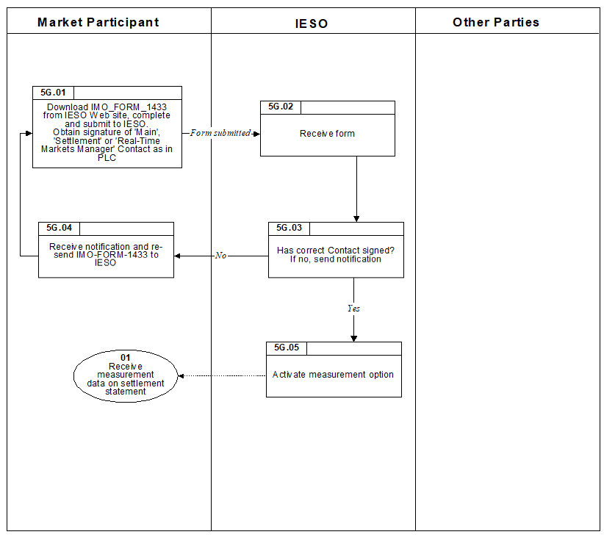

Figure E–4: Work flow for Submitting Optional Measurement Data Records

Submitting Request for Optional Measurement Data Records

M*arket participants* may request optional measurement data records to be included in the *settlement* data file.

The steps shown in the following table are illustrated in Section 2.7, Figure 2-7.

Table E–4: Procedural Steps for Submission of Optional Measurement Data Records

| Ref. | Task Name | Task Detail | When | Resulting Information | Method | Completion Events |
| --- | --- | --- | --- | --- | --- | --- |
| 5G.01 | Download IMO_FORM_1433 from our web site, complete and submit to us.  Obtain signature of ‘Main’, ‘Settlement’ or ‘Real-Time Markets Manager’ Contact as in CDMS. | *Market participant* downloads the form, completes it and submits it to us.  The m*arket participant* ensures it is signed by one of ‘Main’, ‘Settlement’ or ‘Real-Time Markets Manager’ contacts. | When *market participant* determines that optional measurement data records are needed. | *Market participant* has requested optional measurement data records. | Fax, mail or courier. | Request for optional measurement data records submitted. |
| 5G.02 | Receive form. | We receive completed form for request for optional measurement data records. | After 5G.01. |  |  | Form received. |
| 5G.03 | Has correct Contact signed?  If no, send notification. | We verify that form is complete and verify the signing contact is correct as in CDMS. If not, we inform the *market participant*. | After 5G.02. | Completed request for optional measurement data records. | If required, email. | Completed request for optional measurement data records. |
| 5G.04 | Receive notification and re-send IMO_FORM_1433. | *Market participant* receives notification that the incorrect contact has signed the form. The form is corrected and re-sent as in 5G.01. | After 5G.04. | Completed request for optional measurement data records. | Fax, mail or courier. | *Market participant* is aware of incorrect contact and has submitted a correct form. |
| 5G.05 | Activate measurement option. | Wewill include optional measurement data records with *settlement* data files. | After successful 5G.03. | Optional measurement data records included in *settlement* data files. |  | *Market participant* receives optional measurement data records. |

Repealed - Fair Hydro Act, 2017

The following provisions of the *Fair Hydro Act, 2017* were repealed effective November 1, 2019. Please refer to sections 1.6.7.7 (Regulated Price Plan) and 1.6.33 (Fair Hydro Act, 2017) for current provisions.

* + - 1. Ontario Fair Hydro Plan RPP Consumer Discount

We used *charge type 1142* “Ontario Fair Hydro Plan Eligible RPP Consumer Discount Settlement Amount”for processing *distributor* submissions. The corresponding setoff, *charge type* 1192 “Ontario Fair Hydro Plan Eligible RPP Consumer Discount Balancing Amount” was entered on the IESO’s *preliminary* *settlement statement* and *final settlement statement* for the last *trading day* of the month to balance the market.

* + - 1. Global Adjustment Modifier

Under the *Fair Hydro Act, 2017*, certain specified *consumers* who are not regulated rate consumers are entitled to an adjustment to the Global Adjustment (GA) amounts they pay. This adjustment, known as the GA Modifier, is implemented as a dollar-per-megawatt ($/MWh) credit applied to the consumer based on the amount of electricity consumed. The GA Modifier rate is set by the OEB, and is available on IESO’s website.

Licensed *distributors* and unit sub-*meter* providers that are *market participants* must submit their claims for reimbursement of the GA Modifier credits paid to their eligible customers. This claim must be submitted monthly to the IESO no later than the fourth *business day* after the last *trading day* of the month. The *settlement amount* for licensed *distributors* and unit sub-*meter* providers will be included on the *preliminary settlement statement* and *final settlement statement* for the last *trading day* of the month under *charge type* 1143 “Ontario Fair Hydro Plan Eligible Non-RPP Consumer Discount Settlement Amount”. The corresponding set-off is *charge type* 1193 “Ontario Fair Hydro Plan Eligible Non-RPP Consumer Discount Balancing Amount”.

* + - 1. Financing Entity

Two additional charge types have been created to settle the administrative costs and interest incurred by the "financing entity" in funding the initiatives under the *Fair Hydro Act, 2017*.

*Charge types* 1144, “Ontario Fair Hydro Plan Financing Entity Amount” and *charge type* 1145, “Ontario Fair Hydro Plan Financing Entity Interest” have been created for the purpose of settling these amounts. These amounts will be balanced to an IESO variance account under *charge type* 1194, “Ontario Fair Hydro Plan Financing Entity Balancing Amount” and charge *type* 1195, “Ontario Fair Hydro Plan Financing Entity Balancing Interest”.

* + - 1. Regulatory Asset

As per the *Fair Hydro Act*, 2017, the IESO may, from time-to-time, transfer a specified portion of the “regulatory asset” established through the Act to a financing entity; and an agreement between the IESO and a financing entity in relation to the transfer of a specified portion of the “regulatory asset” shall provide for consideration of a payment by the financing entity to the IESO in an amount equal to the amount of the specified portion.

*Charge type* 6000 "Ontario Fair Hydro Plan - Regulatory Asset Transfer Amount" is the amount debited to the financing entity and *charge type* 6050 "Ontario Fair Hydro Plan - Regulatory Asset Transfer Balancing Amount" is the amount credited to the IESO and is used to reduce the variance account.

Debt Retirement Charge (DRC)

The *debt retirement charge* (DRC) is charged on the *real-time market settlement statement* to all wholesale *market participants* withdrawing *energy* from the *IESO-controlled grid*. The charge is based on allocated quantity of *energy* withdrawn (AQEW) at each *delivery point*. We must collect and remit payment related to the *debt retirement charge* from you as required by any regulations made under the “*Electricity Act, 1998*”.

DRC Exemption

The regulations allow for other collectors and certain other persons to provide *exemption* certificates as described in:

* “Ontario Regulation 493/01 and 494/01”; and
* information guidelines provided by the Ministry of Finance.

If eligible, you can apply to us to be exempt from our collection of the DRC:

* for *energy* you withdraw for your specific *delivery points* to which the *exemption* applies; or
* to all *delivery points* where you withdraw *energy*.

If you wish to be exempt from our collection of the DRC, you should:

* complete the *exemption* certificates as indicated in the regulation; and
* submit the *exemption* certificates by mail or courier to the address provided in the “Contact Us” section on our web site; write on the envelope, “**Attention: *Settlements***”;wewill acknowledge receipt of the certificate.

Reduced Debt Reduction Charge (DRC) Certification

The regulation also identifies specific local utility service areas where *facilities* are eligible for reduced DRC rates.

If your *facilities* qualify for the reduced DRC rates:

* download IMO_FORM_1438 “Application for Reduced Debt Retirement Charge Form” from our web site; and
* submit the completed form by mail or courier to the address provided in the “Contact Us” section on our web-site; write on the envelope, “**Attention: Settlements**”; wewill acknowledge receipt of the form.

Submitting DRC Exemption Certificate

If you are exempt from DRC, you must submit exemption certificates to us. The steps in Figure 2-5 illustrate the process for submitting a DRC exemption certificate to us, and are described in detail in Section 3.5, Table 3-5.

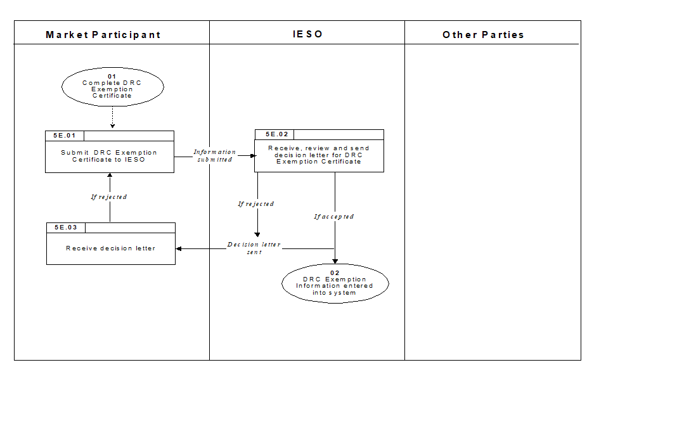

Figure E–5: Work flow for Submitting DRC Exemption Certificate

Submitting Reduced DRC Certification

You must submit reduced DRC certification form to us. The steps in Figure 2-6 illustrate the process for submitting reduced DRC certification information to us, and are described in detail in Section 3.6, Table 3-6.

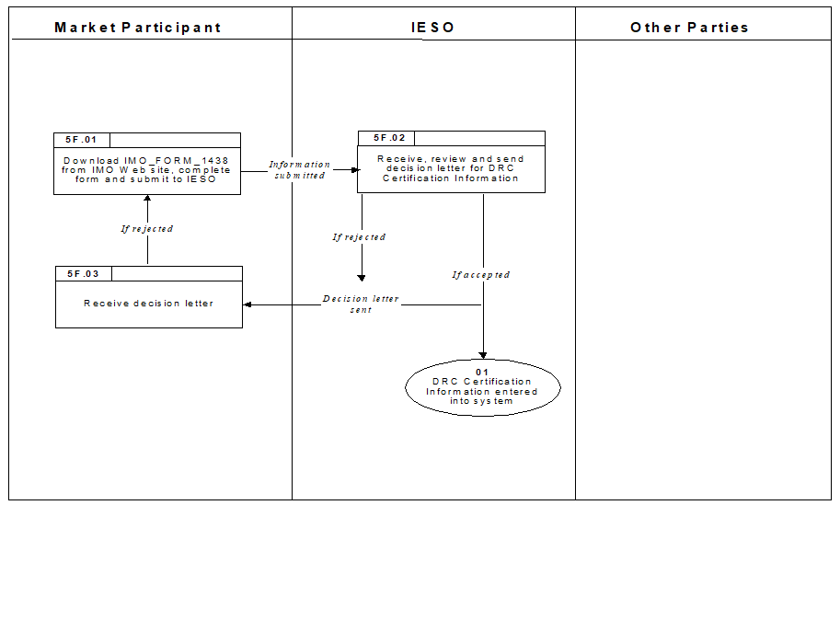

Figure E–6: Work flow for Submitting Reduced DRC Certification Information

Submitting DRC Exemption Certificate

M*arket participants* must register with the Ministry of Finance as indicated in “Regulation 493/01 and 494/01” and submit DRC exemption information to us in order to be exempt from the *debt retirement charge*.

The steps shown in the following table are illustrated in Section 2.5, Figure 2-5.

Table E–5: Procedural Steps for Submission of DRC Exemption Certificate

| Ref. | Task Name | Task Detail | When | Resulting Information | Method | Completion Events |
| --- | --- | --- | --- | --- | --- | --- |
| 5E.01 | Submit DRC Exemption Certificate to us*.* | *Market participant* submits hard copy of DRC exemption certificate as indicated in the Ministry of Finance procedure. | When DRC exemption certificate is complete. | Exemption certificate. | Mail or courier. | DRC exemption certificate submitted to us*.* |
| 5E.02 | Receive, review and send decision letter for DRC Exemption Certificate. | We receive DRC exemption certificate, review it for completeness and send a decision letter either accepting the certificate or rejecting it. | Upon receipt. | None. | Fax. | DRC exemption certificate received, reviewed and decision letter sent to *market participant*. |
| 5E.03 | Receive decision letter. | *Market participant* receives decision letter from us. If the information was incomplete, the *market participant* revises the information and resubmits it to us. | After Step 5E.02. | None. | Fax. | Decision letter received by *market participant*. |

Submitting Reduced DRC Certification Information

M*arket participants* must complete the reduced DRC certification to be charged the reduced DRC rate as indicated by the Ministry of Finance “Regulation 493/01”.

The steps shown in the following table are illustrated in Section 2.6, Figure 2-6.

Table E–6: Procedural Steps for Submission of Reduced DRC Certification Information

| Ref. | Task Name | Task Detail | When | Resulting Information | Method | Completion Events |
| --- | --- | --- | --- | --- | --- | --- |
| 5F.01 | Download IMO_FORM_1438 from ourweb site, complete form and submit to us. | *Market participant* downloads the Reduced DRC Certification form, completes it and submits it to us. | Prior to *trading day* the DRC reduced rate should apply. | Reduced DRC Certification. | Mail or courier. | Reduced DRC Certification submitted. |
| 5F.02 | Receive, review and send decision letter for DRC Certification Information. | We receive the “Reduced Debt Retirement Charge (DRC) Certification” (IMO_FORM_1438), review it for completeness and send a decision letter either accepting or rejecting the information. | Upon receipt. | None. | Fax. | Decision letter sent to *market participant.* |
| 5F.03 | Receive decision letter. | *Market participant* receives decision letter. If the information was incomplete, the *market participant* revises the information and resubmits it to us. | After Step 5F.02. | None. | Fax. | Decision letter received by *market participant*. |

− End of Section 

OPG Rebate

OPG Rebate

1. The provisions of this Appendix do not apply for any period beginning after April 30, 2009. The provisions of this Appendix have been retained in the event that a re-calculation of the OPG Rebate for any period prior to May 1, 2009 is necessary.

OPG Rebate Calculation

In accordance with our *Independent Electricity System Operator* *Licence*, we are required to pay the OPG rebate to you if the average price of *energy* for OPG’s non‑prescribed assets is above a specified price during the applicable Settlement Period. The OPG Rebate is in effect until April 30, 2009.

The OPG Rebate payment is calculated and distributed quarterly to eligible *market participants,* if warranted. Table 1–2 summarizes the Settlement Periods and submission deadlines.

The OPG Rebate amount payable by OPG:

**For the Period from May 1, 2006 to April 30, 2009, OPG is to make quarterly payments to the *IESO*, beginning with the OPG Rebate Payment on the October 31, 2006 *settlement statement* as follows:**

OPG Rebate amount = Sum over all hours [(HOEP – ORL) x (ONPAO x 0.85 – PAA) +  
(PAP – PAORL) x PAA)]

Ontario Power Generation’s quarterly payments are based on a cumulative calculation commencing May 1, 2006 to the end of each quarter less the same cumulative calculation to the end of the previous quarter. This continues until the final quarter ending April 30, 2009. Where the payment formula results in an amount owing to OPG for any quarter, no such payment will be made to OPG by the *IESO* and any such amount will be carried forward into subsequent quarters.

Where:

**ONPA or OPG’s Non-Prescribed Assets** are those generation assets operated and controlled by Ontario Power Generation in service as of January 1, 2006, excluding Lennox Generating Station, and excluding stations whose generation output is subject to a contract with the *IESO* in the form of a hydroelectric *energy* supply agreement (entered into by the *OPA* and OPG pursuant to a ministerial direction made under section 25.32 of the *Electricity Act, 1998*), that are not prescribed assets under Section 78.1 of the “*Ontario Energy Board Act, 1998*” as amended by the “*Electricity Restructuring Act, 2004*”.

**HOEP** is the *Hourly Ontario Energy Price* as determined by the *IESO*.

**ONPAO** is the generation output from OPG’s Non-Prescribed Assets, over each hour of the quarter adjusted to take account of volumes sold through forward contracts in effect as of January 1, 2005. For greater certainty, any output from ONPA resulting from fuel conversion by Ontario Power Generation in ONPA, or incremental output from ONPA resulting from refurbishment or expansion, or that is subject to a contract with the *OPA* in the form of a hydroelectric *energy* supply agreement, [entered into by the *OPA* and OPG pursuant to a ministerial direction made under section 25.32 of the *Electricity Act, 1998*] is to be excluded from ONPAO.

**Incremental Output** is defined as:

generation output x (new total installed capacity – installed capacity as of January 1, 2006) / new total installed capacity.

**ORL** is the Ontario Power Generation Revenue limit.

For the period May 1, 2006 to April 30, 2007 ORL is equal to $46/ MWh.

For the period May 1, 2007 to April 30, 2008 ORL is equal to $47/ MWh.

For the period May 1, 2008 to April 30, 2009 ORL is equal to $48/ MWh.

**PA** is the Pilot Auction administered by the *Ontario Power Authority* in the first half of 2006.

**PAA** is the volume in MWh over each hour in the quarter that is sold by Ontario Power Generation through the PA.

**PAORL** is the Pilot Auction Ontario Power Generation Revenue limit.

For the period May 1, 2006 to April 30, 2007 PAORL is equal to $51/ MWh.

For the period May 1, 2007 to April 30, 2008 PAORL is equal to $52/ MWh.

For the period May 1, 2008 to April 30, 2009 PAORL is equal to $53/ MWh.

**PAP** is the weighted average auction price in $/ MWh over each hour of the quarter realized for the PAA by Ontario Power Generation.

OPG Rebate Payment

If eligible, you will receive a pro rata share of the OPG Rebate Amount based on your allocated quantity of *energy* withdrawn for the applicable *settlement* period. Your OPG Rebate payment appears under *charge type* 112 “Ontario Power Generation Rebate”. If the calculated amount of the OPG Rebate is negative, we will not make any rebate payments.

Since the OPG Rebate is already included in the Regulated Price Plan rates established by the *OEB* for *energy*, you will not receive the OPG rebate if:

* You are a *market participant* that is a low-volume or designated *consumer*, as defined in the “*Electricity Act*” and its associated regulations; or
* You are a customer of a *distributor* and a low-volume or designated *consumer*.

*Distributors* are required to submit information to us in advance of OPG Rebate payments to allow us to determine their OPG Rebate amount. This submission requirement is described below in Section 1.6.3.3.

F.1.2.1 Distributor Submission Requirement

*Market participants* that are *distributors* must submit information to us prior to the distribution of the OPG Rebate. We use this information to calculate the OPG Rebate amount for the *distributor*.

For the applicable quarter, *distributors* must advise us of the volume of *energy* withdrawn from the *IESO-controlled grid* that is associated with *consumers* who are not being charged the Regulated Price Plan (RPP) price for their electricity consumption*.*

The quantity provided must account for the volumes associated with any embedded *distributors* in the *distributor’s* service area.

Distributors must submit the Ontario Power Generation Rebate - Quarterly Distributor information to us online. Table F-1 summarizes the submission deadlines for this information. Enter these volumes, rounded to the nearest kWh (3 decimal places on an MWh), via the Settlements community within the *IESO* Gateway.

F.1.2.2 Pass-Through of Rebate

Some *market participants* are required to pass OPG Rebate amounts through to their customers. If you are required to do this, any pass-through amounts that you are unable to distribute or that are returned to you by your customers must be returned to us. Please notify us of the amounts to be returned via the ‘OPG Rebate Returned to IESO’s *settlements* data entry screen of the *IESO* Gateway.

Table F–1: Summary of Deadlines

| OPG Rebate for: | Deadline for Submission of the OPG Rebate Quarterly Distribution Energy Volume | Applicable Settlement Period (AQEW Totals and Data Required on Form Pertains to): | For Distributors: Include Low Volume and Designated Consumers Known as of: | Rebate Payment to Eligible MPs on Settlement Statement for Trading Day (if warranted): |
| --- | --- | --- | --- | --- |
| **For the Period from May 1, 2006 to April 30, 2009:** | | |  |  |
| Quarters ending July 31 | 3 *business days*  before October 31 | May 1 – July 31 | mid – October | October 31 |
| Quarters ending October 31 | 3 *business days*  before January 31 | August 1 – October 31 | mid – January | January 31 |
| Quarters ending January 31 | 3 *business days* before April 30 | November 1 – January 31 | mid – April | April 30 |
| Quarters ending April 30 | 3 *business days* before July 31 | February 1 – April 30 | mid – July | July 31 |

− End of Section 

References

| Document ID | Document Title |
| --- | --- |
| MDP_RUL_0002 | Market Rules for the Ontario Electricity Market |
| PRO-408 | Market Manual 1: Connecting to Ontario’s Power System,  Part 1.5: Market Registration Procedures |
| MDP_PRO_0017 | Market Manual 2: Market Administration, Part 2.1: Dispute Resolution |
| MDP_MAN_0005 | Market Manual 5: Settlements, Part 5.0: Settlements Overview |
| MDP_PRO_0031 | Market Manual 5: Settlements, Part 5.1: Settlement Schedule and Payments Calendars (SSPCs) |
| MDP_PRO_0032 | Market Manual 5 Settlements, Part 5.2: Metering Data Processing |
| MDP_PRO_0034 | Market Manual 5, Settlements, Part 5.3: Submission of Physical Bilateral Contact Data |
| MDP_PRO_0035 | Market Manual 5: Settlements, Part 5.6: Physical Markets Settlement Invoicing |
| MDP_PRO_0036 | Market Manual 5: Settlements, Part 5.9: Settlement Payment Methods and Schedule |
| MDP_PRO_0046 | Market Manual 5: Settlements, Part 5.7: Financial Markets Settlement Statements |
| MDP_PRO_0047 | Market Manual 5: Settlements, Part 5.8: Financial Markets Settlement Invoicing |
| MDP_PRO_0027 | Market Manual 4: Market Operations, Part 4.2: Submission of Dispatch Data in the Real-Time Energy and Operating Reserve Markets |
| IMP_PRO_0034 | Market Manual 4: Market Operations, Part 4.3: Real-Time Scheduling of the Physical Markets |
| IMP_PRO_0057 | Market Manual 3: Metering, Part 3.8 Creating and Maintaining Delivery Point Relationships |
| IMO_MAN_0024 | Market Manual 6: Participant Technical Reference Manual |
| IESO_MAN_0080 | Market Manual 9: Part 9.5. Settlement for Day-Ahead Commitment Process |
| IMP_GDE_0103 | The Applications Status Tool: A User Guide |
|  | Guide to Settlement Claims and Data Submissions via Online IESO |
| IMP_LST_0001 | IESO Charge Types and Equations |
| IMP_SPEC_0005 | Format Specifications for Settlement Statement Files and Data Files |
| IMP_SPEC_0006 | File Format Specification for Participant Transmission Tariff Data Files |
| IMP_SPEC_0007 | File Format Specification for Transmitter Transmission Tariff Data File |
| IMP_SPEC_0008 | File Format Specification for Transmitter Reconciliation Data File |
| IMO_SPEC_0100 | Outbound Automated Document Application Programming Interface |
| IMP_REP_0016 | Transmission Tariff Peak System Demand Data Report |
| IMP_AGR_0013 | Settlement Agreement between Ontario Power Generation Inc. and the Independent Electricity Market Operator |
| Quick Take 15 | Retrieving Reports via the IESO Reports Site |
| *IESO* Step-by-Step Guide | IESO Interactions for Unit Sub-Metering Providers |
|  | OEB Retail Settlement Code |
|  | Ontario Energy Board Act, 1998 |
|  | Legislation Bill 4 “An Act to amend the Ontario Energy Board Act 1998 with respect to energy pricing”. |
|  | Legislation Bill 100  "Electricity Restructuring Act, 2004" |
|  | Order-in-Council 141/2006 |
|  | Regulation 42/04 (Under the Ontario Energy Board Act, 1998) |
|  | Regulation 43/04 (Under the Ontario Energy Board Act, 1998) |
|  | Regulation 339/02 (Under the Ontario Energy Board Act, 1998) "Electricity Pricing" |
|  | Regulation 341/02 (Under the Ontario Energy Board Act, 1998) "Compensation and Set-Offs Under Part V of the Act" |
|  | Regulation 342/02 (Under the Ontario Energy Board Act, 1998) "Payments to the IMO" |
|  | Regulation 433/02 (Under the Ontario Energy Board Act, 1998) "Electricity Pricing" |
|  | Regulation 435/02 (Under the Ontario Energy Board Act, 1998) "Payments re Section 79.4 of the Act" |
|  | Regulation 436/02 (Under the Ontario Energy Board Act, 1998) "Payments re Various Electricity-Related Charges" |
|  | Regulation 427/04 “Payments to the Financial Corp. re Section 78.2 of the Act” |
|  | Regulation 428/04 “Payments re Section 79.4 of the Act” |
|  | Regulation 398/10 enacted in October 2010 Amending Ontario Regulation 429/04 “Adjustments Under Section 25.33 of the Act” |
|  | Regulation 430/04 “Payments re Section 25.33 of the Act” |
|  | Regulation 431/04 “Payments re Section 25.34 of the Act” |
|  | Section 78.3 of the (Ontario Energy Board) Act |
|  | Section 78.4 of the (Ontario Energy Board) Act |
|  | Section 78.5 of the (Ontario Energy Board) Act |
|  | Regulation 53/05 made under “OEB Act, 1998” re “Payments under Section 78.1 of the Act” |
|  | Regulation 95/05 made under “OEB Act, 1998” re “Classes of Consumers and Determination of Rates” |
|  | Regulation 98/05 made under “OEB Act, 1998” re “Payments re Various Electricity-Related Charges” |
|  | Regulation 330/09 made under “OEB Act, 1998” re “Cost recovery regarding section 79.1 of the Act” |
|  | Regulation 66/10 made under “OEB Act, 1998” re “Assessments for Ministry of Energy and Infrastructure Conservation and Renewable Energy Program Costs”. |
|  | Regulation 495/10 made under “Ontario Clean Energy Benefit Act, 2010”. |
|  | Regulation 363/16 made under “Ontario Rebate for Electricity Consumers Act, 2016”. |
|  | Regulation 364/16 made under “Ontario Rebate for Electricity Consumers Act, 2016”. |

- End of Document -

1. The *settlement amounts* relating to the sale or purchase of *transmission rights* in any round of a *TR auction* appear on the financial markets *settlements* *statement*. See “Part 5.7: Financial Markets Settlement Statement” for details on this *statement*.
2. Our system summarizes s*ettlement amounts* by time period (*trading* *day*, trading hour, trading interval) and location as *charge types*. Items that we refer to as *settlement amounts* in this procedure will be summarized as *charge types* on the *settlement statement* itself.
3. You are considered to be an active *market participant* if you have at least one non-zero *settlement amount* on the *trading day* in question. Sometimes a *settlement amount* for a *trading day* may come from adjustments to previous *trading days* or from amounts that you incur indirectly, such as *default levy* amounts.
4. Manual line item entries will be less common than the preceding three record types and will not appear within every statement file.
5. See Chapter 9, Sections 6.3.10, 6.3.18.1, 6.3.19.1, 6.3.21.2 and 6.3.22.2 of the *market rules*.
6. For more information, refer to Online IESO page on the IESO’s public website.
7. See Chapter 7, Sections 8.4A.13-8.4A.16 of the *market rules*. See also Section 1.6.7 “Administrative Pricing Event” in this manual.
8. Refer to the “Market Manual 2: Market Administration, Part 2.1, Dispute Resolution” for more information.
9. See “Part 5.6, Physical Markets Invoicing”for more details of the invoicing process.
10. See Chapter 9, Sections 6.3.11, 6.3.18.2 and 6.3.19.1 of the *market rules*.
11. The file format specifications for the following data files/reports are provided on our web site:

    * Participant Transmission Tariff Data File;
    * Transmission Tariff Peak System Demand Data Report;
    * Transmitter Transmission Tariff Data File; and
    * Transmitter Reconciliation Data File.

   
12. See the reference document “IESO Charge Types and Equations” for more information.
13. The *transmission customer* is associated as the *metered market participant* Transmission (MMPT) for one or more *delivery points* defined for transmission network charges or transmission *connection charges*. See the “Market Manual 3: Metering, Part 3.8 Creating and Maintaining Delivery Point Relationships” for more information on this assignment process.
14. See the reference document “File Format Specification for Participant Transmission Tariff Data File” for details on this file.
15. Measurements at specific *delivery points* defined for transmission network charges are listed in each participant’s “Participant Transmission Tariff Data File”. This information is confidential and is not provided to other *market participants*.
16. The collection of *transmission tariff* charges is specified in Chapter 10 of the *market rules*.
17. See Chapter 9, Section 6.3.21.2b of the *market rules*.
18. See “Part 5.6: Physical Markets Settlement Invoicing” for further details of this process.
19. See Chapter 9, Section 6.1.2 of the *market rules*.
20. Details about the optional measurement data records can be found in the document “IESO Charge Types and Equation”.
21. In this Section 1.6.1, “you’ refers to a *metered market participant*.
22. In this Section 1.6.1 and 1.6.2, “you’ refers to a *metered market participant*.
23. *Electricity storage participants* are to use the Generation Station Service Form
24. See Chapter 7, Section 8.4A.5 of the *market rules*.
25. See Chapter 7, Section 8.4A.13, 8.4A.14, 8.4A.15 and 8.4A.16 of the *market rules*.
26. Renewable generation refers to electricity produced by wind, solar, small hydroelectric, biomass, bio-oil, bio-gas and landfill gas.
27. Demand in these references refers to Allocated Quantity of Energy Withdrawn (AQEW) from the *IESO-controlled grid*.
28. *Electricity storage participants* are to use the Embedded Generation Energy Storage and Class A Load form. The IESO will update the title of this form to include the term “Electricity” storage during further iterations of tool updates.
29. DSO = Dispatch Scheduling and Optimization
30. The Green Energy Act was introduced in the Ontario Legislature on February 23, 2009.
31. See Chapter 9, Sections 3.5 and 4.8 of the *market rules*
32. Refer to “IESO Charge Types and Equations” and “Format Specifications for Settlement Statement Files and Data Files”, located on the Technical Interfaces page of our web site for details of these *charge types.*
33. Attribute submitted to the IESO and maintained by the market participant as a part of facility registration. Refer to Section 5.1.3 of Market Manual 9, Part 9.1: Submitting Registration Data for the DACP.
34. Attribute submitted as a part of the Daily Generation Data. Refer to Section 5.2 of Market Manual 9, Part 9.2: Submitting Operational and Market Data for the DACP.
35. These curtailment reason codes are described in Market Manual 4.3: Real-Time Scheduling of the Physical Markets, Section 6.6 – Transaction Coding.
36. These curtailment reason codes are described in Market Manual 4.3: Real-Time Scheduling of the Physical Markets, Section 6.6 – Transaction Coding.
37. The service providers are the entities as defined by OESP regulation, O. Reg. 314/15.
38. Ramp-down rate limited (RDRL) means that the calculated *dispatch* instruction is ‘limited’ by the generator’s offered ramp rate.
39. “Unit sub-meter provider” is defined in the Ontario Rebate for Electricity Consumers Act, 2016.
40. Capitalized terms in Section 1.6.33 are defined in Market Manual 13.1: Capacity Export Requests, Appendix A: Glossary of Capacity Export Terms
41. Refer to the “Outbound Automated Document Application Programming Interface” if using an application programmable interface (API) to retrieve reports from the IESO Reports site.
42. Ibid.
43. Ibid.
44. Ibid.
45. “Embedded *distributor”* is classified by regulation, where it is assumed to take the meaning described in the *OEB* “Retail Settlement Code”.
46. Ibid.
47. In this section, “you” refers to a DR3 participant.
48. Refer to “IESO Charge Types and Equations” and “File Format Specification for Settlement Statement Files and Data files” located on the Technical Interfaces page of the IESO Web site for details of these *charge types*.
49. Ibid
50. Ibid
51. Ibid
52. In this section, “you” refers to a DR2 participant.
53. EPT means Eastern Prevailing Time, being either Eastern Standard Time or Eastern Daylight Savings Time, as in effect from time to time.
54. Refer to “IESO Charge Types and Equations” and “File Format Specification for Settlement Statement Files and Data Files” located on the Technical Interfaces page of the IESO Web site for details of these *charge types*.
55. Ibid
56. Ibid
57. We use the value for *minimum loading point* that is in our Market Entry database corresponding to the *start-up time.*
58. Ibid
59. A unit sub-meter provider is a person licensed by the *OEB* to engage in unit sub-metering, being activities in relation to unit sub-meters in multi-unit complexes. Unit sub-meter means a unit meter that is installed by a unit sub-meter provider in a unit of a multi-unit complex where the multi-unit complex is connected to a bulk meter.
60. Refer to Market Manual 5.2 Metering Data Processing for details on the meter data collection application.
61. See Section 1.3.8 of Operations Market Manual 4.2 for details on how not fully available for Curtailment is determined.